NMN-Mediated BUBR1 Stabilization as a Research Strategy for BUB1B-Related Mosaic Variegated Aneuploidy
  - Literature-based scientific report and proposed validation framework | 16 October 2026

Executive summary
Mosaic variegated aneuploidy (MVA) type 1 is a rare, generally biallelic BUB1B-associated chromosome-instability disorder. Patient-derived cell experiments establish that insufficient or dysfunctional BUBR1 compromises the spindle assembly checkpoint and chromosome alignment [1,2]. Separately, preclinical work demonstrates that the NAD⁺-dependent deacetylase SIRT2 regulates BUBR1 acetylation and stability, and that nicotinamide mononucleotide (NMN) increases BUBR1 abundance in mice [3]. We propose NMN as a mechanism-led research candidate, not an established treatment. Whether NMN restores functional BUBR1 or improves chromosome segregation in MVA has not been demonstrated.

1 | Background and unmet need
The BUB1B gene encodes BUBR1, a central regulator of the spindle assembly checkpoint, which delays mitotic progression when chromosomes are not correctly attached to the spindle. Biallelic BUB1B variants can produce MVA type 1, characterized by mosaic aneuploidy and developmental and cancer-related complications [1,2]. BUB1B variants differ mechanistically: some impair protein function directly, whereas others decrease protein abundance. This distinction matters because a stabilization strategy requires residual functional protein to stabilize [2].

2 | Research question and hypothesis
Research question: Can NMN-associated modulation of NAD⁺–SIRT2 signaling increase functional BUBR1 abundance and improve chromosome segregation accuracy in relevant BUB1B-related MVA cellular models?
Hypothesis: In MVA cells retaining stabilizable, partially functional BUBR1, NMN-associated changes in NAD⁺ metabolism may support SIRT2-dependent BUBR1 stabilization and improve mitotic checkpoint performance. This is a testable extrapolation from existing studies, not a demonstrated therapeutic effect.

3 | Literature review methods
This report uses a targeted, qualitative review of primary literature on (i) BUB1B/BUBR1 dysfunction and rescue in MVA patient cells and (ii) NAD⁺–SIRT2–BUBR1 regulation and NMN in preclinical systems. Primary claims were checked against the original publications or PubMed records. Evidence was classified as directly demonstrated in MVA cells, directly demonstrated in non-MVA preclinical models, or hypothetical extrapolation. This was not a systematic review or meta-analysis; no original experimental data were collected.

4 | Published findings and evidence strength
Finding | Primary evidence | Interpretation
BUB1B variants cause MVA in affected families | Hanks et al. (2004) [1] | Human genetic association; does not establish NMN response
Patient-derived MVA cells have low BUBR1, impaired checkpoint, chromosome alignment defects | Suijkerbuijk et al. (2010) [2] | Direct disease-model evidence
Functional BUBR1 expression restores checkpoint response in studied MVA cells | Suijkerbuijk et al. (2010) [2] | Positive mechanistic control; not NMN evidence
SIRT2 regulates BUBR1 K668 acetylation and abundance | North et al. (2014) [3] | Direct molecular mechanism in studied systems
NMN increases BUBR1 abundance in mice | North et al. (2014) [3] | Preclinical target-related effect; not MVA rescue
NMN corrects chromosome segregation in MVA | No direct primary evidence identified in these studies | Prospective hypothesis only

5 | Mechanistic pathway
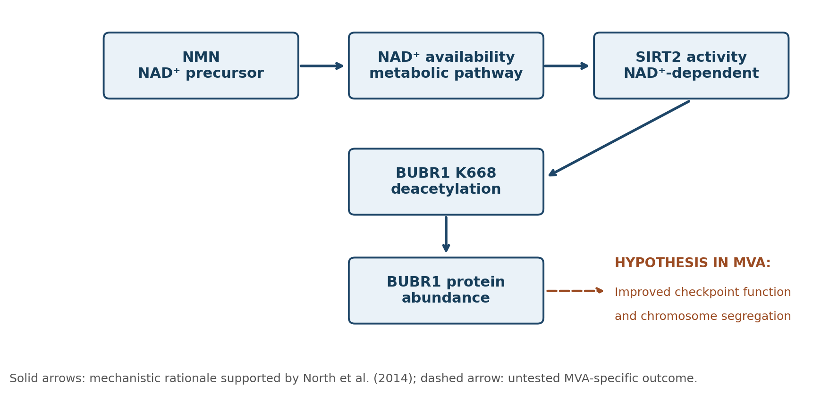
Figure 1. NMN–NAD⁺–SIRT2–BUBR1 mechanistic rationale. The final functional rescue step is a hypothesis requiring direct testing in MVA cells.

6 | Proposed validation study (conceptual design)
Model: independently characterized BUB1B-related MVA cellular models, with healthy reference cells and a documented residual-BUBR1 profile. A model lacking any functional BUBR1 should be analyzed separately because stabilization alone may not rescue it. Genetic status and baseline checkpoint phenotype should be established before interpreting a candidate response.
Comparison arm | Scientific purpose
Healthy reference cells | Define normal range
MVA cells + vehicle | Disease baseline
MVA cells + NMN | Test candidate-associated change
MVA cells + functional BUBR1 restoration | Positive functional rescue benchmark
MVA cells + NMN + BUBR1 restoration | Explore whether responses are complementary
MVA cells + NMN with SIRT2 function disrupted | Assess mechanistic dependence
Primary endpoint: chromosome segregation error frequency, compared between the NMN and vehicle MVA groups. Secondary endpoints: full-length BUBR1 protein abundance, spindle checkpoint performance, BUBR1 acetylation where measurable, SIRT2 dependence, and cell viability/mitotic progression. Assay selection and execution would require a qualified research laboratory and appropriate oversight.

7 | Prespecified interpretation and success criteria
Evidence supporting advancement would require (a) a reproducible decrease in chromosome segregation errors versus vehicle; (b) consistent improvement in checkpoint function; (c) evidence that functional full-length BUBR1 is present and its abundance or regulation changes in the predicted direction; (d) attenuation of the response when SIRT2 function is disrupted; and (e) no material adverse change in cell health or mitotic progression. Results should be replicated across independent biological experiments and, ideally, multiple genetically characterized models. Statistical methods, sample size and thresholds should be set prospectively; no numerical effect size is assumed here.
A rise in BUBR1 abundance without improved segregation is target engagement, not functional rescue. Improvement that persists despite SIRT2 disruption suggests an alternative mechanism. Lack of benefit in a null/truncation-dominated model would narrow applicability rather than necessarily invalidate the biochemical mechanism.

8 | Limitations and translational considerations
- North et al. studied BUBR1 regulation and NMN in non-MVA settings; their results cannot be generalized directly to MVA patients.
- NMN-induced BUBR1 abundance does not establish restoration of spindle checkpoint function, chromosomal stability, cancer-risk reduction or clinical benefit.
- BUB1B genotype matters: nonsense-mediated decay, absent full-length protein or function-disrupting variants may prevent a stabilization-only strategy from working.
- SIRT2 has multiple cellular substrates and mitotic roles; pathway modulation may have context-dependent effects.
- The proposed study is a conceptual validation framework, not completed experiments, a clinical protocol, or a recommendation to use NMN.
- This focused evidence assessment does not establish NMN superiority over all alternative candidates or comprehensive freedom to operate.

9 | Conclusion
NMN is a defensible lead research candidate because a primary preclinical study connects it to increased BUBR1 abundance through an NAD⁺–SIRT2-associated mechanism, while independent MVA patient-cell work demonstrates that BUBR1 abundance and function are disease-relevant. The critical missing link is whether NMN can restore chromosome segregation fidelity in genetically appropriate MVA models. A controlled cellular study centered on functional endpoints and genotype-specific responsiveness is the next scientific step. NMN should be described as an investigational hypothesis, not a treatment for MVA.

References
[1] Hanks S, et al. Constitutional aneuploidy and cancer predisposition caused by biallelic mutations in BUB1B. Nature Genetics. 2004. PMID: 15475955. https://pubmed.ncbi.nlm.nih.gov/15475955/
[2] Suijkerbuijk SJE, et al. Molecular Causes for BUBR1 Dysfunction in the Human Cancer Predisposition Syndrome Mosaic Variegated Aneuploidy. Cancer Research. 2010;70(12):4891–4900. doi:10.1158/0008-5472.CAN-09-4319. https://pmc.ncbi.nlm.nih.gov/articles/PMC2887387/
[3] North BJ, et al. SIRT2 induces the checkpoint kinase BubR1 to increase lifespan. EMBO Journal. 2014;33(13):1438–1453. doi:10.15252/embj.201386907. https://pmc.ncbi.nlm.nih.gov/articles/PMC4194088/

