**API Test Automation Report**

# Test Execution Summary

Report generated on: 2025-05-02 15:49:09

|  |  |  |
| --- | --- | --- |
| Total Tests | Passed | Failed |
| 5 | 4 | 1 |

## Test Results Overview:

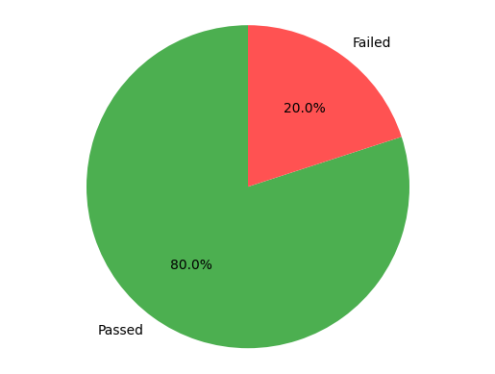

# Environment Information

|  |  |
| --- | --- |
| **Base API URL** | https://qas-api.simtro.com.br/api |
| **Python Version** | 3.13.2 |
| **Platform** | win32 |
| **Requests Version** | 2.32.3 |
| **Hostname** | PDINOTE-03 |
| **CPU Cores** | 8 |

# Execution Information

|  |  |
| --- | --- |
| **Test Execution Started** | 2025-05-02 15:49:05 |
| **Test Execution Finished** | 2025-05-02 15:49:09 |
| **Total Test Duration** | 0 minutes 3.75 seconds |

# Test Errors Report

The following 1 test(s) encountered errors:

**Test Description: Invalid credentials should be rejected**

**Test: test_invalid_login**

**Error Type: AssertionError**

*Error Message: 400 != 460*

**Request Body:**

{

"login": "invalid_user",

"password": "wrong_password"

}

Response Status: 400

Response URL: https://qas-api.simtro.com.br/api/login

Response Content:

{

"errors": [

"Usu\u00e1rio ou senha incorretos"

],

"status": 400

}