Machine Learning – Coursera

Note
Jordan Bouchoucha
Table of content
Week 1 3
Introduction 3
What is « Machine Learning » ? 3
What is Supervised Learning 3
What is Unsupervised Learning 3
Linear Regression With One Variable 4
Model and Cost Function 4
Gradient descent 5

Week 1

Introduction

What is « Machine Learning » ?
« Field of study that gives computers the ability to learn without being explicitly programmed. » (Arthur Samuel - 1959).
« A computer program is said to « learn » from experience E with respect to some task T and some performance measure P, if its performance on T, as measured by P, improves with experience E. » (Tom Mitchell – 1998).
Suppose your email program watches which emails you do or do not mark as spam, and based on that learns how to better filter spam. What is the task T in this setting ?

Classify emails as spam or not spam. = T
Watching you label emails as spam or not spam. = E
The number (or fraction) of emails correctly classified as spam/not spam. = P

What is Supervised Learning
→ Get a data set to the algorithm with the “right answers”.
Categorized into two problems :
- Regression problem : trying to predict results within a continuous output.
Given data about the size of houses, we have to predict their prices.
- Classification problem : trying to predict results in a discrete output.
Given a patient with a tumor, we have to predict whether the tumor is malignant or benign.

What is Unsupervised Learning
→ Get a data set with no real stucture.
Unsupervised learning allow us to approach problems with little or no idea what our results shoud look like. We can derive structure from data where we don't necessarily know the effect of the variables.
Categorized into two problems :
- Clustering problem : Take a collection of 1000000 different genes, and find a way to automatically group these genes into groups.
- Non clustering problem : “Cocktail Party Algorithm” allows you to find structure in a chaotic environment. (i.e identifying individual voice and music from a mesh of sounds)

Linear Regression With One Variable

Model and Cost Function

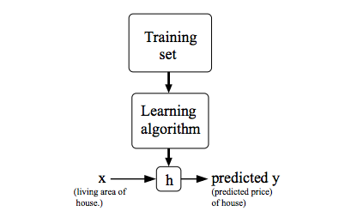

X represent inputs of the hypothesis h, which give us an output y with the estimated value.

Here the hypothesis function is a simple linear function.
are here called parameters.
The idea is to choose the best parameters so that is close to y for our training examples (x, y)
Let's normalize this, what we want is to minimize the difference between the output of the hypothesis and the answer to be small. So, one thing we might do is try to minimize the square difference.

With a training set of size m, and a train represented by where i is the index of a training example :

To make the math a little bit easier, we can minimize the average minimize by adding 1 over 2m

For be more cleaner, we can finally write

This is called, the cost function. It's the function that we want to minimize. By convention, this is how we usually define the cost function.
It's also called the squared error function.
Why use squared ?
This is the most commonly used cost function and a reasonable choice, work for many problems. There is other cost function that will work pretty well, but it stay the most common for regression problem.

Gradient descent
To recap
Hypothesis | Parameters | Cost Function | Goal

Gradient descend is the basic algorithm which allow us to find the best parameters for minimizing the goal. The algorithm is pretty simple.
- Start with some
- Keep changing to reduce until we hopefully end up at a minimum.
repeat until convergence {
(for j = 0 and j = 1)
}
is called the learning rate. It basically controls how big a step we take downhill with creating descent. So if it's very large, that will create a very aggressive gradient and can fail to converge, or even diverge but if it's too small, that will be very slow.
is called the derivative term.
A correct implementation would be : | A incorrect implementation would be :

It's very important to update all the parameters together after we compute the descent. (Simultaneous update)
Gradient descent converge to a local minimum. (when the derivative term is equal to 0).
As we approach a local minimum, gradient descent will automatically take smaller steps. So, no need to decrease the learning rate over time.

For write this piece of code, we need to figure out what is the partial derivative term.

So, now we are ready for put it in Gradient descent algorithm
repeat until convergence {

}
This kind of algorithm, when we use all the training sample for one step, is called batch gradient descent. We can also find others gradient descent which use a subset of the training sample for one step.

Week 2

Linear Regression with Multiple Variables

Multivariable Linear Regression
Here, we will see how to do linear regression with a lot of variables.
First, our previous hypothesis
begin
Our hypothesis now can be write like follow (with )
where and (T means transpose)

Hypothesis | Parameters | Cost Function | Goal

We got a new algorithm for the gradient descent with multivariable.
repeat until convergence {

}

Feature Scaling
Idea : Make sure features are on a similar scale.
For example, if you have two features x1 which represent size (0 – 20000 feet) and x2 which represent the number of bedrooms (1-5), there is obviously a big difference between the two variables.
For scale the features, you just need to divide your features by (for example) the maximum.
Now our feature will be and
The goal is to have every feature into approximately a range.
It's not important if they are not exactly in the same scale.
In addition to do Feature Scaling, we can also apply mean normalization which help for the learning. In fact, we just need to subtract the average of the variable in the training set before to make feature scaling.
Our x1 and x2 will become and

Learning rate
How to make sure gradient descent is working correctly ?
First, should decrease after every iteration. It's hard to say when the algorithm will converge. For example, you can declare convergence if decreases by less than in one iteration. But again, it's hard to define this ““ which stay an arbitrary choice.
The main common cause of fail during gradient descent, is a too big learning rate.
How to choose learning rate ?
Try a range of value (1, 0.1, 0.01, 0.001 …)

Normal Equation
Gradient descent gives one way of minimizing J. Let’s discuss a second way of doing so, this time performing the minimization explicitly and without resorting to an iterative algorithm. In the "Normal Equation" method, we will minimize J by explicitly taking its derivatives with respect to the θj ’s, and setting them to zero. This allows us to find the optimum theta without iteration. The normal equation formula is given below:

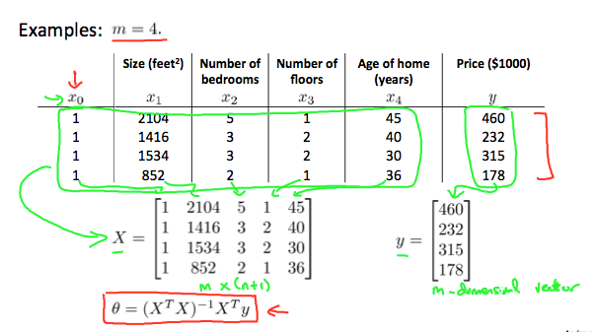
Here, you don't need feature scaling.
Gradient Descent | Normal Equation
Need to choose alpha | No need to choose alpha
Needs many iterations | No need to iterate
Works well when n is large | Slow if n is very large

In practice, when n exceeds ~10.00 it might be a good time to go from a normal solution to an iterative process.
When implementing the normal equation in octave we want to use the 'pinv' function rather than 'inv.' The 'pinv' function will give you a value of even if is not invertible.
If is noninvertible, the common causes might be having :
- Redundant features, where two features are very closely related (i.e. they are linearly dependent)
- Too many features (e.g. m ≤ n). In this case, delete some features or use "regularization" (to be explained in a later lesson).

