BookLibrary Sample
WPF Application Framework (WAF)

Introduction
The BookLibrary Sample shows how to use the WPF Application Framework (WAF) in a data oriented application. The sample includes:
- Layered Architecture and the Model-View-ViewModel pattern (MVVM).
- All layers are unit tested. The Foundation layer has 100% code coverage, the Domain and Application layer has tested everything except the entity framework related code and the Presentation layer is partly tested.
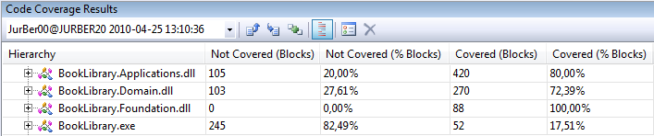
- Validation: The entities provide validation rules which are reflected on the user interface. The application shows how to configure WPF Binding for validation support.
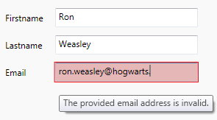
- When validation errors occur then the ‘Save’ command and the ‘Add’ new book command are disabled. This logic works for validation errors (e.g. Pages: -5) and for parsing errors (e.g. Pages: asdf) as well.
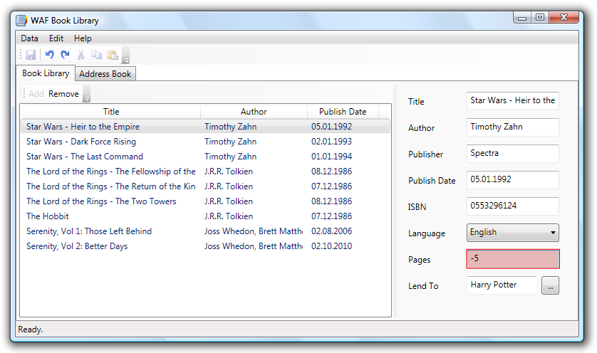
- The Entity Framework is used in combination with a SQL Server Compact Edition database. The database is stored in the BookLibrary.sdf file.
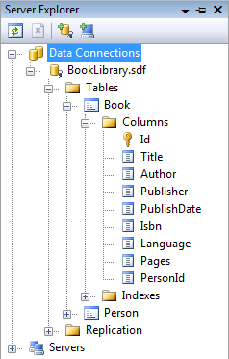
- The BookLibrary application checks if the application has unsaved changes when the user closes the BookLibrary.
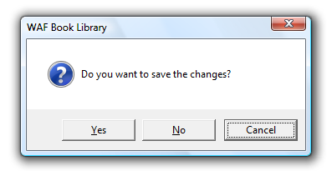
The BookLibrary Sample is part of the WPF Application Framework (WAF) download.

Run the sample
- Open the WpfApplicationFramework solution.
- Set the BookLibrary.Presentation project as StartUp project and start it in Debug mode.

UI Composition
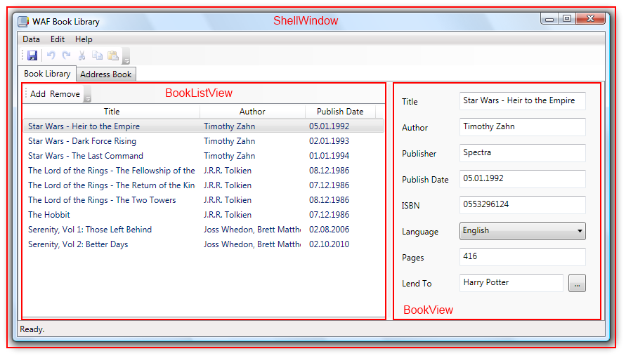
The ShellWindow class inherits from Window and contains the menu, the toolbar, the status bar and the TabControl. The TabControl hosts two tabs. The first tab shows the Book views and the second one shows the Person views.
The first TabItem contains two views which are separated via a splitter. The left one is the BookListView and the right one is the BookView. Both views inherit from UserControl. The second TabItem looks similar but contains the PersonListView and the PresonView.
When the user clicks on the ‘Lend To’ Button then the LendToWindow is shown as modal dialog.
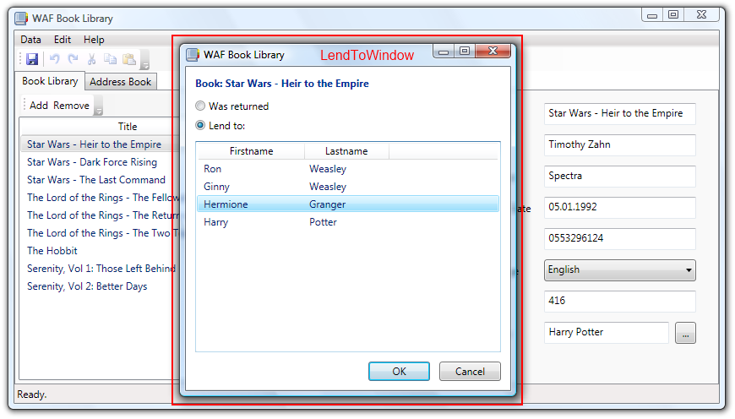

Project structure
The following C# projects are part of the BookLibrary sample application:
- BookLibrary.Presentation Presentation layer
- BookLibrary.Applications Application layer
- BookLibrary.Domain Domain layer
- BookLibrary.Foundation Foundation layer
- BookLibrary.Presentation.Test Unit tests for the Presentation layer
- BookLibrary.Applications.Test Unit tests for the Application layer
- BookLibrary.Domain.Test Unit tests for the Domain layer
- BookLibrary.Foundation.Test Unit tests for the Foundation layer

BookLibrary.Presentation
- Converters Value converters
- Resources ResourceDictionaries, Images, Icons
- Services Implementation of the QuestionService
- Views WPF Views (Windows, UserControls)

BookLibrary.Applications
- Controllers Use case controllers
- Services Interfaces and implementation of services
- ViewModels The ViewModels for the Views
- Views The interfaces for the Views

BookLibrary.Domain
- (Root) Entity Data Model and partial classes for the Entities
- Resources Database file

BookLibrary.Foundation
- (Root) Helper classes for the IDataErrorInfo interface

Domain Layer
