ViewModel Sample
WPF Application Framework (WAF)

Introduction
The ViewModel Sample shows how to use the Model-View-ViewModel pattern in different scenarios. The sample includes:
- View composition
- Command binding
- Showing of a modal dialog
- UI workflow (Wizard)
- ViewModel adds UI specific functionality to a business object
- Usage of the WeakEvent pattern to prevent memory leaks
- Synchronization of data when binding doesn’t work
- Unit testing of the Application layer
Remark: The Model-View-ViewModel pattern is often referred as PresentationModel pattern.
The ViewModel Sample is part of the WPF Application Framework (WAF) download.

Run the sample
- Open the WpfApplicationFramework solution.
- Set the EmailClient.Presentation project as StartUp project and start it in Debug mode.
- The main window shows an email client with a message list on the left hand side and the message content on the right hand side.
Remark: To keep the sample application simple, the message list view and the message content view doesn’t provide any functionality.
- Click on “Tools” and then on the “Email Accounts…” menu item. A wizard comes up which helps you to create a new email account.
- Select “Microsoft Exchange” and click on the “Next” button. Now you can enter some values into the fields.
- Click on “Next” and the exchange email account gets saved. In the Visual Studio Output View you can see the current list of saved email accounts.
Note: You might need to open the Output Window first in Visual Studio (View -> Output).
- Start the email accounts wizard again and select the “Pop3” email account this time.
- Enter some values into the fields for the Pop3 and Smtp Server settings.
- Activate the “Use the same username…” checkbox. Now the username and password field for the Smtp server settings are disabled.
- Deactivate the checkbox and see that the old Smtp username and password are restored.
- Click on the “Next” button to save the Pop3 email account.

Main Window
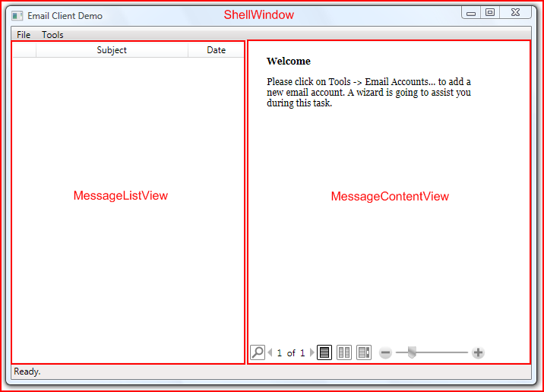
The main window consists of three independent WPF views which are composed together at runtime:
- ShellWindow : Window
- MessageListView : UserControl
- MessageContentView : UserControl

Project structure
The following C# projects are part of the ViewModel sample application:
- EmailClient.Presentation Presentation layer
- EmailClient.Applications Application layer
- EmailClient.Domain Domain layer
- EmailClient.Applications.Test Sample unit tests for the Application layer

Code Walkthrough
- Open the WpfApplicationFramework solution.
- Open the EmailClient.Presentation / App.xaml.cs file.
  - First we initialize the IoC Container. This sample uses the Managed Extensibility Framework (MEF).
  - The EmailClient.Presentation and EmailClient.Applications assembly are added to the catalog so that MEF inspects their types for the [Export] and [Import] attributes.
  - Then we initialize the container.
  - At last we retrieve the ApplicationController from the IoC Container and call Initialize() and Run() of the controller.
- Open the EmailClient.Applications / ApplicationController.cs file
  - In the constructor we retrieve the three views for the main window (ShellView, MessageListView and MessageContentView) and create the main business object (EmailClientRoot).
  - In the Initialize method the “Exit” and “Email Accounts” commands are set. The controller is responsible for these two commands because they affect the workflow of the application.
  - Furthermore, in the Initialize method the MessageListView and the MessageContentView are put into the ShellWindow. In this scenario the controller is responsible for the view composition. This has the advantage that the views and the view-models don’t have to refer each other.
  - The Run method shows the main window.
  - The RunCreateEmailAccountController gets invoked when the “EmailAccounts” command is executed. The method just creates a sub controller (use-case controller) which is responsible for the wizard.
- Open the ShellViewModel.cs file
  - This class exposes properties for the shell commands and the views. These properties are set by the application controller.
Remark: Here it’s necessary to use the RaisePropertyChanged method inside the property setter. Otherwise, the WPF view wouldn’t be updated after the application controller has set the properties.
- Open the EmailClient.Presentation / ShellWindow.xaml file
  - The ShellWindow defines the menu items and binds to the ShellViewModel command properties.
  - The class defines the layout (two columns) and puts placeholders (ContentPresenter) in it which binds to the view properties of the ShellViewModel.

Email Accounts Wizard
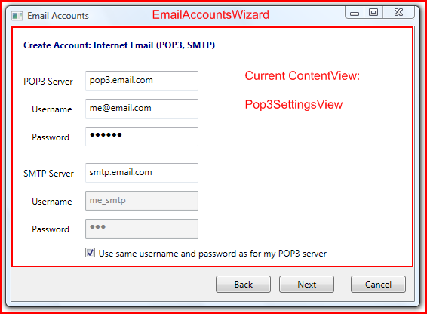
The wizard consists of the EmailAccountsWizard (Window) and a content view which is dynamically set through the controller. In the picture above you see the Pop3SettingsView (UserControl) as current content view.

Code Walkthrough
- Open the EmailClient.Applications / CreateEmailAccountController.cs file.
  - This controller is created, instantiated and run by the ApplicationController when the user clicks on ”Tools / Email Accounts…” menu item.
This class is responsible for the workflow of this wizard.
  - In the constructor it retrieves the wizard (EmailAccountsViewModel) and the first wizard page (CreateEmailAccountViewModel).
Then it creates the delegate commands for Back, Next and Cancel.
  - In the Initialize method the class sets the delegate commands into the EmailAccountsViewModel command properties.
  - The method Run is responsible to set the first wizard page and show the wizard as modal dialog.
Remark: When you show a modal dialog then it’s recommended to set the Owner property of the dialog. Otherwise, the dialog behaves wrong in some special user scenarios.
  - The next methods, CanBack, Back and Next are responsible for the workflow.
Remark: The design for processing the workflow is very simplified. In more advanced scenarios you might use a better design for this task.
  - The method Next checks the current wizard view and then proceeds with the workflow.
  - The show methods (ShowPop3SettingsView and ShowExchangeSettingsView) create the needed business object and then retrieve the view from the IoC Container. After that, they create the ViewModel and set the view as new ContentView.
  - In the save methods, the controller takes over the responsibility to add the setting object to the email accounts of the EmailClientRoot.
Remark: Creating of business objects or advanced modifications on them should be done in the Controller and not in the ViewModel class.
- The EmailAccountsViewModel and the EmailAccountsWizard class are very similar to the Shell (See MainWindow for more information).
- Open the EmailClient.Applications / CreateEmailAccountViewModel.cs file.
  - This ViewModel class provides the logic for the first wizard page in which you can choose between a Pop3 and an Exchange email account.
  - It exposes two Boolean properties which can be bound by the RadioButtons in the view. These properties contain the logic that only one of them can be true at the same time.
- Open the EmailClient.Presentation / CreateEmailAccountView.xaml file.
  - The two RadioButtons bind their IsChecked property to the two ViewModel properties.
- Open the EmailClient.Applications / ExchangeSettingsViewModel.cs file.
  - This ViewModel class just exposes the business object ExchangeSettings through the Model property.
- Open the EmailClient.Presentation / ExchangeSettingsView.xaml file.
  - The TextBoxes binds over the ViewModel.Model property directly on the business object ExchangeSettings.
- Open the EmailClient.Applications / Pop3SettingsViewModel.cs file.
  - Whereas the ExchangeSettingsViewModel was really simple we put a bit more logic into this class to show what a ViewModel can do.
  - The constructor stores the business object Pop3Settings and adds a weak event listener to the Pop3UserCredits object. See the section Domain Layer for an overview of the business objects.
  - The Model property exposes the underlying business object Pop3Settings.
  - The UseSameUserCredits property controls the behavior when the user changes the “Use the same username…” checkbox in the view.
  - Pop3UserName and Pop3Password wrap the similar properties of the business object to add some new functionality. When the UseSameUserCredits property is set to true then it sets the same value for the Smtp username or the password on the business object too.
  - SmtpUserName and SmtpPassword are responsible to store the user entered value in the ViewModel class. Therefore, it is possible to restore the old values when the user deactivates the “Use the same username…” checkbox.
  - Because we have wrapped the Pop3Username and Pop3Password properties from the business object, we have to relay the PropertyChanged events from the business object too.
Remark: We have to use the weak event pattern here because the business object might life longer than the Pop3SettingsViewModel class. Without this pattern we would produce a memory leak.
  - Conclusion: We have extended the business logic with the UseSameUserCredits feature in the ViewModel class. It would have been easier to put the UseSameUserCredits feature into the business logic class. But if we consider the Single Responsibility Principle then it was the right decision not to overburden the business logic with UI specific logic.
- Open the EmailClient.Presentation / Pop3SettingsView.xaml file.
  - The TextBoxes bind to the properties of the ViewModel class.
  - The PasswordBox doesn’t support data binding. We added an event handler to the LostFocus event in the code-behind file.
  - The Smtp username and password box bind their IsEnabled property to the UseSameUserCredits property of the ViewModel.
- Open the EmailClient.Presentation / Pop3SettingsView.xaml.cs file.
  - It’s a design goal to keep the code-behind file of a WPF view as small as possible. However, in some scenarios you have to use it anyway. In our example the PasswordBox doesn’t support data binding and so we listen to the LostFocus event in this file.
  - In the LostFocus handlers we transfer the user entered values to the business object.
Remark: In a real world application you shouldn’t store passwords in simple strings like this sample application does. The PasswordBox supports the SecureString which is a better choice to store the passwords.

Domain Layer
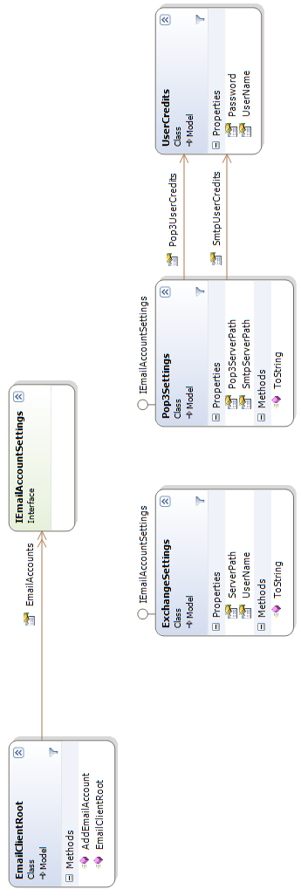

Unit Testing
- Open the EmailClient.Applications.Test project
- Open the references folder. The unit test project depends on the EmailClient.Applications and EmailClient.Domain project but doesn’t refer the EmailClient.Presentation project. The views implemented in the Presentation layer are replaced by mock objects.
- Open the Pop3SettingsViewModelTest.cs file
  - The test method UseSameUserCreditsTest checks if this feature works correct in the Pop3SettingsViewModel class.
  - To create a Pop3SettingsViewModel object we create first a ViewMock for the IPop3SettingsView interface and create the business object Pop3Settings.
  - The test method PropertyChangedRelayTest checks that changes at the business objects are relayed through the ViewModel class.
- Open the CreateEmailAccountControllerTest.cs file
  - The CreateExchangeAccountTest method checks the workflow of the CreateEmailAccountController.
  - At first the IoC Container is initialized. But in the unit test we don’t register the EmailClient.Presentation assembly because we replace the WPF views with mock objects.
  - We need to register all the views with mock objects which are used during the tested workflow.

