Writer Sample
WPF Application Framework (WAF)

Introduction
The Writer Sample shows how to use the WPF Application Framework (WAF) in a document oriented application. The sample includes:
- Layered Architecture and the Model-View-ViewModel pattern (MVVM).
- Full unit tested application layer and partly tested presentation layer (regarding code coverage).
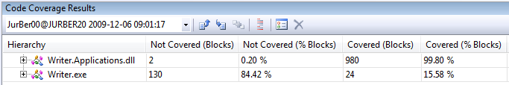
- Tabbed MDI (Multiple Document Interface).
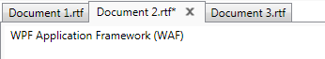
- Document management with support for multiple file types. The sample allows saving a text as “.rtf” or “.xps” format.
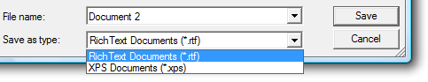
- Usage of the message service and the open / save file dialog service.
- Writer implements a save changes dialog that is shown when the user wants to close an unsaved document or the whole application.
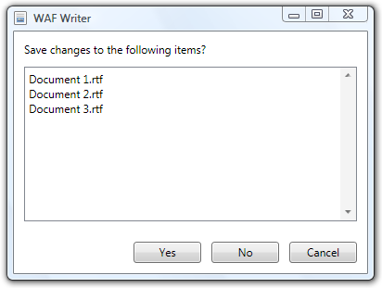
- The sample shows how to write an own dialog service for the print dialog.
- Print preview in the same window (Similar to Microsoft Word).
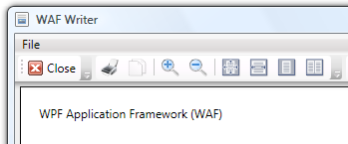
- Shows how to write a service that contains shared data used by different ViewModels and Views. See ZoomService class.
- Full localized application (English and German). You are able to select your preferred language.
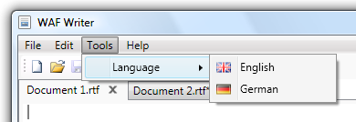
The Writer Sample is part of the WPF Application Framework (WAF) download.

Run the sample
- Open the WpfApplicationFramework solution.
- Set the Writer.Presentation project as StartUp project and start it in Debug mode.

UI Composition
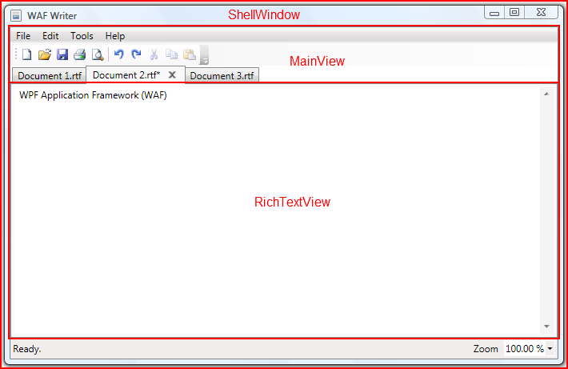
The ShellWindow class inherits from Window and contains just the status bar because this will be shared between the main view and the print preview view.
The MainView class derives from UserControl and defines the menus and the TabControl for writing documents.
The RichtTextView class derives as well from the UserControl and hosts a RichTextBox that is used for writing documents. Please note that we create an own RichTextView instance for every document.
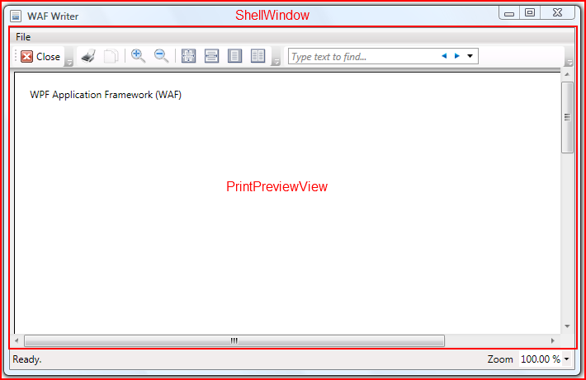
The PrintPreviewView inherits from UserControl and replaces the MainView when the user wants to see the print preview for the selected document.
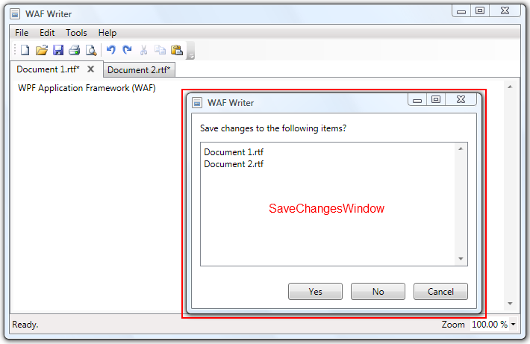
The SaveChangesWindow derives from Window and defines a modal dialog. It contains all UI elements needed for this dialog.

Project structure
The following C# projects are part of the Writer sample application:
- Writer.Presentation Presentation layer
- Writer.Applications Application layer
- Writer.Presentation.Test Unit tests for the Presentation layer
- Writer.Applications.Test Unit tests for the Application layer

Writer.Presentation
- Converters Value converters
- Resources ResourceDictionaries, Images, Icons
- Services Implementation of the PrintDialogService
- Views WPF Views (Windows, UserControls)

Writer.Applications
- Controllers Use case controllers
- Documents Implementation of the document management
- Services Interfaces and implementation of services
- ViewModels The ViewModels for the Views
- Views The interfaces for the Views

