**Практическая работа №6. Создание класса базы данных. Реализация основных операций с данными (CRUD) в настольном приложении. Использование TreeView.**

Выполнила: Кирьянов Вячеслав

Предметная область: Аэропорт

Ход работы:

1. Модуль database.py

import sqlite3  
  
class DB:  
 def __init__(self):  
 self.conn = sqlite3.connect("myair.db")  
 self.cur = self.conn.cursor()  
 self.cur.execute(  
 "CREATE TABLE IF NOT EXISTS air (id INTEGER PRIMARY KEY, number TEXT, tipe TEXT, place TEXT, speed TEXT)")  
 self.conn.commit()  
  
 def __del__(self):  
 self.conn.close()  
  
 def view(self):  
 self.cur.execute("SELECT * FROM air")  
 rows = self.cur.fetchall()  
 return rows  
  
 def insert(self, number, tipe, place, speed):  
 self.cur.execute("INSERT INTO air VALUES (NULL,?,?,?,?)", (number, tipe, place, speed))  
 self.conn.commit()  
  
 def update(self, id, number, tipe, place, speed):  
 self.cur.execute("UPDATE air SET number=?, tipe=?, place=?, speed=? WHERE id=?", (number, tipe, place, speed, id,))  
 self.conn.commit()  
  
 def delete(self, id):  
 self.cur.execute("DELETE FROM air WHERE id=?", (id,))  
 self.conn.commit()  
  
 def search(self, number=""):  
 self.cur.execute("SELECT * FROM air WHERE number=?", (number,))  
 rows = self.cur.fetchall()  
 return rows

1. Модуль main.py

from tkinter import *  
from tkinter import messagebox  
from tkinter import ttk  
from database import DB  
  
db = DB()  
  
def get_selected_row(event):  
 global selected_tuple  
 index = tree.focus()  
 selected_tuple = tree.item(index, 'values')  
 e1.delete(0, END)  
 e1.insert(END, selected_tuple[0])  
 e2.delete(0, END)  
 e2.insert(END, selected_tuple[1])  
 e3.delete(0, END)  
 e3.insert(END, selected_tuple[2])  
 e4.delete(0, END)  
 e4.insert(END, selected_tuple[3])  
  
def view_command():  
 tree.delete(*tree.get_children())  
 for row in db.view():  
 tree.insert('', END, values=row)  
  
def search_command():  
 tree.delete(*tree.get_children())  
 for row in db.search(product_text.get()):  
 tree.insert('', END, values=row)  
  
def add_command():  
 db.insert(product_text.get(), price_text.get(), comment_text.get(), mine_text.get())  
 view_command()  
  
def delete_command():  
 db.delete(selected_tuple[0])  
 view_command()  
  
def update_command():  
 db.update(selected_tuple[0], product_text.get(), price_text.get(), comment_text.get(), mine_text.get())  
 view_command()  
  
window = Tk()  
window.title("Аэропорт")  
  
window.configure(bg='blue')  
window.option_add('*TButton*background', 'blue')  
window.option_add('*TButton*foreground', '#FFFFFF')  
window.option_add('*TEntry*background', 'blue')  
window.option_add('*TEntry*foreground', '#FFFFFF')  
window.option_add('*Treeview*background', 'blue')  
window.option_add('*Treeview*foreground', '#FFFFFF')  
  
def on_closing():  
 if messagebox.askokcancel("", "Закрыть программу?"):  
 window.destroy()  
  
window.protocol("WM_DELETE_WINDOW", on_closing)  
  
columns = ('ID', 'Номер', 'Тип', 'Места', 'Скорость')  
  
tree = ttk.Treeview(window, columns=columns, show='headings', height=25)  
for col in columns:  
 tree.heading(col, text=col)  
tree.grid(row=2, column=0, rowspan=6, columnspan=2)  
  
sb1 = Scrollbar(window, orient='vertical', command=tree.yview)  
sb1.grid(row=2, column=2, rowspan=6, sticky='ns')  
  
tree.configure(yscrollcommand=sb1.set)  
  
tree.bind('<<TreeviewSelect>>', get_selected_row)  
  
l5 = Label(window, text="ID", bg='blue', fg='#000000')  
l5.grid(row=0, column=0)  
  
l1 = Label(window, text="Номер", bg='blue', fg='#000000')  
l1.grid(row=0, column=0)  
  
l2 = Label(window, text="Тип", bg='blue', fg='#000000')  
l2.grid(row=0, column=2)  
  
l3 = Label(window, text="Места", bg='blue', fg='#000000')  
l3.grid(row=1, column=0)  
  
l4 = Label(window, text="Скорость", bg='blue', fg='#000000')  
l4.grid(row=1, column=2)  
  
product_text = StringVar()  
e1 = Entry(window, textvariable=product_text, bg='blue', fg='#000000')  
e1.grid(row=0, column=1)  
  
price_text = StringVar()  
e2 = Entry(window, textvariable=price_text, bg='blue', fg='#000000')  
e2.grid(row=0, column=3)  
  
comment_text = StringVar()  
e3 = Entry(window, textvariable=comment_text, bg='blue', fg='#000000')  
e3.grid(row=1, column=1)  
  
mine_text = StringVar()  
e4 = Entry(window, textvariable=mine_text, bg='blue', fg='#000000')  
e4.grid(row=1, column=3)  
  
button_bg_color = 'blue'  
button_fg_color = '#000000'  
  
b1 = Button(window, text="Посмотреть все", width=12, command=view_command, bg=button_bg_color, fg=button_fg_color)  
b1.grid(row=2, column=3)  
  
b2 = Button(window, text="Поиск", width=12, command=search_command, bg=button_bg_color, fg=button_fg_color)  
b2.grid(row=3, column=3)  
  
b3 = Button(window, text="Добавить", width=12, command=add_command, bg=button_bg_color, fg=button_fg_color)  
b3.grid(row=4, column=3)  
  
b4 = Button(window, text="Обновить", width=12, command=update_command, bg=button_bg_color, fg=button_fg_color)  
b4.grid(row=5, column=3)  
  
b5 = Button(window, text="Удалить", width=12, command=delete_command, bg=button_bg_color, fg=button_fg_color)  
b5.grid(row=6, column=3)  
  
b6 = Button(window, text="Закрыть", width=12, command=on_closing, bg=button_bg_color, fg=button_fg_color)  
b6.grid(row=7, column=3)  
  
b1.grid(row=2, column=3, pady=5)  
b2.grid(row=3, column=3, pady=5)  
b3.grid(row=4, column=3, pady=5)  
b4.grid(row=5, column=3, pady=5)  
b5.grid(row=6, column=3, pady=5)  
b6.grid(row=7, column=3, pady=5)  
  
view_command()  
  
window.mainloop()

1. Результат:

Добавление:

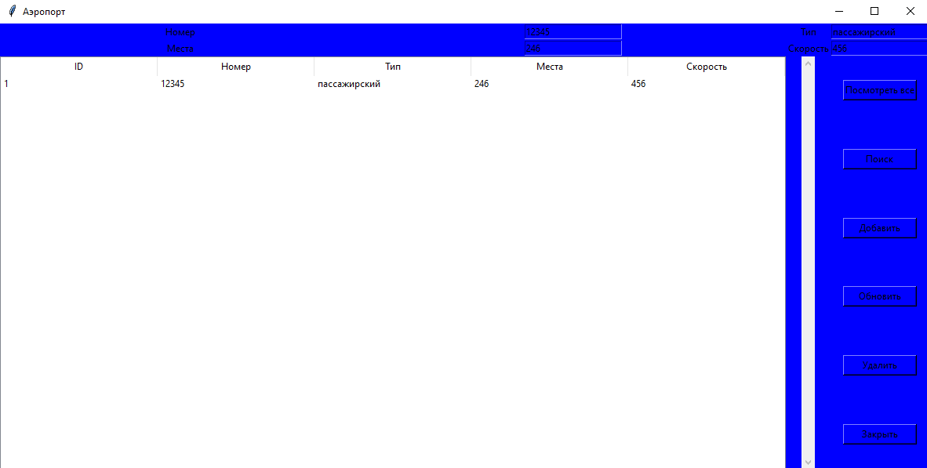

Обновление:

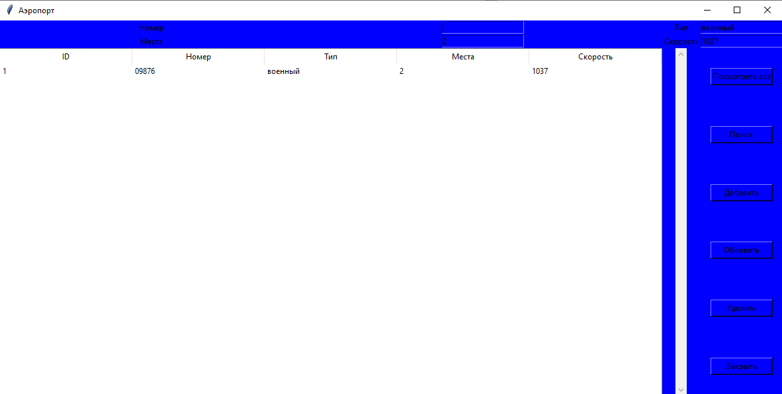

Поиск:

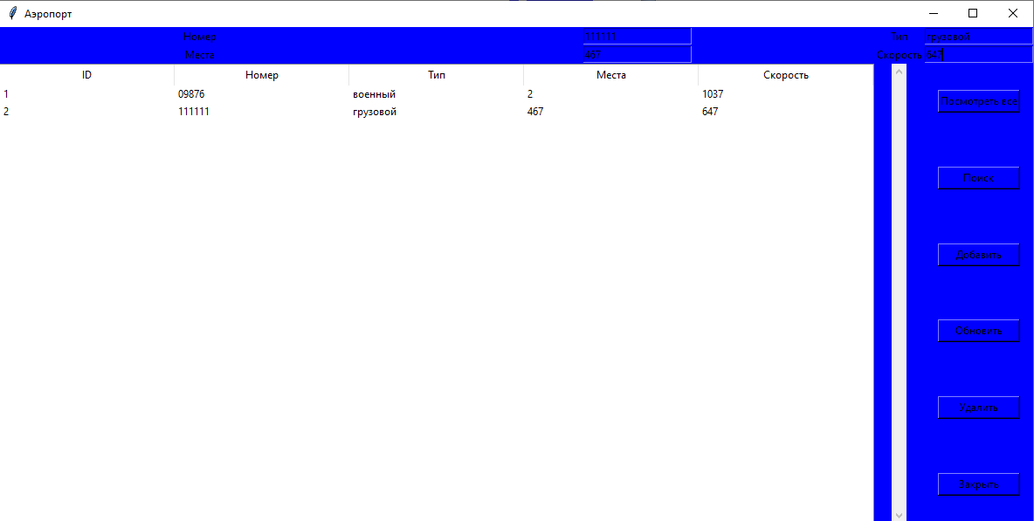

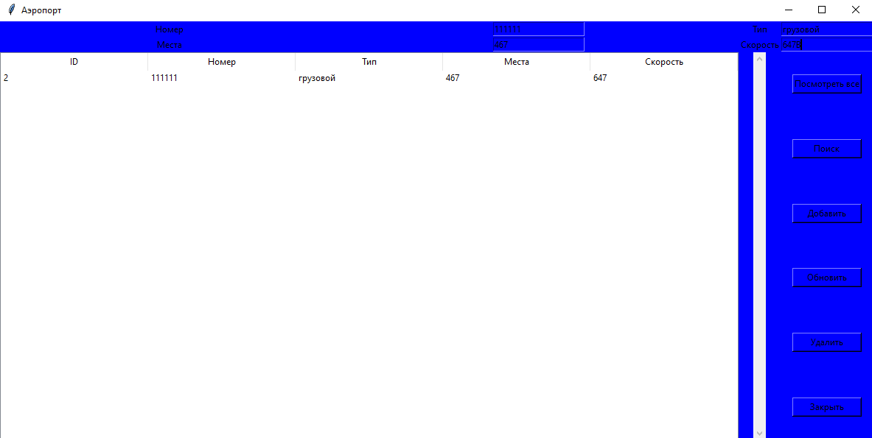

Посмотреть все:

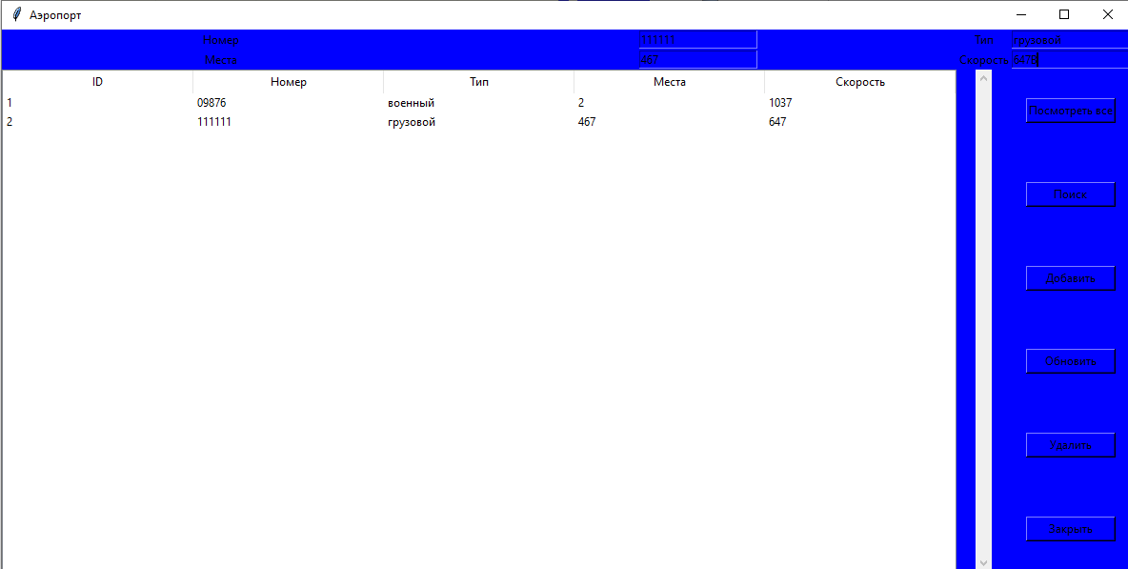

Удаление:

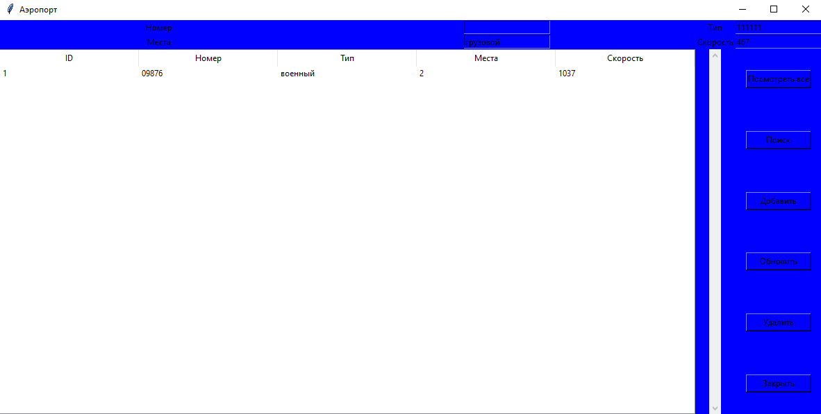

Закрыть:

