**Test result report**

<https://saveus.co.nz/>

**23.02.2022-23.03.2022**

**Test team:**

|  |  |  |
| --- | --- | --- |
| **Name** | **Position** | **Role in the project** |
| Stepovoy Ivan | Tester | Functional testing |

**Testing process description:**

**Test environment:** OC Widows 10.

**Application:** <https://saveus.co.nz/>

**Test level:** System testing.

**Test types used:** Functional, GUI

All test scenarios where created based on common sense and clarifying questions from the customer.

All tests performed manually, execution details see at: **app.qase.io** test plan and test statistic sections of this document.

**Summary:**

**News:**

**Test Status:** **Failed**

**Test Analysis:** A total of 8 new bugs have been detected, but for the first testing of this complex application, this is normal.

**Testing timetable:**

Follow the link:

<https://docs.google.com/spreadsheets/d/1Q6VEzSpcQE9YO3VwOblQP6o9OfFc28dLGDLdDp9mo7Q/edit#gid=1089403859>

**Recommendations**:

1. It is recommended to pay special attention to regression testing, testing functionality, especially on test cases for uploading images.
2. Click on the tab “Volunteer” then click on the tab “Foster homing”, click on the button “Foster”:

the field can be made in the form of a dropdown menu, just as it was done in the "Location" field.

1. Click on the tab “Volunteer” then click on the tab “Foster homing”, click on the button “Foster”:

sorting should take place in turn, starting with the first left letter entered, then with the second letter entered, and so on, and not by all letters in the word.

1. Click on the tab “Volunteer” then click on the tab “Foster homing”, click on the button “Foster”:

the web application "SaveUs" itself should reduce the size of the downloaded image to the required size.

1. Click on the tab “Volunteer” then click on the tab “Foster homing”, click on the button “Foster”:

in a ready-made ad with a picture, in a small circle for pictures, display the full reduced version of the picture, and not part of it.

1. Use more detailed, informative hints. Develop an individual semantic hint for each field.
2. Because of second field of foster homing card unnecessary, we can fill only first value “From” without second field “until”. In the finish value it looks very unfriendly and can disorient users. When we see just “1” we think “they can take my pet only for 1 day”, but in reality it means “from 1 day – until infinity”. Offer: when leave second field clear, in ready card displays not just a number, but something like “from 1” or “1-∞”

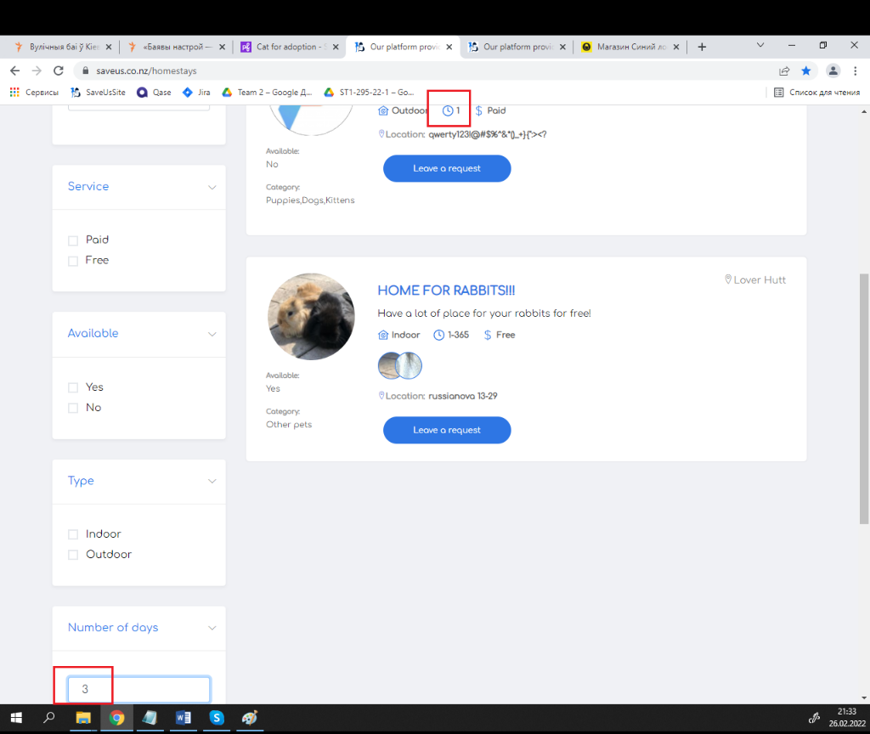

**New bugs found:**

|  |  |  |
| --- | --- | --- |
| 1 | Incorrect display of the "Location" field when entering "Space" in it, in the Foster menu. | IS1 |
| 2 | The red hint "Invalid data" under the second (right) "Number of days:" field is NOT displayed when this field is ampty. | IS2 |
| 3 | The red hint "Invalid data" under the second (right) "Number of days:" field is NOT displayed, when in this field is any symbol, except numbers. | IS3 |
| 4 | The red hint "Invalid data" is not appear under the second (right) "Number of days:" field , but is shifted to the left, when write any negative symbols in the second (right) "Number of days:" field. | IS4 |
| 5 | The same date can not be selected in the "From" and "To" fields. | IS5 |
| 6 | In an ad in a large circle for an image, the uploaded image is not displayed if: when creating this ad, in the "Foster" menu, the switch in the field radio button "Show as:" field is selected [User] | IS6 |
| 7 | In an ad , the uploaded image is not displayed if: when creating this ad, in the "Foster" menu, the switch in the field radio button "Show as:" field is selected [User] and in the second (right)  "Number of days:" field is any numbers. | IS7 |
| 8 | In an ad in a "Headline" field, text is not displayed if: when creating this ad, in the "Foster" menu, the switch is selected [User] in the field radio button "Show as:" field. | IS8 |

**All bugs statistics:**

|  |  |  |  |  |  |
| --- | --- | --- | --- | --- | --- |
| **Status** | **Quantity** | **Severity** | | | |
| **Highest** | **High** | **Medium** | **Low** |
| Submitted | 17 | 3 | 7 | 7 | 0 |