A Foundation-Model T-cell Dysfunction Screen: Translational Candidates, Then a Full Audit
Four checkpoint/persistence hits, tissue-validated -- and what a full concordance, ambient, and donor-level audit does and does not change about them.
Kaisar Dauyey · Shinji Nakaoka
Laboratory of Mathematical Biology, Faculty of Advanced Life Science, Hokkaido University
Contact: k.dauyey.bio.nu@gmail.com
Talk length: within 30 minutes; the time slot itself is not fixed. The main talk (slides 1-21) is budgeted at 23:45 of speaking, leaving about 5 minutes for questions; per-slide budgets are in the deck's speaker notes. The abstract has no stated word limit.
Written report of the IMRaD oral presentation built 2026-09-25 23:57 JST (14:57Z). Every sentence and number below is taken from the deck or its abstract; sources are listed at the end.

Contents
Right-click and choose Update Field to build the table of contents.

Abstract
Background: Foundation models fine-tuned on single-cell transcriptomes can be probed for candidate disease-state drivers by in-silico perturbation. A classifier trained on real tissue, however, also learns whatever else correlates with its labels (ambient RNA, detection artifacts, cohort composition), and a screen alone cannot say which of these it found.
Methods: A donor-disjoint SCLC/LUAD/normal T-cell classifier (46,140 cells, 42 donors; 91.9% accuracy, macro F1 0.903, a third of which comes from one held-out normal-class donor with 566 cells) supported an in-silico deletion and overexpression screen, scored by significance and by bidirectional concordance between the two operations. A screen-level ambient-risk audit and a donor-weighted reanalysis followed the screen.
Results: Four checkpoint and persistence candidates from the original work (TIGIT, TIM-3, CTLA-4, IL7R) replicate by deletion (FDR<0.05, same deletion sign in all three SCLC donors) and validate in independent spatial tissue data (antigen-presentation programme, rho=0.361, 7.95 sigma above the null). The concordance half of their original call came from a panel runner that overexpressed into all 2,424 SCLC cells but deleted only in detected cells; it has not been rerun on paired cell sets. The original work left a checkpoint-axis ordering open. At donor level, SCLC and LUAD do not differ significantly on that axis (p=.216, two-sided Monte Carlo, 100,000 replicates, 19 v 22 donors) once one donor's 74.9% cell share is accounted for. In a later, expanded screen the two most significant hits by FDR (S100A8, S100A9; FDR~1e-224) fail bidirectional concordance in all six comparisons tested; screen-wide, half of the top 120 candidates by effect are ambient-flagged, a curated ambient anchor, or both. One candidate, NBEAL1, survives every check applied. Model precision (bf16 vs fp32) replicates cleanly (rho>0.998) and explains none of these results. The pre-registered 104M sign-agreement gate still reads FAIL, final, because a bitwise-deterministic fp32-vs-fp32 rerun set its noise floor to zero, which is not a usable sign threshold. That FAIL is a property of the floor, not evidence that bf16 disagrees with fp32, and the domain reviewer ruled to leave the frozen gate unamended.
Discussion: A perturbation screen can support real translational candidates and still require gene-by-gene auditing for confounds. Significance and effect size alone are not sufficient evidence of a cell-intrinsic driver, and an ordering claim built on a cell-weighted cross-cohort comparison needs a donor-level check before it is reported either way.

Introduction

T cells in lung cancer: why they matter, and what was already known
Added 2026-09-28 for a general genetics audience; not in the 25 Sep deck.
The disease
Lung cancer comes in distinct types. Small cell lung cancer (SCLC) is the most aggressive thoracic malignancy; lung adenocarcinoma (LUAD) is a non-small-cell type.
SCLC itself splits into subtypes defined by master transcription factors (ASCL1, NEUROD1, POU2F3) (Rudin 2019).
The immune angle
T cells can kill tumour cells. Under chronic stimulation they can become dysfunctional ("exhausted"), marked by inhibitory receptors such as PD-1, TIM-3 and CTLA-4 (Wherry 2015).
Immune checkpoint inhibitors release these brakes, but add only a modest survival benefit in extensive-stage SCLC (Horn 2018), despite its high tumour mutational burden.
The open question
Whether SCLC T cells are dysfunctional, and through which genes, was poorly characterised at single-cell resolution when this work began.
SCLC subtypes differ in immune activation; an inflamed subtype benefits most from immunotherapy (Gay 2021). This talk asks what a model trained on T cells themselves can say.
In plain words: we study the immune cells inside lung tumours, because drugs that re-activate them help SCLC patients less than hoped, and nobody knows exactly why.
Sources: SCLC 'most aggressive thoracic malignancy', 'responds poorly to immune checkpoint blockade despite a high tumour mutational burden', 'transcriptional basis poorly characterised at single-cell resolution': JSDP poster, section A 'Why this matters' - data/sources/poster_final.pdf (our 24JSDP poster, P25; geneformer-lung-tcell poster/poster_final.pdf, untracked; sha256 94638dba...) | SCLC transcription-factor subtypes: Rudin CM, Poirier JT, Byers LA, et al. Molecular subtypes of small cell lung cancer: a synthesis of human and mouse model data. Nat Rev Cancer 2019. doi:10.1038/s41568-019-0133-9 | T-cell exhaustion and inhibitory receptors: Wherry EJ, Kurachi M. Molecular and cellular insights into T cell exhaustion. Nat Rev Immunol 2015. doi:10.1038/nri3862 | Modest benefit of adding atezolizumab to chemotherapy in extensive-stage SCLC: Horn L, Mansfield AS, Szczęsna A, et al. First-line atezolizumab plus chemotherapy in extensive-stage small-cell lung cancer. N Engl J Med 2018. doi:10.1056/NEJMoa1809064 | Inflamed SCLC subtype and immunotherapy benefit: Gay CM, Stewart CA, Park EM, et al. Patterns of transcription factor programs and immune pathway activation define four major subtypes of SCLC with distinct therapeutic vulnerabilities. Cancer Cell 2021. doi:10.1016/j.ccell.2020.12.014

Our 24JSDP poster (P25) and what the audit changed
Added 2026-09-28 for a general genetics audience; not in the 25 Sep deck.
Our 24JSDP poster (P25) reported a donor-held-out classifier (91.9% accuracy), four replicated edits (TIM-3, TIGIT, CTLA-4, IL7R) and tissue validation in 5 Visium SCLC sections (15,632 spots).
Poster statement | Status after the audit (this talk)
Four edits concordant, FDR < 0.05 in both arms, same sign in all 3 SCLC donors | Deletion replication stands. The concordance half was scored on different cell sets per arm (overexpress 2,424 cells, delete 202-1,131) and has not been rerun.
"The model implies Normal < SCLC < LUAD on the checkpoint axis ... an open question" | Closed as null: donor-level SCLC vs LUAD, p = 0.216.
Detection vs effect size, rho = -0.60: sparse genes fake big effects | Unchanged; the original talk's own QC slide, shown here as Results R2.
Tissue: dysfunction tracks T-cell abundance (rho 0.161); talk: antigen presentation rho 0.361 | Unchanged; not re-analysed here.

In plain words: the poster's main hits survive; one of its claims (an ordering of the three disease states) did not hold up once each person was counted once.
Sources: Poster title, number, authors, sections and all poster quotes: data/sources/poster_final.pdf (our 24JSDP poster, P25; geneformer-lung-tcell poster/poster_final.pdf, untracked; sha256 94638dba...) | rho 0.361 / 7.95 sigma: data/sources/JSDP_P25_talk.pdf (the talk that accompanied the poster; geneformer-lung-tcell talk/JSDP_P25_talk.pdf, untracked; sha256 3f013a5d...) (slide 9). | Status column restates this deck's own slides: Results R1 (cell-set caveat; targeted_panel_delete_overexpress_merged.csv @ 6882627, runner fix 66d235b) and R3 (t6_permutation_tests.csv @ 9ec518c). | Held-out cell count: poster 9,377 vs confusion matrix 9,376 is a known one-cell truncation with no effect at any reported precision (METHODS.md lines 125-166) - not an audit change. | Per the human's ruling (2026-09-28), the poster is named only as 'our 24JSDP poster (P25)': no venue, date or meeting details.

A perturbation screen can look statistically overwhelming and still be wrong
Foundation models fine-tuned on single-cell transcriptomes can be probed for candidate disease-state drivers: delete or overexpress a gene's simulated expression in a held-out cell, and read the shift in a fine-tuned classifier's predicted state. A dose-responsive driver should move the model toward its target when overexpressed and away from it when deleted.
A classifier trained on real tissue also learns whatever else correlates with its labels -- ambient RNA from other cell types, detection-rate differences, cohort composition, tissue of origin. None of that is cell-intrinsic biology, and a screen does not tell you on its own which one it found.
This talk presents a set of translational candidates identified this way, then applies the audit a screen like this needs: a concordance test, a screen-level ambient-contamination check, and a donor-level reanalysis of a cross-cohort ordering claim.

Four replicated checkpoint/persistence hits, tissue-validated
A donor-disjoint SCLC/LUAD/normal T-cell classifier supported an applied in-silico perturbation screen for candidate CAR-T/ICI-relevant drivers. Four hits replicated across the screen: TIGIT, TIM-3 (HAVCR2), CTLA-4, IL7R.
Independent Visium spatial validation (GSE263196, 5 SCLC specimens, 15,632 in-tissue spots) supported a tissue-validated antigen-presentation programme.
Presented at JSDP, 2026-08-17. No caveat attached here -- none of these four hits is implicated in anything that follows.
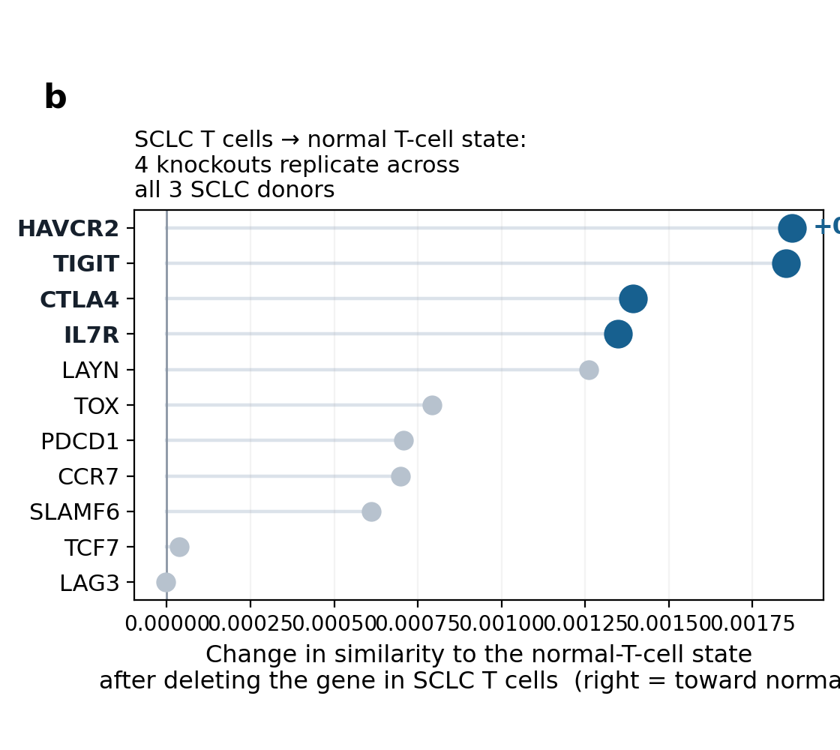
Figure 1. Slide 3 of the 25 Sep deck: Four replicated checkpoint/persistence hits, tissue-validated. Source: talk/JSDP_P25_talk.pptx; poster/poster_final.html. Image: data/assets/screen_b.png.
Source (slide 3 of the 25 Sep deck): talk/JSDP_P25_talk.pptx; poster/poster_final.html

One test was already flagged as pending; one new screen needed the same scrutiny
The poster's own hedge | The talk's own QC slide, “TESTED SINCE THE POSTER” | What this talk adds
“The model implies Normal < SCLC < LUAD on the checkpoint axis. This conflicts with the clinical tumour-level picture of SCLC as cold and ICI-resistant, so it remains an open question rather than a reconciled conclusion.” | “The states are not on a line, so there is no ordering to contradict... Test 1 of 4 — sign directions, not centroid geometry. Pending T2 and T3.” The donor-level test was named as open before this work began. | A later, expanded screen surfaced two new high-FDR candidates needing the same concordance scrutiny the original four received. This talk completes the pending test and applies that scrutiny — it does not reopen a settled claim.

Source (slide 4 of the 25 Sep deck): poster/poster_final.html; talk/JSDP_P25_talk.pdf ("TESTED SINCE THE POSTER", p.7)

Methods

Three tools, one analogy each
Added 2026-09-28 for a general genetics audience; not in the 25 Sep deck.
Single-cell RNA sequencing
Reads which genes are switched on in each individual cell, not in a ground-up tissue sample.
Analogy: a list of every fruit in the bowl, instead of the smoothie.
Here: 46,140 T cells from 42 people (HTAN MSK collection, CELLxGENE).
Geneformer, a foundation model
A neural network pre-trained on a large corpus of single-cell profiles (Theodoris 2023). It reads a cell as its genes ranked by expression, most-expressed first, and turns it into a list of numbers (an embedding) that puts similar cells near each other.
Analogy: a map coordinate for every cell. We fine-tuned it to tell SCLC, LUAD and normal-tissue T cells apart.
In silico perturbation
Delete one gene from a cell's ranked list, or move it to the top ("overexpress"), re-read the cell, and measure how far the model's picture of it moves toward another disease state.
Analogy: a Perturb-seq screen run on the computer. Nothing is edited in a lab: it generates hypotheses, it is not a knockout.
In plain words: we taught a model what SCLC, LUAD and normal T cells look like, then asked it "what if this gene were missing, or boosted?" for thousands of real cells.
Sources: 46,140 cells, 42 individuals, HTAN MSK / CELLxGENE dataset 6fde3ad9: data/git/dd7366c/sclc_validation/perturbation_workflow/METHODS.md (geneformer-lung-tcell @ dd7366c) (lines 5-10) and the poster's cohort panel. | Geneformer: Theodoris CV, Xiao L, Chopra A, et al. Transfer learning enables predictions in network biology. Nature 2023. doi:10.1038/s41586-023-06139-9 | 'Reads a cell as an ordered list of its genes, most-expressed first'; 'nothing is edited in a laboratory'; 'a hypothesis generator, not a knockout experiment'; 'a Perturb-seq screen run in silico': JSDP poster Fig. 1 and Fig. 5 captions - data/sources/poster_final.pdf (our 24JSDP poster, P25; geneformer-lung-tcell poster/poster_final.pdf, untracked; sha256 94638dba...) | Delete = token removed from the rank-value encoding; overexpress = moved to the front: data/git/dd7366c/sclc_validation/perturbation_workflow/METHODS.md (geneformer-lung-tcell @ dd7366c) (lines 180-187).

46,140 T cells, 42 donors, one fine-tuned classifier
Held-out test performance
91.9% accuracy, macro F1 0.903, donor-disjoint split. Geneformer V2 104M fine-tune.
Normal-class test performance rests on 1 held-out donor (566 cells)
A third of this macro-F1. Already flagged in the repo's own methods (perturbation_workflow/METHODS.md, lines 57-67 the split table, line 112: “Normal-class metrics are flagged explicitly given 1 test donor”).
19 SCLC + 22 LUAD + 4 normal = 45, but 42 unique donors: three donor_ids (RU675, RU682, RU684) each carry two biospecimens from the same clinical patient, one LUAD tumour and one normal-tissue sample (METHODS.md, lines 33-39).
In plain words: shown T cells from 8 people it had never seen, the model named the right disease state for about 92 of every 100 cells; the normal-tissue part of that score rests on one person.
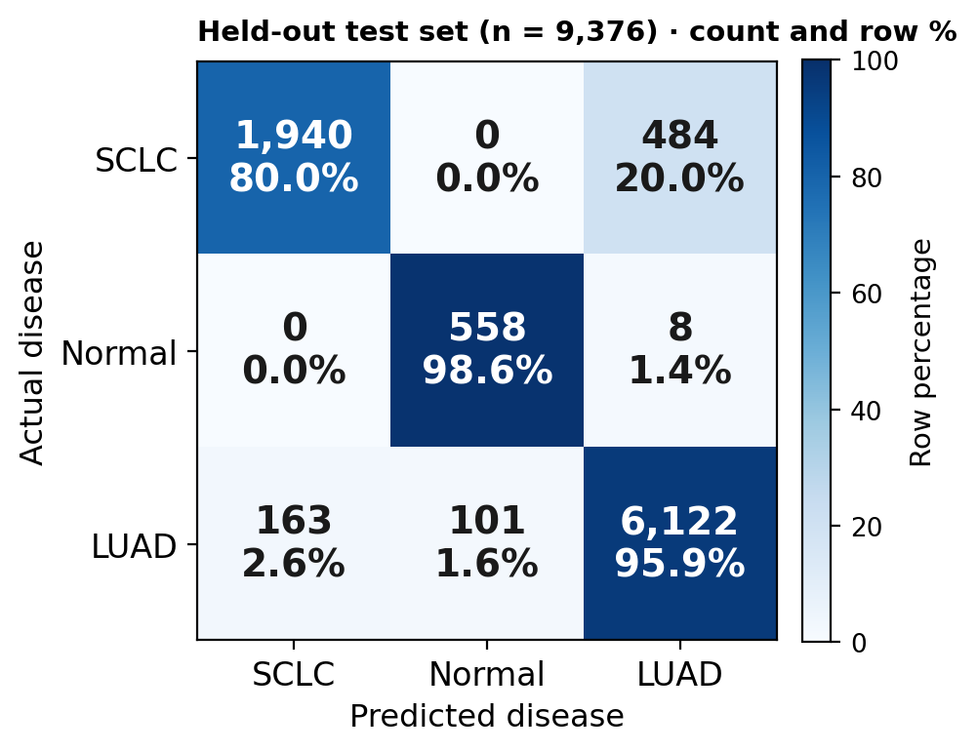
Figure 2. Slide 5 of the 25 Sep deck: 46,140 T cells, 42 donors, one fine-tuned classifier. Source: README.md; perturbation_workflow/METHODS.md. Image: data/assets/confusion.png.
Source (slide 5 of the 25 Sep deck): README.md; perturbation_workflow/METHODS.md

Delete or overexpress, in held-out cells, across six comparisons
Each gene is deleted (its token removed from a cell's rank-ordered input) or overexpressed (promoted to the front of the rank) in held-out cells, and the shift in the classifier's predicted disease-state probability is read for both operations.
Six source→goal disease-state comparisons: SCLC→LUAD, SCLC→normal, LUAD→SCLC, LUAD→normal, normal→SCLC, normal→LUAD.
A dose-responsive driver should move the model toward its target under overexpression and away from it under deletion — the two operations are read together, never one alone.
Source (slide 6 of the 25 Sep deck): README.md

A real driver must move opposite ways under deletion and overexpression
The concordant criterion, used throughout this repo's perturbation work:
delete_fdr < 0.05 AND overexpress_fdr < 0.05 AND delete_shift × overexpress_shift < 0 AND delete_n ≥ 25
Significance in one arm is not enough. A gene must clear both arms and reverse sign between them — the signature a dose-responsive driver actually produces. A gene can be significant in both arms and still fail this test if deletion and overexpression push the classifier the same direction — the model reacting to the gene's presence at all, not to a dose-responsive relationship with the labelled state.
In plain words: a gene counts only if removing it and boosting it push the cell in opposite directions, each beyond chance; FDR < 0.05 means at most about 5% of such calls are expected to be false.
Source (slide 7 of the 25 Sep deck): primary_test_perturbation/scripts/build_delete_overexpress_shift_report.py @ b99365b

Two further checks, applied after the screen, not instead of it
Ambient-risk audit | Donor-weighted reanalysis | Why both, not either
Every top-effect gene is checked against a curated ambient-contamination panel and a curated T-cell-intrinsic anchor panel. The flag threshold is the 25th percentile of the full ambient-anchor population's own risk scores — a within-panel, not an absolute, cutoff. | Any cross-cohort comparison is recomputed donor-level (mean within donor first, then an unweighted mean of donor means) alongside the original cell-weighted statistic, to separate a real group difference from one donor's cell count dominating the mean. | A significance test alone cannot distinguish a cell-intrinsic effect from an ambient or cell-count artifact. Both audits are applied to every candidate discussed in Results, not selectively to ones that already look questionable.

Source (slide 8 of the 25 Sep deck): ambient_risk_diagnostic.py line 198 @ b99365b; immune_axis_test/donor_robustness.py @ 9ec518c

Results

Four hits replicate and validate independently in tissue
TIGIT, TIM-3 (HAVCR2), CTLA-4, IL7R
Four replicated checkpoint/persistence edits from the applied screen (screen_b.png, Introduction). Replication here means: deletion FDR < 0.05 and the same deletion sign in all 3 SCLC donors.
GSE263196 Visium, 5 SCLC specimens, 15,632 in-tissue spots: antigen-presentation programme rho = 0.361, 7.95 sigma above the null.
The concordance half of the original call was made by the pre-2026-09-22 panel runner, which overexpressed into all 2,424 SCLC cells while deleting only in the 202–1,131 cells expressing each gene; it has not been rerun with paired cell sets. Unaffected by S100, ambient or T6 below; the spatial number is untouched. A qualifier, not a retraction.
In plain words: in real tumour slices, spots with more antigen-presentation activity also held more T cells (rho 0.361, where 0 is no relation and 1 is perfect), far beyond chance (7.95 sigma).
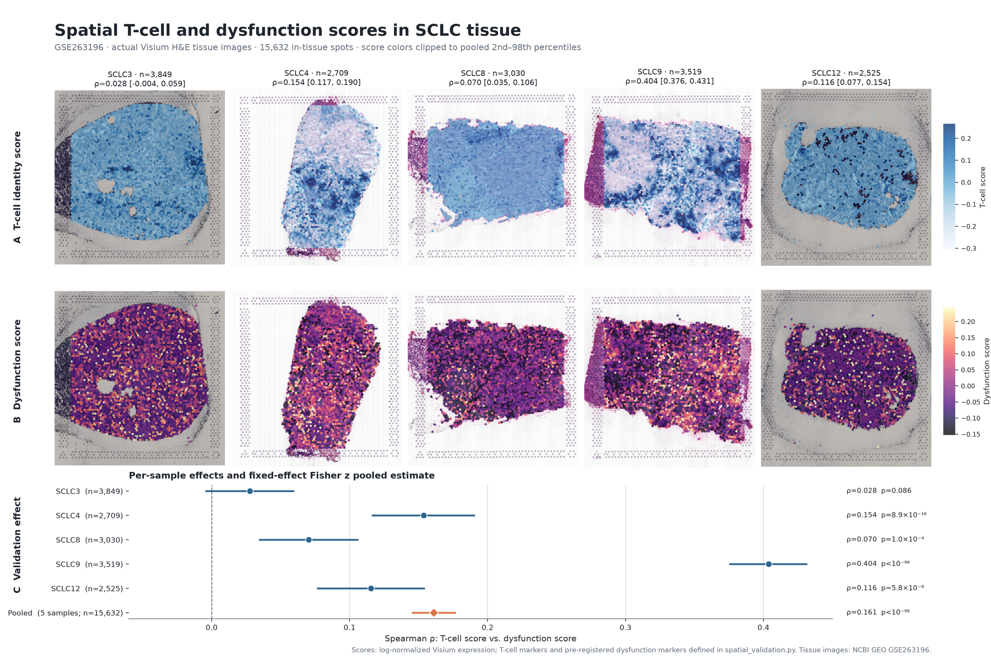
Figure 3. Slide 9 of the 25 Sep deck: Four hits replicate and validate independently in tissue. Source: talk/JSDP_P25_talk.pptx/pdf (rho, sigma: talk only); targeted_panel_delete_overexpress_merged.csv @ 6882627; runner fix 66d235b. Image: data/assets/spatial.png.
Source (slide 9 of the 25 Sep deck): talk/JSDP_P25_talk.pptx/pdf (rho, sigma: talk only); targeted_panel_delete_overexpress_merged.csv @ 6882627; runner fix 66d235b

Sparse genes fake big effects, and the poster's own ordering fails its own test
Detection vs. effect size: Spearman rho = -0.60 (p = 2.7e-5, n = 42) across the full 50-gene panel.
“TESTED SINCE THE POSTER” (talk, slide 7): “the states are not on a line, so there is no ordering to contradict... Working reading: a triangle — SCLC ≤ Normal < LUAD... Test 1 of 4 — sign directions, not centroid geometry. Pending T2 and T3.”
This is the original team's own self-correction, dated before this work began — not a finding of ours.
In plain words: the rarer a gene is in the data, the bigger its apparent effect tends to be (rho -0.60), so the size of an effect alone is not evidence.
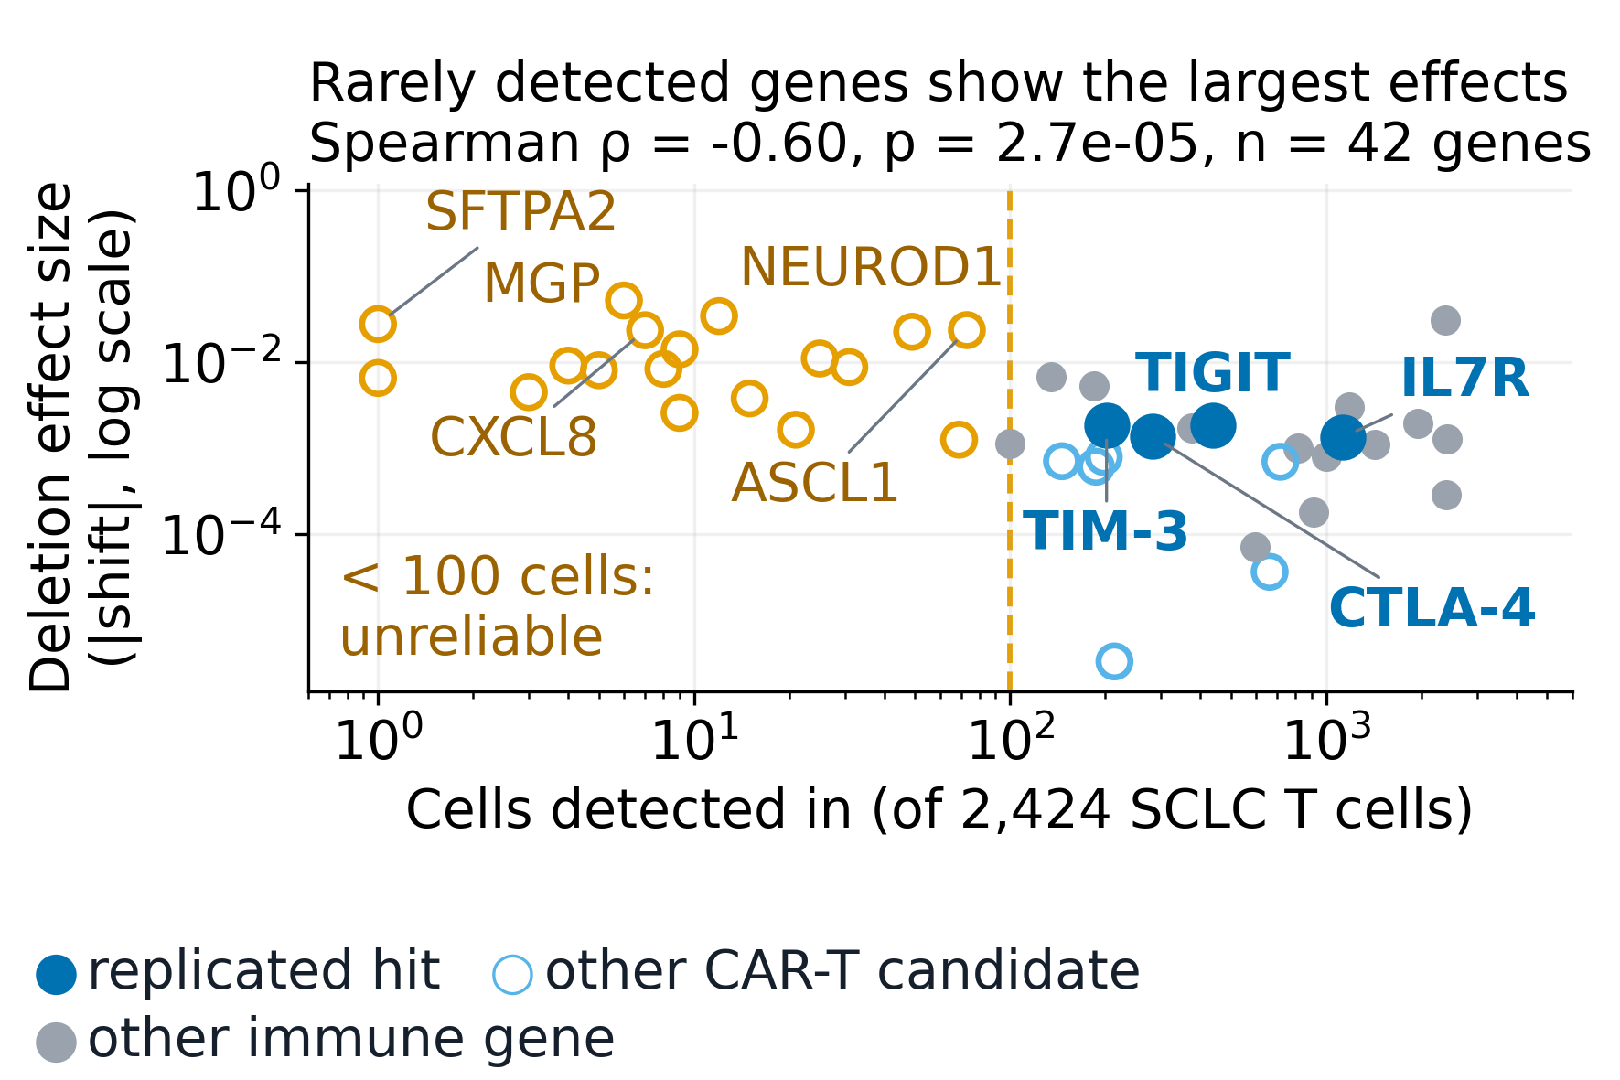
Figure 4. Slide 10 of the 25 Sep deck: Sparse genes fake big effects, and the poster's own ordering fails its own test. Source: talk/JSDP_P25_talk.pdf, slide 7. Image: data/assets/detection.png (readable redraw of 2026-09-28, same data; original: data/assets/detection_orig.png).
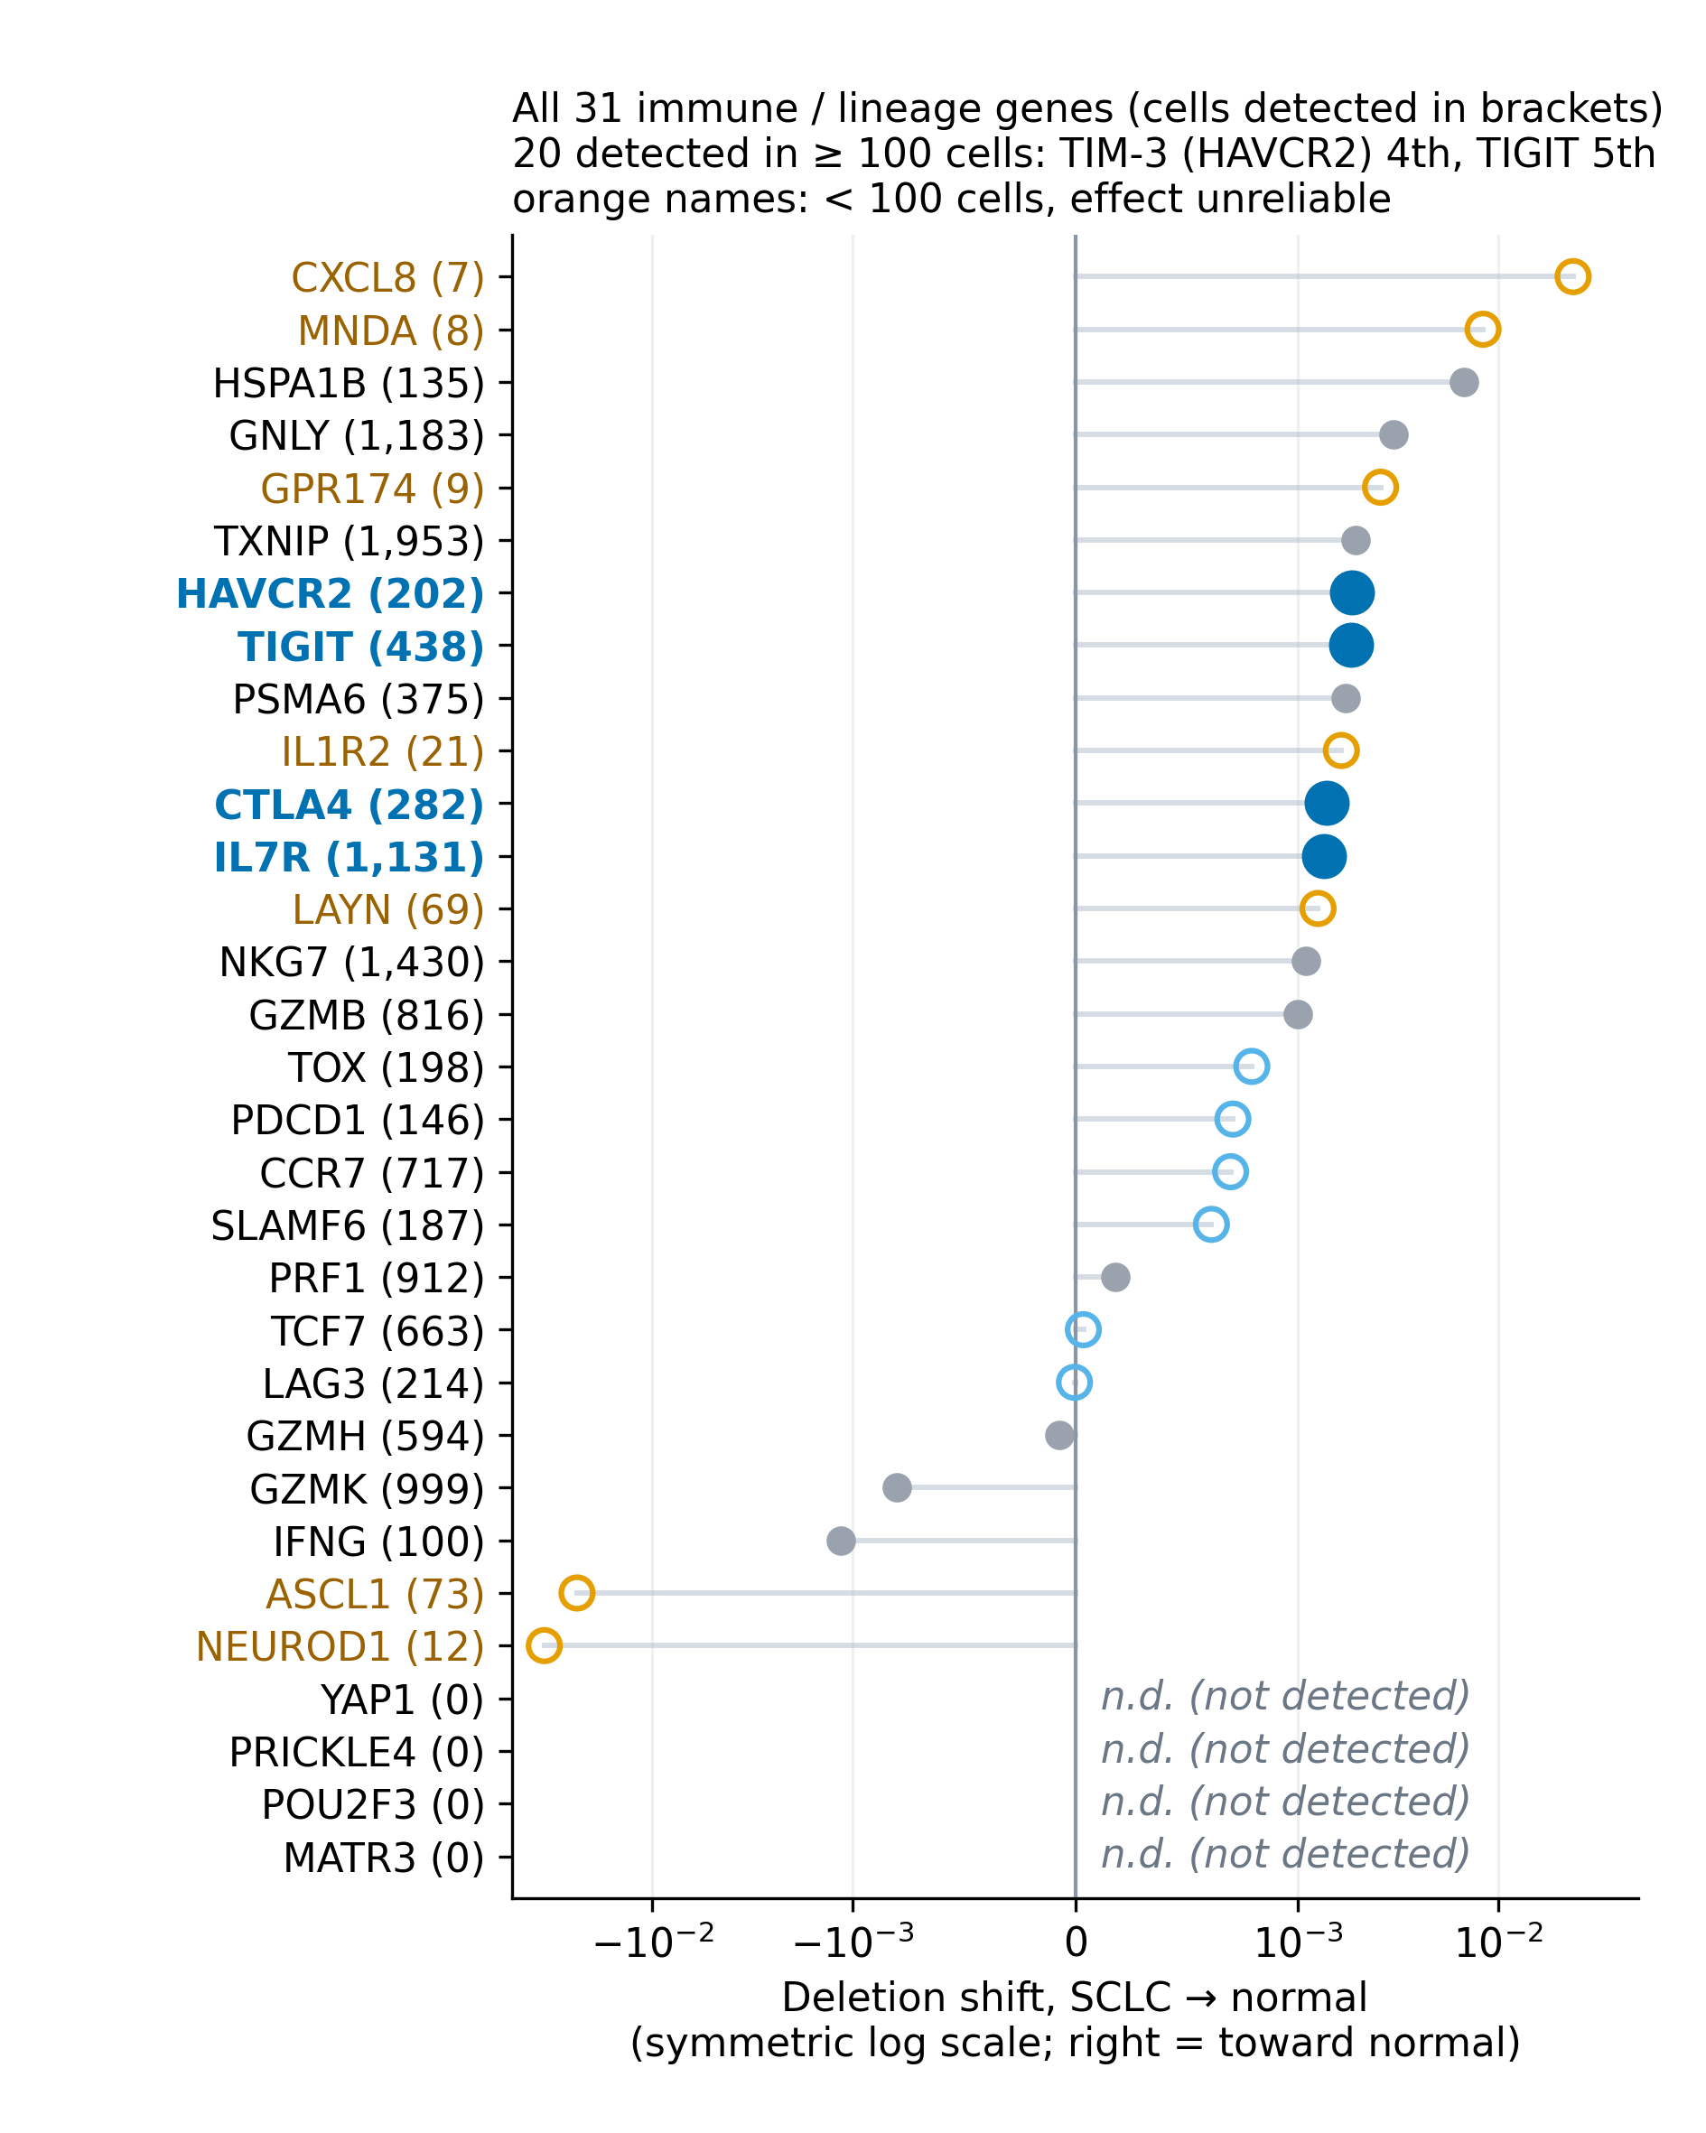
Figure 4 (continued), panel b: all 31 immune / lineage genes ranked by deletion shift, SCLC → normal. Panel b of the same original figure, drawn separately so its gene names stay readable. Image: data/assets/detection_rank_report.png.
Source (slide 10 of the 25 Sep deck): talk/JSDP_P25_talk.pdf, slide 7

The open question is now closed as null
Donor-level: no reversal
Complete population: SCLC 0.301 > LUAD 0.244. Test-only: SCLC 0.321 > LUAD 0.267. Two-sided Monte Carlo test, 100,000 replicates: p = 0.216, 19 vs. 22 donors. Not significant.
PleuralEffusion: one genuine donor
Carries 74.9% of test-only SCLC cells. HTAN_Participant_ID confirms exactly one participant (HTA8_2001), not several merged (METHODS.md, lines 29-32).
A separate, exact-enumeration test on the 3-vs-4-donor test-only slice: only 35 label assignments exist; the smallest attainable two-sided p is 0.0571 (2/35) — that design cannot reach significance regardless of the true effect.
In plain words: counting each person once instead of each cell, SCLC and LUAD T cells do not differ significantly on this axis (p = 0.216); one donor had supplied most of the test-only SCLC cells.
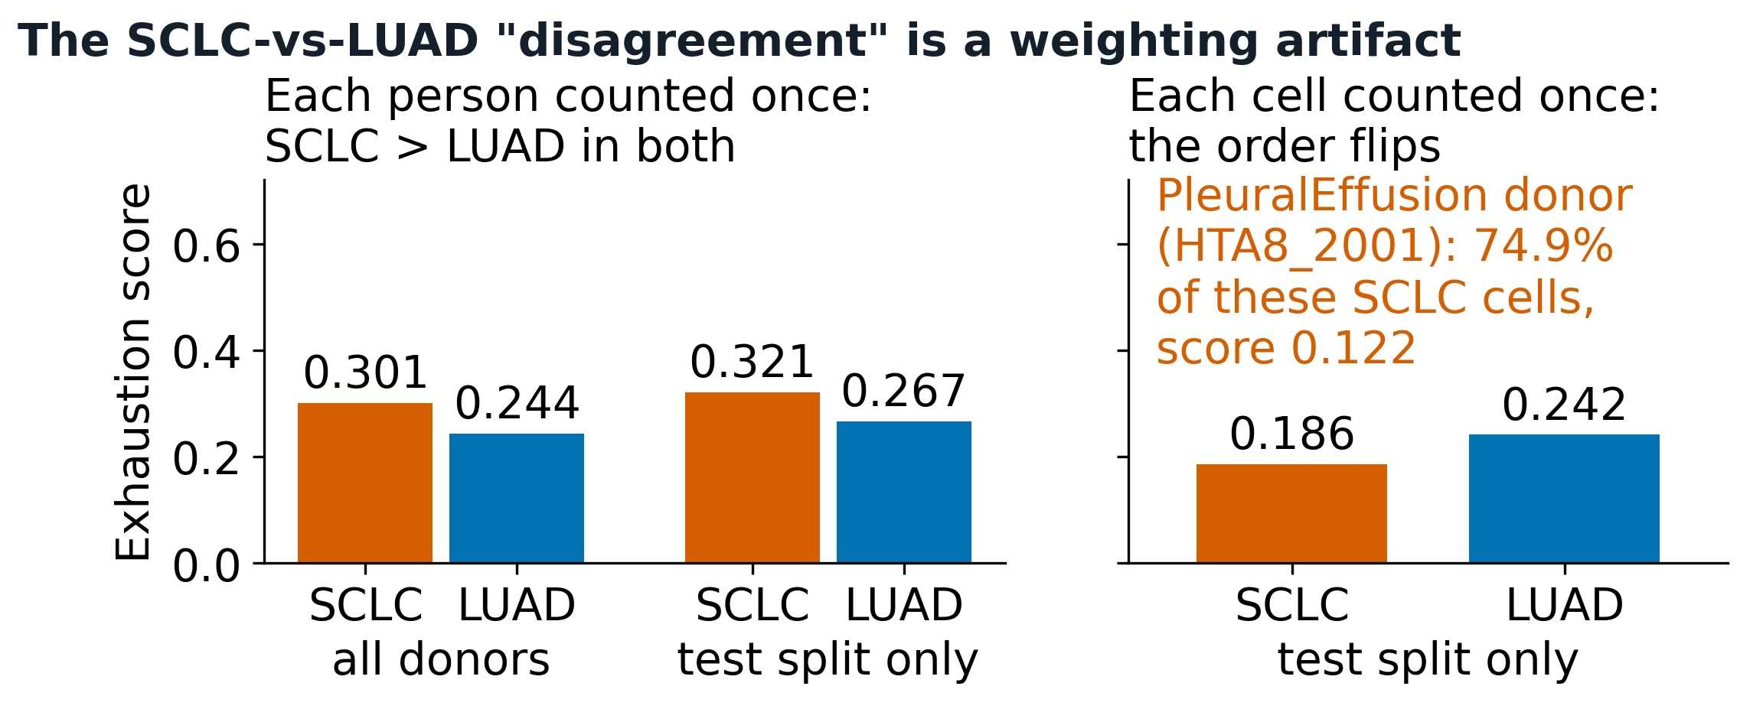
Figure 5. Slide 11 of the 25 Sep deck: The open question is now closed as null. Source: t6_weighting_reconciliation.csv, t6_permutation_tests.csv @ 9ec518c. Image: data/assets/fig_t6_reversal.png (readable redraw of 2026-09-28, same data; original: data/assets/fig_t6_reversal_orig.png).
Source (slide 11 of the 25 Sep deck): t6_weighting_reconciliation.csv, t6_permutation_tests.csv @ 9ec518c

S100A8 and S100A9: an overwhelming FDR, and no concordance at all
9 of 12 rows same-sign; 0 of 6 comparisons concordant
Example: S100A8, LUAD→SCLC deletion — FDR = 1.45e-224, N = 713 detections, shift = +0.0255. The FDR is a certainty claim, not a size claim — it says nothing about direction. First appearance of these two genes in this deck: caveated from the start, not a later correction.
What the LUAD-normal and SCLC-normal rows can and cannot lean on
Of 12 rows, 8 touch the normal class (4 comparisons). For luad↔normal, 3 of 4 normal donors are the same patients as 3 LUAD donors — real protection against a separate-cohort confound, though only 3 of 4. No such pairing exists for sclc↔normal.
In plain words: an FDR of 1.45e-224 says the shift is almost certainly not chance, not that it is large or meaningful; S100A8/S100A9 still fail the both-directions test in all 6 comparisons.
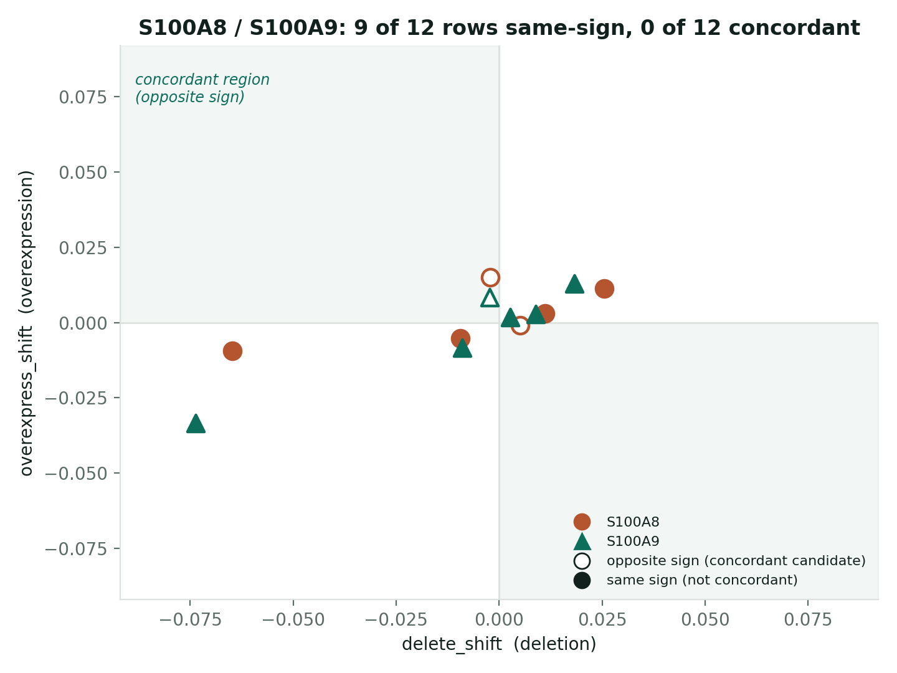
Figure 6. Slide 12 of the 25 Sep deck: S100A8 and S100A9: an overwhelming FDR, and no concordance at all. Source: isp_plausibility_top_candidates.csv @ b99365b. Image: data/assets/fig_concordance.png.
Source (slide 12 of the 25 Sep deck): isp_plausibility_top_candidates.csv @ b99365b

Half the top 120 is ambient-flagged or a curated ambient anchor
60/120
rows are ambient-flagged, a curated ambient anchor, or both: 31 flagged-only, 5 anchor-only, 24 both — a real partition of the 120, not two overlapping counts added together
5/120
rows are anchors below the flag threshold — mechanical, not a miss: the threshold is the anchors' own 25th percentile of risk, so some anchors falling under it is built in.
0/36
of the 36 curated T-cell-intrinsic anchor genes (a different denominator: the full curated list, not a row count) appear anywhere in the 120.
In plain words: half of the 120 strongest hits carry a flag for possible contamination by RNA from other cells, or are known contaminant marker genes, so they need caution before being called T-cell biology.
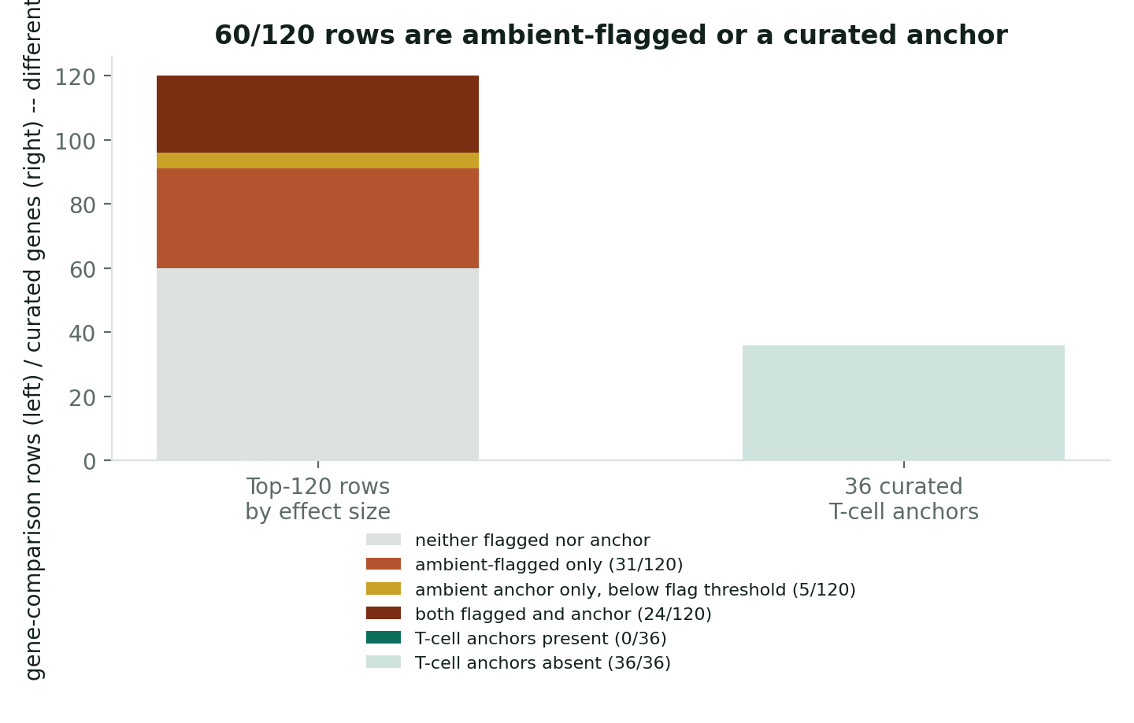
Figure 7. Slide 13 of the 25 Sep deck: Half the top 120 is ambient-flagged or a curated ambient anchor. Source: top_n_by_effect rows, ambient_risk_manifest.json @ b99365b. Image: data/assets/fig_ambient_breakdown.png.
Source (slide 13 of the 25 Sep deck): top_n_by_effect rows, ambient_risk_manifest.json @ b99365b

One candidate survives every check
NBEAL1
5 of 5 comparisons concordant — every one it appears in — detected in 75.0% of cells.
Passes the same concordance test that eliminates S100A8/S100A9, at a detection rate well above the ambient range flagged for those two. Does not make it a validated driver on its own — makes it the one candidate this screen has not been able to eliminate.
Not everything restored from the original screen fails, and the one thing that doesn't fail is more informative for having survived a real test.
In plain words: NBEAL1 passed the both-directions test in all 5 comparisons it appears in and is seen in 3 of every 4 cells, so it is not a rare-gene artefact; it is a candidate, not a proven driver.
Source (slide 14 of the 25 Sep deck): isp_plausibility_top_candidates.csv @ b99365b

S100 genes did not beat their matched control genes
Added 2026-09-28 for a general genetics audience; not in the 25 Sep deck.
Question and design
Do simulated deletion and overexpression of S100 genes push LUAD T cells toward normal or SCLC more than matched control genes do, and more so for the 4 S100 genes at high ambient-RNA risk (S100A2, S100B, S100A13, S100PBP) than for 4 at low risk (S100A4, S100A6, S100A10, S100A11)?
Each gene vs its own 20 detection-matched controls; the two groups of 4 compared with an exact Mann-Whitney test; all registered in advance.
Result: negative in both comparisons
LUAD → normal: U = 1.5, p = 6/70 (0.086).
LUAD → SCLC: U = 5.5, p = 34/70 (0.49).
Stability gate not positive (0/160 leave-one-control-out). No-op check passed. S100P and S100A16 not estimable (40 and 48 cells, below the 50-cell gate). S100A8/S100A9 excluded by design (classifier anchors).
How to read it
The test was small: with 4 v 4 the smallest possible p is 2/70 (0.029), reached only by complete separation.
The ambient-high genes did not beat matched controls more than the ambient-low genes. No claim is made from the ambient-low genes' high scores.
This neither confirms nor contradicts the S100A8/S100A9 slides.
In plain words: in a small, pre-registered test, S100 genes flagged for possible contamination did not stand out against look-alike control genes.
Sources: NEW since the 25 Sep deck; pre-registered; run 2026-09-28. | Status, U, p, stability gate, no-op PASS, S100P/S100A16 not_estimable, anchors S100A8/A9: data/git/53adee2/.../results_s100_luad_20260928/RESULT.md (geneformer-lung-tcell @ 53adee2; merged to main in PR #37, 4455914); numbers read at build time from data/git/53adee2/.../results_s100_luad_20260928/primary_results.json (@ 53adee2) | Gene groups and ambient risk: data/git/53adee2/.../s100_isp/analyse_s100_luad_20260928.py (@ 53adee2): gene groups, Ensembl IDs, ambient-risk values | Wording rules (never 'no effect'; state the 2/70 floor; no claim from clean genes' high Q): the lab's ISP outcome standard (ISP-STD-1 v1.1, the floor's wording rules; not in this package) | Mann-Whitney test: Mann HB, Whitney DR. On a test of whether one of two random variables is stochastically larger than the other. Ann Math Stat 1947. doi:10.1214/aoms/1177730491

Discussion

What this establishes, and what it rules out
Establishes | Resolves | Rules out
Four checkpoint/persistence hits (TIGIT, TIM-3, CTLA-4, IL7R) replicate and validate independently in spatial tissue data. A concordance test and a screen-level ambient audit are necessary companions to significance for any further perturbation-based driver claim. One further candidate (NBEAL1) clears every check applied. | The checkpoint-axis ordering the original team flagged as open (“pending T2 and T3”) is closed: donor-level SCLC-vs-LUAD shows no significant difference in either direction, once a single donor's cell-count share is accounted for. | S100A8/S100A9 as T-cell-intrinsic dysfunction drivers, at high confidence, independent of model precision. Model precision (bf16) as an explanation for any finding in this deck.

The S100 ISP result in context (added 2026-09-28)
The pre-registered S100 in silico perturbation test (Results) was negative in both LUAD comparisons: the four S100 genes at high ambient-RNA risk did not beat their detection-matched controls more than the four at low risk. The test was small (4 v 4; the smallest attainable p is 2/70), so it could only have passed on a complete separation of the two groups, and no claim is drawn from the low-risk genes' high scores. It neither confirms nor contradicts the S100A8/S100A9 findings above: those two genes are classifier anchors and were deliberately excluded from the test.
Sources: data/git/53adee2/.../results_s100_luad_20260928/RESULT.md (geneformer-lung-tcell @ 53adee2; merged to main in PR #37, 4455914); the lab's ISP outcome standard (ISP-STD-1 v1.1, the floor's wording rules; not in this package)

Limitations

What this study does not establish
Detection-confound axis is an imperfect proxy | Single cohort; curated lists | Thin normal class, both counts | Tissue-of-origin skew, per contrast
Ambient risk is scored partly against the classifier being audited — evidence of resemblance to known contaminants, not a direct contamination measurement. | One HTAN/CELLxGENE cohort; the ambient-anchor and T-cell-anchor gene lists are curated, not ground truth. A different cohort or anchor set could shift specific gene calls. | 1 held-out test donor AND 4 cohort donors overall — already a named limitation in the repo's own methods (METHODS.md, lines 24-25), carried forward here, not newly flagged. | SCLC: 7/19 (37%) lung, 12/19 metastatic. LUAD: 16/22 (73%) lung. Normal: 4/4 (100%) lung. Skews sclc_to_normal/normal_to_sclc, not luad_to_normal/normal_to_luad (which benefits from the 3-of-4 shared-patient pairing above).

Open questions: the original talk's CRISPR TIGIT/HAVCR2 knockout proposal; does NBEAL1 replicate independently; the talk's own still-open question — “if SCLC T cells are not exhausted, what are they, and why does ICI still fail?” A clean negative, honestly obtained, is a contribution.
Source (slide 18 of the 25 Sep deck): perturbation_workflow/METHODS.md lines 24-25; talk/JSDP_P25_talk.pdf, slide 11

Glossary

Terms used in this talk
Added 2026-09-28 for a general genetics audience; not in the 25 Sep deck.
Term | Meaning here
Single-cell RNA-seq | Measures which genes are active in each individual cell.
T-cell dysfunction / exhaustion | A worn-out T-cell state after chronic stimulation, with inhibitory receptors (PD-1, TIM-3, CTLA-4) (Wherry 2015).
Immune checkpoint | An inhibitory receptor that brakes T cells; checkpoint-inhibitor drugs block it.
Foundation model (Geneformer) | A model pre-trained on many cells, then fine-tuned for one task (Theodoris 2023).
Embedding | The list of numbers the model uses to place a cell; similar cells sit close together.
In silico perturbation | Deleting or boosting a gene in the model's input and measuring the shift.
Concordant | Deletion and overexpression move the cell in opposite directions, both significant.
FDR | False discovery rate: the expected share of false calls among all calls (Benjamini 1995).
Donor-level analysis | Each person counted once, so one person's many cells cannot dominate.
Ambient RNA | Free-floating RNA from other cells that contaminates a cell's reads (Young 2020).
Matched controls | Non-S100 genes chosen to be detected about as often as the gene tested.
Mann-Whitney U | A rank test of whether one group tends to score higher than another (Mann 1947).
Pre-registration | Fixing the test and its pass/fail rule in writing before seeing the result.
bf16 | A lower-precision number format; used to check that rounding does not drive results.

Sources: Glossary definitions are this talk's working definitions. Literature: Wherry EJ, Kurachi M. Molecular and cellular insights into T cell exhaustion. Nat Rev Immunol 2015. doi:10.1038/nri3862; Theodoris CV, Xiao L, Chopra A, et al. Transfer learning enables predictions in network biology. Nature 2023. doi:10.1038/s41586-023-06139-9; Benjamini Y, Hochberg Y. Controlling the false discovery rate: a practical and powerful approach to multiple testing. J R Stat Soc B 1995. doi:10.1111/j.2517-6161.1995.tb02031.x; Young MD, Behjati S. SoupX removes ambient RNA contamination from droplet-based single-cell RNA sequencing data. GigaScience 2020. doi:10.1093/gigascience/giaa151; Mann HB, Whitney DR. On a test of whether one of two random variables is stochastically larger than the other. Ann Math Stat 1947. doi:10.1214/aoms/1177730491

Appendix
Deep-dive material kept for questions; in the talk these are backup slides.

No: precision replicates cleanly; model size is the axis that moves things
Same model, fp32 vs. bf16 (half precision)
104M panel (300 rows): rho = 0.9998, sign agreement 298/300. 316M canary (60 rows): rho = 0.9987, sign agreement 60/60.
The pre-registered 104M sign-agreement gate is still recorded FAIL — a bitwise-deterministic fp32-vs-fp32 rerun made the noise floor zero, not a usable sign threshold; the domain reviewer's ruling was that the frozen gate stands unamended, not that bf16 disagrees with fp32. Both are true at once.
Same model, changed precision vs. changed size
Precision (104M fp32→bf16): rho = 0.9998. Size (104M→316M, both bf16): rho = 0.489. Using (1−rho) as the divergence measure, size moves results ~2,500x (~3.4 orders of magnitude) more than precision. None of this deck's findings are precision artifacts.
In plain words: rerunning the model at lower numerical precision gave essentially the same answers (rho 0.9998), so rounding does not explain any result in this talk.
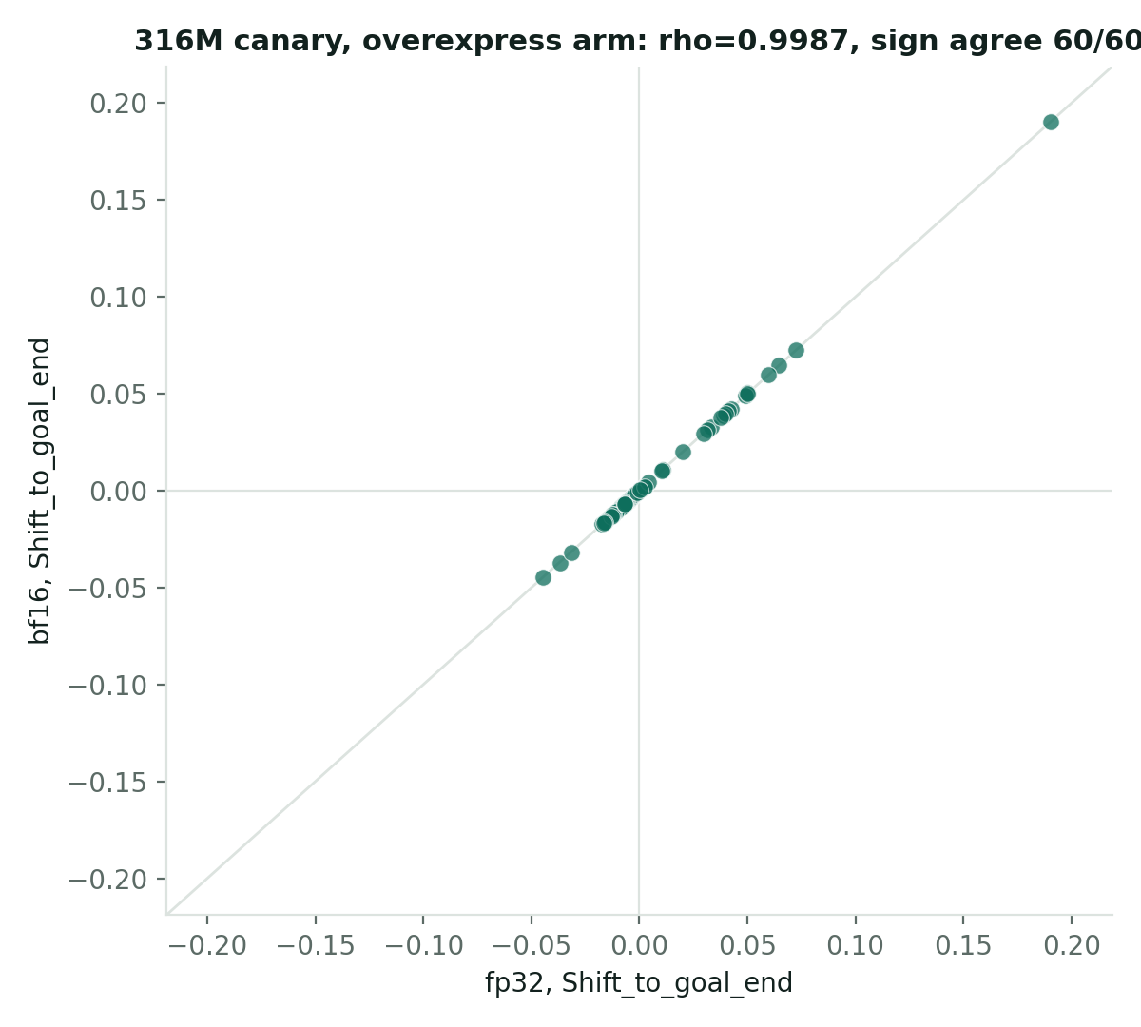
Figure 8. Slide 15 of the 25 Sep deck: No: precision replicates cleanly; model size is the axis that moves things. Source: committed_run_stats/{bf16,316m_bf16,...} @ origin/main; RESULTS_BF16.md @ afa0564. Image: data/assets/fig_bf16_canary.png.
Source (slide 15 of the 25 Sep deck): committed_run_stats/{bf16,316m_bf16,...} @ origin/main; RESULTS_BF16.md @ afa0564

The four original hits sit in one connected interaction neighbourhood
From prior literature, not inferred from these cells
TIGIT: CAR-T support. TIM-3: solid-tumour knockout precedent. CTLA-4: real signal, less CAR-T-specific. IL7R: persistence, not exhaustion. 54 STRING edges among 16 context genes; TOX and LAYN have no edge above threshold; PD-L1 is absent from the T-cell atlas.
No caveat — these four hits are unaffected by anything in this deck's audit.
In plain words: the links between these genes come from STRING, a public database of known and predicted protein interactions (Szklarczyk 2023), i.e. from prior literature, not from these cells.
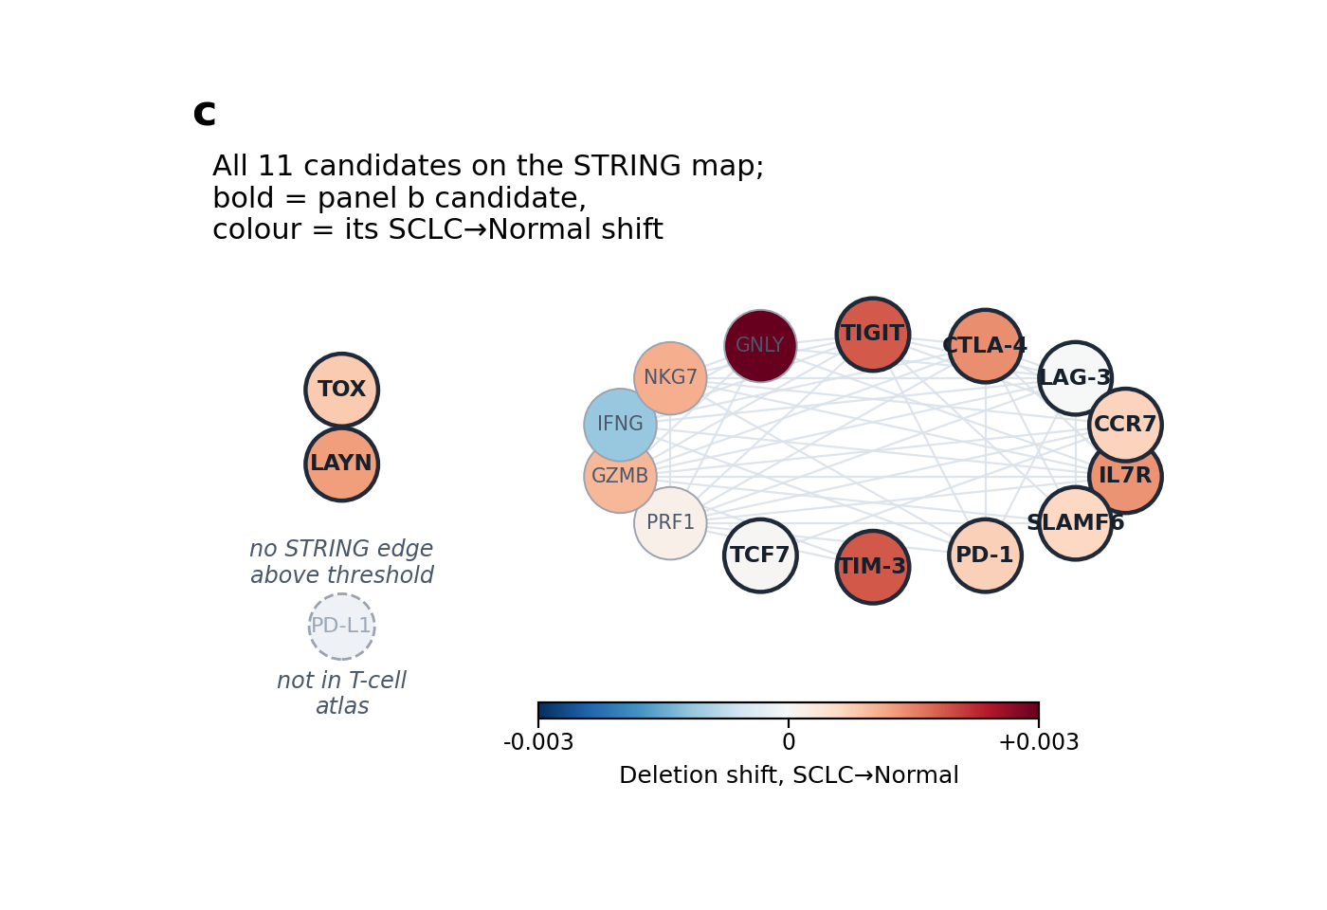
Figure 9. Slide 16 of the 25 Sep deck: The four original hits sit in one connected interaction neighbourhood. Source: talk/JSDP_P25_talk.pdf, slide 10 (STRING literature overlay). Image: data/assets/network_c.png.
Source (slide 16 of the 25 Sep deck): talk/JSDP_P25_talk.pdf, slide 10 (STRING literature overlay)

Each S100 gene's percentile against its own 20 matched controls (Q)
Added 2026-09-28 for a general genetics audience; not in the 25 Sep deck.
Gene | Ensembl ID | Group | Ambient risk | Q, LUAD→normal | Q, LUAD→SCLC
S100A2 | ENSG00000196754 | ambient-high | 0.955 | 88.1 | 97.6
S100B | ENSG00000160307 | ambient-high | 0.859 | 21.4 | 16.7
S100A13 | ENSG00000189171 | ambient-high | 0.796 | 26.2 | 59.5
S100PBP | ENSG00000116497 | ambient-high | 0.744 | 54.8 | 78.6
S100A4 | ENSG00000196154 | ambient-low | 1.1e-06 | 88.1 | 97.6
S100A6 | ENSG00000197956 | ambient-low | 3.4e-05 | 97.6 | 88.1
S100A10 | ENSG00000197747 | ambient-low | 0.000312 | 92.9 | 88.1
S100A11 | ENSG00000163191 | ambient-low | 0.000144 | 64.3 | 50.0

Group test (exact two-sided Mann-Whitney, 4 v 4): LUAD→normal U = 1.5, p = 6/70; LUAD→SCLC U = 5.5, p = 34/70. Negative in both. The ordering seen (ambient-low above) is descriptive only; the ambient-low genes' high Q was not tested and supports no claim.
Sources: Q values and group test read at build time from data/git/53adee2/.../results_s100_luad_20260928/primary_results.json (@ 53adee2) | Ensembl IDs, groups and ambient-risk values: data/git/53adee2/.../s100_isp/analyse_s100_luad_20260928.py (@ 53adee2): gene groups, Ensembl IDs, ambient-risk values | Q is the gene's midrank percentile among its 20 matched controls; 8 of 8 genes have 20 valid controls in both contrasts.

References and sources
Literature cited in the added sections (each DOI checked on Crossref, 2026-09-28):
1. Theodoris CV, Xiao L, Chopra A, et al. Transfer learning enables predictions in network biology. Nature 2023. doi:10.1038/s41586-023-06139-9
2. Horn L, Mansfield AS, Szczęsna A, et al. First-line atezolizumab plus chemotherapy in extensive-stage small-cell lung cancer. N Engl J Med 2018. doi:10.1056/NEJMoa1809064
3. Wherry EJ, Kurachi M. Molecular and cellular insights into T cell exhaustion. Nat Rev Immunol 2015. doi:10.1038/nri3862
4. Rudin CM, Poirier JT, Byers LA, et al. Molecular subtypes of small cell lung cancer: a synthesis of human and mouse model data. Nat Rev Cancer 2019. doi:10.1038/s41568-019-0133-9
5. Gay CM, Stewart CA, Park EM, et al. Patterns of transcription factor programs and immune pathway activation define four major subtypes of SCLC with distinct therapeutic vulnerabilities. Cancer Cell 2021. doi:10.1016/j.ccell.2020.12.014
6. Young MD, Behjati S. SoupX removes ambient RNA contamination from droplet-based single-cell RNA sequencing data. GigaScience 2020. doi:10.1093/gigascience/giaa151
7. Benjamini Y, Hochberg Y. Controlling the false discovery rate: a practical and powerful approach to multiple testing. J R Stat Soc B 1995. doi:10.1111/j.2517-6161.1995.tb02031.x
8. Mann HB, Whitney DR. On a test of whether one of two random variables is stochastically larger than the other. Ann Math Stat 1947. doi:10.1214/aoms/1177730491
9. Szklarczyk D, Kirsch R, Koutrouli M, et al. The STRING database in 2023: protein-protein association networks and functional enrichment analyses for any sequenced genome of interest. Nucleic Acids Res 2023. doi:10.1093/nar/gkac1000
Package sources for the added sections:
data/sources/poster_final.pdf (our 24JSDP poster, P25; geneformer-lung-tcell poster/poster_final.pdf, untracked; sha256 94638dba...)
data/sources/JSDP_P25_talk.pdf (the talk that accompanied the poster; geneformer-lung-tcell talk/JSDP_P25_talk.pdf, untracked; sha256 3f013a5d...)
data/git/dd7366c/sclc_validation/perturbation_workflow/METHODS.md (geneformer-lung-tcell @ dd7366c)
data/git/53adee2/.../results_s100_luad_20260928/RESULT.md (geneformer-lung-tcell @ 53adee2; merged to main in PR #37, 4455914)
data/git/53adee2/.../results_s100_luad_20260928/primary_results.json (@ 53adee2)
data/git/53adee2/.../s100_isp/analyse_s100_luad_20260928.py (@ 53adee2): gene groups, Ensembl IDs, ambient-risk values
the lab's ISP outcome standard (ISP-STD-1 v1.1, the floor's wording rules; not in this package)
Per-slide sources, from docs/lung_tcell_talk_imrad_sources_20260925.md (commits are in the geneformer-lung-tcell repository).
Slide | Section | Claim | Source
1 | Title | — | —
2 | Background | (framing only) | —
3 | Intro I1 | 4 original hits, tissue validation | talk/JSDP_P25_talk.pptx/pdf
4 | Intro I2 | Poster/talk hedges, quoted | poster/poster_final.html; talk/JSDP_P25_talk.pdf p.7
5 | Methods M1 | 91.9%/F1 0.903 + 1-donor caveat; 42-vs-45 | README.md; perturbation_workflow/METHODS.md lines 57–67, 111–112, 33–39
6 | Methods M2 | ISP mechanics, six comparisons | README.md
7 | Methods M3 | Concordance criterion, verbatim | primary_test_perturbation/scripts/build_delete_overexpress_shift_report.py @ b99365b
8 | Methods M4 | Ambient/donor-weighted methodology | ambient_risk_diagnostic.py line 198 @ b99365b; immune_axis_test/donor_robustness.py @ 9ec518c
9 | Results R1 | 4 hits + spatial validation; cell-set caveat on the concordance half (2026-09-25) | talk/JSDP_P25_talk.pptx/pdf; targeted_panel_delete_overexpress_merged.csv @ 6882627 (overexpress_n 2,424 constant; delete_n 202/438/282/1,131); runner fix 66d235b (2026-09-22); no later commit to the results table
10 | Results R2 | JSDP's own QC + pending-test flag | talk/JSDP_P25_talk.pdf, slide 7
11 | Results R3 | p=0.216 Monte Carlo (B=100,000); PleuralEffusion/HTA8_2001; 2/35 exact-enumeration floor | t6_weighting_reconciliation.csv, t6_permutation_tests.csv @ 9ec518c; METHODS.md lines 29–32
12 | Results R4 | S100A8/S100A9 FDR + concordance failure | isp_plausibility_top_candidates.csv @ b99365b
13 | Results R5 | Ambient audit, 60/120 union | same CSV + ambient_risk_manifest.json @ b99365b
14 | Results R6 | NBEAL1 | same CSV @ b99365b
15 | Results R7 | bf16 + frozen-FAIL gate | committed_run_stats/* @ origin/main; RESULTS_BF16.md @ afa0564
16 | Results R8 (designated cut) | STRING mechanism | talk/JSDP_P25_talk.pdf, slide 10
17 | Discussion D1 | Synthesis | (rolls up the above)
18 | Discussion D2/D3 | Limitations, closing | perturbation_workflow/METHODS.md lines 24–25; talk/JSDP_P25_talk.pdf, slide 11

Data files shipped with this report's build package (data/MANIFEST.tsv).
File | Origin | sha256 (first 16)
git/b99365b/sclc_validation/primary_test_perturbation/tables/isp_plausibility_top_candidates.csv | sclc_validation/primary_test_perturbation/tables/isp_plausibility_top_candidates.csv (git b99365bd0a1d3fcf128256b962fab440033e739d (geneformer-lung-tcell)) | 5f271197973ec01a
git/b99365b/sclc_validation/primary_test_perturbation/tables/ambient_risk_manifest.json | sclc_validation/primary_test_perturbation/tables/ambient_risk_manifest.json (git b99365bd0a1d3fcf128256b962fab440033e739d (geneformer-lung-tcell); redacted 2026-09-29 for publication (host paths and people's names replaced by roles; no numbers changed)) | 5de2754dc8fb119a
git/6882627/sclc_validation/perturbation_workflow/targeted_panel/results/targeted_panel_delete_overexpress_merged.csv | sclc_validation/perturbation_workflow/targeted_panel/results/targeted_panel_delete_overexpress_merged.csv (git 688262714a4efd6decbfaf4a2087a067195e7ac2 (geneformer-lung-tcell)) | 3a331a9d37629fd8
git/9ec518c/sclc_validation/immune_axis_test/results/t6_weighting_reconciliation.csv | sclc_validation/immune_axis_test/results/t6_weighting_reconciliation.csv (git 9ec518c55087b723be3171decdb9d38289ad1f2c (geneformer-lung-tcell)) | 93d88077fb2e9b92
git/9ec518c/sclc_validation/immune_axis_test/results/t6_donor_level_scores.csv | sclc_validation/immune_axis_test/results/t6_donor_level_scores.csv (git 9ec518c55087b723be3171decdb9d38289ad1f2c (geneformer-lung-tcell)) | 1994edf0ebf4bfc9
git/9ec518c/sclc_validation/immune_axis_test/results/t6_permutation_tests.csv | sclc_validation/immune_axis_test/results/t6_permutation_tests.csv (git 9ec518c55087b723be3171decdb9d38289ad1f2c (geneformer-lung-tcell)) | 3209017cf24b89f0
git/dd7366c/sclc_validation/perturbation_workflow/METHODS.md | sclc_validation/perturbation_workflow/METHODS.md (git dd7366c7714894f2e77d34d3be22c37516c65801 (geneformer-lung-tcell)) | 9c0b4554bff91306
git/afa0564/sclc_validation/bf16_bench/RESULTS_BF16.md | sclc_validation/bf16_bench/RESULTS_BF16.md (git afa05640c51035314aba7fbee26aae1b172241ad (geneformer-lung-tcell); redacted 2026-09-29 for publication (host paths and people's names replaced by roles; no numbers changed)) | bc4c20302737e020
assets/confusion.png | geneformer-lung-tcell/talk/assets/confusion.png (untracked, gitignored); staged copy analysis-workspace/reports/lung_tcell_talk_imrad_assets_20260925/confusion.png (filesystem, staged 2026-09-25 13:06 JST by lung_tcell_talk_imrad_figures_20260925.py) | e03feaea8f1e7d09
assets/screen_b.png | geneformer-lung-tcell/talk/assets/screen_b.png (untracked, gitignored); staged copy analysis-workspace/reports/lung_tcell_talk_imrad_assets_20260925/screen_b.png (filesystem, staged 2026-09-25 13:06 JST by lung_tcell_talk_imrad_figures_20260925.py) | 3984e9c85f2a80d5
assets/detection_orig.png | geneformer-lung-tcell/talk/assets/detection.png (untracked, gitignored); staged copy analysis-workspace/reports/lung_tcell_talk_imrad_assets_20260925/detection.png (filesystem, staged 2026-09-25 13:06 JST by lung_tcell_talk_imrad_figures_20260925.py) | 14d21cbbd9325df7
assets/spatial.png | geneformer-lung-tcell/talk/assets/spatial.png (untracked, gitignored); staged copy analysis-workspace/reports/lung_tcell_talk_imrad_assets_20260925/spatial.png (filesystem, staged 2026-09-25 13:06 JST by lung_tcell_talk_imrad_figures_20260925.py) | 8516f56b99fd8677
assets/network_c.png | geneformer-lung-tcell/talk/assets/network_c.png (untracked, gitignored); staged copy analysis-workspace/reports/lung_tcell_talk_imrad_assets_20260925/network_c.png (filesystem, staged 2026-09-25 13:06 JST by lung_tcell_talk_imrad_figures_20260925.py) | e15d0177129415d5
assets/qr.png | regenerated 2026-09-30 (CoreImage CIQRCodeGenerator, level M, 8 px per module, #10243C on white); encodes https://github.com/Kays3/talks (replaces the 2026-09-25 copy, which pointed at the private project repository) | 1260157e5cab893a
assets/fig_concordance.png | analysis-workspace/reports/lung_tcell_talk_assets_20260924/fig_concordance.png (filesystem (analysis workspace, not git); built 2026-09-24 by lung_tcell_talk_figures_20260924.py (src/reference/)) | 51cad1128f30f2d4
assets/fig_ambient_breakdown.png | analysis-workspace/reports/lung_tcell_talk_assets_20260924/fig_ambient_breakdown.png (filesystem (analysis workspace, not git); built 2026-09-24 by lung_tcell_talk_figures_20260924.py (src/reference/)) | c40eb77c3708184c
assets/fig_t6_reversal_orig.png | analysis-workspace/reports/lung_tcell_talk_assets_20260924/fig_t6_reversal.png (filesystem (analysis workspace, not git); built 2026-09-24 by lung_tcell_talk_figures_20260924.py (src/reference/)) | 0c8055cdc26f0192
assets/fig_bf16_canary.png | analysis-workspace/reports/lung_tcell_talk_assets_20260924/fig_bf16_canary.png (filesystem (analysis workspace, not git); built 2026-09-24 by lung_tcell_talk_figures_20260924.py (src/reference/)) | 775f3f5079a5f42f
git_facts.json | git log / rev-parse on geneformer-lung-tcell (see _note inside) (snapshot 2026-09-28) | 82a1222d3994a384
git/53adee2/sclc_validation/perturbation_workflow/s100_isp/results_s100_luad_20260928/RESULT.md | sclc_validation/perturbation_workflow/s100_isp/results_s100_luad_20260928/RESULT.md (git 53adee29b83165903028042a4ffbce0e988c70dd (geneformer-lung-tcell; on main via PR #37 merge 4455914); redacted 2026-09-29 for publication (host paths and people's names replaced by roles; no numbers changed)) | 93dcf694f9738491
git/53adee2/sclc_validation/perturbation_workflow/s100_isp/results_s100_luad_20260928/primary_results.json | sclc_validation/perturbation_workflow/s100_isp/results_s100_luad_20260928/primary_results.json (git 53adee29b83165903028042a4ffbce0e988c70dd (geneformer-lung-tcell; on main via PR #37 merge 4455914)) | 1934acbdf7274cc4
git/53adee2/sclc_validation/perturbation_workflow/s100_isp/analyse_s100_luad_20260928.py | sclc_validation/perturbation_workflow/s100_isp/analyse_s100_luad_20260928.py (git 53adee29b83165903028042a4ffbce0e988c70dd (geneformer-lung-tcell; on main via PR #37 merge 4455914); redacted 2026-09-29 for publication (host paths and people's names replaced by roles; no numbers changed)) | a10f97c979228880
sources/poster_final.pdf | geneformer-lung-tcell/poster/poster_final.pdf (untracked, gitignored) (filesystem copy 2026-09-28 of the 24JSDP P25 final (2026-08-15 22:10 JST)) | 94638dba7d4683d2
sources/JSDP_P25_talk.pdf | geneformer-lung-tcell/talk/JSDP_P25_talk.pdf (untracked, gitignored) (filesystem copy 2026-09-28 of the 24JSDP P25 final (2026-08-17 18:12 JST)) | 3f013a5d2da32abe
git/eb533f8/sclc_validation/checkpoint_cart_perturbation/tables/cart_overexpression_vs_deletion.csv | sclc_validation/checkpoint_cart_perturbation/tables/cart_overexpression_vs_deletion.csv (git eb533f8bc1c3fbd7d1d5ce3e986eeb4f2caf2f7e (geneformer-lung-tcell; tables last changed at 37a0211)) | 3be81d6a32cfde1f
git/eb533f8/sclc_validation/checkpoint_cart_perturbation/tables/cart_engineering_perturbation.csv | sclc_validation/checkpoint_cart_perturbation/tables/cart_engineering_perturbation.csv (git eb533f8bc1c3fbd7d1d5ce3e986eeb4f2caf2f7e (geneformer-lung-tcell; tables last changed at 37a0211)) | 1d292e4259991562
git/eb533f8/sclc_validation/checkpoint_cart_perturbation/scripts/make_detection_figure.py | sclc_validation/checkpoint_cart_perturbation/scripts/make_detection_figure.py (git eb533f8bc1c3fbd7d1d5ce3e986eeb4f2caf2f7e (geneformer-lung-tcell; tables last changed at 37a0211)) | 9cc5ce5e19bc9798
git/9ec518c/sclc_validation/immune_axis_test/RESULTS_T6.md | sclc_validation/immune_axis_test/RESULTS_T6.md (git 9ec518c55087b723be3171decdb9d38289ad1f2c (geneformer-lung-tcell)) | 9369894c318d5b43
assets/detection.png | generated 2026-09-28 by src/make_readable_figures.py (sha256 fac09168150f; regenerated by ./build.sh office) (readable redraw; inputs sha256[:12] 3be81d6a32cf,1d292e425999; original kept as assets/detection_orig.png) | ea7c296d4f1bf60d
assets/detection_rank.png | generated 2026-09-28 by src/make_readable_figures.py (sha256 fac09168150f; regenerated by ./build.sh office) (readable redraw of panel b of detection_orig.png; inputs sha256[:12] 3be81d6a32cf,1d292e425999) | d6fea712d234da82
assets/detection_rank_report.png | generated 2026-09-28 by src/make_readable_figures.py (sha256 fac09168150f; regenerated by ./build.sh office) (readable redraw of panel b of detection_orig.png; inputs sha256[:12] 3be81d6a32cf,1d292e425999) | 11d8237f5aa20440
assets/fig_t6_reversal.png | generated 2026-09-28 by src/make_readable_figures.py (sha256 fac09168150f; regenerated by ./build.sh office) (readable redraw; inputs sha256[:12] 93d88077fb2e,1994edf0ebf4; original kept as assets/fig_t6_reversal_orig.png) | 361d7bcfe98b0780

