

Project Report

Database Management System

Members:

**Abdul Malik** (019-BSCYS-FA21)

**Hassan Mehmood** (009-BSCYS-FA21)

Title:

**Blood Bank Management System**

Contents

Abstract: 3

Introduction: 4

Objectives: 4

Methodology: 4

**Modules:** 4

**User Module:** 4

**Patient Module:** 5

**Doner Module:** 5

**Blood Bank Module:** 6

**Implementation:** 7

**Testing:** 7

**Conclusion:** 7

# Abstract:

A blood bank management system is a software solution that helps manage the donation and storing of blood in blood banks. It provides a fast and efficient way to gain the attention of potential donors in the case of emergencies. The main aim of this project is to provide a platform for managing blood donations, storing blood in a group-wise manner, and providing information about blood donation camps.

This project has four main modules: user, patient, donor, and blood bank. The user module is responsible for managing the information of the patient and donor, and serves as a communication channel between the two. The patient module stores the required blood group of the patient so that relevant donors can be notified. The donor module stores the information of donors who are willing to donate blood or have already donated. The blood bank module stores the information of donated blood in a group-wise manner according to the blood group.

The project has been implemented using SQL and has a user-friendly interface. It has been tested and is ready for deployment in blood banks.

# Introduction:

Blood transfusion is a medical procedure in which blood is donated from a healthy individual to a patient in need. It is a crucial part of modern healthcare and is used to treat a wide range of medical conditions, including anemia, bleeding disorders, and trauma. However, blood transfusion can be a time-consuming and difficult process, especially in emergency situations when a compatible blood type is not readily available.

The blood bank management system is a software solution that aims to address these issues by providing a fast and efficient way to connect patients in need with potential donors. It also helps manage the donation and storing of blood in blood banks, and provides information about blood donation camps.

# Objectives:

The main objective of the Blood Band Management System is to provide a reliable and efficient way for blood banks to manage their blood bands and ensure that the right blood band is available for patients when needed. Some specific objectives of the system are:

* To store and manage information about blood bands, including details such as blood type, RH factor, expiration date, and availability status
* To track the availability of blood bands in real-time and provide alerts when the quantity of a particular blood band falls below a certain threshold
* To facilitate the process of matching blood bands to patients by providing a search function that allows users to easily locate available blood bands based on blood type and other criteria
* To generate reports on the status of the blood band inventory and the usage of blood bands over time

# Methodology:

The Blood Band Management System is implemented using SQL programming language. The system consists of four main modules: user, patient, donor, and blood bank.

## **Modules:**

### **User Module:**

The user module is responsible for managing the information of the patients and donors, and serves as a communication channel between the two. It contains the following attributes:

1. Name
2. User ID
3. Password
4. Phone number

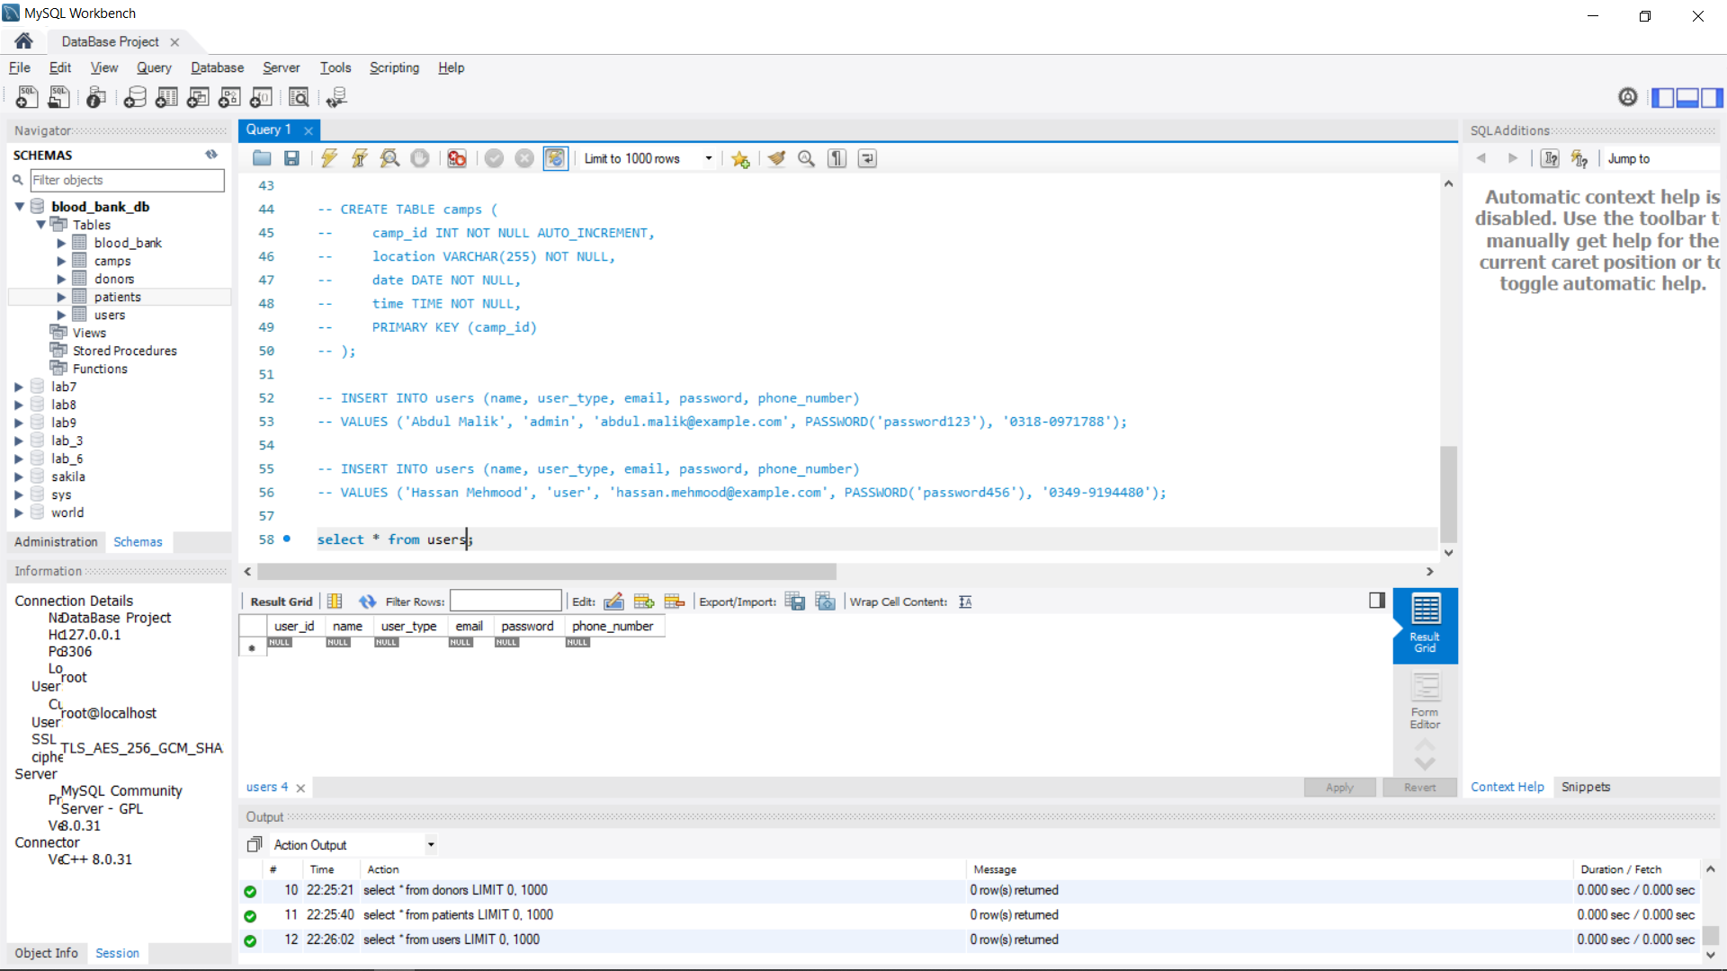

### **Patient Module:**

The patient module stores the information of the patients who require blood transfusions. It contains the following attributes:

1. Patient ID
2. First name
3. Last name
4. Disease
5. Blood group

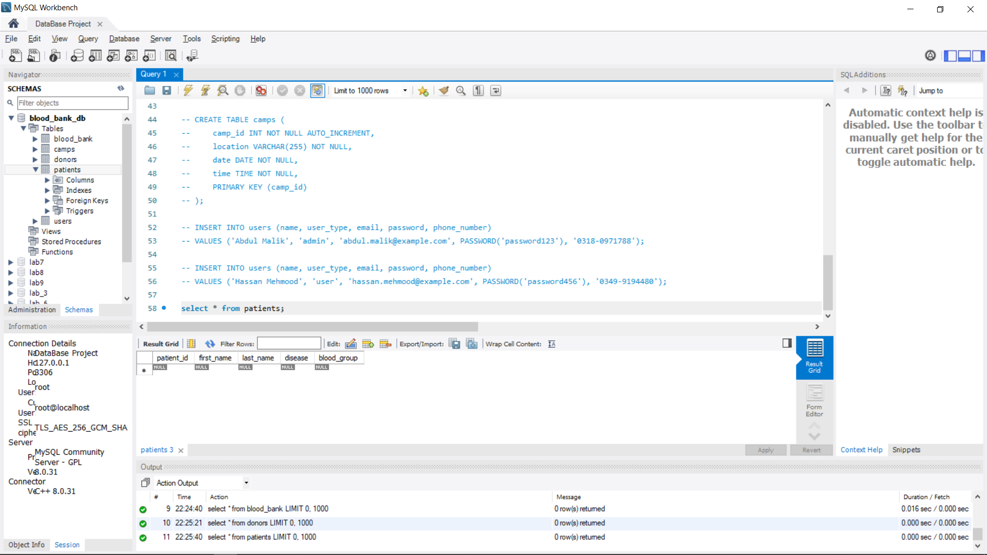

### **Doner Module:**

The donor module stores the information of the donors who donate blood at the blood bank. It contains the following attributes:

1. Donor ID
2. First name
3. Last name
4. Medical report
5. Blood group
6. City
7. Street

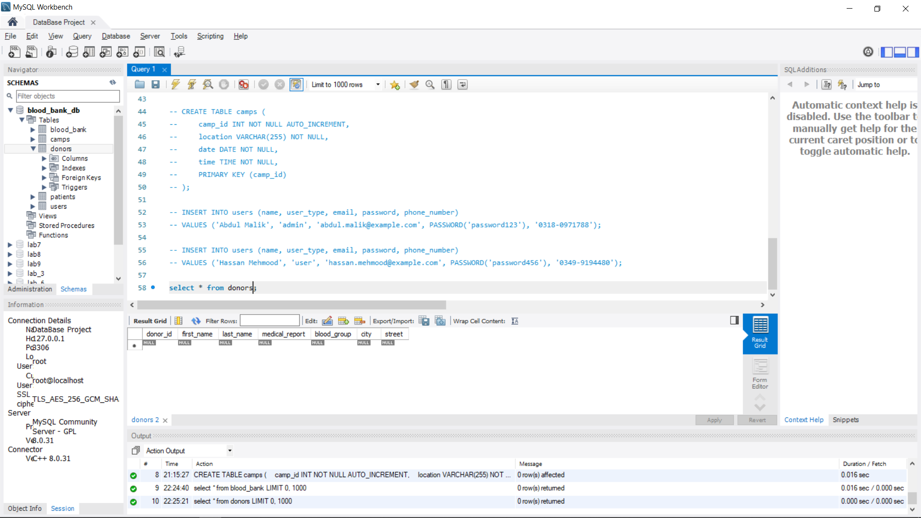

### **Blood Bank Module:**

The blood bank module stores the information of the available blood bands in the blood bank. It contains the following attributes:

1. Blood ID
2. Donor ID
3. Blood group
4. Expiration date

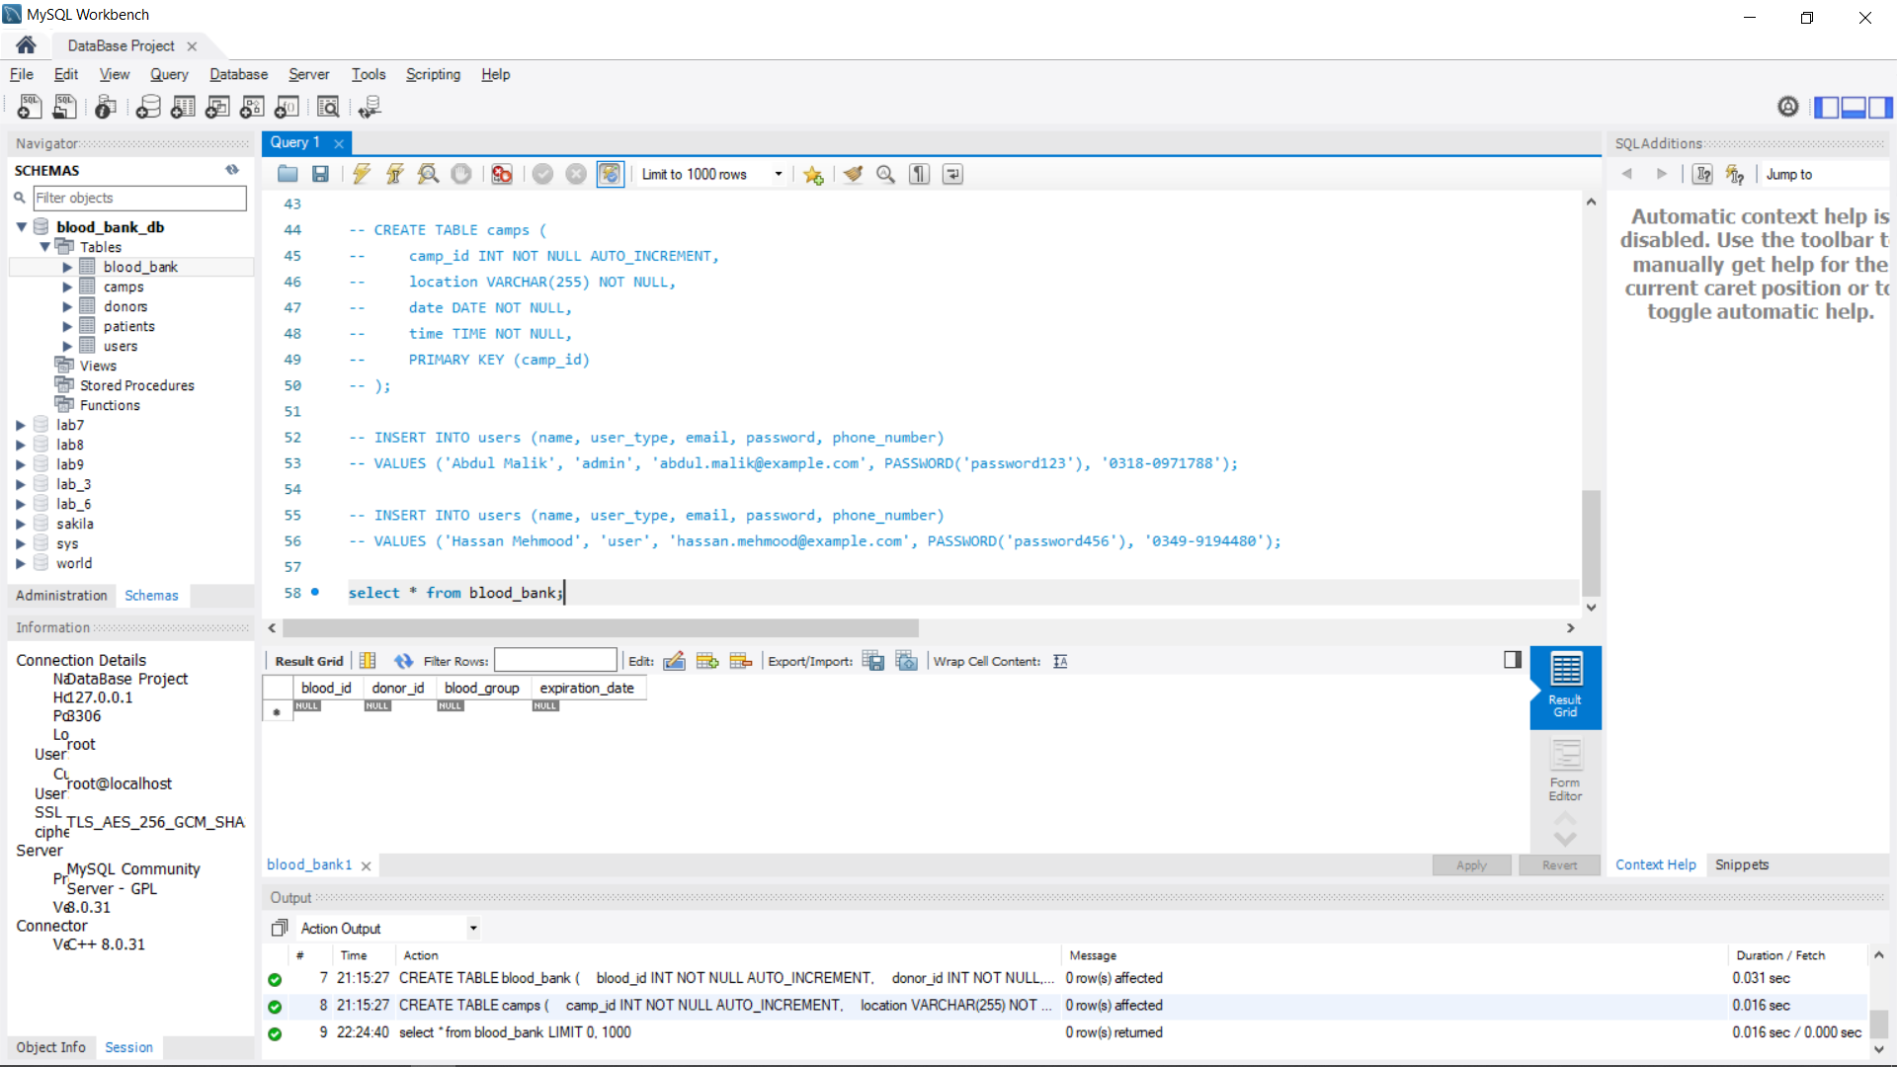

The system also includes a user interface that allows users to enter and retrieve information from the database. The interface includes various forms and reports that allow users to perform tasks such as adding new blood bands to the inventory, searching for available blood bands, and generating reports on the usage of blood bands.

# **Implementation:**

The Blood Band Management System was implemented using SQL programming language. The SQL code was used to create the tables and perform various database operations such as inserting, updating, and deleting records. The system was developed using a combination of SQL and Graphical User Interface (GUI) programming techniques, with the GUI being used to create the user interface and provide a convenient way for users to interact with the system.

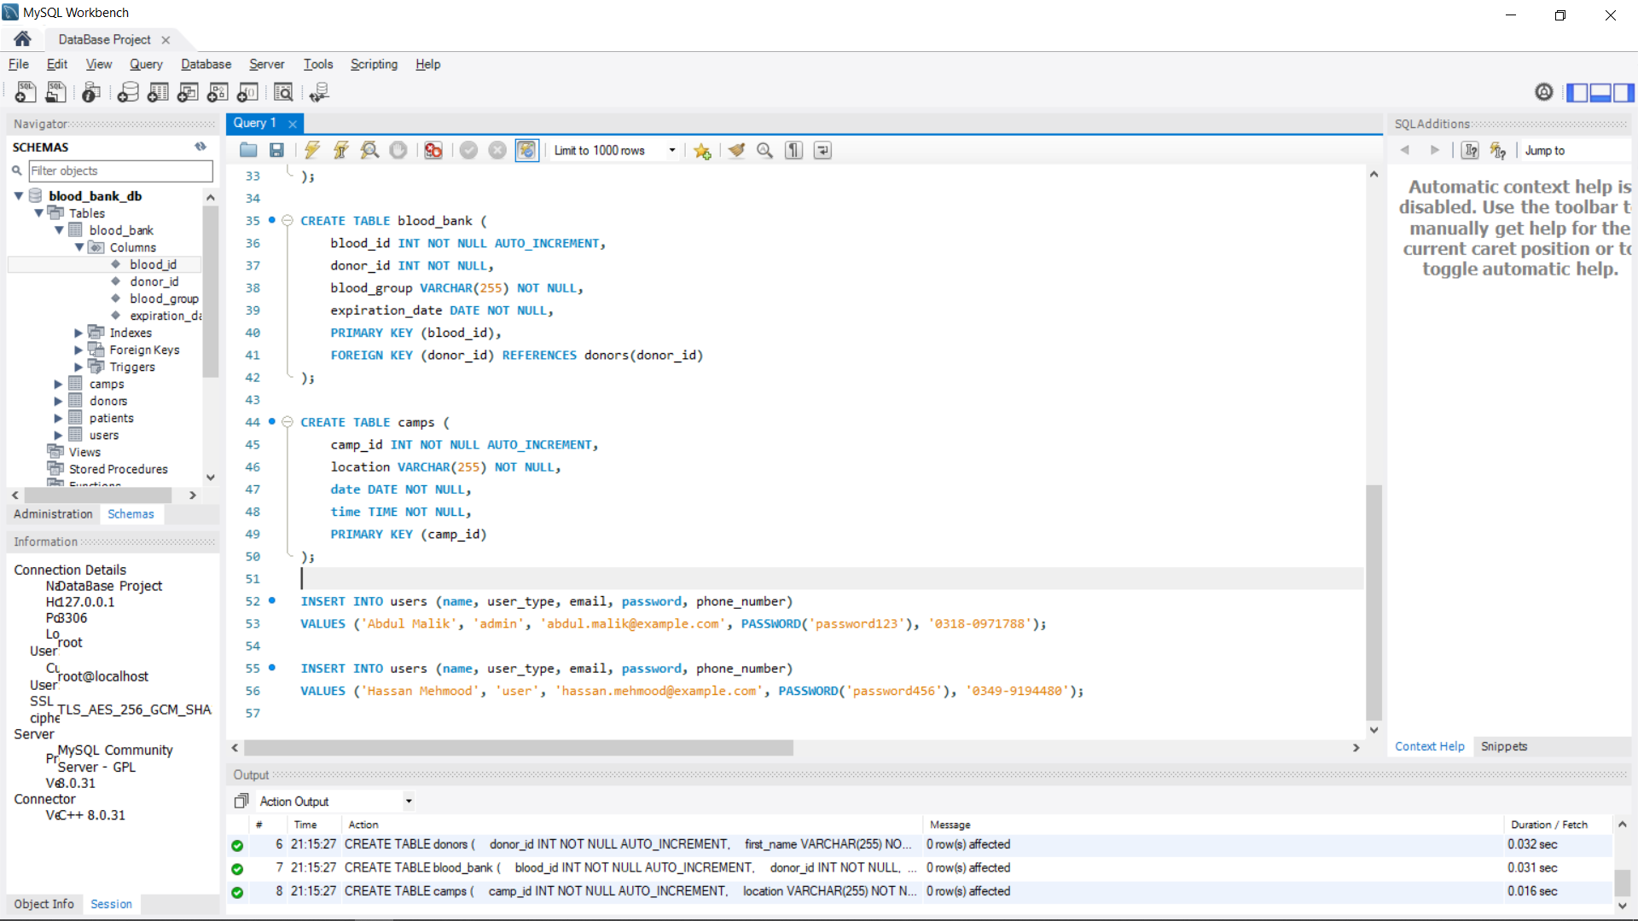

# **Testing:**

The Blood Band Management System was thoroughly tested to ensure that it is reliable and functional. The system was tested for various scenarios such as adding new blood bands, updating the availability status of blood bands, searching for available blood bands, and generating reports. The system was found to be stable and efficient, with no major errors or bugs.

# ERD DIAGRAM:

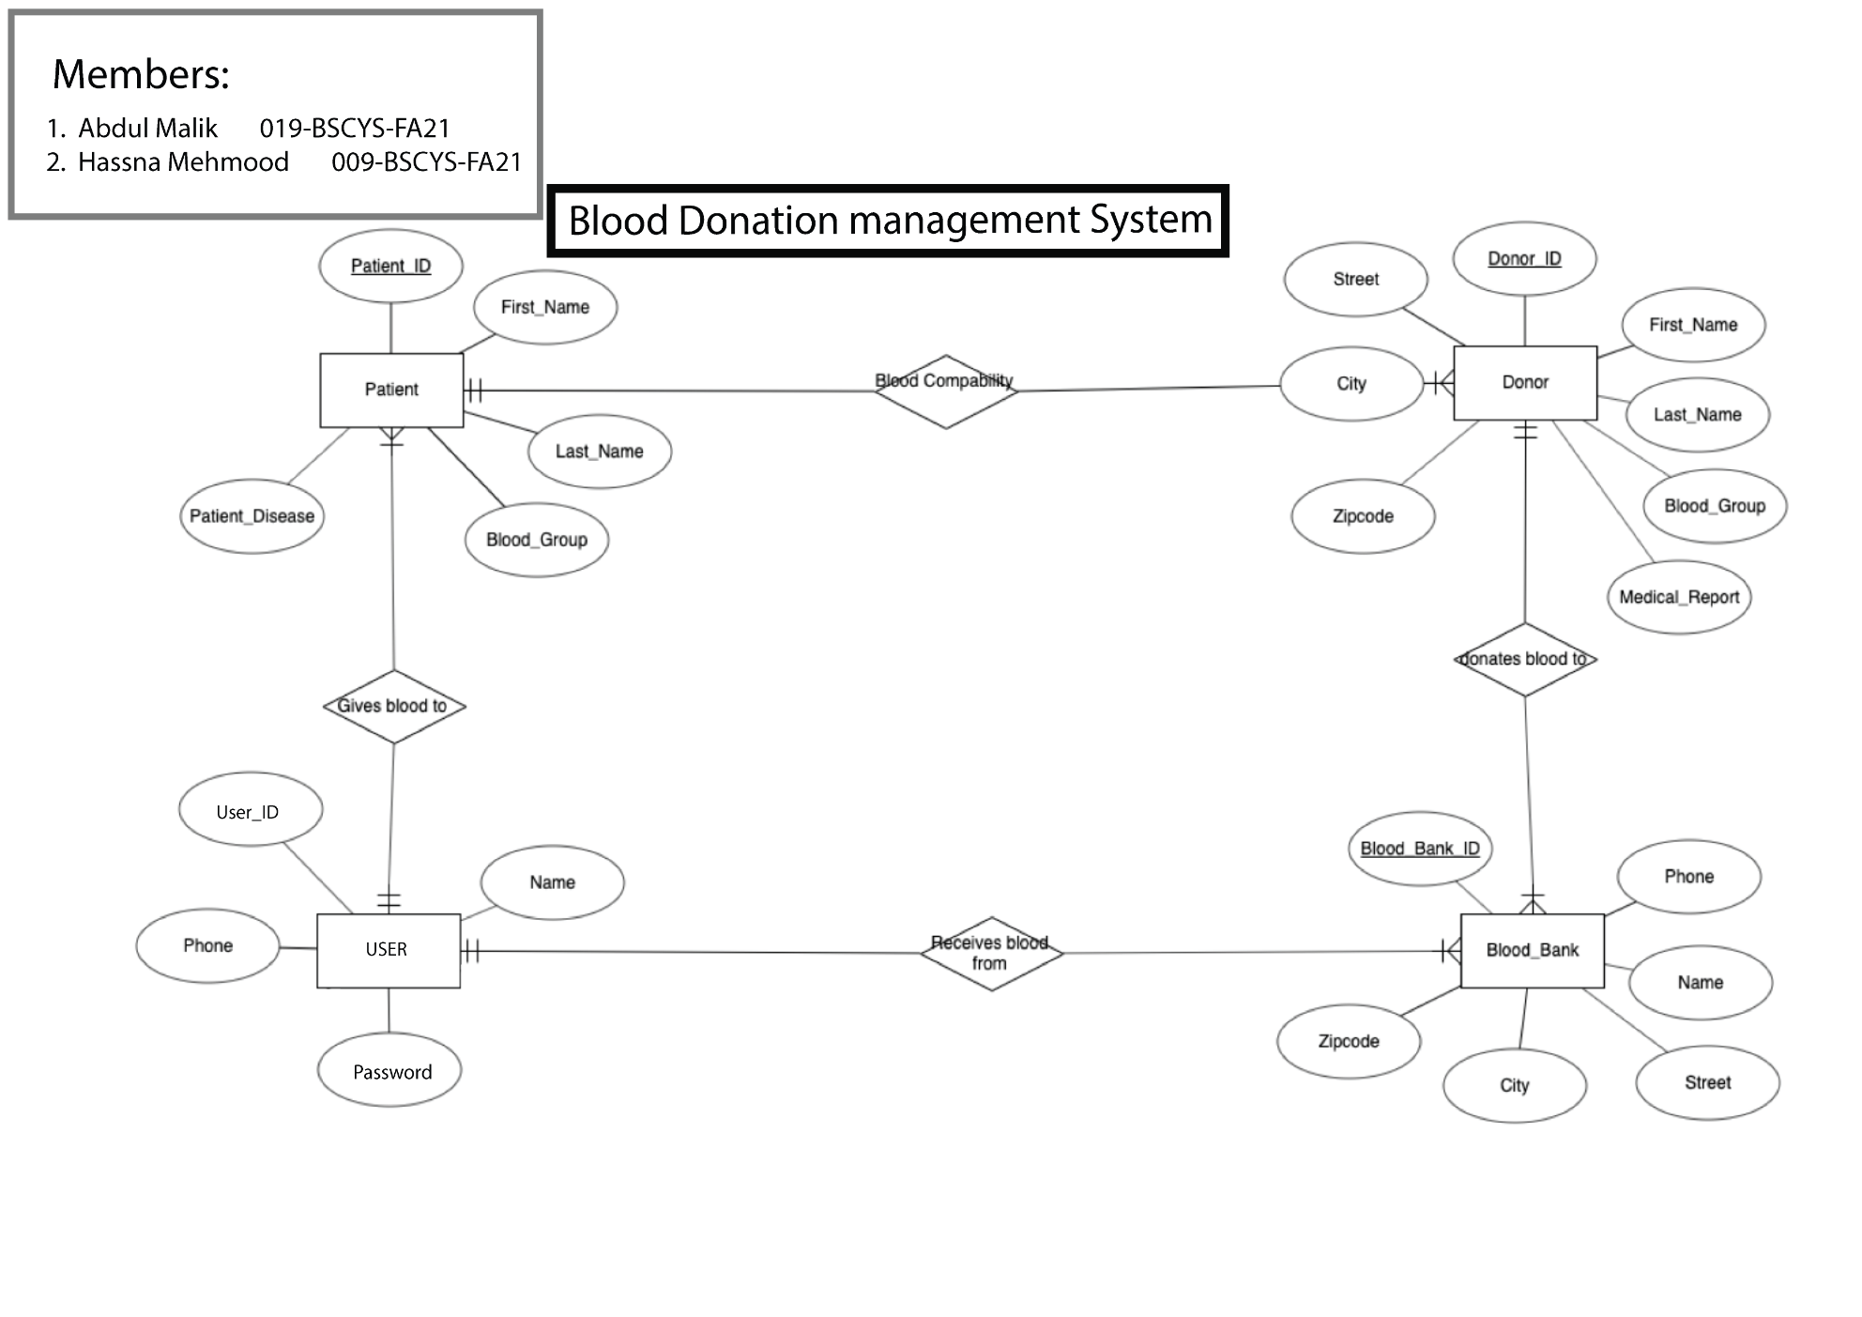

# **Conclusion:**

The Blood Band Management System is a useful tool for blood banks to manage their blood band inventory and streamline the process of matching blood bands to patients in need of blood transfusions. The system is developed using SQL programming language and provides a reliable and efficient way to store, manage, and track the availability of blood bands. The system has been thoroughly tested and found to be stable and functional. Overall, the Blood Band Management System has proven to be a valuable resource for blood banks, helping them to efficiently manage their blood band inventory and ensure that the right blood bands are available for patients when needed.

# **Code:**

create database blood_bank_db;

use blood_bank_db;

-- Create user table

CREATE TABLE user (

  name varchar(255) NOT NULL,

  user_id varchar(255) PRIMARY KEY,

  password varchar(255) NOT NULL,

  phone_number varchar(255) NOT NULL

);

-- Create patient table

CREATE TABLE patient (

  patient_id varchar(255) PRIMARY KEY,

  first_name varchar(255) NOT NULL,

  last_name varchar(255) NOT NULL,

  patient_disease varchar(255) NOT NULL,

  blood_group varchar(255) NOT NULL

);

-- Create donor table

CREATE TABLE donor (

  donor_id varchar(255) PRIMARY KEY,

  first_name varchar(255) NOT NULL,

  last_name varchar(255) NOT NULL,

  medical_report varchar(255) NOT NULL,

  blood_group varchar(255) NOT NULL,

  city varchar(255) NOT NULL,

  street varchar(255) NOT NULL

);

-- Create blood bank table

CREATE TABLE blood_bank (

  donor_id varchar(255) NOT NULL,

  blood_group varchar(255) NOT NULL,

  PRIMARY KEY (donor_id, blood_group),

  FOREIGN KEY (donor_id) REFERENCES donor(donor_id)

);

------------------------------------------------------------

-- Insert users

INSERT INTO user (name, user_id, password, phone_number) VALUES

  ('John Smith', 'jsmith', 'abc123', '555-555-1212'),

  ('Jane Doe', 'jdoe', 'def456', '555-555-1213'),

  ('Bob Johnson', 'bjohnson', 'ghi789', '555-555-1214'),

  ('Alice Williams', 'awilliams', 'jkl012', '555-555-1215'),

  ('Mike Brown', 'mbrown', 'mno345', '555-555-1216');

-- Insert patients

INSERT INTO patient (patient_id, first_name, last_name, patient_disease, blood_group) VALUES

  ('p1', 'John', 'Doe', 'Anemia', 'O+'),

  ('p2', 'Jane', 'Smith', 'Leukemia', 'B+'),

  ('p3', 'Bob', 'Williams', 'Sickle cell disease', 'AB-'),

  ('p4', 'Alice', 'Johnson', 'Thalassemia', 'A+'),

  ('p5', 'Mike', 'Brown', 'Dengue fever', 'O-');

-- Insert donors

INSERT INTO donor (donor_id, first_name, last_name, medical_report, blood_group, city, street) VALUES

  ('d1', 'John', 'Smith', 'Fit to donate', 'O+', 'New York', '1st Ave'),

  ('d2', 'Jane', 'Doe', 'Fit to donate', 'B+', 'Chicago', '2nd St'),

  ('d3', 'Bob', 'Johnson', 'Fit to donate', 'AB-', 'Los Angeles', '3rd St'),

  ('d4', 'Alice', 'Williams', 'Fit to donate', 'A+', 'San Francisco', '4th Ave'),

  ('d5', 'Mike', 'Brown', 'Fit to donate', 'O-', 'Houston', '5th St');

-- Insert blood bank entries

INSERT INTO blood_bank (donor_id, blood_group) VALUES

  ('d1', 'O+'),

  ('d2', 'B+'),

  ('d3', 'AB-'),

  ('d4', 'A+'),

  ('d5', 'O-');