COMP 309 — Machine Learning Tools and Techniques Assignment 4: Performance Metrics and Optimisation

Name: Karu Skipper
ID: 300417869

2.1 Part 1: Performance Metrics in Regression [35 marks]
For this section I will be performing regression techniques on the diamonds.csv dataset located in part1/Part 1 – regression/diamonds.csv . I will be using the sci-kit learn tool to perform the regression techniques on this dataset.

Loading the dataset:
The first step is to import the required sci-kit learn and basic Python libraries that will help us when applying our regression techniques. After this, we load the desired dataset so we can manipulate it later, in this case we are loading ‘diamonds.csv.’

Initial Data Analysis:
I have attatched an image below that helps us analyse some of the initial data. From quickly applying some functions to our dataset, we see there are eleven different attributes to each diamond instance. We can also see there is an ‘unamed’ attribute, which labels the number of the listed instance. I will remove this as it doesn’t help our investigation and more importantly, won’t help our regression techniques.
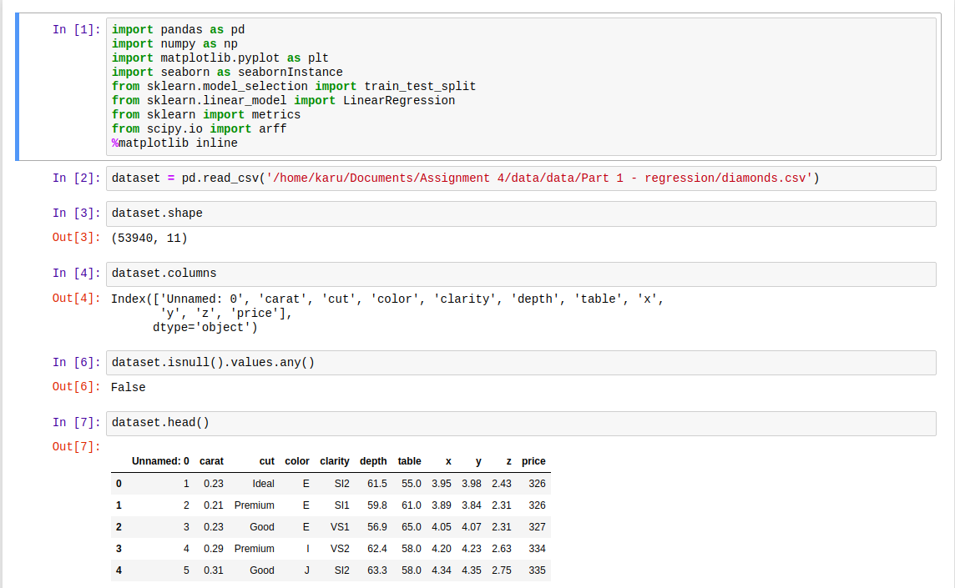
• Step 3. Preprocess Data
• Step 4. Exploratory Data Analysis
• Step 5. Build classification (or regression) models using the training data
• Step 6. Evaluate models by using cross validation (Optional)
• Step 7. Assess model on the test data.

