COMP 309 — Machine Learning Tools and Techniques Assignment 4: Performance Metrics and Optimisation

Name: Karu Skipper

ID: 300417869

2.1 Part 1: Performance Metrics in Regression [35 marks]

For this section I will be performing regression techniques on the diamonds.csv dataset located in *part1/Part 1 – regression/diamonds.csv .* I will be using the sci-kit learn tool to perform the regression techniques on this dataset. When running the pipeline, it is preferred to use the Pipeline-Tensor-Flow.py on google colab as some algorithms take about 20 minutes locally.

**Loading the dataset:**

The first step is to import the required sci-kit learn and basic Python libraries that will help us when we apply our regression techniques. Pandas is developed for fast, efficient & easy practical real-world data manipulation and data analysis. Using pandas, we can load in the diamonds.csv file with simply one line “dataset = pd.read.csv(‘diamonds.csv’).

**Initial Data Analysis:**

I have attached an image below that helps us analyse some of the initial data. From quickly applying some functions to our dataset, we see there are eleven different attributes to each diamond instance. We can also see there is an *‘Unnamed’* attribute, which labels the number of the listed instance. I will remove this as it doesn’t help our investigation and more importantly, won’t help our regression techniques.

*Screenshot of data_analytics.py, this gives us a preview of the information in our dataset*

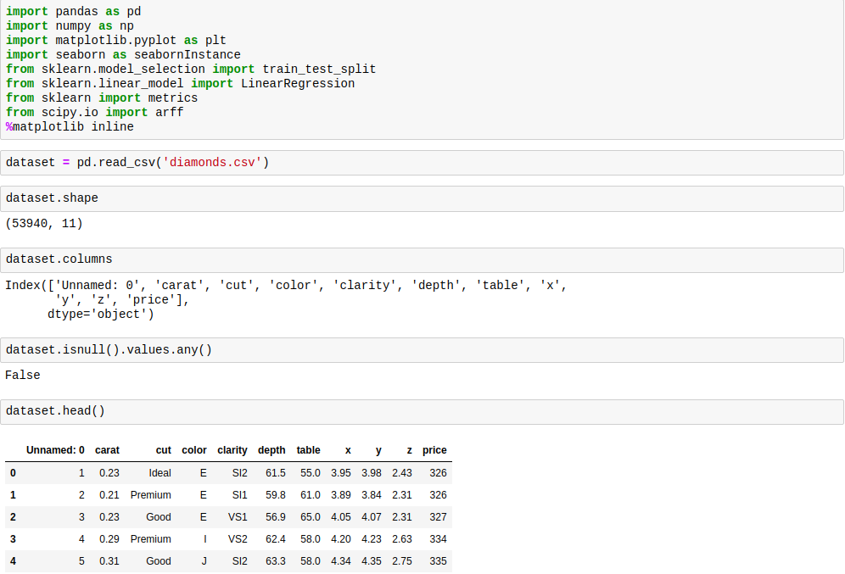

Attributes

* Carat: Carat weight of the Diamond.
* Cut: Describe cut quality of the diamond.
* Colour: Colour of the Diamond
* Clarity: Diamond Clarity refers to the absence of the Inclusions and Blemishes
* Depth: The Height of a Diamond, measured from the Culet to the table, divided by its average Girdle Diameter.
* Table: The Width of the Diamond's Table expressed as a Percentage of its Average
* X: Length of the Diamond in mm.
* Y: Width of the Diamond in mm.
* Z: Height of the Diamond in mm.
* Price: The Price of the Diamond.

Description of attributes

* Cut in increasing order Fair, Good, Very Good, Premium, Ideal.
* With D being the best and J the worst.
* (In order from Best to Worst, FL = flawless, I3= level 3 inclusions) FL, IF, VVS1, VVS2, VS1, VS2, SI1, SI2, I1, I2, I3
* Qualitative Features (Categorical): Cut, Colour, Clarity.
* Quantitative Features (Numerical): Carat, Depth, Table, Price, X, Y, Z.
* Price is the Target Variable.

**Pre-process Data:**

*Drop the index from the dataset using “data = data.drop(data.colums[0], axis=1).*

*Cut, Colour and Clarity* all have string values, we need to change this these to numerical

values this is demonstrated in the screenshot below.

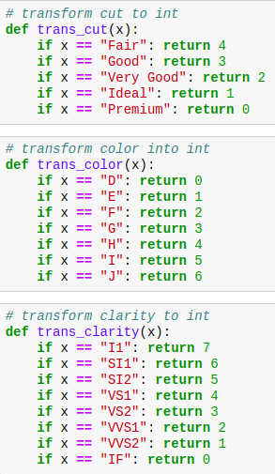

To begin our pre-processing, we need to drop the first attribute, then run a null value scan to see if there are any missing values in the dataset. This resulted in ‘*False*,’ so we can continue our investigation and convert each result in a hierarchical numerical structure. (As pictured on the left). This converts each string result for each attribute in the dataset. We are applying this pre-processing technique for our regression algorithms later. From doing this, we should see if there are any correlations between our attributes a lot easier. This will be described in the later steps.

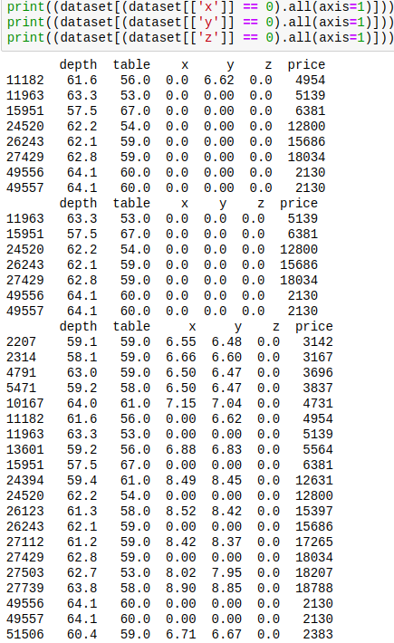*Image of zero checking (data cleansing), this can be found in the data_analytics.py file. But is also applied in my pipeline.py.*

Just because there are no ‘*null*’ values present in the dataset, doesn’t mean we shouldn’t check attributes for inaccurate values. For example, I have individually checked each x, y, z attribute for the number ‘0.’ This is because you physically can’t have a diamond with a dimension of 0. For presentation purposes, I have printed every occurrence of this in the dataset. The code I used to drop all 0 occurrences is:

**data = data [(data[['x', 'y', 'z']] != 0).all(axis=1)]**

This will give us a far more accurate result when applying our regression algorithms.

**Exploratory Data Analysis:**

plt.figure(figsize = (15, 10))

sns.heatmap(dataset.corr(), annot = True)

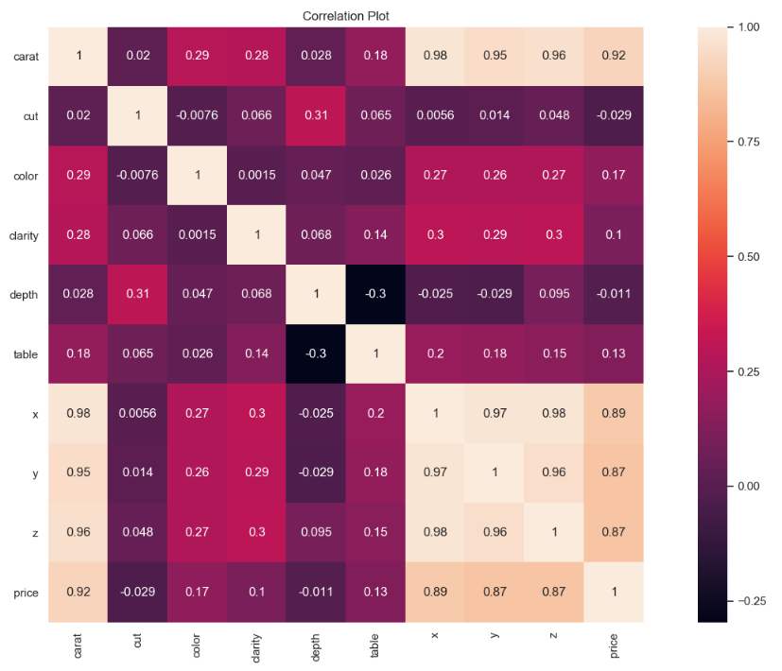

Now let's look at the correlation graph using seaborn heat correlation map:

* We can see x, y, z and carat have extremely high correlations with the price of diamonds.
* Depth has one of the lowest correlations, when comparing to price, we could assume that the depth of a diamond does not affect the price of a diamond, solely because of the close to ‘0’ correlation presented in the heatmap.
* We can also see that table and depth have a strong negative correlation with each other, we may remove this later depending on the performance of our machine learning techniques.

**Build classification (or regression) models using the training data**

Before we apply our regression algorithm, we must split the data into the required training and test set. As required by the handout, I have applied the random_state = 0 and the test size to be 30% of the dataset. This is done through a simple sci kit function ‘train_test_split (x, y, test_size = 0.3, random_state = 309)’



We can create an evaluation model by combining common steps, therefor I have created the below function to act on our parsed model_type.

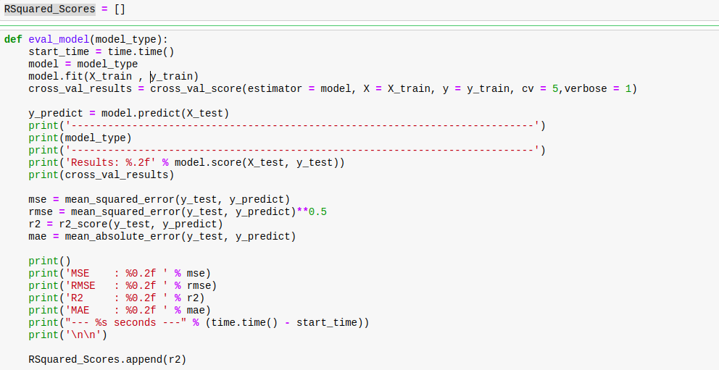

This applies to most models but not all, bringing us to our main () function which will execute all 10 algorithms when run.

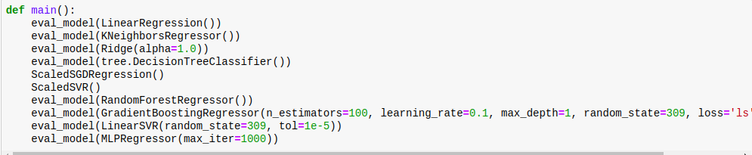

As you can see both *scaledSVR* and *scaledSGDRegression* require extra work and cannot be passed

through the eval_model. Thus, I have created separate functions for these algorithms to be run alongside the rest.

**Assess model on the test data.**

|  |  |  |  |  |  |
| --- | --- | --- | --- | --- | --- |
| **Model** | LinearRegression | Ridge | DecisionTree | SVR | RandomForest |
| SCORE | 0.90 | 0.90 | 0.97 | 0.9416 | 0.98 |
| MSE | 1631602.42 | 1632206.75 | 547945.21 | 949286.03 | 320793.45 |
| MAE | 839.32 | 839.73 | 363.80 | 507.52 | 285.01 |
| RMSE | 1277.34 | 1277.58 | 740.23 | 974.31 | 566.39 |
| R2 | 0.90 | 0.90 | 0.97 | 0.94 | 0.98 |

|  |  |  |  |  |  |
| --- | --- | --- | --- | --- | --- |
| **Model** | GradientBoosting | LinearSVR | MLPRegressor | K-NN | MLP |
| SCORE | 0.91 | 0.80 | 0.95 | 0.95 | 0.93 |
| MSE | 1427945.21 | 3274041.47 | 858964.08 | 752865.31 | 1128628.63 |
| MAE | 699.97 | 1059.18 | 541.45 | 467.84 | 672.95 |
| RMSE | 1194.97 | 1809.43 | 926.80 | 867.68 | 1062.37 |
| R2 | 0.91 | 0.80 | 0.95 | 0.95 | 0.93 |

Part 2: Performance Metrics in Classification [35 marks]

**Step 1. Load Data**

There are two methods of approach for loading the data, due to me using google-colab and jupyter notebook. The reason for this is the google TPU runs 4x faster when running the pipelines.

Loading the data via juypter-notebook:

*“data_train = pd.read_csv('adultTrain.csv')” &*

*“data_test = pd.read_csv('adultTest.csv')”*

Loading the data via google-colab:

*“drive.mount('/content/gdrive')”*

*“train_data = pd.read_csv('/content/gdrive/My Drive/Colab Notebooks/adultTrain.csv')” &*

*“test_data = pd.read_csv('/content/gdrive/My Drive/Colab Notebooks/adultTest.csv')”*

**Step 2. Initial Data Analysis**

* Age: continuous.
* Work-class: Private, Self-emp-not-inc, Self-emp-inc, Federal-gov, Local-gov, State-gov, Without-pay, Never-worked.
* Fnlwgt: continuous.
* Education: Bachelors, Some-college, 11th, HS-grad, Prof-school, Assoc-acdm, Assoc-voc, 9th, 7th-8th, 12th, Masters, 1st-4th, 10th, Doctorate, 5th-6th, Preschool.
* Education-num: continuous.
* Marital-status: Married-civ-spouse, Divorced, Never-married, Separated, Widowed,
* Married-spouse-absent, Married-AF-spouse.
* Occupation: Tech-support, Craft-repair, Other-service, Sales, Exec-managerial, Prof-specialty, Handlers-cleaners, Machine-op-inspct, Adm-clerical, Farming-fishing,
* Transport-moving, Priv-house-serv, Protective-serv, Armed-Forces.
* Relationship: Wife, Own-child, Husband, Not-in-family, Other-relative, Unmarried.
* Race: White, Asian-Pac-Islander, Amer-Indian-Eskimo, Other, Black.
* Sex: Female, Male.
* Capital-gain: continuous.
* Capital-loss: continuous.
* Hours-per-week: continuous.
* Native-country: United-States, Cambodia, England, Puerto-Rico, Canada, Germany, Outlying-US(Guam-USVI-etc), India, Japan, Greece, South, China, Cuba, Iran, Honduras, Philippines, Italy, Poland, Jamaica, Vietnam, Mexico, Portugal, Ireland, France, Dominican-Republic, Laos, Ecuador, Taiwan, Haiti, Columbia, Hungary, Guatemala, Nicaragua, Scotland, Thailand, Yugoslavia, El-Salvador, Trinidad & Tobago, Peru, Hong, Holland-Netherlands.
* Income-Class - >50K, <=50K. “Extraction was done by Barry Becker from the 1994 Census database. A set of reasonably clean records were extracted using the following conditions: ((AAGE>16) && (AGI>100) && (AFNLWGT>1) && (HRSWK>0))”

**Step 3. Pre-process Data**

Firstly, we notice both the test and train data files do not have column titles so let's start by

assigning a title to each column using dataset.columns command and the column titles

discovered in part step 2.

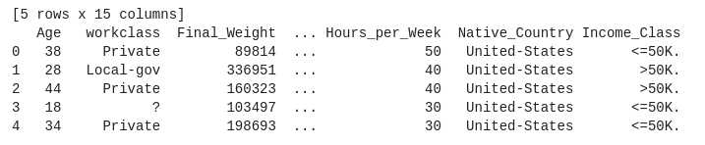

Now also looking more closely at the description of the data in part 2, we see that there is string

values we need to convert to numeric values as the decision trees implemented in scikit-learn uses

only numerical features and these features are interpreted always as continuous numeric variables. Here are some of the transformations made:

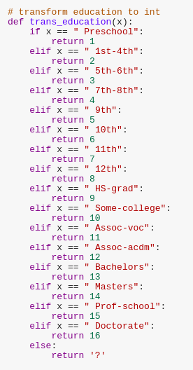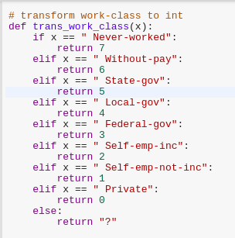

Examples of transformation of

work-class & education

We repeat this process for the other following:

* Marital status
* Education
* Occupation
* Race
* Income class
* Native country

Then calling on the functions we implemented above, we replace all string values within both the

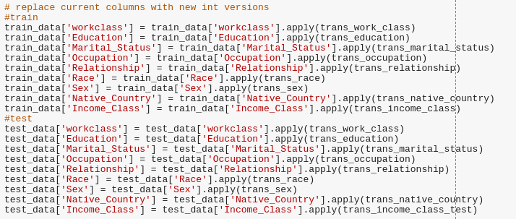train and test set with numeric values respectively as seen below.

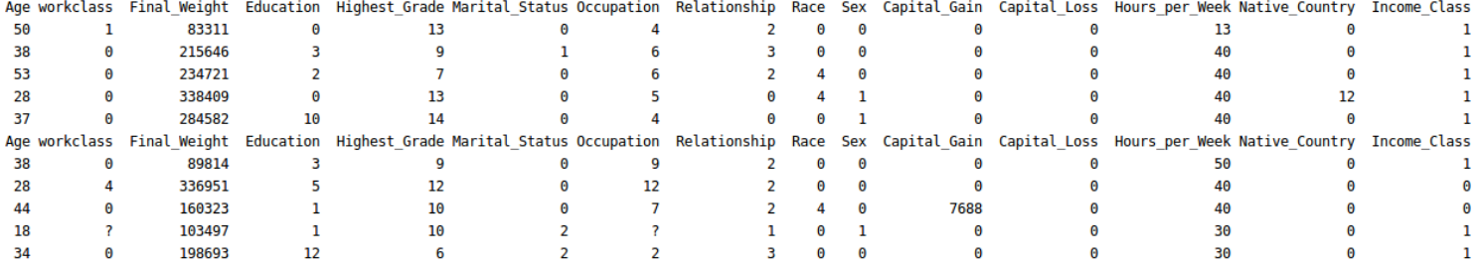



This is the result of applying the transformed data after this technique. Once this is complete we can identify ‘?’ values and replace them with a numpy.NaN value.

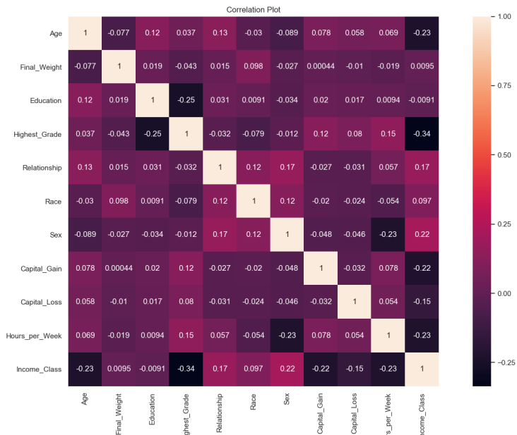Looking at the correlation graph above we can see the both final_weight and education have very low correlation with the class attribute, we can go ahead and remove these two using “data.drop”

**Results:**

|  |  |  |  |  |  |
| --- | --- | --- | --- | --- | --- |
| **Model** | K-NN | GaussianNB | SVM | DecisionTree | RandomForest |
| ACCURACY | 0.85 | 0.82 | 0.83 | 0.82 | 0.81 |
| PRECISION | 0.84 | 0.81 | 0.82 | 0.82 | 0.84 |
| RECALL | 0.91 | 0.93 | 0.95 | 0.87 | 1.00 |
| F1 | 0.88 | 0.87 | 0.88 | 0.85 | 0.91 |
| AUC | 0.77 | 0.71 | 0.70 | 0.76 | 0.59 |

|  |  |  |  |  |  |
| --- | --- | --- | --- | --- | --- |
| **Model** | AdaBoost | GradientBoost | LinearDiscriminant | MLP | Logistic |
| ACCURACY | 0.86 | 0.87 | 0.83 | 0.84 | 0.84 |
| PRECISION | 0.85 | 0.86 | 0.82 | 0.83 | 0.83 |
| RECALL | 0.94 | 0.95 | 0.94 | 0.95 | 0.94 |
| F1 | 0.89 | 0.90 | 0.87 | 0.89 | 0.88 |
| AUC | 0.77 | 0.78 | 0.71 | 0.72 | 0.74 |

**The best performance metric**

The accuracy output of a model is not the best metric to evaluate the classifiers performance. The best way to way to evaluate the performance of a classifier is the confusion matrix. This is a combination of accuracy, recall and F1-score. We must use the four outputs to generate our confusion matrix to draw the best conclusions.

**The best two algorithms.**

The two best classifiers are Adaboost and GradientBoosting, these outperform the other classifiers and are very similar in results. We can see that both algorithms are using ‘boosting,’ which is a good way to construct a robust model. AdaBoost is adaptive in the sense that weak learners are tweaked in favour of instances misclassified by previous classifiers. **Adaboost** is sensitive to noisy data and outliers. In some problems in can be less susceptible to the overfitting problem than other learning algorithms.

**Gradient boosting** is used for both regression and classification problems. This algorithm also allows for the optimization of arbitrary differentiable loss functions. This algorithm constructs a new base learner which needs to be maximally correlated with a negative gradient.

**Adaboost**

* Accuracy: 0.86
* Precision: 0.85
* Recall: 0.94
* F1: 0.89
* AUC: 0.77

**GradientBoosting**

* Accuracy: 0.87
* Precision: 0.86
* Recall: 0.95
* F1: 0.90
* AUC: 0.78

Part 3: Optimisation Methods [30 marks]

OptimisationMethod.py found at:

*/part3/Part 3 – optimisation/template/Template/LinearRegression/src/*

I have had to re-locate the utilities folder as the current release of this program is broken and can’t locate the utilities module. It would benefit everyone if this was fixed in the next release of the template code.

1.

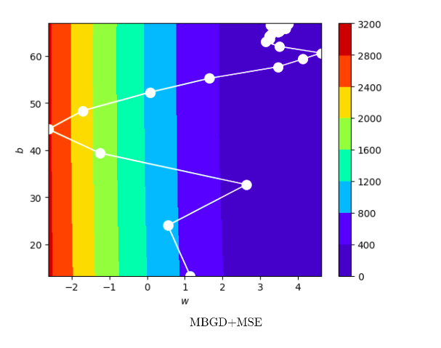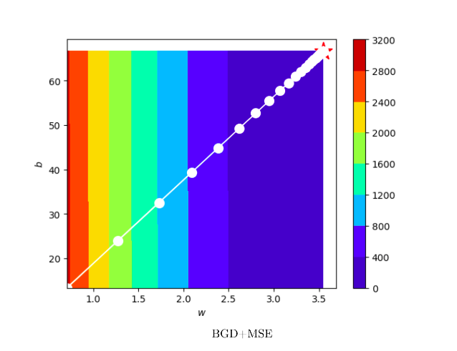a)

* The path of gradient descent of **MBGD + MSE** is highly unstable (high path variance). This is because the batch_size of MBGD is significantly lower (10) than BGD.
* The path of gradient descent of **BGD + MSE** is stable and it is a straight line which go to the local optimal point. This is because there is a larger batch_size, meaning there is less variation.

BGD computes the gradient over the entire dataset, averaging over potentially a vast amount of

information.

**Mini-batch gradient descent** is a variation of the gradient descent algorithm that splits the training

dataset into small batches that are used to calculate model error and update model coefficients.

b)

Results:

|  |  |  |  |  |
| --- | --- | --- | --- | --- |
|  | **BGD + MSE** | **MiniBGD + MSE** | **PSO + MSE** | **PSO + MAE** |
| **MSE** | 2.41 | 2.62 | 2.41 | 2.43 |
| **R-Squared** | 0.83 | 0.82 | 0.84 | 0.83 |
| **MAE** | 1.28 | 1.32 | 1.28 | 1.28 |

From the table is shown above, the model optimized by **PSO + MSE** has the highest **R-squared value**. It also has the smallest **MSE and MAE value**, which means it is the best model among these four models. The **MiniBGD + MSE** has the poorest performance. It has the smallest R-squared value and highest MSE and MAE value.

c)

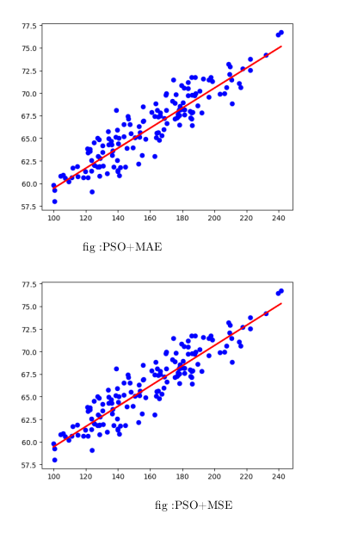d)

|  |  |  |  |
| --- | --- | --- | --- |
|  | **BGD + MSE** | **MiniBGD + MSE** | **PSO + MSE** |
| **Execution Time** | 0.008 | 0.015 | 0.360 |

From the results table, we can see BGD is the fastest with an execution time of 0.008 seconds. Usually, BGD would be slower than MiniBGD but due to the dataset size being small, the execution time is faster. This could also be due to the MiniBGD batch_size being set inappropriately.

If this is done correctly, with good vectorisation and an appropriate batch_size. MiniBGD will out-perform BGD.

PSO is the slowest because it has a low convergence rate in the iterative process.

2.

a)

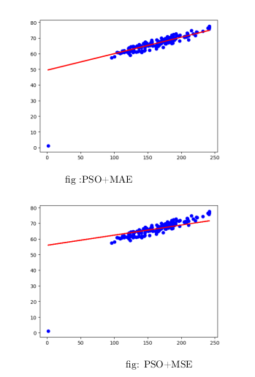b)

If we compare the two plots from question one (c), we can visually see a difference in how they perform in comparison to question two (a). Firstly, there is an outlier included in the results of this algorithm. In comparison we can see that it’s more likely that this algorithm is to be affected by outliers. This is probably due to the format of the algorithm (Particle Swarm Optimisation), which tries to improve a solution regardless of a given measure of quality.

If we compare the two in this question, it seems that the PSO + MSE line is inaccurate to the groupings, unlike PSO + MAE. Because the MSE is squared before they are average, the MSE gives a relatively high weight to large errors. This means the MSE would be desirable in situations where there aren’t outliers. To conclude, the MAE would likely be less prone, because MSE also increases variance associated with the frequency distribution of error magnitude also increases.

c)

**References:**

<https://makingnoiseandhearingthings.com/2017/12/30/how-to-be-wrong-measuring-error-in-machine-learning-models/>

<https://www.ncbi.nlm.nih.gov/pmc/articles/PMC1464136/>