Machine Learning Tools and Techniques
Assignment 2: Real-World Data Handling, Modelling and Visualisation

Name: Karu Skipper
ID: 300417869

2.1 Part 1: Core: Evidence related to fish stocks in New Zealand [40 marks]

“Whatever happens, over-fishing today will lead to collapses tomorrow, ... ” Jun 14 2019 Stuff

- Firstly, what evidence can be found to support (or dismiss) the newspaper headlines?

- Secondly, what features can be considered as the underlying cause for any increase (or decrease) in fish numbers (stocks)?

- Thirdly, what trends and predictions can be made from the data?

- Finally, what findings would you communicate, based on your analysis [also consider the consequences of publicising the information found]?

Overview of all datasets

Data sets name | Links to the datasets
Number of trawl tows | Link
Estimated fish and invertebrate bycatch | Link
Marine Protected Areas | Link
Sea Temperature | Link

a)

Dataset : Estimated fish and invertebrate bycatch
Note: Bycatch is the amount of unwanted fish caught per tonne
Tool: WEKA
Description: The unintended catch of marine species other than the target species puts
pressure on the populations of marine species by removing individuals or potentially modifying ecosystems.
Coverage: 1991–2012, New Zealand waters

Manipulating the data:
Removing features:
For the “Estimated fish and invertebrate bycatch” dataset I have removed unnecessary attributes that are not relavent to our investigation. These include ‘feature 5’ which only included two values through out the dataset. This feature I was unable to find the reasoning for, however because of it’s low appearances it was rendered useless for this case.

I also removed ‘estimated type’, which described the type of scale the fish had. This was removed because of it not relating to our investigation. Finally, I removed rows of information that contained (no_data) as it may affect the techniques we apply to it.

Merging features:
Because this is the first question I have not merged the datasets together yet, I have only removed features that are unnecessary to our results.

I will be using a pipeline to analyse my solutions, comparing and contrasting between different learning algorithms in WEKA.

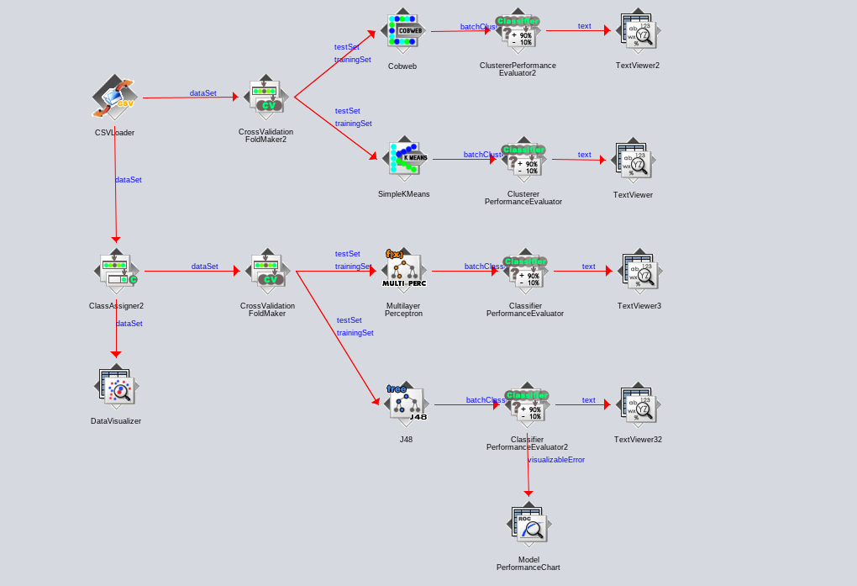

b)

Determining the methods to use on the dataset:
Classification methods are used for categorical data eg.(yes/no or positive/negative). For the dataset I am using, it is unlikely the MLP will perform well. This is because the Fishery class we are categorising them into has multiple fish types with little data. It will also perform poorly because we are expecting to identify correlations between the attributes, not classify them.

Clustering is quite different though: there there are no outputs in the data at all. So in clustering, the idea is to assign different classes to different data points depending on how they group together. Clustering is called an “unsupervised” learning method, because there are no examples of “correct” labelling that can be used for training. It is also used for finding similarities/patterns in observed data, which relates well to how we want to analyse the dataset.

Regression does not apply to the provided dataset and throws errors in the current pipeline. This is because we have a categorical attribute (fishery) in the dataset. Regression analysis is the statistical model which is used to predict the numeric data instead of labels. It can also identify the distribution trends based on the available data or historic data. Predicting a person’s income from their age, education is example of regression task.

To have a good comparison, I have chosen two very different techniques to analyse my data with. Firstly, I will run a MLP on the dataset as it falls under classification, which doesn’t necessarily fit the criteria for our analysis.

Secondly, I will use a clustering approach and use K-Means to analyse my data. This should help give me a clearer understanding of why a technique may perform better than the other.

Multi Layer Perceptron in the Pipeline - Classification:
Correctly Classified Instances 65 38.0117 %
Incorrectly Classified Instances 106 61.9883 %
Kappa statistic 0.2843
Mean absolute error 0.1652
Root mean squared error 0.2885
Relative absolute error 75.8379 %
Root relative squared error 87.3886 %
Total Number of Instances 171

The MLP correctly classified 38.0117% of the data correctly, which is extremely low for classification. One major difference between this technique and the clustering is the visualation and
-- in depth or change mlp?
Simple K-Means - Clustering
Visualise option in WEKA :
Note: Usually years would be displayed on the x axis but due to the fish names taking up space it was easier to display on the y.

Years = x axis
Bycatch = y axis
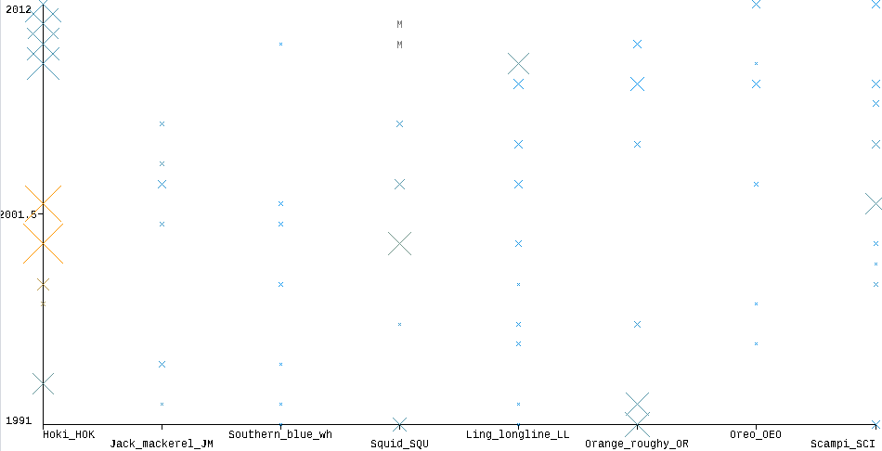

Summary:
From running Simple K-Means clustering on the dataset, I found some interesting assumptions in the visualisaltion graph. Here I am comparing the year vs the fishery (fish type). The greater the X on the graph, the higher the fish bycatch count. This is interesting a we can see what fish populations have been affected over time.

Let’s take the first category ‘Hoki’ as an example of the fish population decreasing relative to bycatch. If we analyse it closely, we can see large amount of Hoki being bycaught around 1992, then shortly decreasing in count over the next few years. This gives the Hoki population a chance to repopulate, then as we climb towards 1998 the bycatch of this species increases again. This maxs around 1999 – 2001 where there is a significant increase in bycatch of this species.

After this point the fish population again comes back and is again but due to previous decreases in bycatch population. We can predict that there will be a significant decrease in the Hoki population considering the current bycatch population of the species. This is similar in most fish populations in this data, meaning that this is supporting the fact we are bycatching to the point where we have significant population decreases.

c)

How does the results from differ from Classification vs Clustering?

Classification:
Classification predicts a discrete number of values. In classification the data is categorized under different labels according to some parameters and then the labels are predicted for the data. Multi-Layer-Perceptron in this case is a supervised learning technique and doesn’t perform as well as clustering techniques and would perform better at classifying emails as either spam or not spam for example.

--talk about results
--refer to dataset

Clustering:
Clustering is the task of partitioning the dataset into groups, called clusters. The goal is to split up the data in such a way that points within single cluster are very similar and points in different clusters are different. It determines grouping among unlabeled data. In this case our results differed quite a lot compared to classification techniques. Clustering is great to visualise results with where MLP is good text results. I was able to analyse relations between features a lot easier than MLP as the results for MLP were just accuaracy of what the output buffer returned.

Because we are trying to make predictions and analyse correlations, it was much more reasonable to use the clustering approach. This is mainly because wernt not looking classy our data into classes, rather calculate relations. This is why clustering was a better approach.

--refer to dataset
--talk about results

d)

Is there any evidence of fish stocks collapsing in NZ waters?
From the evidence I have gathered we can see that their is a problem with fish stocks being negatively affected. This could be due to many reasons but not neccessarily the Estimated fish and invertebrate bycatch dataset I have analysed. There is no correlation between bycatch and year that this occured. Although there is evidence to suggest that some fish populations are due to decrease in the next few years.

Does bycatch amount suggest that their is a population decrease in fish stocks?
Their is some evidence in the fish bycatch trend that indicate drastic changes in fish population. It could be possible that we are bycatching species less because their is less fish to catch. Although this is true, their could be other variables affecting the fish population. For example, less bycatch could be due to temperature change or even pollution. Further investigation would be needed to draw proper conclusion. Combining relevant datasets would be a good start to find a proper correlation between attributes.

Is there evidence of fishing stocks increasing in NZ waters?
Before we make conclusions we must have sufficent evidence to support the increase in fish stock. If we use ... as an example

Part 2: Completion: Feature importance to Fish stocks in New Zealand [40 marks]

Identify features that are important to determining Fish Stocks in New Zealand. For example, how important is the location, time of the year, weather conditions during the sample collection and so forth? Show how the machine learning tools can identify such features

a)

What features can be considered as the underlying cause for any increase (or decrease) in fish numbers (stocks)?

This is an interesting question as we can go into further investigation of fish stock in NZ. We can investigate into other attributes that may be influencing and causing the fish population to increase or decrease. This could include the location, time of year or weather conditions. For example a fish population may be greater in other parts of New Zealand at different times of year due to temperature. This means we have to run further technique to prove or disprove the reasoning behind the fish stock increase or decrease.

This means we have to find the main features that could be affecting the NZ fish stock/population. I have listed below, mroe attributes to investigate:

- Location
- Time of the year
- Weather conditions
- Temperature

From this selection I have chosen a Sea Temperature dataset, that averages the yearly temperature of NZ sea waters. This needs to be converted to monthly data to increase our instance count and also accurarcy of temperature. This is specifically important as seasons are a main impact on the temperate of the water. If we can categorise the months into seasons we would have more of an accurate result to analyse. From this I will also implement a fish stock data set to compare against it.

Why was the temperature data gathered? What did the acquisition hope to achieve?

The ocean waters surrounding New Zealand vary in temperature from north to south. They interact with heat and moisture in the atmosphere and affect our weather.

The sea surface temperature anomaly provides an indication of the heat change in the ocean.
Long-term changes and short-term variability in sea-surface temperatures can affect marine processes, habitats, and species. some species may find it hard to survive in changing environmental conditions.

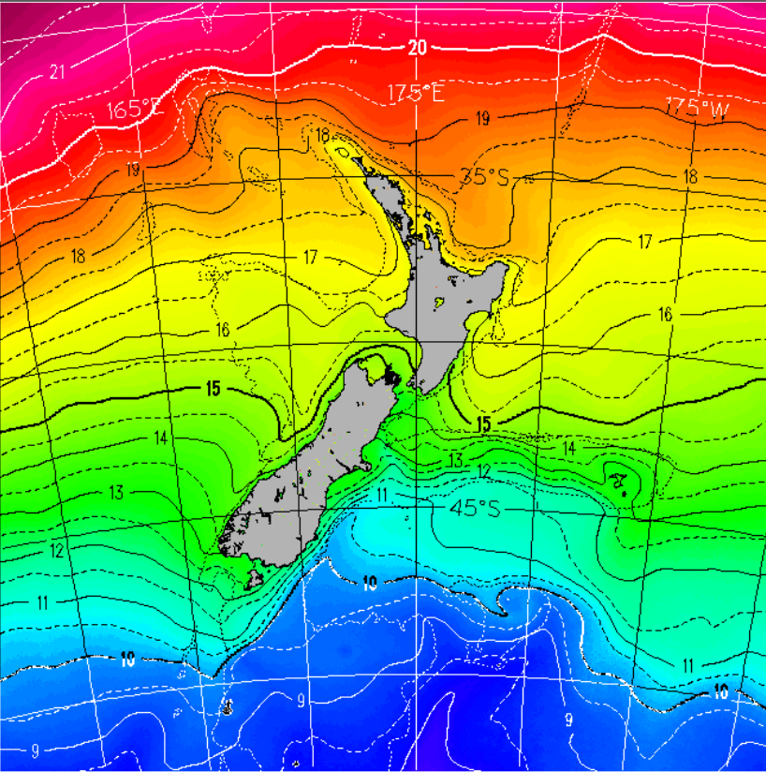
Describe why the dataset(s) chosen are appropriate to the business understanding case.

Temperature:

It’s likely that temperature could also be affecting the fish population, making it an important dataset to investigate. From this, it is likely we can draw further conclusions to support our buiness question. This will most likely be shown through similarities and correlations between other attributes.

Bycatch:

Methodology
This supporting information is based on coarse and refined estimates of fish and invertebrate bycatch. These estimates relate only to the larger offshore fisheries where observer data allow the estimation of bycatch. Inshore fisheries have lower observer coverage and comprehensive estimates of bycatch have not been made.

-- explain more?
-- the original datset of bycatch
--get the description of temperature and explain what it means.

b)

• (10 marks) Using suitable techniques, such as WEKA command-line, merge the datasets together. In the report, describe how this merging was achieved. Note that appending two datasets with identical features but different instances is different from merging distinct data sources that consider different features related to the same task/problem.

I used the WEKA CLI technique as described in lectures to merge my dataset into 1. This resulted in a dataset that included both the temperature and bycatch of marine species by year. In doing this I had to make slight altercations to the temperature dataset which didnt match the marine bycatch instance amount correctly. This involved removing some instances to match the correct amount, which included data reduction techniques.

• (10 marks) Utilise dimensionality reduction technique(s) to identify which features are irrelevant and/or redundant to selected tools’ performance, e.g. classification, regression and so fourth. Remove redundant/irrelevant data. Handle missing data. Discretise continuous ranges as necessary. Remove any unnecessary instances, e.g. redundant instances, outliers (take care whether this is necessary/appropriate) or non-effective instances.

To start, removal of irrelevant features was necessary in producing suitable data to analyse. For the temperature dataset I removed the sample size and standard deviation as we wern’t using these features to support our question of temperature affecting fish populations. Along with the refined bycatch dataset, merging the dataset was quite easy. The only original conflict was the instance amount being different and the years not corresponding properly. This was resolved through keeping neccessary data from the bycatch and removing redundant instances that wernt necessary to our research. eg. (years from 1991 – 1993 didnt include any temperature features at this time, so it was removed).
-- irrelevant features
-- redundant tools
-- missing data
-- discrete ranges
--remove instances non effective ones

• (10 marks) Now only a subset of the original features and instances should exist. Analyse the output of the ML tool on this processed dataset to identify which features are important to a selected tools’ output, e.g. which features are near the start

