SWEN303 ASSIGNMENT 2
Karu Skipper 3000417869

Default - Persona - Use-cases - Reflection

Part 1 :
Introduction to the project:

Description

Assignment 2 will be focusing on the design aspects and interfaces of the Carbon Calculator website. I will establish my own abstract wireframes and ideas based of the Carbon Calculator website using the online tool Balsamiq. Here I will clearly show my design ideas, relating it to users and their needs. I have updated this report to include these requirements and related it to similiar systems. I have used techniques to prototype and ideate sections of this assignment to improve it from assignment 1.

In Assignment 2’s report I have updated the scenarios, personas and relfection of this report. As well as including an important Wireframed website re-creation in the Design section. This is important as we will be relating personas and their needs by creating a better userflow for the website. This will in turn, better represent how a user accesses and navigates through the website.

--a1 feedback

This report will be analysing the usability of the Carbon Footprint Calculator website, (https://www.carbonfootprint.com/calculator.aspx). I have conducted my own individual bias based on the User Interface Design of the website. This is based on the overall functionality and usability as an average user. To do this I will be creating individual personas who are likely to be the key kinds of people who will be using the website. Existing problems that I have identified is the over complexity of the user inputs, text size and use and positioning of elements on the webpage. As well as usability, poor navigation, feature overload and inconsistent layouts which will be discussed throughout this the report.

Business Objectives:
The Carbon Calculator website is a global, multi-country targeted website that provides a carbon footprint calculator to its users. Their first objective should be to create a healthy and sustainable future for people worldwide, which can be supported through the number of active users from different locations around the world. The website must be creative and abstract to draw users in, which should be the primary goal of the website's UI Design. The second objective links in to the first and can be supported through ease of access with user inputs and displays. User input and calculations must be as simple as possible, especially with websites of this criteria. The final objective is to provide accurate statistical data to ‘shock’ and convince the user they’re damaging the environment.

For this website, I have derrived 3 main objectives for the Carbon Caluclator website:
- Create a healthy and sustainable future for people worldwide.
- Show users their own overall carbon emission release in combination with plastic usuage.
- Provide users with statistical information on the carbon emission and plastic usuage subject.

These objectives can be achieved through more visually aesthetic interfaces such as
replacement of generic text links with icons, low user entry prompting, good user flow and consistent layers. As well as making the website suited to all demographics and personalities that access the website. For example, the Carbon Calculator Website currently displays text in the tabs where icons could be used in replacement. The tabs themselves should be re-done or even abstracted to be a single page or section. Right now, the accessibility of these tabs are tedious and don't represent good user flow. A lot of the hyperlinks are jammed together under tabs and offer excessive amounts of information that no normal user would read through. This ties into the page inconsistency which plays a massive role in professionalism for the website, which is important to a lot of their objectives.

The website is designed to for fill these objectives through ‘shocking’ the user with their calculated result, pushing them to change the way they think, act and use plastic and carbon-based products every day. Unfortunately, after short analysis of the User Interface Design we can notice flaws in the website which can result in a lower active user population. Which means less exposure and less users aware of their carbon footprint impact.

The importance to stakeholders:
The Carbon Footprint Calculator website is important to many groups and individuals worldwide, especially with the exceptionally high amounts of carbon emissions in the atmosphere. Users want to be able to calculate their daily, weekly, monthly or even yearly impact on the environment. Because of this importance, a working User Interface and Design is extremely important and vital to keeping users active on their website. Having the user overwhelmed with information and inputs can be very off putting and can cause users to give up or be frustrated. It is important to have these proper design aspects on global websites like this. You are targeting many people from different cultures, ethnicities and lifestyles. You must be cable of providing a user-friendly environment for all people and be sure they are convinced that filling out this calculator will be beneficial for themselves and most importantly, others.

Awareness of environmental impact has increased significantly over the years and people are expecting websites like this to be the gateway to producing a healthier world. As a user of this website, you want to be reminded and be able to share to others your carbon footprint. It’s almost given that you should be able to convince other people that they should use this website. So they can also share with others, creating a cycle where more and more people are influenced to change their response to carbon emission and plastic use.

Part 2 :
Personas and Requirements
--UPDATE SCENARIOS YOU THINK ARE MOST IMPORTANT

Overview
From assignment 1, I have made no altercations to my persona cards. Instead I have slightly updated/added system requirements for that specified persona. These will relate to the design section later in this report. I will be showing the interactions of Awesome Andrew first as his importance and understanding of UX Design is higher than Modest Margarets.

Personas
Creating the personas:
This lead me on to persona creation to give a better wider overall representation of the summarised User Groups who would access the Carbon Calculator Website. In creation of my personas, User Modelling techniques, including Abstract Representation were used as well as User Design techniques to help empathise with my personas. Firstly, I hypothesised about the user types who would access this website. I then prioritised the most likely users to be accessing the Carbon Calculator. I then took two abstract groups and their behavioural variables to create Andrew and Margaret as individuals.

My first persona Awesome Andrew was created in the light of students and the younger demographic. Andrew follows the persona of a impatient user who is easily frustrated with complicated functions and design interfaces. He does not care for look as such, more ease of accessibility. Because of his field of study, he expects high standards from global websites like the Carbon Calculator.

My second persona Modest Margaret was created in the light of older, mature audiences who are interested in sustainability and a green future for their children. Unlike Andrew, she is patient and doesn’t get as easily frustrated because of her maturity and patience as a mother. Although this is the case, she can find it hard to navigate through some websites and needs help from other family members. This makes UI Design important to her, she prefers big buttons, large text and helpful guidelines.

From these individuals I have created Essential Use Case Diagrams to better represent the user flow of these individuals on the website. These will be prioritised with the Calculation of carbon emissions being more important than the Websites Login, as calculation takes instant priority over the storage of your recent emissions. The login is next because the users should be able to store their data for comparison of other times where they have calculated their carbon emissions.

I have used examples of available functions on the website and displayed them below:

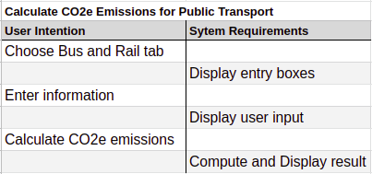
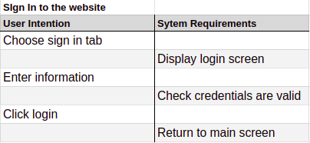

The diagram below is created using LucidChart, an online UML diagram creator.

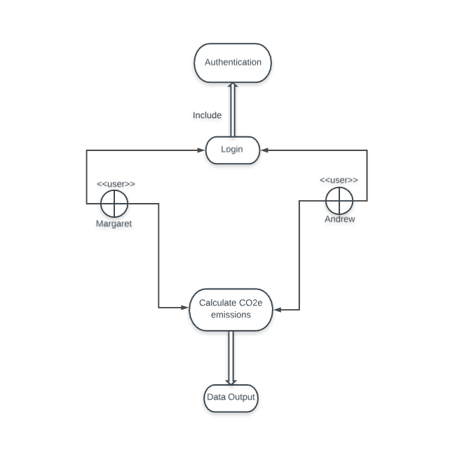

Scenarios
Used website https://xtensio.com/ to create these Persona cards:
Persona 1 : Awesome Andrew

System Requirements for Awesome Andrew:
Andrews expectations for the system is that it returns valid, correct information that is displayed in a user friendly matter. Although he does not care for dramatic UX Design, he expects that international websites will have a better User Flow.

Scenario 1: Calculating your footprint:
Andrew is trying to calculate his effect on the environment when using public transport and is considering walking to University instead. First, Andrew loads the website and finds the public transport calculator. Andrew is soon frustrated there isn't a more interactive way of entering the user input and has to google the distance of his bus ride to University and back before entering the result in the website. He then repeats this technique but gets impatient and calculates his footprint after only 2 entries, resulting in an inaccurate result. From this he visualises that his impact isn't that significant as he thought because of the information being displayed in tonnes of CO2e. Andrew thinks that his carbon footprint can't be affecting the environment that significantly because of this measuring unit, he then quits the website and the website is used counter-intuitively as the Andrew is less aware of his impact on the environment.

Problem:
The calculator expects tedious amounts of information from the user to calculate your footprint as well as having accuracy problems with inputs.

Why this is a Problem?
Users are not likely to know most of the fields required from the website without their own calculation first, for example the secondary footprint calculator would expect the user to calculate their total costs (such as food and drink costs total) individually before entering them into the website. The accuracy of computing these calculations may be incorrect due to inpatient users or even lack of knowledge. The website also doesn't offer an input of any other currency besides GBD, USD and EURO. Forcing the user to again, make their own individual calculations and currency translations.

Solution
For currency translation issues, use the current user's location (with permissions) instead of asking in a dropdown box, this can be easily done by using inbuilt website functions. For the tedious amounts of user input, summarise inputs into categories. This will make the calculations less of a convenience for the user.
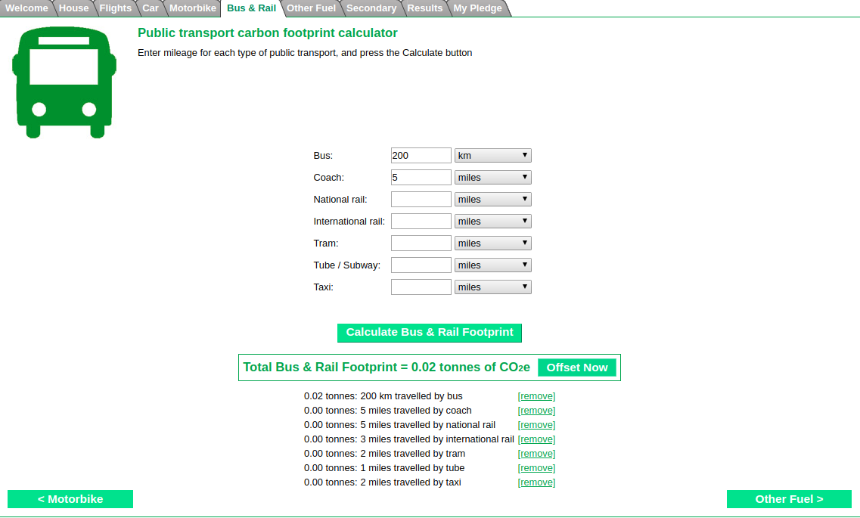
Image below of Public Transport tab (Note measurements and excessive input) :

Scenario 2: Navigation:
Andrew is interested in researching and further understanding how he could decrease his carbon footprint. Andrew is looking for important information that can be beneficial to his decrease. After some navigation he locates the information tab at the top of the screen. Andrew is familiar UI design and rather than an interactive website he is confronted with a basic page with text sizes, styling and positioning. Andrew doesn't mind this as he prefers functionality over looks but is concerned on the professionalism on the website.

He decides to check other tabs in case there's a more user-friendly area. He notices a lot of tabs are inconsistent with each other, some overwhelming with information and some not. Andrew soon gives up with navigating pages of information as he prefers small summaries and conclusions.

Problem:
The pages are not consistent with each other and have a different layout, which is unappealing and messy for users. If you’re designing a tab-based system on your website, it needs to have less options when having a drop-down menu. In the picture below, we can see there is 7 options for Offsetting, which is an excessive amount of navigation for the user.

Why is this a Problem:
Users like Andrew tend to have a low attention span even if they are interested in learning about a subject. It’s part of the UI design to keep them interested and hooked in the website. Users like Margaret are more likely to sit and read a few of these pages but because of the information overload it can be hard for anyone to want to learn in depth about Carbon Emissions.

Solution:
Make accessibility of the different information easier, with a decreased amount of options. combining similar pages into the same tabs.

Image below of Home page :
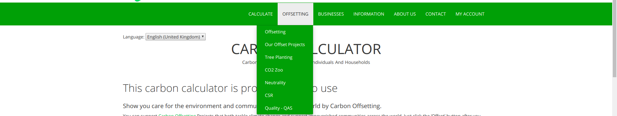
Persona 2 : Modest Margaret

System Requirements for Modest Margaret:

Scenario 3: Signing up to the website:
Margaret is trying to sign up for the Carbon Calculator website so she can record her CO2e emissions over a period of time. She locates the sign in button after small amounts of frustration but gets confused when going to create the account. After clicking on the create account button the website throws an error, telling her she hasn't entered her email correctly. What she doesn't realise is that the Sign Up and Login page are conjoined and after entering her details she must ignore the automatic response of clicking the green button next to her information. She must navigate to the lower right side of the screen and click the create account button after entering her information, or another error will be thrown.

Margaret not being familiar with poor website design believes she’s entering her information incorrectly. She then has to ask her son to navigate the website for her and enter her details. She then gets sent a confirmation email with an auto-generated password from the website instead of her own. Margaret then decides that this is too much effort and would rather look for a better alternative.

Problem:
The main concern with this layout is mixing the login and create account in the same tab. You must select the create account button in the bottom right section after entering your details. The entry section for both your email and password have a green sign in button. But you must ignore the usual spot for the create account button and navigate elsewhere. This is ridiculous website design structure and these 2 tabs should be separated into their own webpages and should clearly indicate its purpose.

Why this is a Problem?
Users like Margaret can be easily confused, this can lead to them quitting or giving up on the website. Margaret sees this as unprofessional and is put off the website and decides to find a more appropriate alternative that accounts for usability.

Solution:
Create separate tabs for each login and sign up page to create better user flow and functionality. Indicate clearly the function or activity that you are trying to present to the user. Websites such as this should not make the user figure out or guess how to use it. Instead, a good idea would be to simplify the website, using bigger text, separate tabs and summarisation of long text areas.

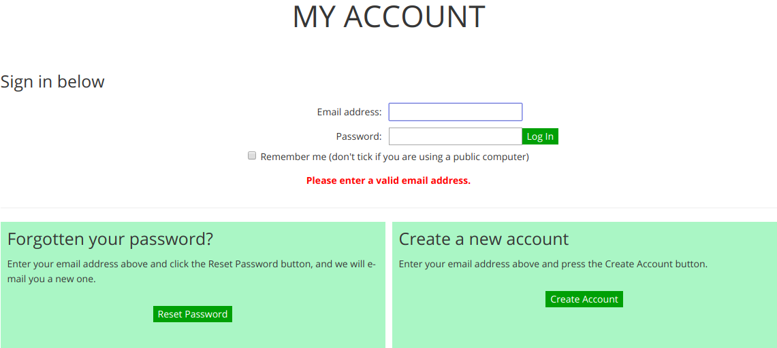
Image below of Login/Sign Up page :

Part 3 :

Link to the interactive Balsamiq wireframe : SWEN303 A2

Design
1) Awesome Andrew – Calculating his carbon transport footprint (Signed In):
Navigation of this wireframed website is more efficient for Andrew as he can understand and follow basic links to selecting the transport tab. If we have a look at the wireframe, we can see that he is is not shown his weekly saving on emissions before entering his information. If this information was not entered for the week, he would be more inclined to calculate his impact on the enviroment as we give him a simple system of comparing previous results. Turning the original boring interface into a more interactive website for its users. This attracts new and old users to the website, regardless if they have already established their CO2e emission savings.

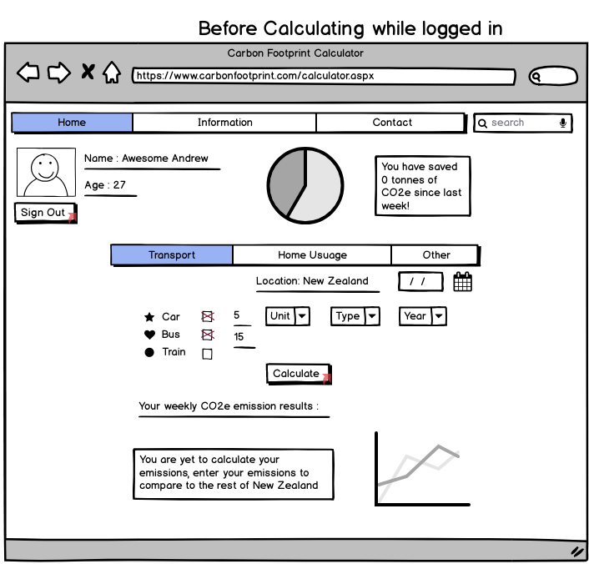

After entering the required fields and units, Andrew can calculate is CO2e emissions. From this he will get updated information telling him how he compares to the rest of New Zealand and his overall CO2e released for transport weekly (In the picture below). From this, he has a more accurate result because of the better unit measurement and is more inclined to compete against the rest of his country.

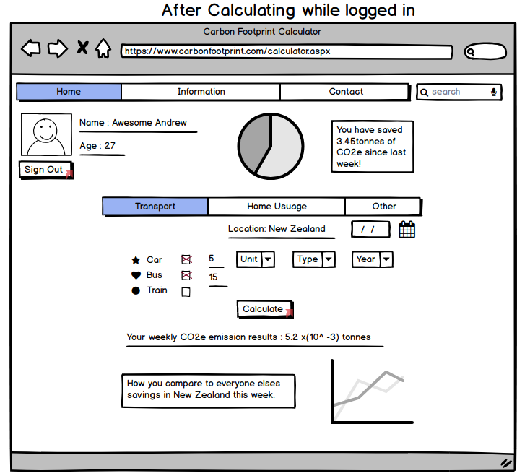
Modest Margaret – Sign in to the website:
Navigation

Part 4 :

Reflection

Persona Reflection
From persona generation I have learnt many techniques which helped me empathise and understand User Groups in more detail. During this process, I was able to create individuals Margaret and Andrew, this was done through User Abstract Representation. I extracted characteristics and attributes that apply to certain groups and narrowed down specific elements that make these user groups. I then summarised these into 2 advanced selective groups to then be transformed to my personas.
This is where I created behavioural variables of my personas to further represent how they would act in certain situations later (Scenarios) . In creation of this I conducted user research before refining and condensing them into a individual persona. Through this technique I have learnt to care for all users of different demographics, ethnicities and cultures. This ties into on the worldwide orientation of the website and how it should apply simple functions like currency conversion for its users. I was able to empathise with users and their issues with UI Design through my created personas. This was because of the differences in characteristics and attributes of my personas. To conclude, these techniques were necessary for development and creation of my abstract personas. I was able to target certain groups more precisely through these techniques and was able to empathise and understand frustrations of users faced with different UI Designs.

Scenario Reflection
For creating my scenarios, I took the main operations of the website and made scenarios that implemented my personas in them. I learnt how other users may access or struggle with some website designs. I understood and analysed small details that could throw users off as well as keep users interested in your website. From the essential use cases I created I had to learn how these scenarios would portray on both the User side and the System side. The UML diagram also gave a better visual representation of the user flow alongside this system. Throughout the scenario section I used context scenarios to better represent the differences between my personas and how they access the website. This relates to the primary and secondary design requirements that I implemented as part of my scenarios to further relate to my personas. In conclusion of my scenario reflection I made assumptions of how users would act based off my personas. I also extracted key problems that many users would face on the website (including myself) and conducted the scenario with this problem. This allowed me to understand and think about the UI Design of the website in a different light by acting how my persona would approach these complications on the website.

