Requirements:
- Arduino IDE (download from http://www.arduino.cc)
- Arduino Mega 2560
- PuTTY Terminal (download from http://putty.org/)
- [Optional] LCD/Keyboard Shield for Arduino

Steps:
0. Unzip the Arduino code to your preferred location.
Upload Arduino Code:
1. Connect Arduino Mega to computer.
2. Start Arduino IDE and select correct Arduino COM PORT under menus: (Tools / Port).
3. Open "kz80_efex.ino" and compile it (From menus: Sketch / Verify-Compile).
4. Upload sketch next (From menus: Sketch / Upload).
Plug RetroShield:
5. Disconnect Arduino Mega from computer.
6. Plug RetroShield to Arduino Mega.
7. Ensure header pins are aligned correctly.
8. Connect Arduino Mega back to computer.
Start Terminal Program:
9. Start Putty Terminal Program.
10. Find the Arduino COM port from Arduino IDE, menu Tools/Ports. (You will see something like COM3, etc.). Enter this number in the Serial Line entry:

Serial Line = COM3
Speed = 115200
Connection Type = Serial
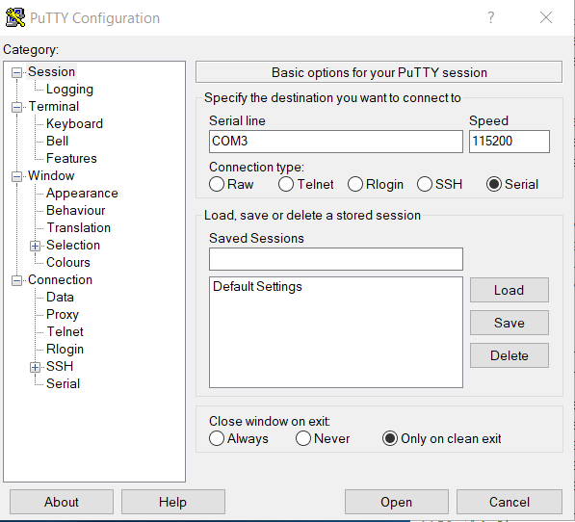

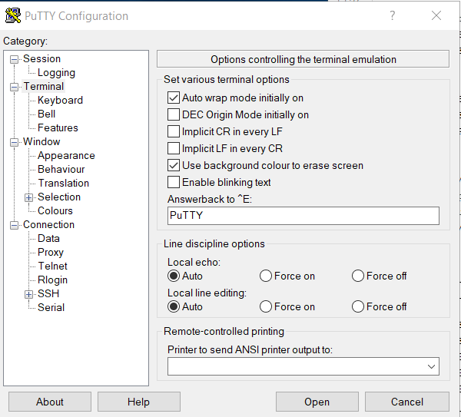

11. Click Open.
12. You should see the initial message from monitor program:
EfexMon By M.PEKER v1.0b
Press H for help
Ready.
C:>

13. type H to print a list of available commands (need to type uppercase for now):
A-Assembler
D-Disassembler
L-Load
S-Save
E-Edit
W-Warmst
M-Move
X-Hexdump
G-Go
F-Fill
U-Routines

14. type A then F000
15. type NOP [ENTER] NOP [ENTER] RET [ENTER]. Be patient after pressing ENTER.
16. hit ESCAPE
17. type G then F000
18. you just executed your first program :)

