Imports KPI’s





Delay Percentage
35.3%
60 of 170 delayed (MTD)
Demands in Process
1
Near-zero backlog
799.9% efficiency (MTD)
169
Total Demands Processed
Total Import Spend
Rs 882M
MTD By Default

Total Demands Received
170
MTD By Default

Supplier Spend & Cumulative Contribution (Rs M · %) MTD By Default
The below chart needs to be updated as per the Category Delays not the one that you see now.

Stores and Logistics
Main KPI’s
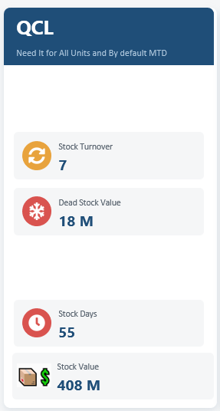
Purchase vs Issuance by Category (Rs Millions)

Logistics

71
Total Dispatches


850 Tons
Total Weight Dispatched



13
Delayed Dispatches
58
On-Time Dispatches


81.7%
On-Time Delivery %

Total vs On-Time vs Delayed By Sector or Segment (MTD By Default)

Container Type Usage
Customer-Wise Delay (Days Delayed >7)







Logistics (Packing)
422
Total Packages
1.74M kg
Total Weight
Rs 11.52M
Total Quoted Cost
Rs 9.48M
Total Actual Cost
Rs 2.05M
Total Savings
Rs 5.44
Avg Saving per Kg

Trucking (Logistics)
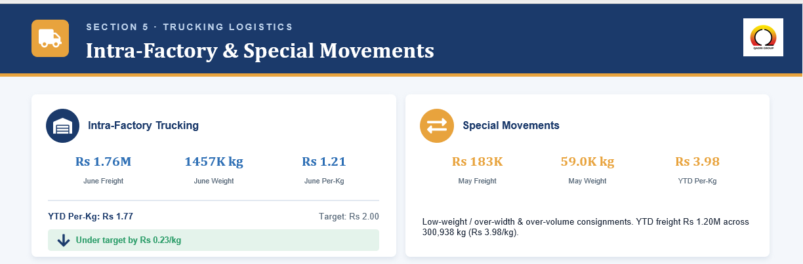
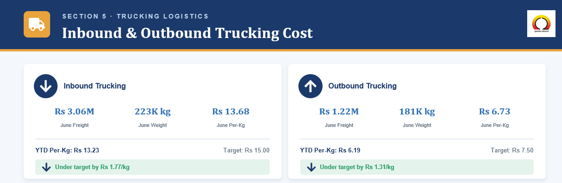

Local Procurement (Need to Set all the KPI’s and charts for Month to Date)
- Total Purchase Quantity
- Total Value (PKR)
- Purchase Delay (Take AVERAGE of Required Date – Purchase Date)
- On Time Rate (%)

