Laboratory work 6
Submission format: word or pdf document containing screenshots of your tasks with answers that covers full-page (Alt+PrtSc).

JOIN operations tasks

- Write a query that displays all flights of a specific airline.
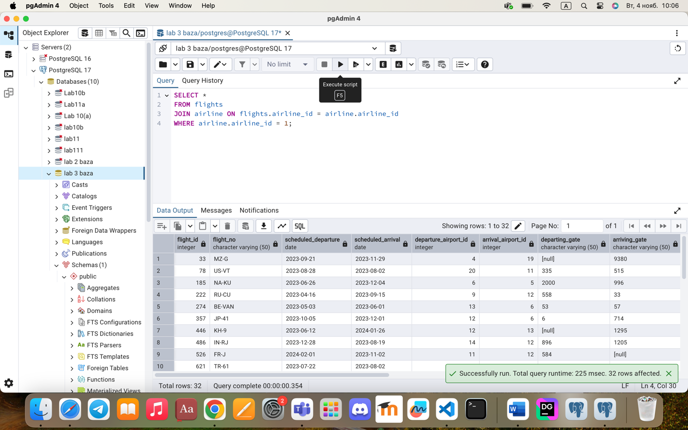
- Compose a query to obtain a list of all flights with the names of departure airports. 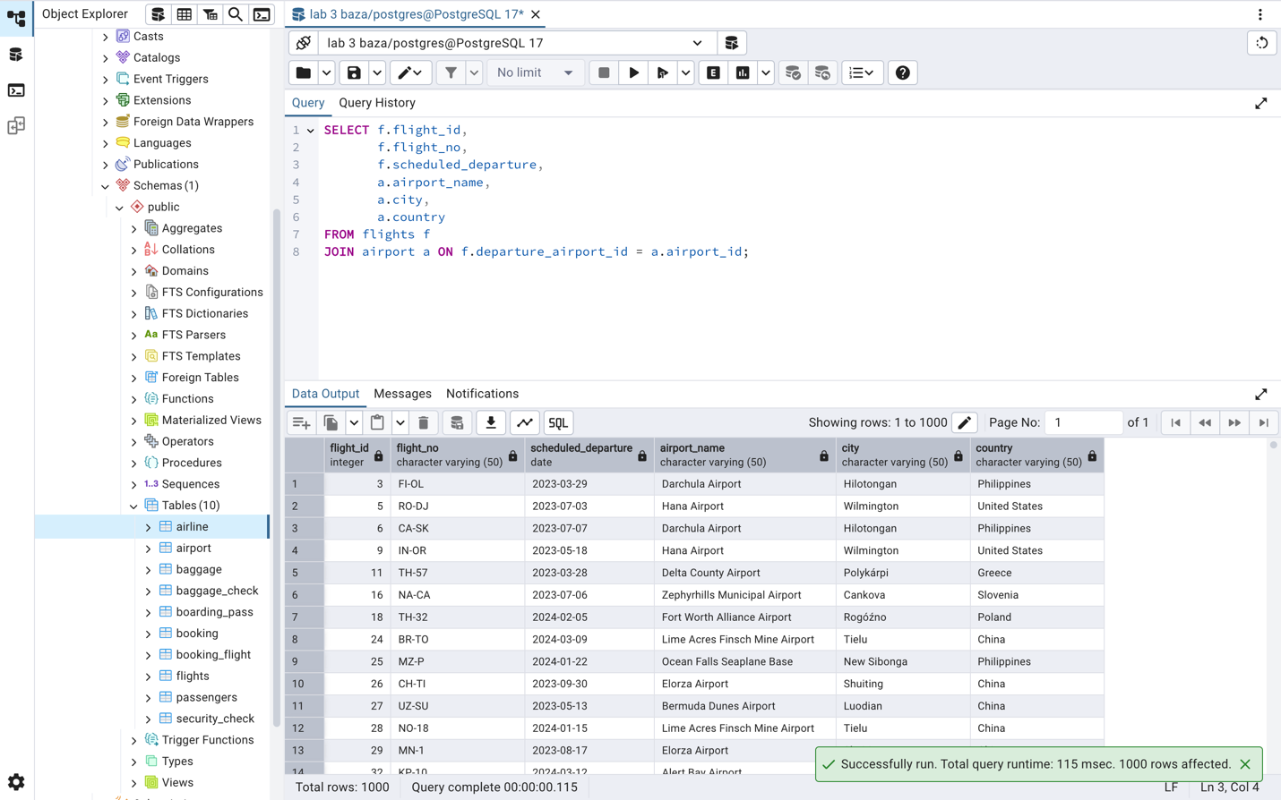
- Create a query that finds all airlines that have no flights scheduled for the next month. 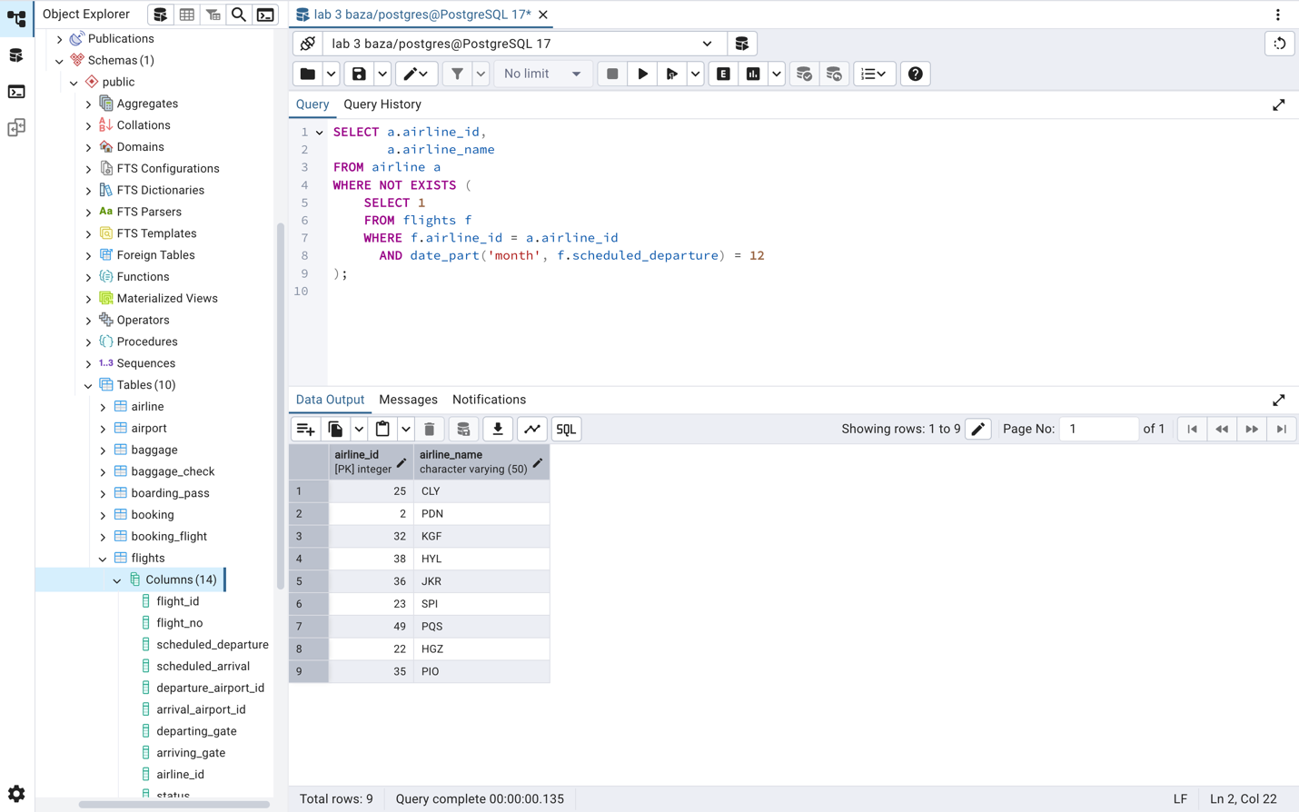
- Create a query to display a list of passengers on a specific flight. 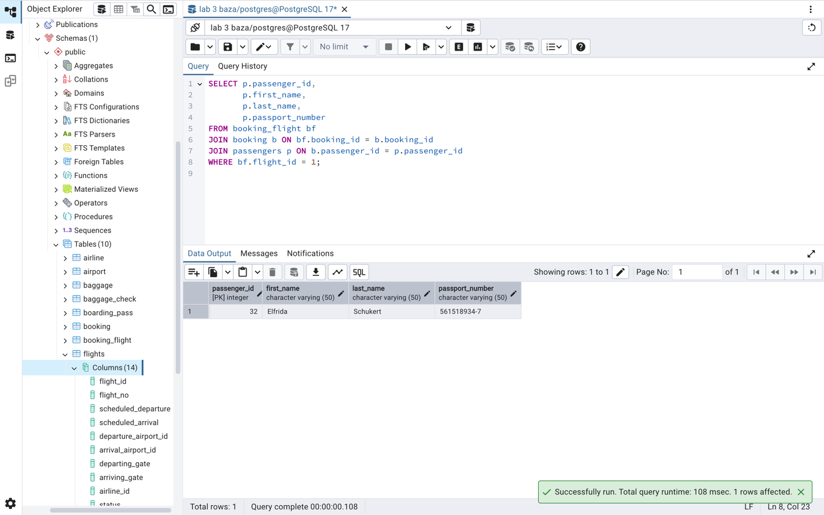
- Write a query that calculates the average, total, maximum and minimum price of tickets for each flight.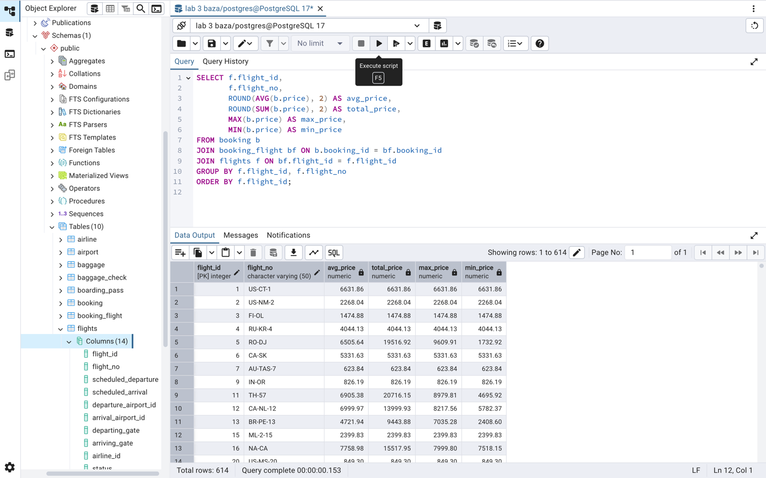
- Create a query that shows all flights flying to a specific country by combining flights, airports and airline, and using the condition on the country name. 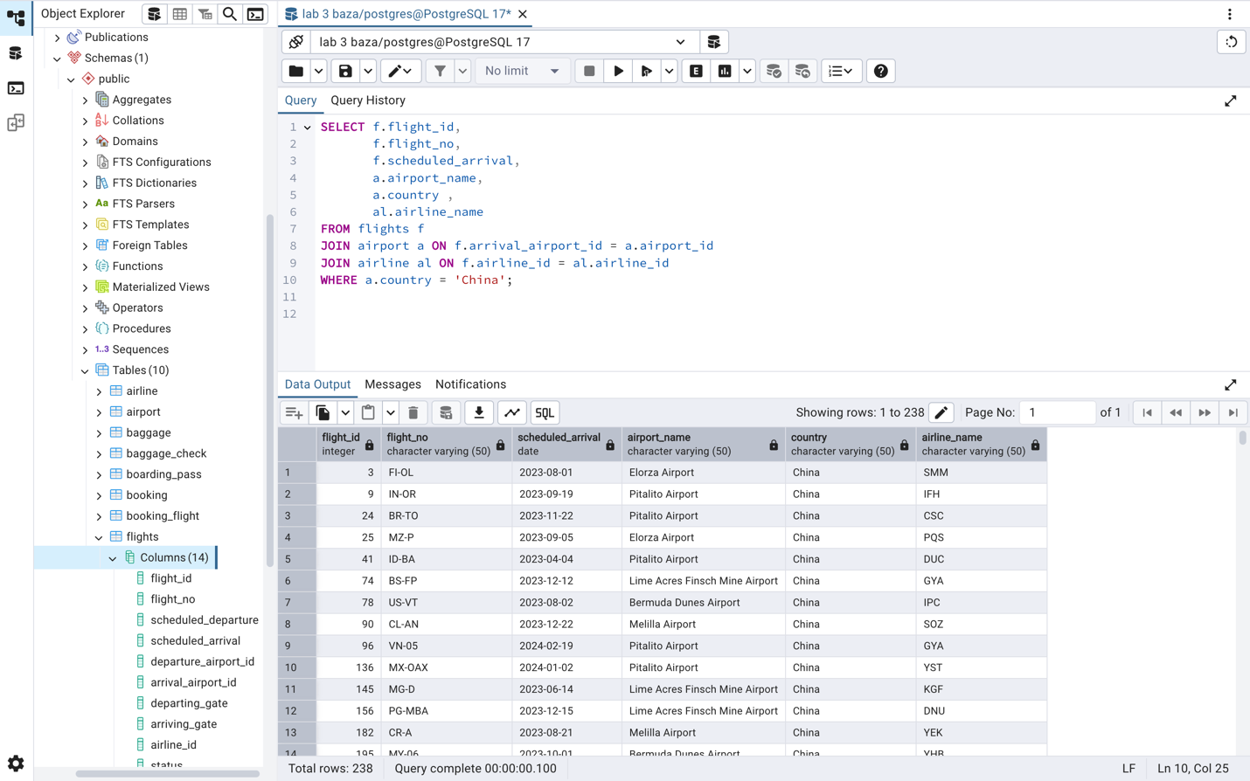
- Display a list of minor passengers and their arrival destination.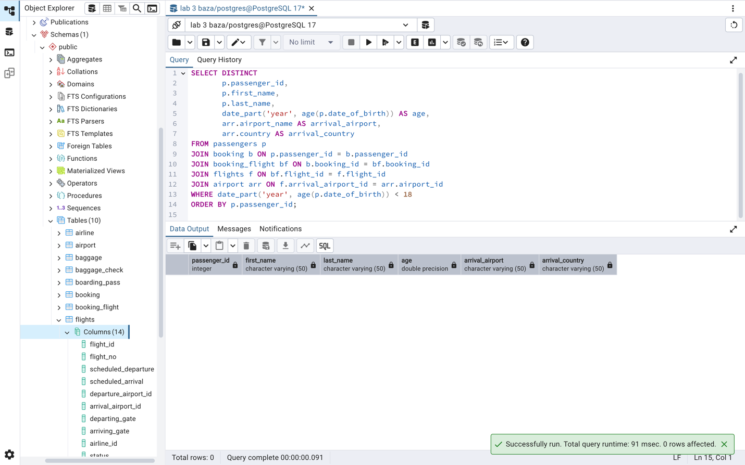
- Display the passenger’s full name, passport number, and the passenger’s current time of arrival at the destination.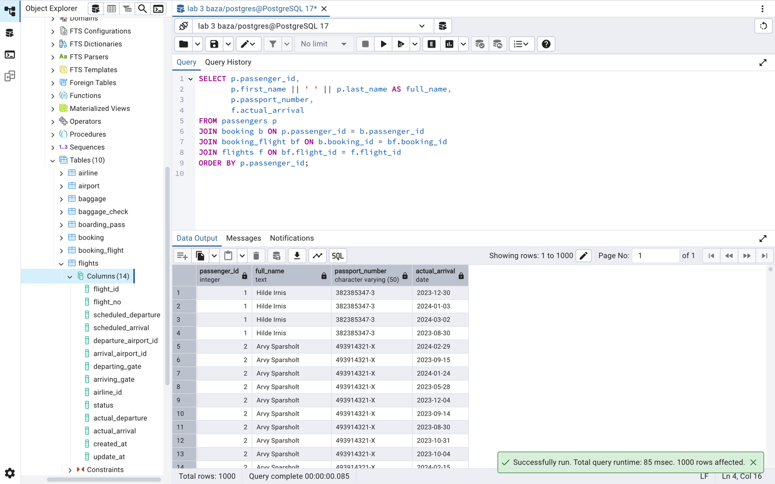
- Print a list of flights where the airline's home country and origin country are the same.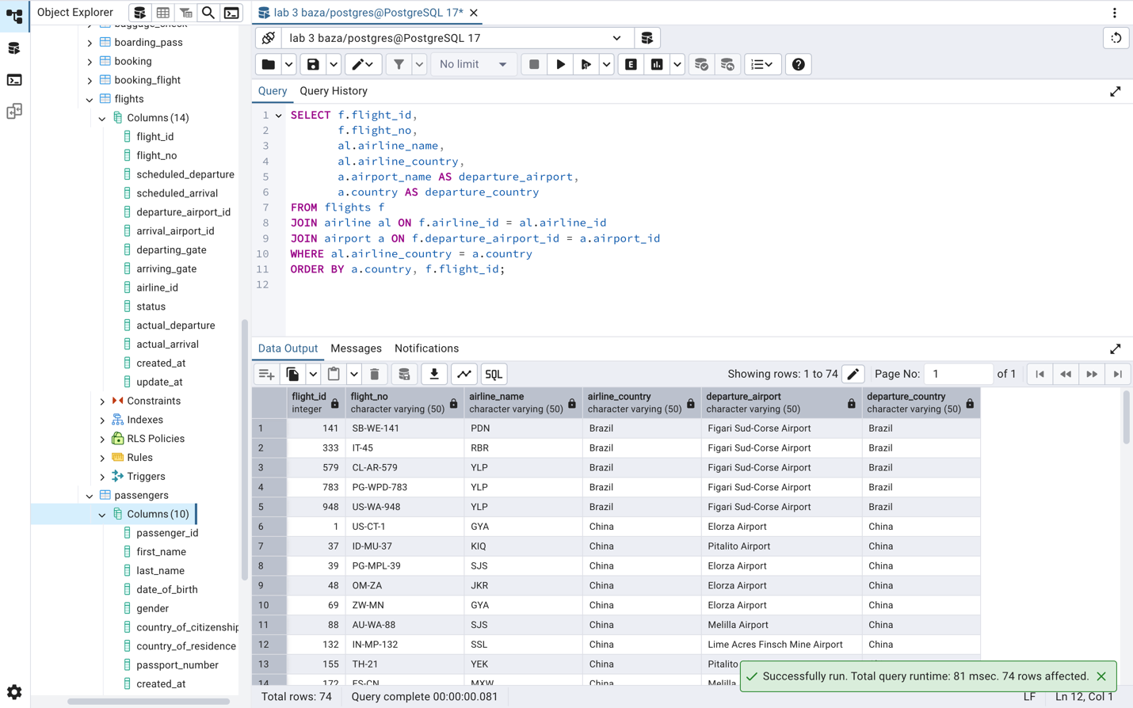 Group them by the airport country.