<https://www.techradar.com/uk/news/best-web-design-software>

A web design juggernaut but possibly overkill for some

Abode Dreamweaver CC

£21.60

/mth

?

[Visit Site](https://adobe.ly/2LRAiebF)

[at Adobe](https://adobe.ly/2LRAiebF)

Very popular web design tool

Suitable for all levels of expertise

Sheer amount of features can be confusing

[Dreamweaver](https://adobe.ly/2LRAieb) is one of the best-known web design tools on the market and has been around in various forms since the turn of the century. The latest iteration of Dreamweaver is available as part of Adobe’s Creative Cloud suite for a fixed monthly fee of €24.59 (£21.60, $28.80).

The tool has a broad appeal to both novice and advanced users. When you first launch Dreamweaver, you'll be asked to choose between 'beginner', 'intermediate' and 'advanced' skill levels. These help to determine the number of features shown to you, and whether you’ll be given options to perform more complex tasks like building a site from code.

Aside from a refreshingly designed and powerful interface, Dreamweaver supports virtually any type of web code from basic HTML to CSS, PHP and JavaScript to name just a few. If you are not quite ready to edit raw code, Dreamweaver supports WordPress and Drupal templates.

Other advanced features include a 'live view' for previewing websites as well as support for certificates and a dedicated workspace for developers. If you're making your first venture into programming sites, Dreamweaver also offers tips for improving your code.

The general consensus from user reviews is that while this web design tool is amazingly flexible, the arsenal of features can be truly overwhelming. Fortunately Dreamweaver offers a free trial, so take some time to experiment and see if it's right for you.

<https://www.pickaweb.co.uk/blog/top-web-design-software/>

[**Dreamweaver**](https://www.adobe.com/in/products/dreamweaver.html)

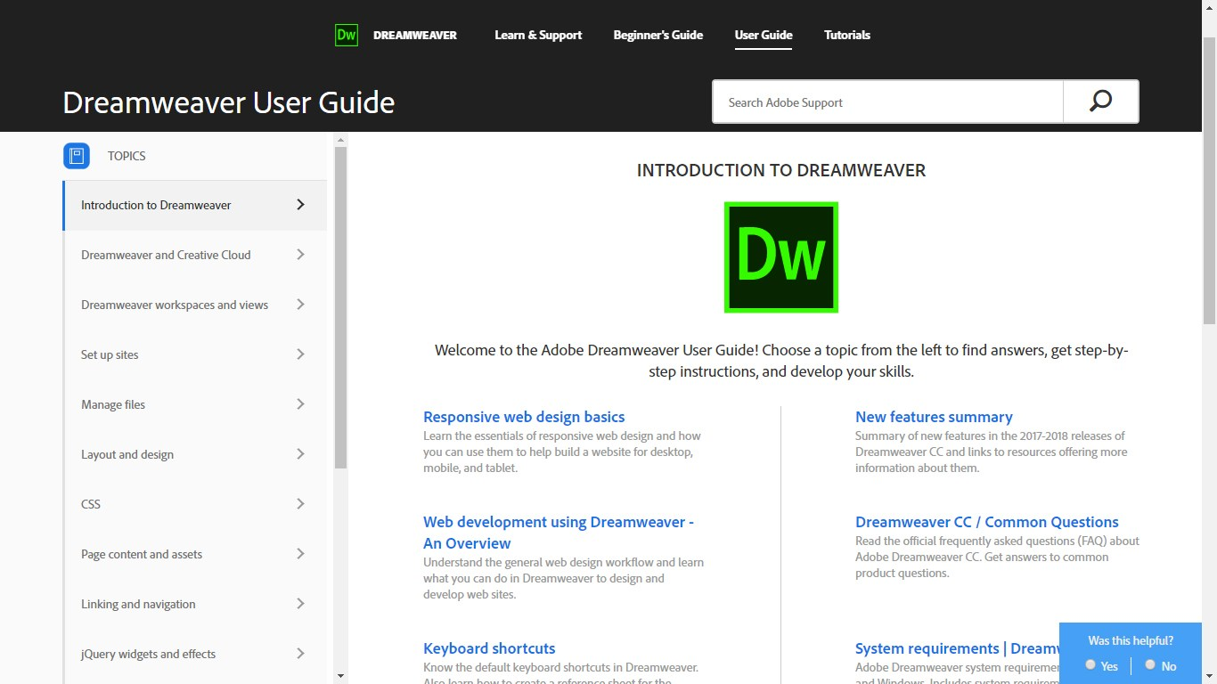

Adobe Dreamweaver is a popular web application that is widely use by web developers and designers.

It is a WYSIWYG editor (What You See Is What You Get) which means that while you work on designing a website in Dreamweaver, it does all the coding in the background for you.

The main benefits are:

* A hand-coding environment for writing and editing HTML, JavaScript, and any other kind of code
* A design environment for visual page layout, visual editing, and application development
* Live view displays a more realistic representation of what your document will look like in a browser, and lets you interact with the document exactly as you would in a browser
* HTML elements can be edited directly and previewed instantly in the same view

<https://uk.pcmag.com/web-hosting-services/42131/the-best-website-builders-for-2019>

<https://uk.pcmag.com/web-hosting-services/34506/wix>



# The Best Website Builders for 2019

* [Review](https://uk.pcmag.com/web-hosting-services/34506/wix)
* [Comments](https://uk.pcmag.com/web-hosting-services/34506/wix#disqus)
* [Specs](https://uk.pcmag.com/web-hosting-services/34506/wix?specs)



[Free TrialVisit Site](https://uk.pcmag.com/web-hosting-services/34506/wix)

* **Pros**

Extremely intuitive site-building interface. Loads of site gadgets. Free site option. Hundreds of templates for specific businesses and other uses. Good mobile site building tools. Rich Web store features.

* **Cons**

No built-in statistics feature. Sites don't use responsive design in the strict sense.

* **Bottom Line**

Not yet reviewed by editors.

Michael Muchmore

[](https://uk.pcmag.com/cyberlink-powerdirector-14/92018/feature/the-best-products-of-2017)If you want to get a website online with a minimum of effort and a maximum of creative latitude, look no further than Wix. Its interface is the most intuitive, slick, and powerful of the growing group of [website-building services](https://uk.pcmag.com/web-site-hosting-services/42131/guide/the-best-website-builders-of-2018) we've tested. It offers standout features such as online storage for your site assets, cool video backgrounds, animations for titles, and mobile apps. A free account option, a gallery of third-party widgets for your site, and strong blogging and commerce features round out this Editors' Choice website builder. As if that weren't enough, the new Wix Code feature lets novices and programmers alike build dynamic web applications.

**Getting Started With Wix**

The only thing Wix requires for you to get started is an email address. If you want a site with a custom URL, no Wix promotions, a custom [favicon](https://www.pcmag.com/encyclopedia/term/43037/favicon), and a web store, you must upgrade to a paid account. These range from the $5-per-month Connect Domain account, which merely lets you use a site address you already own, to the full $25-per-month VIP plan, which includes a shopping cart, 20GB of storage, domain name, unlimited bandwidth, professional site review, and priority support. For a full rundown of account types, see Wix's [premium account grid](http://www.wix.com/upgrade/website).

[[View Gallery](https://uk.pcmag.com/software/96395/gallery/wix)View All 17 Photos in Gallery](https://uk.pcmag.com/software/96395/gallery/wix)

That pricing is reasonable compared with [Duda](https://uk.pcmag.com/dudaone/35322/review/duda)[Free at Dudaone UK](https://uk.pcmag.com/web-hosting-services/34506/wix), whose paid plans start at $14.25 per month, and Squarespace and Weebly, which both start at $8 per month. Their top business plans are $22.50, $40, and $25 per month, respectively.

After creating an account, you choose whether you want Wix to automatically create a site for you using ADI (Artificial Design Intelligence) or to use a site template. More in ADI in a bit. Wix users can choose from 15 top levels, each with several subcategories to choose from. For instance, there's a Restaurant choice with subcategories for bar, café, catering, and more. For my first Wix test site, I used Photography > Travel Photographer. Clicking a big Go button opens a generous choice of templates. There are 15 beautiful template options just for that narrow field, including those for landscape, street, and portrait photographers.

In all, Wix offers hundreds of template choices, more than [Squarespace](https://uk.pcmag.com/squarespace/34505/review/squarespace)[£8.00 at Squarespace UK](https://uk.pcmag.com/web-hosting-services/34506/wix) or Weebly. The vast majority of these are free, though some require a subscription at the eCommerce level ($17 per month). Each template preview helpfully shows you how your site will look on a smartphone screen, too.

**Web Design in Wix**

After you've chosen a template and started editing your site, you're treated to a one-minute introductory video. Templates are modern and attractive, many pinning your navigation to the top as the site viewer scrolls down. Five round buttons that expand when you hover the mouse over them let you add elements, change the background, access the App Market (from which you get third-party site widgets), see your uploads, and start blogging. You can easily hide these controls if you need to edit the area under them.

Elements you can add include everything we've become used to on webpages. All the usual options for text, media, social media widgets, buttons, shapes, and so on are available, and you can find anything not in Wix's default selection in its App Market. You can also embed HTML and Flash code. You can easily add SoundCloud and [Spotify](https://uk.pcmag.com/spotify/19266/review/spotify) playlists to treat your site visitors' ears, too.

Editing the template design is dead simple. Just click on any element, and you see resizing handles and dragging buttons. You have a lot more freedom to place objects where you want them than in Weebly or Squarespace. Double-click on text, and you can edit and format it. As you move objects around, guides appear when they're in line with other objects, to help with alignment.

<https://www.expertmarket.co.uk/website-builders/wix-review#Review>

Wix Review 2019 

Wix is a **website builder** with a promise: *anyone* can build a website. No, really - ***anyone***. No prior tech or coding experience required.

This promise of simplicity has been exceptionally well-received by **businesses and individuals** alike. The numbers speak for themselves: Wix now boasts **110 million users** across 190 countries, and 45,000 new sign-ups per day.

But with competition among website builders becoming increasingly fierce, how does Wix match up? We took a closer look to decide whether or not it lives up to the hype.

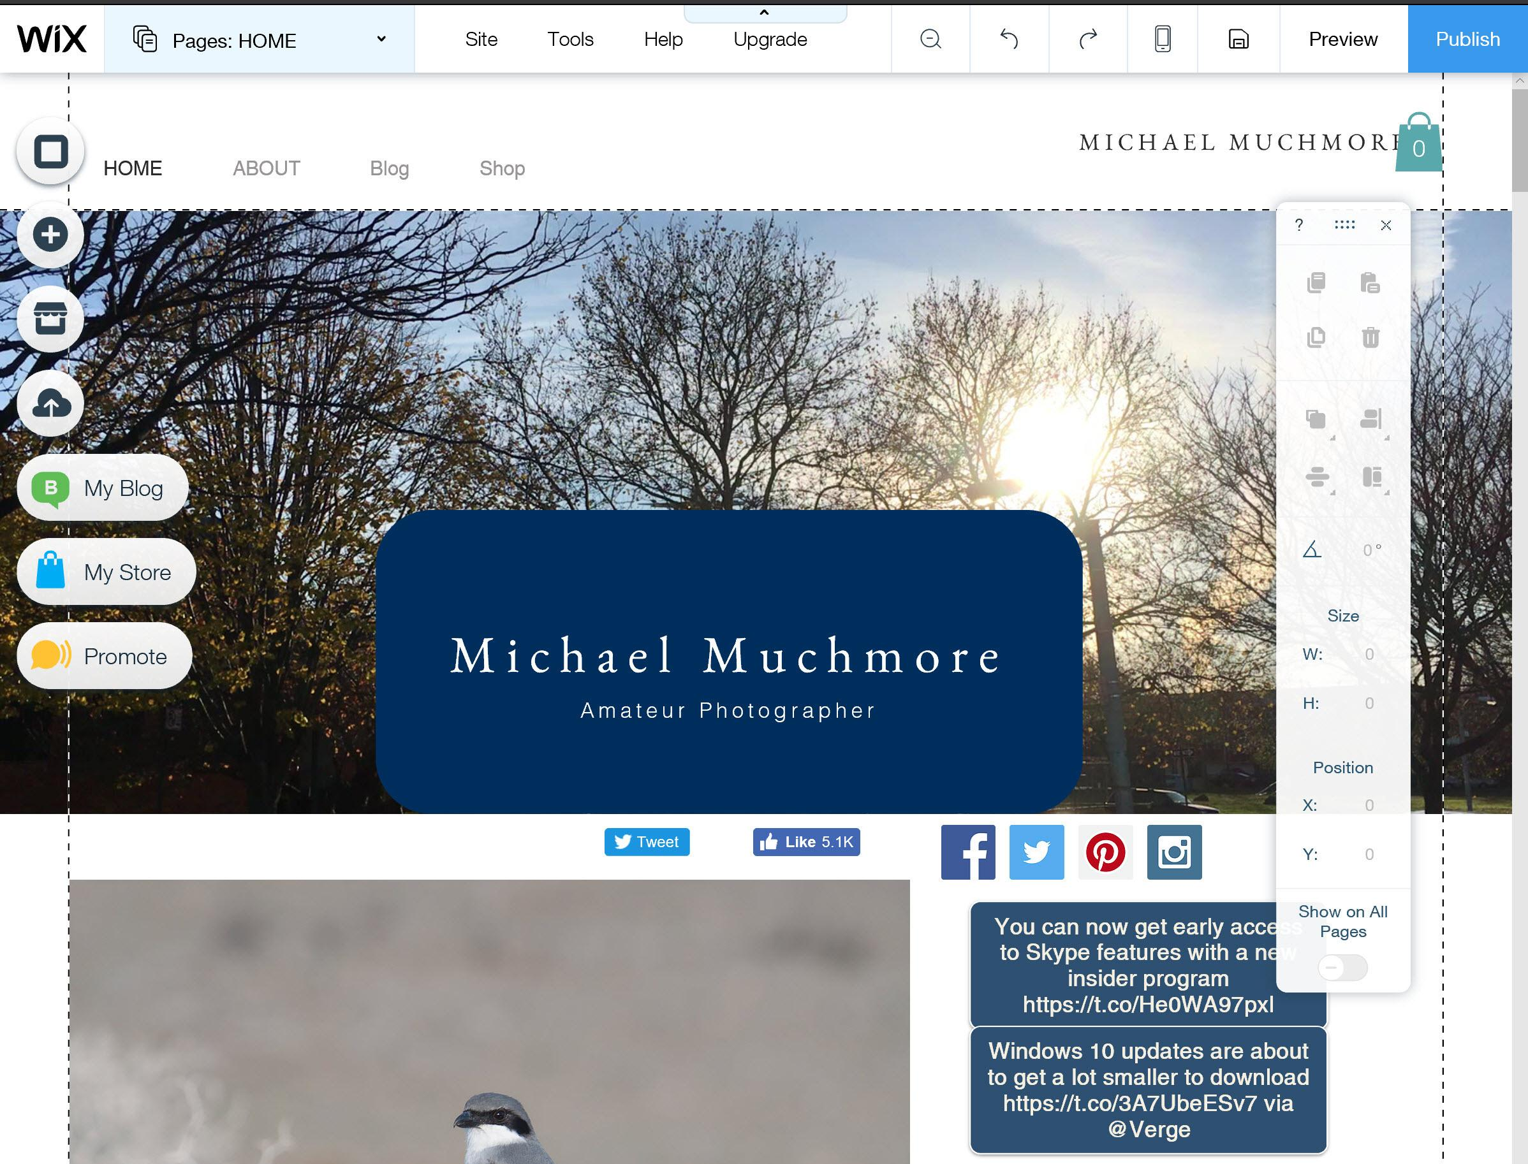

A toolbar on the right offers tools for sizing and arranging objects, including exact pixel sizes for objects, size matching, alignment, and overlap options. If you select than one object, you can move them together around the page. Any object can be animated on load, with effects like Bounce-In, Glide-In, and Spin-In. Nifty!

One thing about the Wix site-building interface that really impresses me is that it uses right-click context menus. Other builders like Squarespace and Weebly do nothing with right clicks, so right-clicking just brings up your browser options, which don't help with site building. Wix lets you change images or edit text that the mouse is over when you right-click.

You can customize page design to your heart's content, including the number of columns, their sizes, and their alignment. But unlike Squarespace and Weebly, Wix doesn't let you change the original template you chose at the outset. You can easily add new pages and drag them around to change site navigation hierarchy. Pages can be password-protected or require membership sign-up or sign-in.

The main account administrative interface is clearer than Weebly's, too, with a full page listing your sites. Click into one and the site dashboard appears with a side rail of site option buttons. You also see a feed of site activity, and there are buttons for common tasks.

One disappointment is the lack of included site-traffic reporting—a particular strength of Duda. However, you can use the Web-Stats app for free or set up a separate Google Analytics account (which requires a paid account level) for this functionality. Web-Stats is pretty informative, telling you where visits came from and what display, computer, and browsers visitors used—even for free users. Another option for paid sites is to add Facebook Pixel reporting.

**Wix Artificial Design Intelligence**

I tried using the Wix ADI to build a test local business website. It dramatically simplifies site building, it's fun, and it offers lots of hand-holding. You start by answering a few basic questions about the site's purpose, features, location, and title. It then searches the web for content related to your business or activity. You can optionally add social accounts such as Facebook, Instagram, and Twitter. After this you pick a style, have ADI create a color pallette based on your logo, and click Create My Site.

[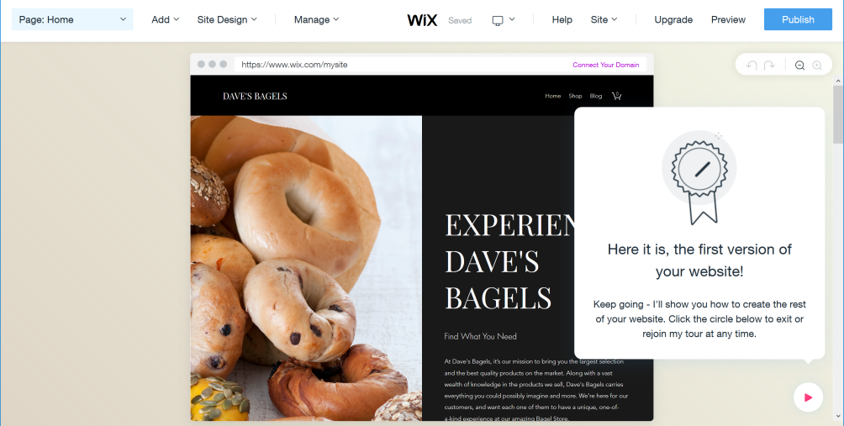](javascript:OpenImageWindow('https://www.pcmag.com/image_popup/0,1740,iid=581062,00.asp',%20'1004',%20'507'))

It can take some time to complete its automatic designing. It tells you what it's doing through the process, like adding menus and optimizing your mobile site. I tested using a local bagel shop's info, and ADI created a site that looks better than the place's actual site! I was also impressed when building a site for an artist friend, who was actually wowed by how good the automatic design was. After ADI builds the initial site, you customize things like boilerplate text and sales items. If you aren't interested in designing your own site, Wix ADI is definitely worth a shot.

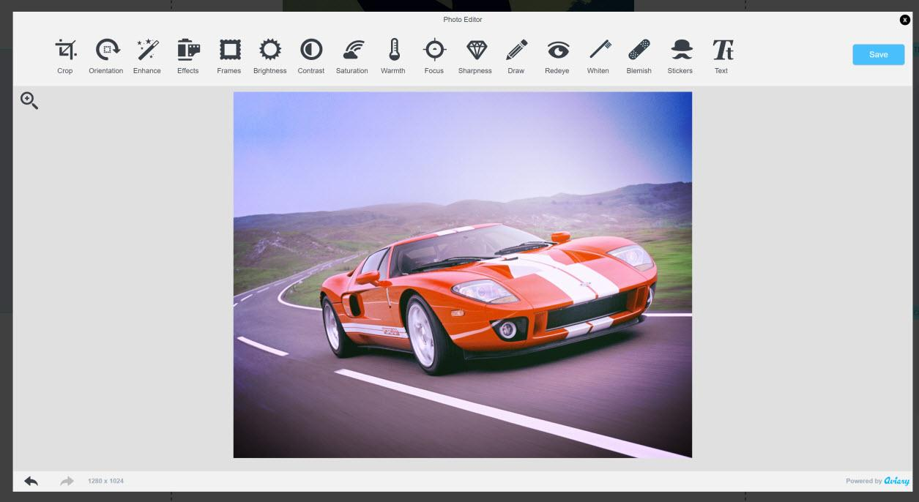

**Working With Photos and Videos**

Wix has a big advantage over Weebly and Squarespace when it comes to photos: It lets you reuse images you've already uploaded by saving them in online folders for you. The other services make you re-upload photos if you want to use them in another place on your site.

Wix also lets you add images from other online sources such as Flickr and Facebook. Ditto for videos. You can use video in places where the others only let you use photos, such as the main theme background. The service also provides lots of stock images and videos to use on your site. Much of this content is free, but you can also purchase stock images from BigStock, at reasonable rates.

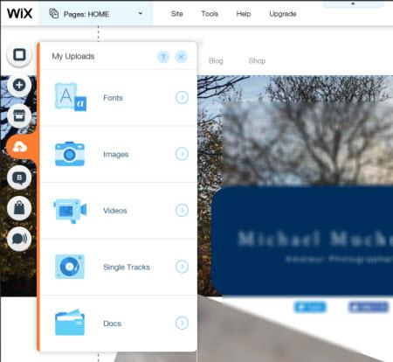

You get full [photo editing](https://uk.pcmag.com/photo-editing-reviews/8546/guide/the-best-photo-editing-software-of-2018) and enhancement capabilities with the integrated Aviary editor. And it's really easy to add a link to an image, either external or to a page in your site. You can also add a border, and animation such as a fade in, and choose among resizing behaviors such as autocrop, center, stretch, and fit.

You can set videos to auto-play on page load and to repeatedly loop, and as mentioned you can add a video as your background image.

**Making Money With Wix**

Wix offers rich [e-commerce](https://uk.pcmag.com/software/42210/guide/the-best-ecommerce-software) capabilities. The Store element from the main toolbar adds a Shop page with a product gallery pre-populated with sample products you replace with your own. You'll need an eCommerce premium plan to actually receive payments. The web store can have multiple pages of its own, including, by default, a product page, shopping cart, and thank you page. There's a detailed product-editing panel, and you can group products by collections, and offer coupons. Credit card processing options include Stripe and Square, and you can accept PayPal and snail-mailed cash. You can enter shipping and tax rules, but the built-in store doesn't help you actually figure these things out, say, with UPS or FedEx integration.

Selling digital downloads requires a paid third-party app from POWr or Sellfy. You can, however, sell music with no transaction fee through Wix's own Music app. There's even an app, Snapcard, that lets you accept Bitcoin payments. For marketing your goods, a Wix mail-blast app called ShoutOut lets you send up to 5,000 emails per month. Third-party integrations for email marketing are available from MPZMail, CakeMail, and V.I. Plus.

**Blogging Tools**

Adding a blog to your site is easy as clicking on the Blog entry on the main site element toolbar. You can design your blog page layout just as with any other site page, or choose a single entry style or one with no header. Subscriptions and comments are options for your readers. You can tag posts, and even display a tag cloud, RSS button, Facebook comments, and Disqus comments.

Wix has a separate, simple blog-posting interface, as opposed to Weebly, which just uses the same webpage interface for blogging. In Wix, you can add photos, galleries, video, and of course text, all formatted to taste. You can schedule any post for later publication and designate it as Featured if you like. In all, it's a rich blogging tool with everything you need.

**Mobile Sites**

Wix sites aren't *responsive* in the strictest sense (meaning you can resize a browser to see its contents squeeze to fit a smaller size), but that shouldn't worry site creators: Wix produces mobile versions of your sites that pass Google's test for mobile-friendliness. Tap the smartphone icon at the top of the site editor, and you can switch to mobile editing view.

By default, my site had the "Make your site mobile friendly" option checked, and because of this, I really didn't have to do anything to make it work well on phones. But Wix gives you the option of editing the mobile view if you're not happy with what it produces automatically. In particular, you can hide elements that you don't want to show up on mobile screens. You can also add a Mobile Action Bar so that visitors can email or call you with a tap of a finger.

On the other side of mobile, Wix now offers apps that let you interact with site visitors and edit store items like products and prices. You can also upload photos from your smartphone, but you can't actually create and edit sites from the app, as you can with Weebly and [Jimdo](https://uk.pcmag.com/jimdo-web-hosting/36788/review/jimdo)'s apps.

**Wix Code**

Wix Code allows site builders—even those with no programming experience—to add features to their websites that in the past would have required familiarity with database development. The feature is still labeled as beta, but is available in all Wix accounts. Wix Code consists of five tools—Databases, Dynamic Pages, External APIs, Forms, and Managed JavaScript.

[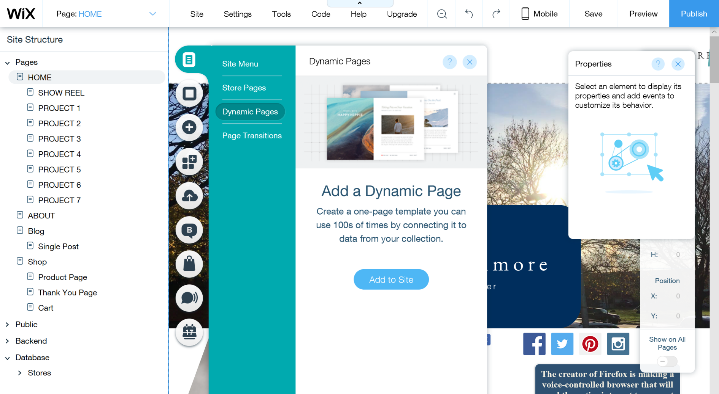](javascript:OpenImageWindow('https://www.pcmag.com/image_popup/0,1740,iid=580834,00.asp',%20'1891',%20'1039'))

Databases, Dynamic Pages, and Forms require no formal knowledge of coding. The use of these prefab databases is similar to filling in a spreadsheet. Custom forms and user input controls are useful for collecting information from site viewers. A food site could let users submit recipes, for example.

Data-driven Dynamic Pages sound like they're for developers, and indeed, using these capabilities increases difficulty of site design quite a bit. But really it just means that your site pages are built on the fly depending on entries in a table. A college course page designed in Wix can display different pages for each course, all using the same template. Duda's InSite feature, which lets you send different content to viewers depending on criteria like time of day, date, location, and number of previous visits, offers similar dynamic customization. The Duda feature is simpler to use, but it's not as powerful as Wix Code is.

Wix also includes new API and JavaScript features that let actual web developers use Wix to design sites and then go under the hood to extend functionality. They can do this via a fully managed JavaScript development environment and by calling external APIs to leverage web services and augment site behavior.

[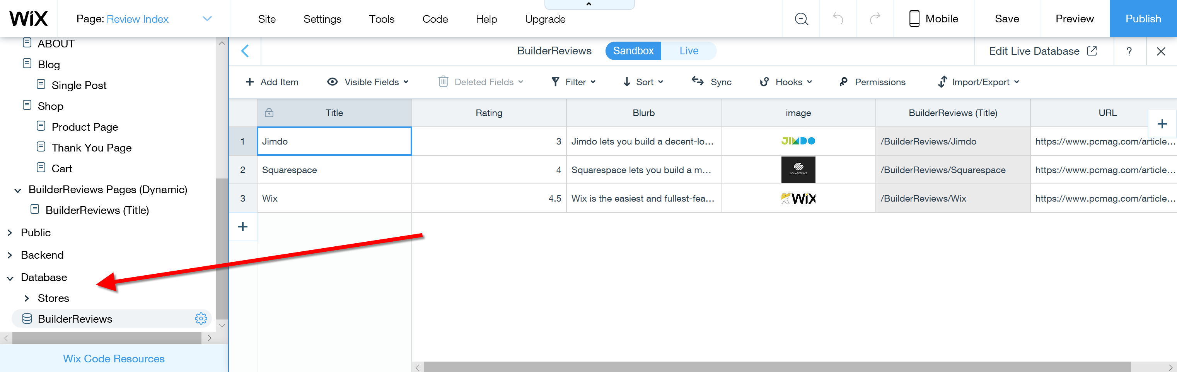](javascript:OpenImageWindow('https://www.pcmag.com/image_popup/0,1740,iid=580837,00.asp',%20'3044',%20'965'))

When I first tapped the Wix Code menu, a panel appeared with an explanatory video and links to resources to get going with the feature. It does indeed add complexity to the site-building interface, adding Backend and Database entries to your Site Structure sidebar. From those, you can add modules and collections, respectively. The latter are similar to spreadsheets in which you add specific types of data, such as images or text.

A wizard helps you fill in the info necessary to create a usable collection, to enable things like dynamic pages, forms, or member-generated content. You can either add dynamic content to a page, dynamically created pages, or index pages drawing from the database. Though all of this is indeed powerful, it moves Wix away from the easy site builder category to being a developer tool. Those who prefer to keep things simple don't ever have to turn on these developer tools. I managed to create dynamic pages with an index to a few of my reviews, and while there are a few hoops to jump through, it wasn't impossible, though database-driven pages on my test site loaded slower than I'd like.

**Wix Support**

Since Wix is one of the more intuitive site builders around, there's a good chance you won't need to contact the support team. The Wix editor displays a question mark at top right that gets you to its well-stocked Help Center. If that doesn't get you the answer to your problem by submitting a support ticket or requesting a phone call back (Monday to Friday from 5 a.m. to 5 p.m. Pacific Standard Time). That service is, impressively, even available to free accounts. [WordPress.com](https://www.pcmag.com/article2/0,2817,2531714,00.asp), on the other hand, only offers its free users access to a knowledgebase.

When you first contact support, a chat bot gets your site info and takes you through logical steps to remedy your problem. When you get to a point where the text robot can no longer help you, you see a Contact Us area, with two options: Submit a ticket, and Talk to a Support Agent. Of course I chose the latter. You enter your phone number (I used my Skype In number rather than my real number) and a description of the problem. I made my initial request at 4:36 p.m., and I received a callback at 4:39.

Customer service representative Maurico talked me through the fairly easy process of changing my [CNAME record](https://www.pcmag.com/encyclopedia/term/39892/cname-record) on the domain provider's management page to match what Wix uses. Even though I acted slow and bumbling, Mauricio stayed with me and we accomplished the transfer successfully. Wix is to be congratulated for its combination of thorough online support and real human support.

**Wix Has All the Tricks**

For ease of site building and breadth of options, you can't beat Wix. If the ability to export site code and a need for true responsive design are priorities for you, you may want to go with Weebly or Squarespace instead. But Wix offers the most when it comes to building your site the way you want it.

The optional new Wix Code feature, while adding a degree of difficulty, also enables more powerful, modern, dynamic site creation. All that, plus online storage of your media, a large third-party gallery of site additions, and a clear, well-thought-out interface keep Wix a PCMag Editors' Choice for online website builders, alongside with the also-excellent Duda.

For tips on getting started building your site, make sure to read our primer, [How to Build a Website](https://uk.pcmag.com/internet-products/8476/feature/how-to-create-a-website).

**Wix**

Excellent

…………………………………………………………………….

<https://www.expertmarket.co.uk/website-builders/wix-review#Review>

# Wix Review 2019

Wix is a **website builder** with a promise: *anyone* can build a website. No, really - ***anyone***. No prior tech or coding experience required.

This promise of simplicity has been exceptionally well-received by **businesses and individuals** alike. The numbers speak for themselves: Wix now boasts **110 million users** across 190 countries, and 45,000 new sign-ups per day.

But with competition among website builders becoming increasingly fierce, how does Wix match up? We took a closer look to decide whether or not it lives up to the hype.

## Features

### Templates

Wix has over **500 professionally designed** [**templates**](http://wixstats.com/?a=10455&c=2149&s1=&s2=EMUK&s3=wixreview&s4=CTA) **to choose from. They have helpfully categorised them into the best templates for the following:**

* Business
* Online Store
* Photography
* Video
* Music
* Design
* Restaurants and Food
* Accommodation
* Events
* Portfolio and CV
* Blog
* Health and Wellness
* Fashion and Beauty
* Community and Education
* Creative Arts

The way Wix categorises its template designs is a huge bonus - it really helps to narrow the search and ensure businesses **remain on trend** within their industry. All templates are **free to use**. You can see their full portfolio [**here**](http://wixstats.com/?a=10455&c=2149&s1=&s2=EMUK&s3=wixreview&s4=CTA).

### Apps

In addition to a great selection of templates, Wix also has an extensive collection of **200+ apps** that can be added to your website. These include **social ‘buttons’** to easily link to your social media accounts, the option to add a **mailing list sign-up** and **Google Adsense** (to display paid adverts on your site).

What’s more, most of these apps are still available to those only using the free Wix model. This is testament to Wix’s commitment to their customers of all pay grades.

[](http://wixstats.com/?a=10455&c=2149&s1=&s2=EMUK&s3=wixreview&s4=CTA)

## Ease of use

### Drag and drop interface

Wix’s **drag and drop interface** is the key to its ease of use. It essentially allows you to add images and other assets to your new site by dragging them from a folder in your computer, and then ‘dropping’ them on the new site. You are then free to play around with sizing, filters etc.

### Wix SEO Wiz

All Wix websites are **‘Search Engine Optimised’**, meaning they are highly compatible with Google and other search engines. This means you don’t need to worry about appearing lower in Google searches with a Wix website than you otherwise would. In fact, Wix is the only **website builder**, aside from Wordpress, to be mentioned in the Google Webmaster Guidelines. This doesn’t mean that other website builders aren’t Google compatible, but it shows that Wix is definitely a safe bet..

Best SEO practices is a really broad and ever-evolving topic. Wix has developed the Wix SEO Wiz with this in mind. With the SEO Wiz, you can easily navigate the treacherous SEO waters with your own personalised plan to help make the most of your content.

### Helpful extras

Here are a few other ways that Wix makes life easy for its customers:

* Websites are **mobile friendly**, meaning you don’t have to worry about alienating your mobile audience
* They offer a huge selection of free, **high quality stock images**
* **Unlimited web pages** allow your site to grow as you do
* All-in-one management allows you to track orders, receive payments etc. **all in one place**

## Getting started

Signing up to Wix is **incredibly simple**. With only a couple of basic details, you have created an account and are free to choose a template to play around with. The template below is **‘Success Coach’. Don't worry about the seemingly endless amount of customisation options - each comes with a concise explanation to help you get to grips with it.**

## Help and support

### Wix ADI

Less of a creative type? Don’t worry, Wix has you covered.

[**Wix ADI**](http://wixstats.com/?a=10455&c=2149&s1=&s2=EMUK&s3=wixreview&s4=CTA) (Artificial Design Intelligence) is Wix’s **pioneering artificial intelligence software** that will design a stunning website on your behalf. It learns about you, and applies this knowledge to create a completely unique site that is perfect for your needs. Sound like your ideal solution? When you first register for your new site, choose to build it using ‘Wix ADI’ rather than ‘Wix Editor’. You can switch to the Editor at any time, and then return to the most recent ADI version of your site using the ‘Site History’ option. Find out more about Wix ADI [**here**](http://wixstats.com/?a=10455&c=2149&s1=&s2=EMUK&s3=wixreview&s4=CTA)

### Online guides and video tutorials

If you get stuck at any stage in the website-building process, check out the support centre. Their **comprehensive online guides** and **YouTube video tutorials** cover a huge variety of material, from **advice and FAQs** to **troubleshooting**.

If you have an issue that isn’t explained, you need only Google your query to receive a myriad of advice from other users. That’s the great thing about using a **website builder** with such an **established user base**; you have a **readymade community of like-minded people** to learn from.

## Prices

Many people are still surprised to find out that you can create and manage a great website using Wix **completely free of charge**. It’s true - Wix operates a **‘freemium’** payment model, giving you the option to use their most basic service for free or to upgrade for additional benefits.

If your website is anything more than a hobby, it is definitely a good idea to upgrade to a paid Wix plan. Not only will you be able to access great additional features (see below) and the most exclusive apps, but crucially your site will not display the **automatic Wix advertising** that comes with the **free and cheapest models**. This is essential for creating a site that looks **professional and credible**. What’s more, even the most ‘expensive’ models are incredibly cheap compared to commissioning a web designer at £200 upwards with ongoing costs, too. A fully-functioning, sleek website could be yours for only **a few pounds a month**:

|  |  |  |
| --- | --- | --- |
| **Plan** | **Features** | **Price** |
| Connect Domain | 1GB Bandwidth, 500MB Storage | £3/month |
| Combo | 2GB Bandwidth, 3GB Storage, Free Domain | £6/month |
| Unlimited | Unlimited Bandwidth, 10GB Storage, Free Domain | £8.50/month |
| Business & ecommerce | 10GB Bandwidth, 20-50GB Storage, Free Domain, Online Store (100% commission free), £75 ad vouchers etc | £13-22/month |
| VIP | Unlimited Bandwidth, 20GB Storage, Free Domain, Online Store, Email Campaigns, Priority Response | £18/month |

[](http://wixstats.com/?a=10455&c=2149&s1=&s2=EMUK&s3=wixreview&s4=CTA)

## Case studies

It’s not surprising, given all the above information, that Wix has a wealth of high-quality example websites in their ‘Get Inspired’ section. Here are some of our favourites:

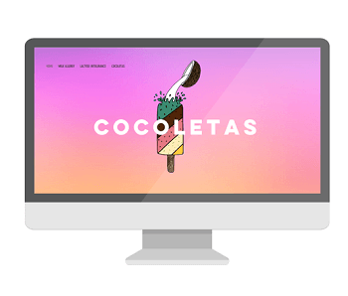  


As you can see, these websites are all very different. However, the emphasis on **bold visual design** is common across all Wix templates. Imagery was once overlooked in favour of written content, but today’s audience expect a stunning visual experience. Just look at the success of image-based social media platforms like **Instagram** and **Tumblr**.

Choosing a web design that makes the most of images is a great way to make sure your website is in line with current trends. What’s more, Wix has a really great selection of **free stock imagery** to complement your own.

## Advantages and disadvantages

As you’ve already seen, Wix comes with many **advantages** for businesses or individuals looking to launch or relaunch a website. To recap:

✔ **Very cheap** - with options starting for free and reaching a maximum of £15.57/month for the most advanced plan, this is a remarkably inexpensive way to **create a website**.

✔ **500+ templates** to choose from, grouped by industry, allowing you to create something that is truly unique to you, and avoid having a generic looking website.

✔ An interface that is **genuinely user-friendly**, and suitable for those with no prior web design experience.

✔ Extensive **online guides** and **video tutorials** to guide you through the process of making your website, and answer any questions that may arise.

✔ **200+ Wix apps** to enrich the functionality of your site.

✔ It’s **very quick** to make a Wix website - you need only fill in a few details, choose a template and modify it to represent you or your business. You could be up and running in only a **couple of hours**.

✔ Huge user base means that **feature updates are constant**, and advice is always readily available from the Wix community.

✔ Amazing showcase of Wix websites to take inspiration from.

✔ All websites are **SEO optimised**.

Although Wix comes with many advantages, there are also a few drawbacks to take into consideration:

✗ Both free and ‘Connect Domain’ plans (the cheapest paid plan) will always **display Wix adverts** on the site.

✗ Once committed to a template you cannot switch, so we suggest experimenting with several before making a final decision.

✗ Although the existing guides are comprehensive, there is no option to speak to someone in support over email/ live chat/ phone. Instead there are open tickets for known faults, and you can add yourself to these to be informed of their progress.

## Verdict

At this moment in time, Wix is the most popular website builder on the planet - and with good reason. Its intuitive interface and commitment to guiding each person through the process means that anyone really can build a modern, sleek and professional website.

In our view, the positives of Wix absolutely dwarf the negatives. The costs for their premium packages are low in comparison to many of their competitors which, when combined with their offerings of free hosting, domain name, email addresses and access to Google Analytics, means you have all the tools to launch a successful and functioning website.

The fact that Wix offers a free version means you have nothing to lose by setting up an account. Take your time to [**explore Wix and see how you get on with it**](http://wixstats.com/?a=10455&c=2149&s1=&s2=EMUK&s3=wixreview&s4=CTA). You can upgrade to the best plan for you later on, and start taking full advantage of everything Wix has to offer. We’re convinced you’ll love it as much as we d



[Visit Site](https://uk.pcmag.com/web-hosting-services/34506/wix)

**Bottom Line:** Wix is the easiest and fullest-featured website builder around, and you can use it to create your own highly customized site for free.