IMAGE: responsive-design-creative-science-labs-3.jpg

LINK:

<https://www.intechnic.com/hs-fs/hubfs/Imported_Blog_Media/responsive-design-creative-science-labs-3.jpg?width=1024&height=768&name=responsive-design-creative-science-labs-3.jpg>

SOURCE:

<https://www.intechnic.com/blog/a-web-development-glossary-7-key-terms-you-should-know/>

CONTENT:

Websites are viewed on many different devices, with different screen sizes, data requirements and operating systems. Responsive design allows websites to be optimised for any device that accesses the website. Responsive design means that users don’t need to change the settings on their device to accommodate different website layouts. Sometimes, it is abbreviated to RWD (Responsive Web Design) and it uses fluid grids, flexible images and media queries to adapt to different display requirements.

Flexbox is an example of a software tool which helps developers to build responsive websites.

IMAGE: X

LINK:

SOURCE:

https://www.designbrooklyn.com/resources/help-center/Website-Planning/Glossary-of-25-commonly-used-tech-terms-in-web-development.html

CONTENT:

UI (User Interface) and UX(User Experience)

These terms are often used interchangeably in web development however they are subtly different.

The User Interface is “the design of how things on screen look”( Dennis Kardys, 2018) So this would cover how the user interacts with the computer through text, graphics (colour, layout, style), animations and auditory features on the screen. Developing the UI involves an understanding of the users’ needs.

The User Experience (UX) is the “application of design tools and techniques to uncover user goals and needs” (Dennis Kardys, 2018). This encompasses everything that impacts on user satisfaction from the feel of the website, ease of navigation, how quickly it loads, to the relevance of content and so on. The emphasis is design for “usability” or “user friendliness”.

This diagram (Pictured X) created by Dan Saffer shows how the complexity of good UX design supports a strong user interface experience.

CONTENT:

* WIREFRAMING

Wireframing is used to provide a basic visual guide or blueprint of the user interface of a website. Wireframes do not have any content; there are no fonts, colours or images and are just simplified sketches of a page layout. They typically include navigational systems, interface elements and how these work together.

A wireframe acts as a functional prototype of a website but without the graphics. It is used to make sure the foundations of the website are sound before any content is added. They are also used to help designers convey to web developers how a website should be structured. Focus is on functionality rather than aesthetics.

IMAGE:

CONTENT:

* CSS

Stands for Cascading Style Sheet. This is a mark-up/coding language that tells browsers how to display a webpage to the end user. It controls the style elements of a page, like the size, colour and location.

It is used to separate presentation from content. It’s a way of separating the presentation of a webpage from its content. Structured content goes into the HTML document and the appearance goes into the stylesheet.

It is recommended by the W3C. CSS means that HTML can be simpler and tells the browser how the HTML elements should be displayed.

HTML

It is the abbreviation for Hypertext Markup Language. It is a computer language used to create websites. It describes how a document should be displayed as a webpage by the browser, (the structure, text layout and other elements (buttons, images)). It is the core language of the world wide web.

IMAGES/QUOTES <https://www.seoclerk.com/html-css-programming/546137/Repair-5-errors-with-your-website-design>

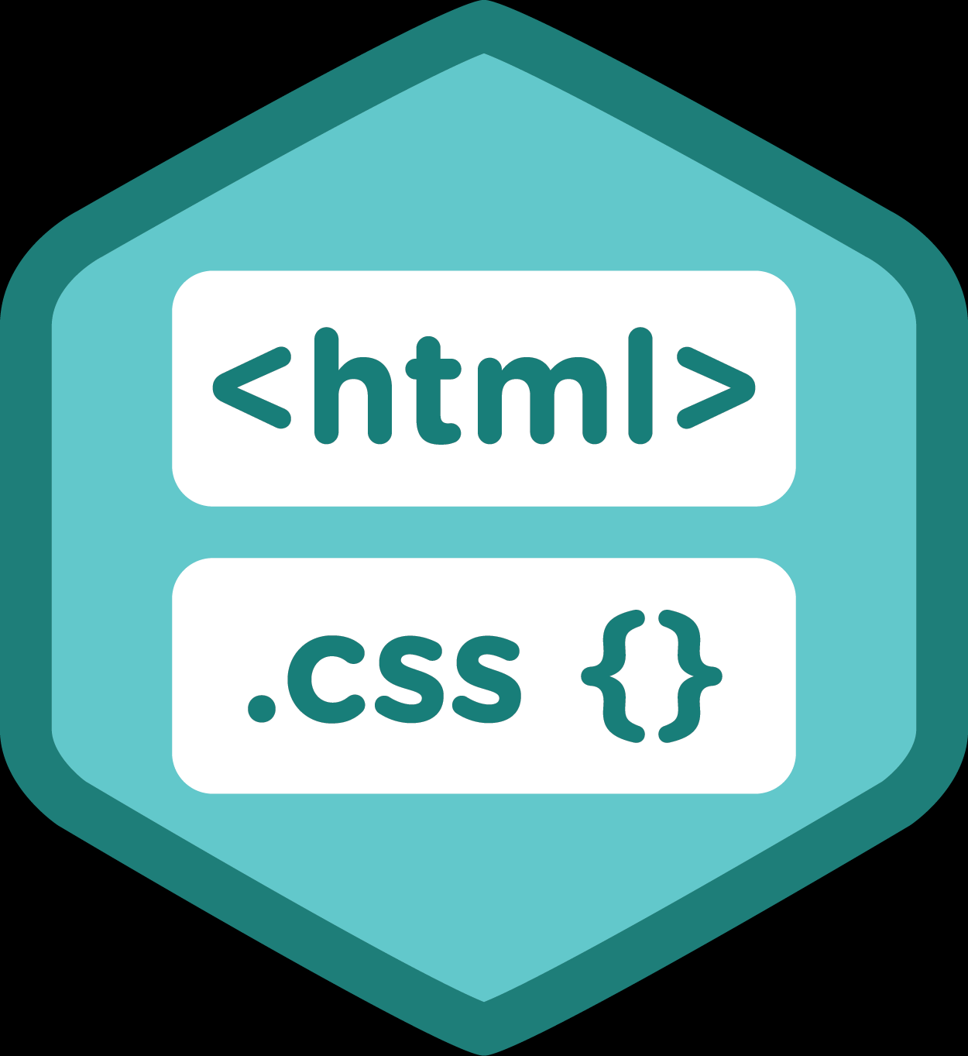

Web Designer Vs Web Developer

Web designers are responsible for specifying the ‘look and feel’ of a website, whilst web developers design the code to build the website. Web designers will typically look at how to incorporate company logo’s, branding, images, and usability whilst web development covers the technical side and of how the website works at creating link pages etc. A web developer takes a design and develops it into a website.

Both designers and developers use HTML, CSS, etc. but developers look at technical issues in greater depth. Increasingly, there is an overlap between the two roles due to improvements in technology.

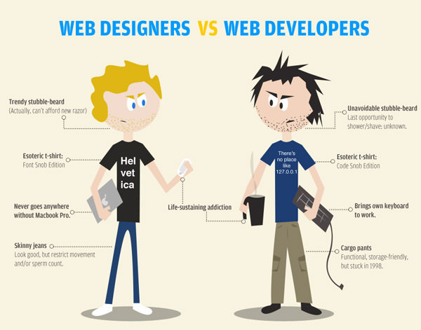

<https://www.hongkiat.com/blog/infographics-web-designers/>

http://customwebsitedevelopement.blogspot.com/2015/03/the-purpose-of-becoming-web-developer.html

CACHE

Is a type of temporary storage that a browser uses to download and store files of information about websites that have been visited. The next time a user visits a website, the browser can load the cache files, rather than from the original server, which can make the webpage load faster. Sometimes the cache can hold onto an older version of the webpage and will need to be cleared if any changes occur on a website.

 <https://www.zazzle.com.au/clear_your_cache_tech_humour_company_logo_mug-168838314123556214>

<https://technofaq.org/posts/2017/05/things-to-look-for-while-hiring-a-web-developer/>

