**General ethos:**

The website is designed for children so I will try to make it attractive as possible. The design will be colorful and attractive but I will still try to maintain readability and easy navigation throughout the website. This way children will enjoy staying on the website and won’t get confused by using it.

**Site Map:**

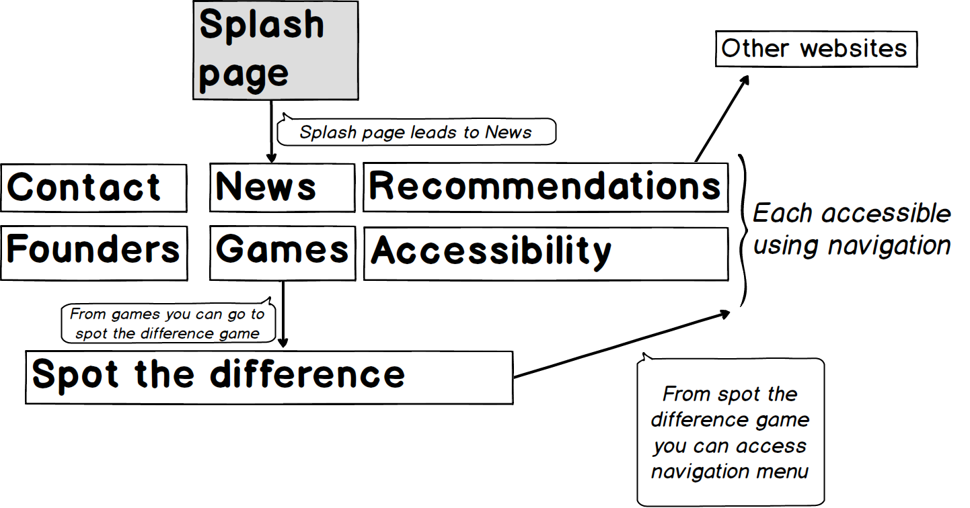

User will first enter splash page which will just welcome the user and won’t have any information on it from which he will be able to access the main page which will be news page because we want our users to always be familiar with news. When the user is not in the splash page all the pages in the website except splash page, spot the difference game will be connected using navigation menu. From games page you will be able to access all the games that are developed (I am going to be developing spot the difference puzzle only). From spot the difference game user will be able to access navigation menu which leads to given pages. Recommendations page may lead to other websites.

**Design mock-ups:**

I will be using mobile first approach and then expand window sizes and check at which number of pixels things start to look not fine and add media queries and those breakpoints. Most likely smallest media query will be for very small mobile phones. I chose HTC Wildfire which is quite old phone with small screen (240x320) and not widely used. But I took into account that the website will be used by children and most children do not have newest and biggest phones. Later I will add breakpoints for most used smartphones. For example, iPhone 5, iPhone 5s, iPhone 6, LG Google Nexus 5X, Nexus 6P and several others. Next breakpoint will be tablets and I will finish with desktops and very large desktops (over 2000px width). The design will be very simple: navigation bar on the top, simple footer at the bottom and content between them.

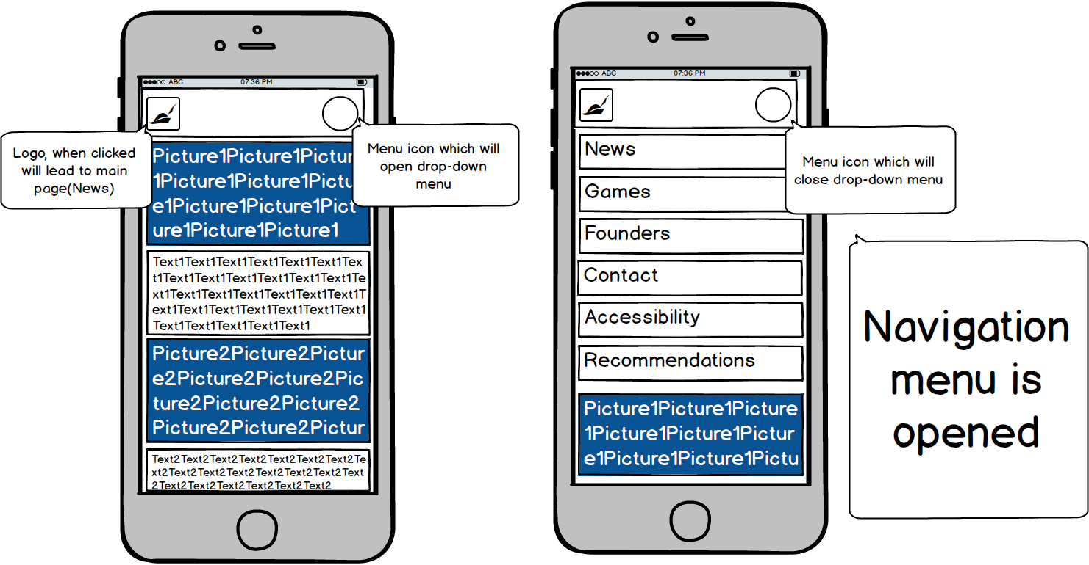From website description I can tell there will be several pages with the same structure and it will be picture and text for the picture. So here is mobile design mock-up for those pages:

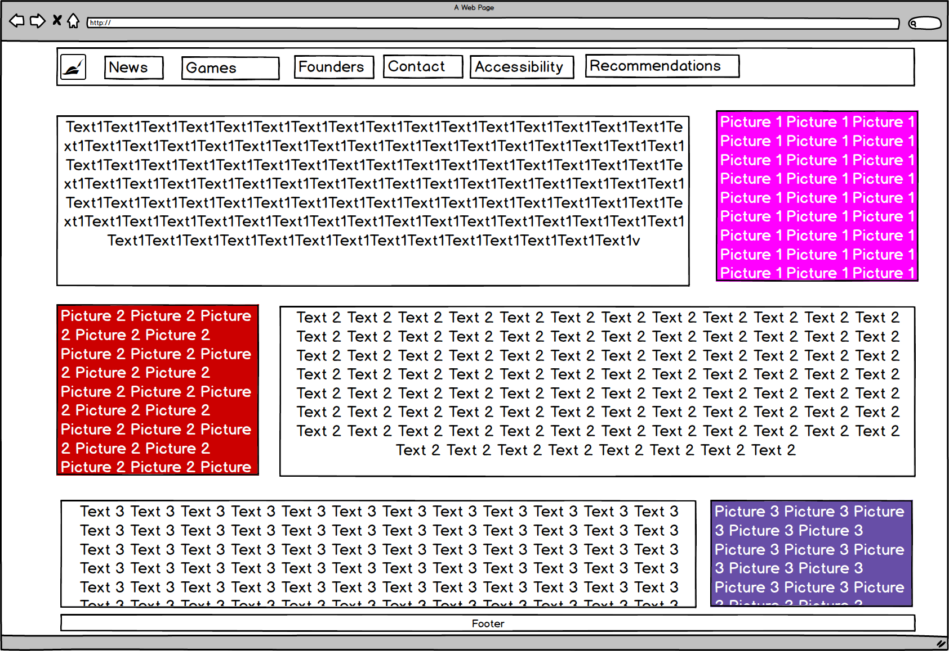For desktops/tablets:

I will be floating text to one side and picture to other one. When it is mobile I will have picture then text displayed in whole page width.

**Menu system:**

For the responsive menu I will be developing drop-down menu when the screen is small.

**Puzzle Game Design:**

I am going to be developing spot the difference puzzle so for the design it is going to be 2 photos side by side and I will try to find spot the difference pictures which are perfectly suitable for children(For example, pictures from popular cartoons). The puzzle will most likely be difficult to use for mobile phone users and will be designed mostly for desktops or tablets. However, I will try to make it as usable as possible for smartphone users as well. As for accessibility there is not much I can do because when you play spot the difference puzzle your eyesight must be decent and I will most likely not add many accessibility functions.