**Changes:**

I sticked to the plan and did not have to make many changes from the plan but I made one: For the splash page I had to add a lot of tweakpoints because the text would flow out of background at certain window sizes.

**Organization:**

I created one template which was for picture + text pages. I used in for Recommendations, Founders, News, Games pages. I created one of them and then used the same structure for others just changing what is said in the paragraphs and pictures.

To organize files, I added all pictures to Pictures folder, all JavaScript files to JavaScript folder and all CSS files to CSS folder while HTML files are in the main folder of the project.

My main debugging tools were Chrome responsive design which I really liked because it has installed most popular devices sizes and you can try website on them very efficiently. In addition, I used Mozilla responsive design tool. Also, when developing the game, I used console.log and checked the console to test my program. Using console.log very helped me to find certain spots where the differences are.

**Optimizations:**

Most pictures I used are compressed or resized to make them load faster. In addition, I am using a lot of logos so I have a couple of them with difference sizes. For example, I am using small sized logo for logo in navigation bar while I used large for splash page.

**Security:**

For the contact page, you will never know if the person who sent you email wrote his own e-mail address. In addition, you can get a lot of spam from the contact page to your personal e-mail.

**Testing:**

Tests for different devices was quite easy because of responsive design browser tools. I used Google’s Chrome responsive tool and Mozilla responsive tool. While testing on difference browsers was harder because I could not find any online tools which could test my website on different browsers because the website in not on the Net and is on my local machine. So, to test website on different browsers (I have tested on most popular browsers: Chrome, Mozilla, Internet Explorer, Opera, Safari) I just downloaded different browsers and checked all functions and overall look of the website on those browsers. In addition, I have used online validators to validate my CSS, HTML, JavaScript codes.

**This is how the website looks like on Chrome while using desktop: (Figure 1)** 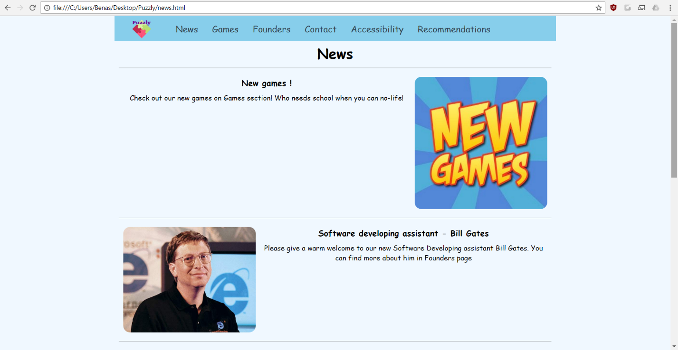

Figure

**This is how the website looks like on Firefox while using desktop: (Figure 2)**

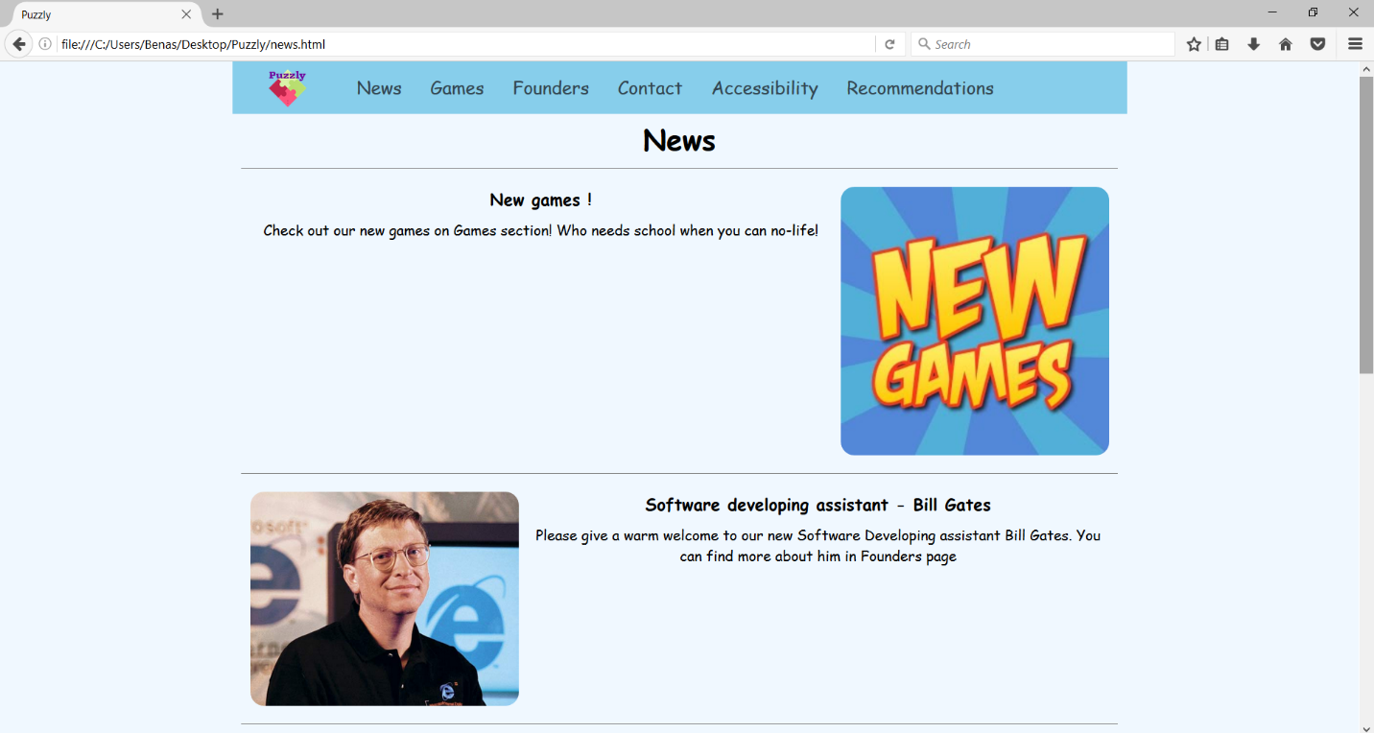

Figure

**This is how the website looks like on Internet Explorer while using desktop: (Figure 3)**

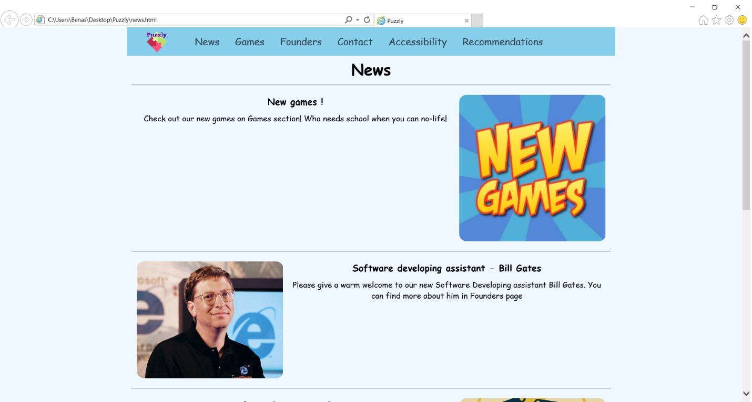

Figure

**This is how the website looks like on Opera while using desktop: (Figure 4)**

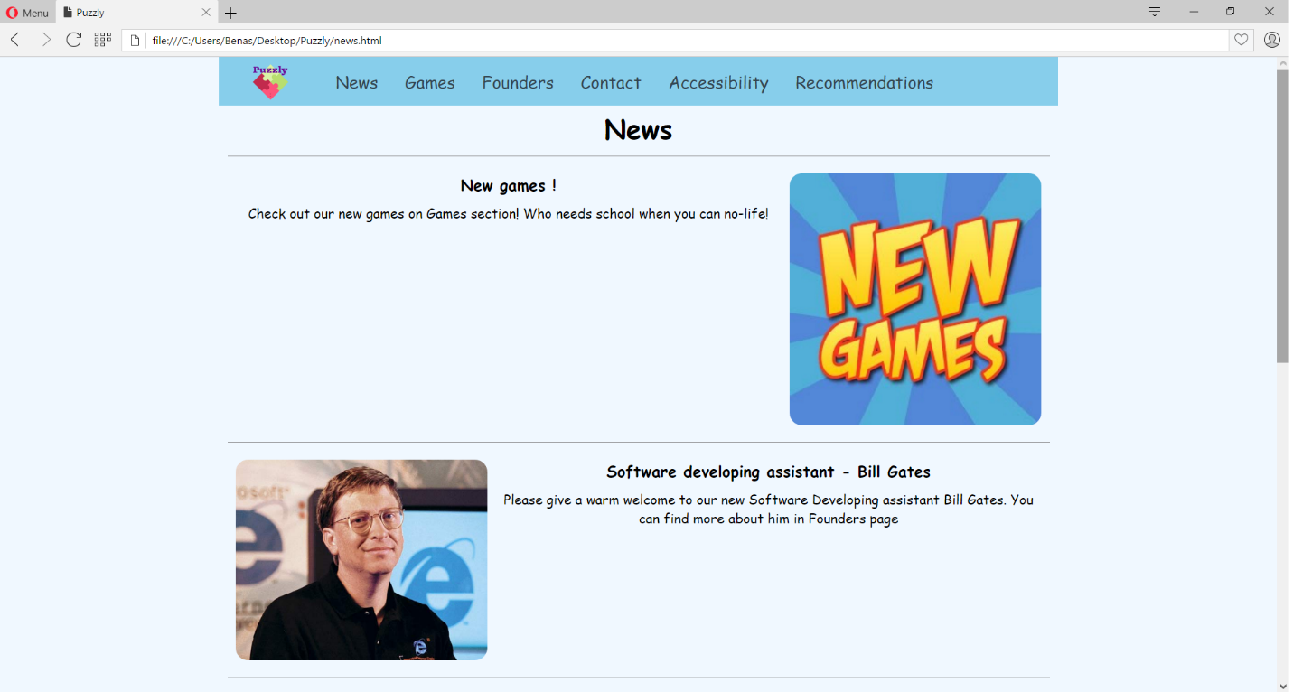

Figure

**This is how the website looks like on Safari while using desktop: (Figure 5)**

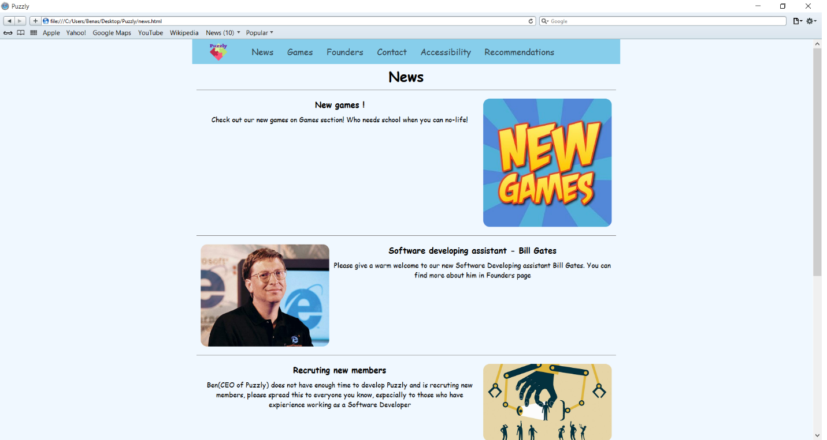

Figure

To sum up looks on desktop, all browsers handled it perfectly, overall look was the same and there were no problems.

**The website looks like this when using a smartphone:(Figure 6)**

Figure 6

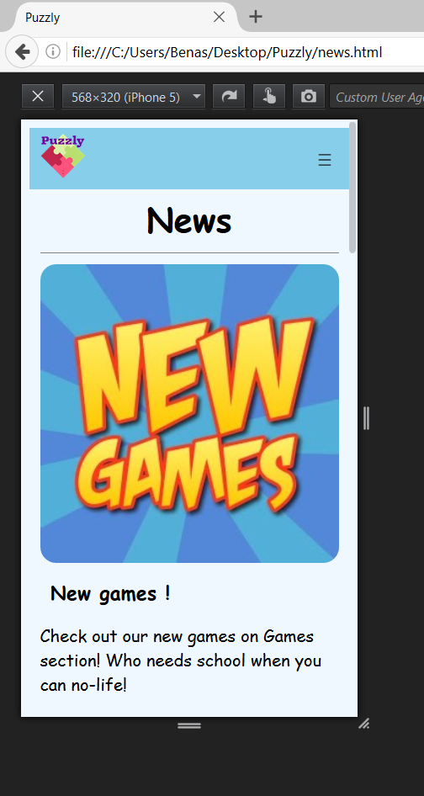

When using website on smartphone all of contents will be displayed as planned and navigation bar only displays logo and menu button which opens drop-down menu.

**The website looks like this on tablets:(Figure 7)**

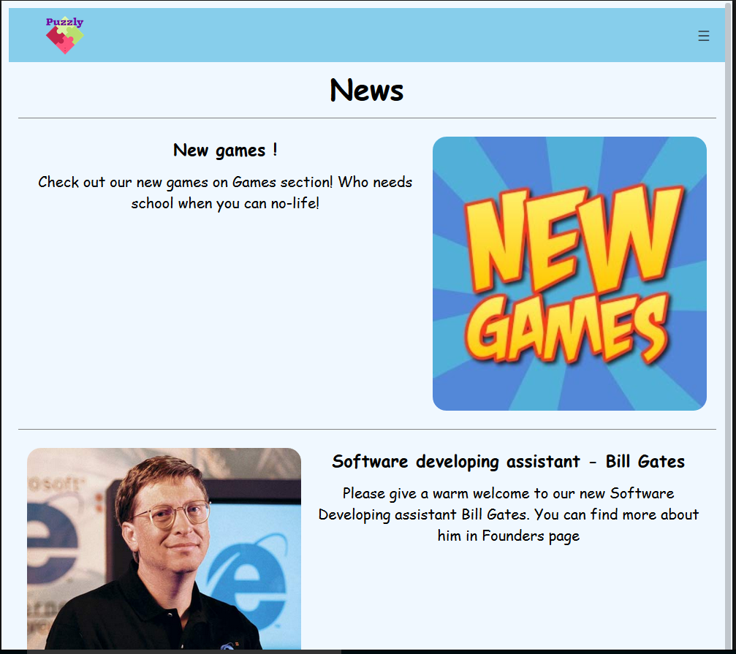

Figure

When using tablets the contents will be displayed as in desktop, while navigation bar still stays the same as while using smartphone.