- Online Yard Sale

The first assumption being made is that all “buyers” will not have registered accounts. Even if they do have registered accounts, the checkout process will remain the same and still ask them for payment method, shipping locations, etc.

The second assumption is when a seller is choosing categories for an item, only subcategories are chosen, while the parent categories are used internal the application for “display” purposes.

We are also assuming that the buyer cannot edit an item, it must be deleted and a new item created. Items can also “go stale” and will auto delete after 30 days.

We are assuming advertisers are using text based advertisements (like on Google's search pages) and that the adds follow a pay-per-click (PPC) model. We are also assuming that the ads are chosen for display randomly from ads not show recently (recently can be tuned in the program but we will assume 5 days). Ads are also not tracking any data for analytics as that would be a much more complicated algorithm to diagram withing 2/3 of an hour.

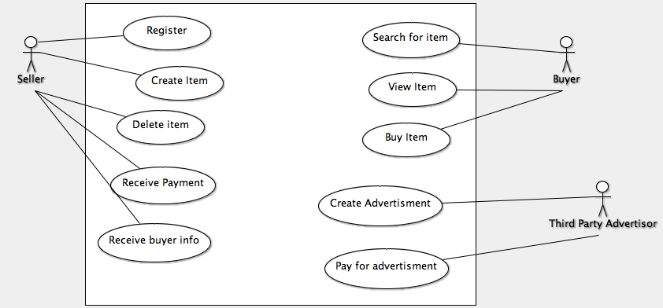
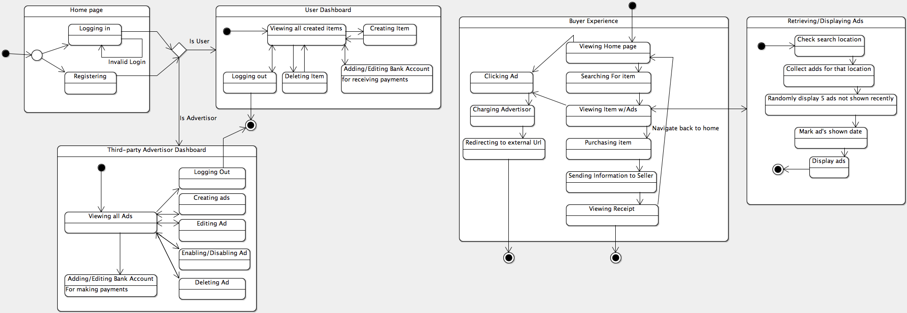

2.

To develop a process guidance outline Sevenly, Boehm & Turner's framework (B&T) will be used to do an assessment of whether Sevenly would require an Agile or plan driven method to development. The five categories to initially examine are Criticality, Size, Personnel, Dynamism, and Culture.
The assumption is made that the software created by Sevenly is not life critical as it is merely software to manipulate “raise social awareness”, and the most damage done by faulty software is that the client does not have any awareness raised. Additionally assumed is that faulty software results in a net zero effect and does not actually generate “negative social awareness” by posting curse-words, illicit material, etc on behalf of the client across the web. Because the average project takes 18 weeks, it can be assumed that the cost of development is rather pricey and failure could consume a large portion of client essential funding for PR, especially because, assumably, most non-profits have a smaller PR budget than other large for-profits. Based on these assumptions, the criticality category would score towards the middle of Agile and Plan Driven, leaning slightly towards Agile because the system would not cause any loss of human life, but could eat away at a large portion of client's essential funding.
The size of Sevenly is rather small. There are only four software developers and two graphic designers. This puts the “development team”, assuming graphic designers are creating front-end graphics for web pages, at a mere six members. A six member team in the B&T is towards the low end of Agile on the spectrum. This is because it is not difficult for members of the development team to communicate with each other and share information. A plan driven approach could cause overruns due to unnecessary time spent documenting every details that could have been spend on development or direct information sharing.
In Sevenly's group of four developers one can assume that at least one, if not more, developer is a level 3 (Able to revise a method to fit unprecedented situations), and the rest of the team are at least level 2 (Able to tailor a method to fit a precedented new situation). This assumption is made because a team this small working on very large projects for numerous different clients will need to be very talented to adapt to the different needs of new clients on a regular basis. With this assumption, Sevenly's personal category ranks very Agile. Therefore, it is not very risky to take a Agile approach as all developers can hold their own in a changing environment. Plan Driven would be rather risky as it could alienate the dynamic, high level programmers regarless of how well the project is managed.
It is difficult to assume the Dynamism for an 18 week long project. For this case, Sevenly is assumed to be creating very dynamic software for two reasons. One, the software is for raising “social awareness” and the way the general public consumes information changes regularly. Therefore the methods the software uses for reaching the public will most likely have to evolve over the course of 18 weeks. Two, the way non-profits wish to represent themselves can change drastically over the course of 18 months. For instance, the charity could have run numerous fund-raising events that they want the public to know about after the start of the software project and before the ending. The way they wish to raise the awareness for these events could be different then how they want awareness raised for the entire organization. Therefore the dynamism of the project points towards taking a more Agile approach to development.
The culture of Sevenly is difficult to extract from the given text, but one could still safely assume that Sevenly is an office that thrives in a chaos. We can make this assumption mainly by the fact that Sevenly has acquire many long-term projects in the past and has no process guidance at all. Therefore, one could safely assume all previous developments were haphazard and chaotic and Sevenly's development team would thrive in an Agile environment over a Plan Driven one. Still that assumption could be wrong based on the fact that Sevenly is now trying to create some kind of process guidance. Therefore either approach will most likely gel with culture as long as it is managed properly.
Based on the findings of B&T of the projects, Sevenly should without a doubt take an Agile approach to developing their projects. While Agile is obviously the correct choice it is not without risks. The biggest risk with taking an Agile approach is that a failed project could not only waste 18 weeks or more of Sevenly's time, but could also cripple their clients by losing a majority of their clients essential funding for PR. This type of damage could cause serious damage to Sevely's reputation, and poses the highest risk of all. Other risk factors include not being able to bring on low level personnel if the team were to expand, and a potential mis-assumption on the culture of the organization. The risk profile of taking each approach is shown below.

Key:

1: Safe
2: Risk that could result in failure with poor management
3: Risk high enough to result in failure even with good management
4. Very Risky and most likely will result in failure

 | Agile | Plan Driven
Criticality | 2 | 2
Size | 1 | 2
Personnel | 2 | 3
Dynamism | 1 | 3
Culture | 2 | 2

3.

Part a.

Function Extraction technology (FX) is technology that does two things. One, it reads the code of any software system and extracts its functionality. Two, it outputs that functionality in a human readable, standardized format regardless of the programming language(s) used to create the system. These outputs are called behavior catalogs and show how a program transforms inputs to outputs for all potential inputs. To demonstrate the benefits of FX consider the following project:

A third-party development team is hired to refactor failed credit card processing functionality in a large online merchants code base. The system has been designed using a SOA approach and the card processor needs to utilize at least five of these different services. Each of the five services has over 500,000 lines of code. The third-party team has no prior knowledge of the system and is off-site in a different state.

By having behavioral catalog for each service in the system. The third-party developers can quickly identify the functionality of the five services needed to create a working credit card processor without looking through 2.5 million lines of code or hundreds of pages of (usually inaccurate) documentation. Additionally they can quickly review the currently failing codes functionality without having to look into the code base. Additionally, the behavior catelog limits the need for direct communication with previous developers of the system and makes it easier to do remote work as direct communication is not needed with employees (assuming the employees who built the systems are even still employed there). By having a behavioral catalog, familiarizing developers with a legacy systems is exponentially faster and more efficient therefore saving time, money, and bugs in the development process. Additionally, when the third-party development team has completed the card processor they can create a behavioral catelog of the card processor which will make it easier for the online merchants internal developers to familiarize themselves with the software when it needs extending or bug fixes.

Part b.

Using the Flow-Service Quality (FSQ) model is very useful when a system needs to asynchronously control hundreds of nodes in a network where each of the nodes needs to quickly and efficiently communicate with each other. The FSQ model is a model of software engineering based on Flow structure/diagrams where communications “flow” over numerous networks and nodes, and these “flows” are explicitly defined. This model of design is extremely useful in systems where the precision is needed an the criticality of system failure is extraordinarily high. FSQ systems add extra complexity to system increasing the overhead of maintenance and developments, but in some circumstances the benefits far outweigh the costs. The classic example is military systems. Where there are multiple in field, automatic and man powered vehicles who are communicating with each other, with the field-base, the base in the home country, UAV's satellites, ground infantry and more. These systems need high redundancy and precision. Additionally every node in the system needs immediate communication with every other node. This would be impossible, or at least very difficult, with more traditional software engineering models. In this circumstance the costs are negligible compared to the benefits. The alternative is a small software company designing a few applications that communicate with each other. The costs of added complexity of a FSQ model would most likely bankrupt the small company.

