The Lightweight IBM Cloud Garage Method for Data Science

Architectural Decisions Document Template

Examining Growth Rate and fall rate in foreign exchange rates

# Architectural Components Overview

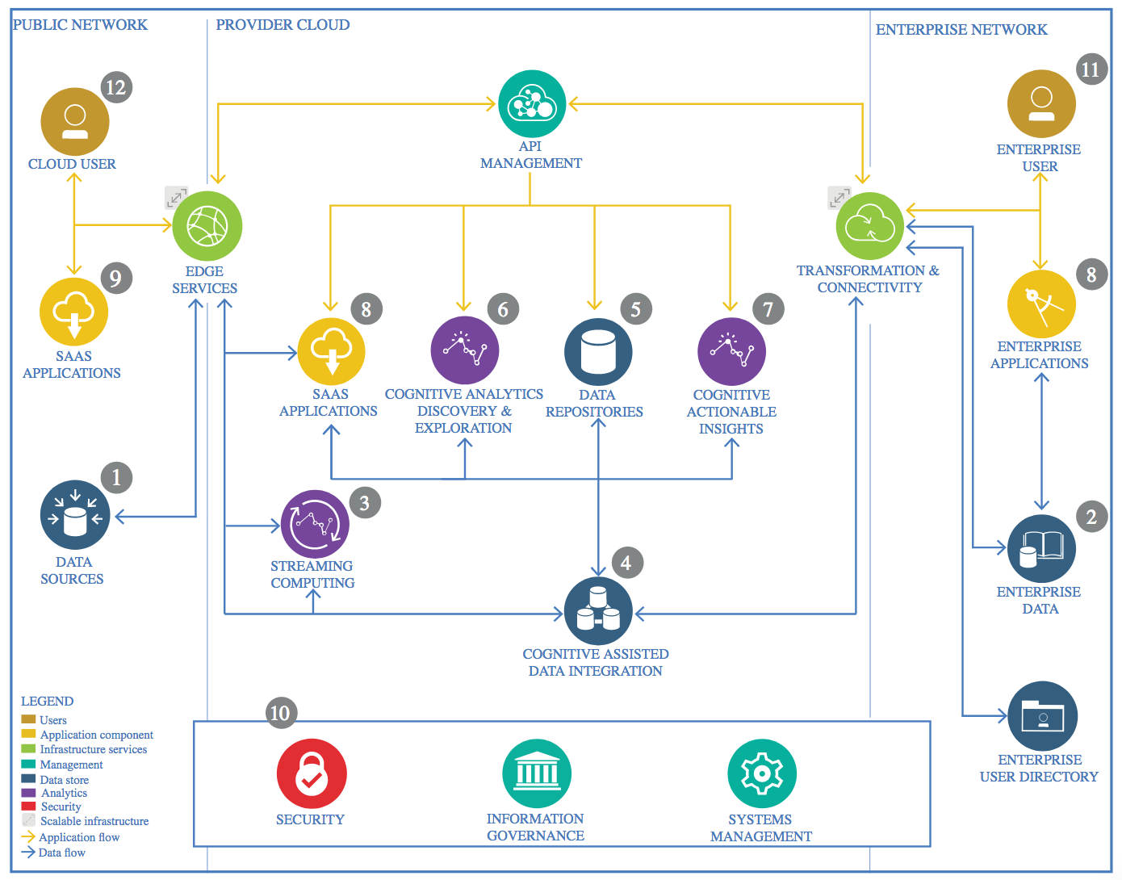

IBM Data and Analytics Reference Architecture. Source: IBM Corporation

## Data Source

<https://www.kaggle.com/brunotly/foreign-exchange-rates-per-dollar-20002019>

### Technology Choice

Kaggle.com

### Justification

Static Data set acquired from kaggle.com

## Enterprise Data

### Technology Choice

CSV file

## Streaming analytics

### Technology Choice

None

### Justification

Not used as data is Static

## Data Integration

### Technology Choice

Python

### Justification

Easy to use with pandas library

## Data Repository

### Technology Choice

Pandas – data frame

### Justification

Easy to integrate with large variety of Api’s and has nice flexibility throughout.

## Discovery and Exploration

### Technology Choice

Matplotlib, numpy, scipy

### Justification

Easy to use for f-tests, chi-squared tests, plotting, root mean square, scikit-learn’s scoring feature

## Actionable Insights

### Technology Choice

RMSE was used and also MAE

### Justification

It was used to perform basic error calculation.

## Applications / Data Products

### Technology Choice

Forecast for Upcoming up lift and down fall for a country Japan’s Exchange currency

### Justification

Our model was able to perform well on the current data set