Netflix Clone | MERN

# **Project Abstract:**

* Netflix Beta (Clone) is a Design and Development of a Netflix-Inspired Platform. In an era dominated by digital streaming services, the creation of platforms that emulate the success and appeal of industry giants like Netflix has become increasingly relevant. This abstract outline the conceptualization, design, and development process of a Netflix-inspired clone platform aimed at offering users a comparable streaming experience.
* The digital age has revolutionized entertainment consumption, with video streaming services like Netflix leading the charge. This project aims to develop a web application replicating core functionalities of popular streaming platforms, offering users a convenient and personalized way to access a vast library of movies and TV shows. Our project, titled "Netflix Lite GIITS Version”, is a Netflix clone built using the MERN stack (MongoDB, Express.js, React.js, and Node.js).

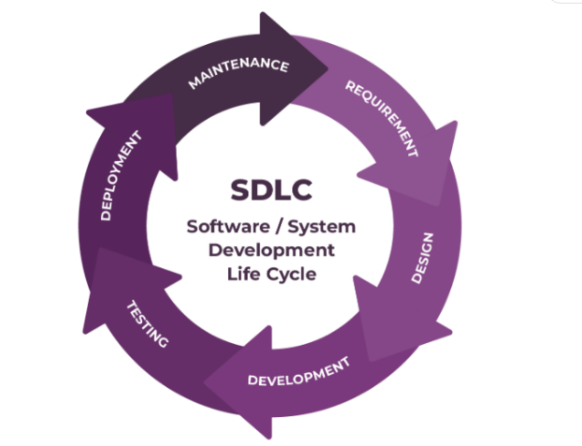

# **Key features**:

* User Registration and Profiles:Allow users to create accounts with unique profiles. Each profile can have personalized settings, viewing history, and recommendations.
* Content Catalogue: Offer a diverse library of movies, TV shows, documentaries, and original content across various genres and languages.
* Search and Filters:Enable users to search for content by title, genre, actor, director, or keyword. Provide advanced filtering options to refine search results.
* Video Streaming:Enable seamless streaming of high-quality video content with adaptive bitrate streaming for different internet connection speeds.
* Content Management System (CMS):Provide an intuitive CMS for administrators to manage content, including adding new titles, updating metadata, and scheduling releases.
* Watchlist: Enable users to add content to a watchlist for future viewing.
* User Reviews and Ratings: Allow users to rate and review content, helping others make informed decisions.

# **Technologies Used:**

### **Frontend (React.js):**

* **React.js:** This popular JavaScript library will be used to build the user interface (UI) of our application. React's component-based architecture allows for efficient development and maintenance of the dynamic and interactive UI elements. Users will interact with features like browsing content, managing profiles and watchlists, and initiating playback through the React-built interface.

**Backend (Node.js, Express.js, MongoDB):**

* Node.js: This lightweight and scalable JavaScript runtime environment will serve as the foundation for our backend server. It will be responsible for handling user authentication, managing API requests, and interacting with the database.
* Express.js: As a web application framework built on top of Node.js, Express.js will streamline server-side development. It will facilitate building RESTful APIs for managing user data, content information, and streaming requests.
* MongoDB: We will leverage MongoDB, a NoSQL document database, for its flexibility and scalability. This allows us to store user information (profiles, watchlists), content details (metadata, genres), and potentially user preferences for the recommendation engine.

# **Project Flow:**

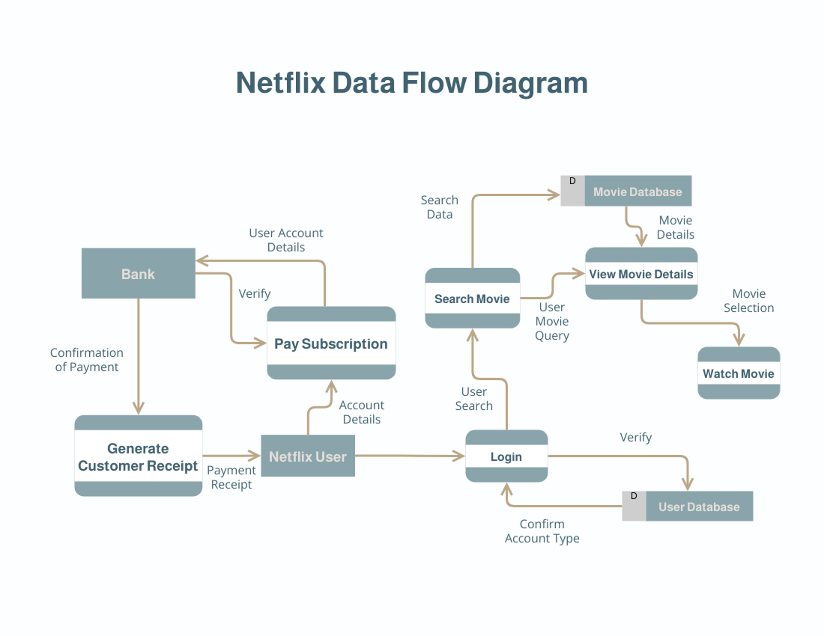

Conclusion:

* This project aims to deliver a functional Netflix clone utilizing the MERN stack. Our application will provide users with a user-friendly platform to stream movies and TV shows, manage profiles and watchlists, and potentially benefit from personalized recommendations (optional). By leveraging the scalability and flexibility of the MERN stack, this project will showcase the capabilities of building a real-world streaming application with robust features. The expected output is a fully functional web application replicating core functionalities of popular streaming services, allowing users to enjoy a personalized entertainment experience.

Best Regards,

Netflix Lite Developers Team #GIITS.