Well Dev Interview

- https://leetcode.com/problems/longest-palindrome/description/



Solution video :https://youtu.be/DSEng0xILV4?si=fxge4453yqlmc4hj

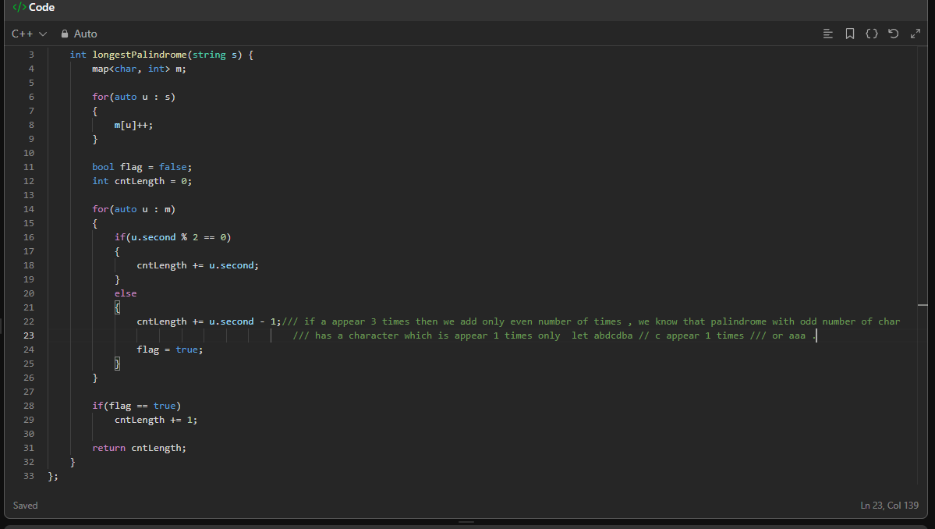

Two Pointer
https://leetcode.com/problems/move-zeroes/description/
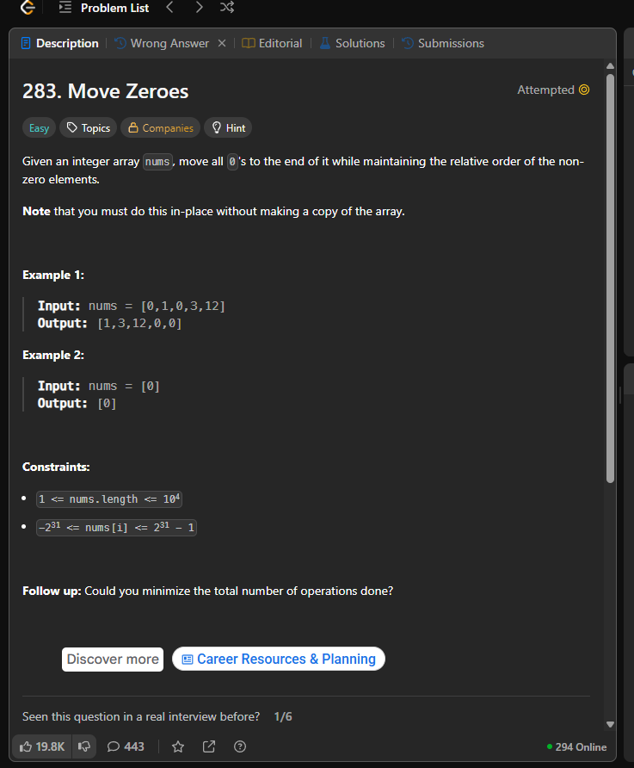
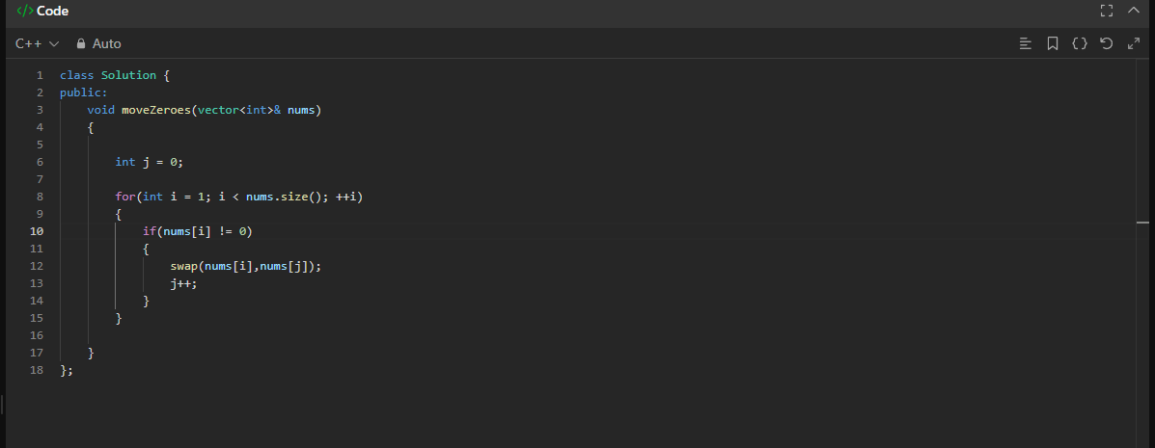
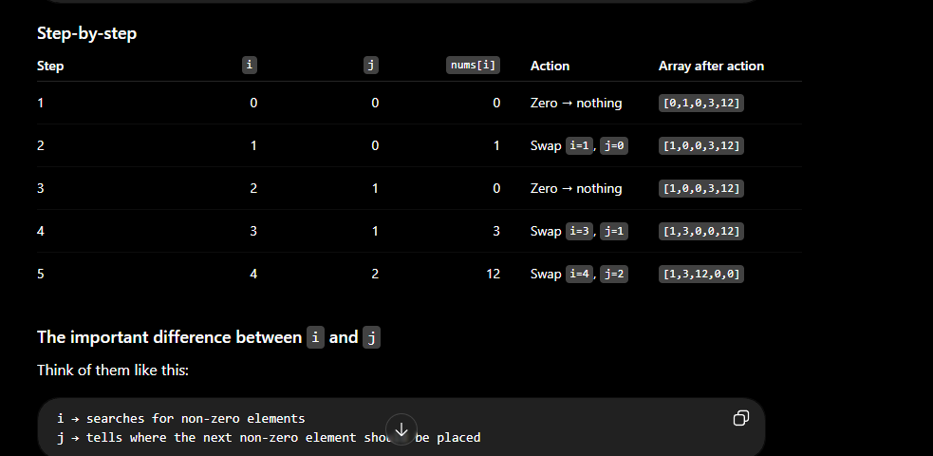

Dynamic Programming
Solution :https://youtu.be/uBhSIKLlvdk?si=89xa8eMxt2QDP27K

Problem
