Interview QUESTIONS Theory

Topic oop

Company Bkash:

Questions: what is inheritance in object oriented programming

Ans:
Inheritance allows us to define a class that inherits all the methods and properties from another class

- The newly created class is known as the subclass/ (child or derived class).
- The existing class from which the child class inherits is known as the superclass (parent or base class).

Inheritance in OOP:
Inheritance is a fundamental concept in OOP where a new class (called child/derived class/subclass) acquires the properties and behaviors (fields and methods) of an existing class (called the parent class or base class/Super class). It allows code reuse, extension, and polymorphism by enabling one class to build upon another.
Think of it like a family tree:
- Grandfather (base class) -> has some qualities (e.g., eye color, height)
- Father (derived class) -> inherits those qualities from Grandfather, but can also add new ones (e.g., voice, skills).
- Son (further derived class) -> inherites from Father (indirectly from Grandfather) and can add even more traits.

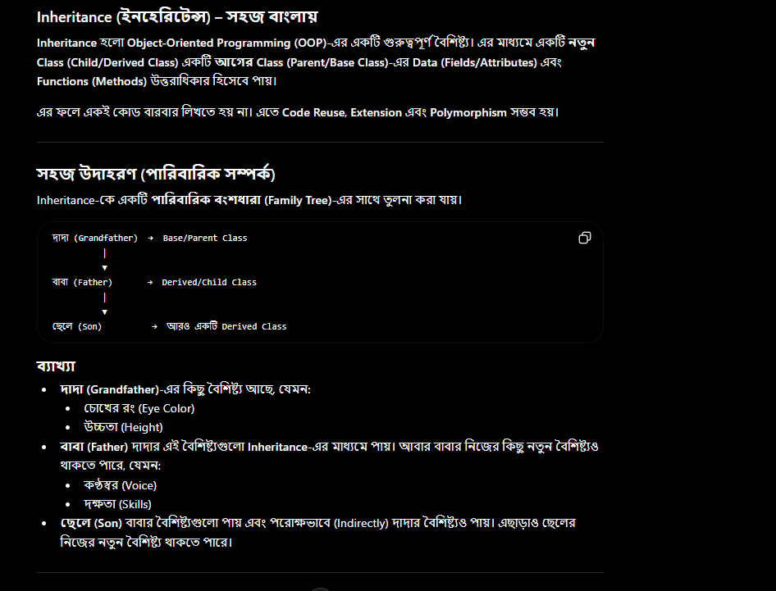

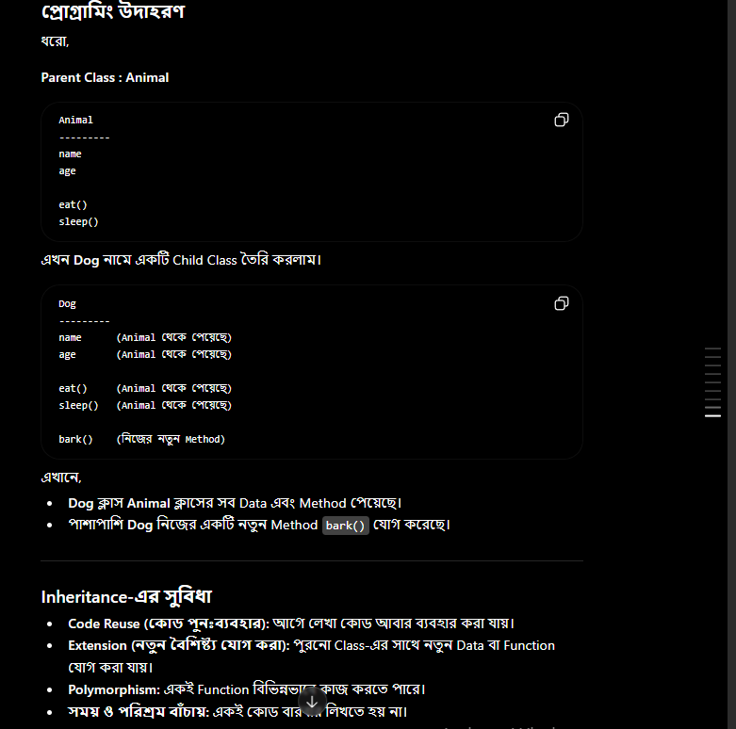

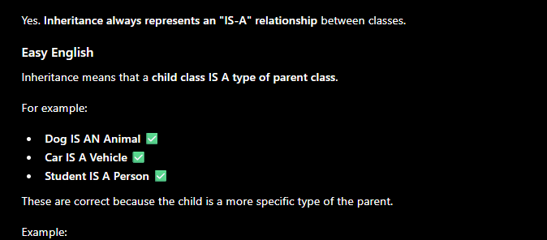

https://www.programiz.com/csharp-programming/inheritance
https://www.w3schools.com/python/python_inheritance.asp
https://www.programiz.com/python-programming/inheritance

Question :
https://www.programiz.com/csharp-programming/polymorphism
https://www.w3schools.com/python/python_polymorphism.asp
https://www.programiz.com/python-programming/polymorphism

What is function overriding in Object-Oriented Programming? How is it different from overloading?

Ans:

Function Overloading in OOP:
- Function overloading occurs when multiple functions in the same class share the same name but have different parameters list (different type, number, or order of parameters)
- It is decided at compile-time.
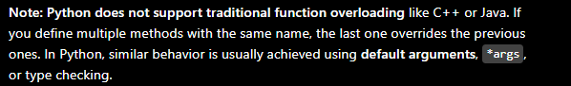
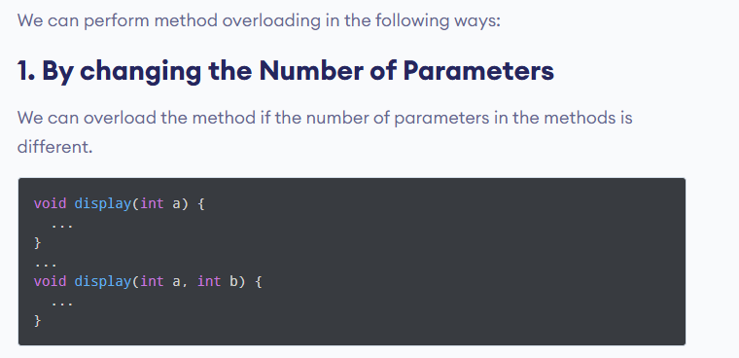
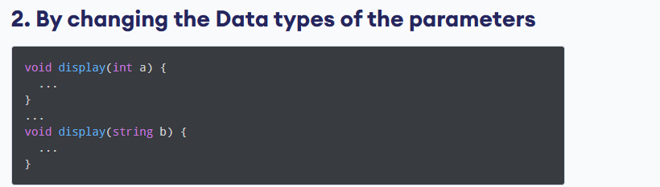
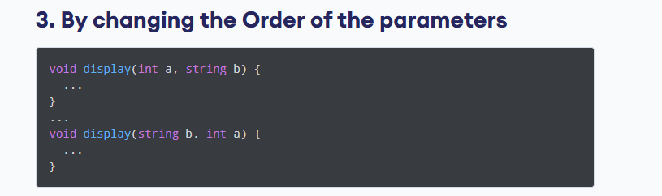

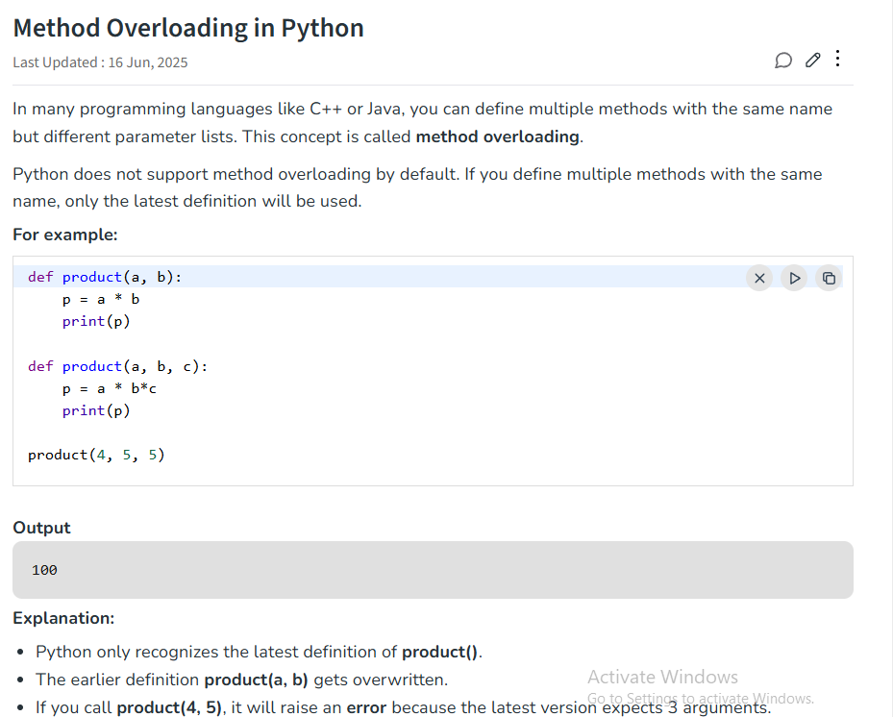

Method overriding:
During inheritance in C#, if the same method is present in both the superclass and the subclass. Then, the method in the subclass overrides the same method in the superclass. This is called method overriding.
In this case, the same method will perform one operation in the superclass and another operation in the subclass.
The function in the child class must have the same name, parameters, and return type as in the parent class
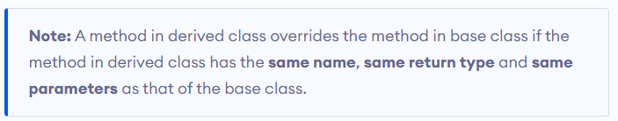

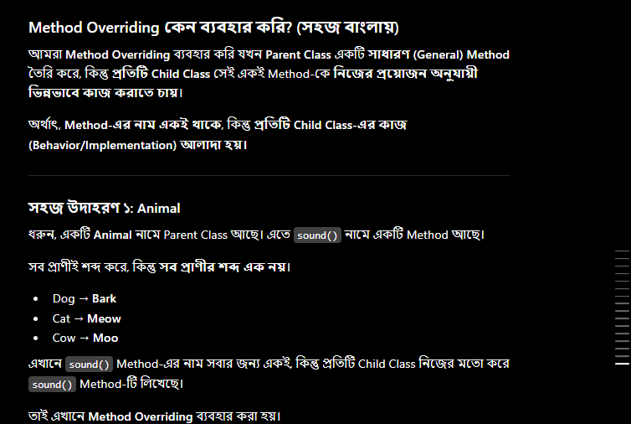
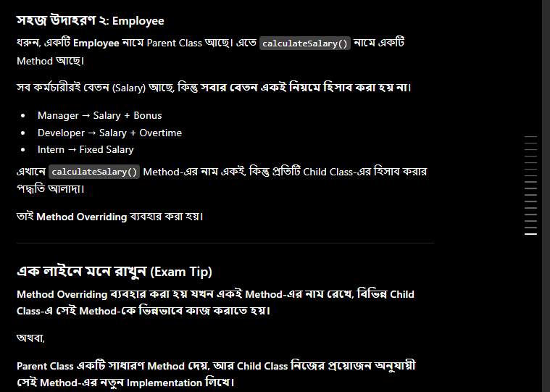

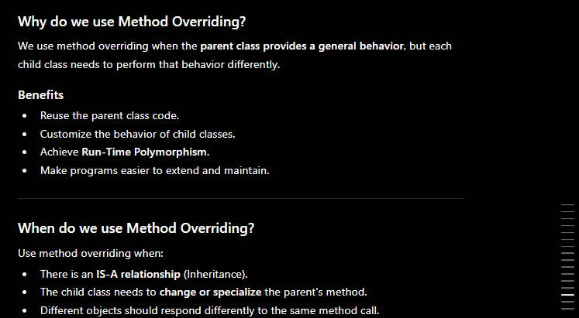
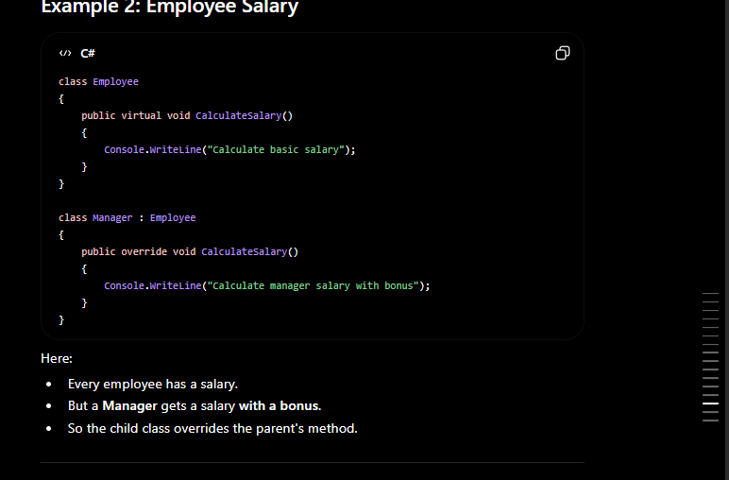

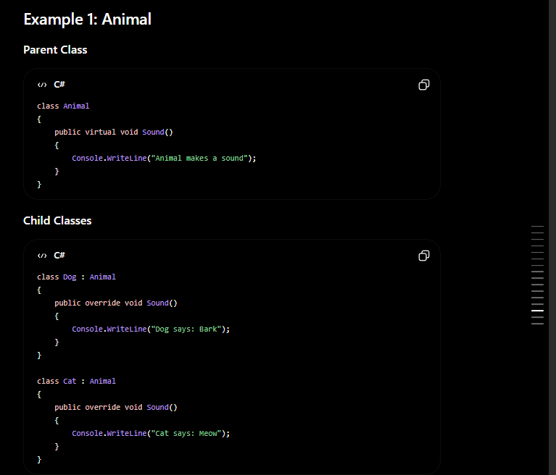
What is polymorphism ?

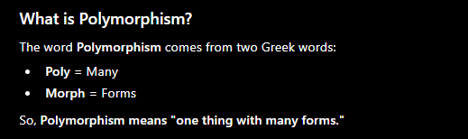

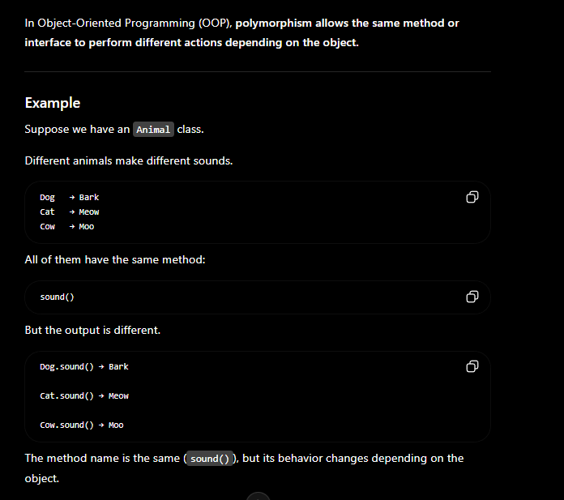
the same entity (method or operator or object) can perform different operations in different scenarios.
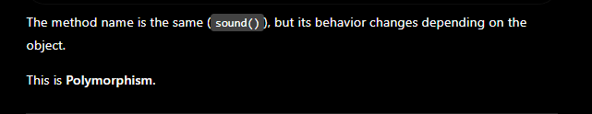

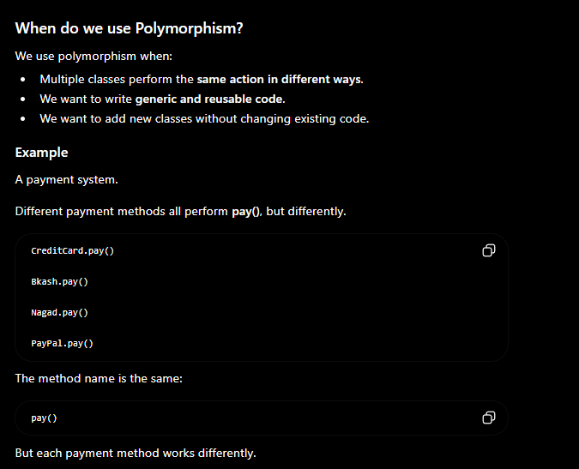

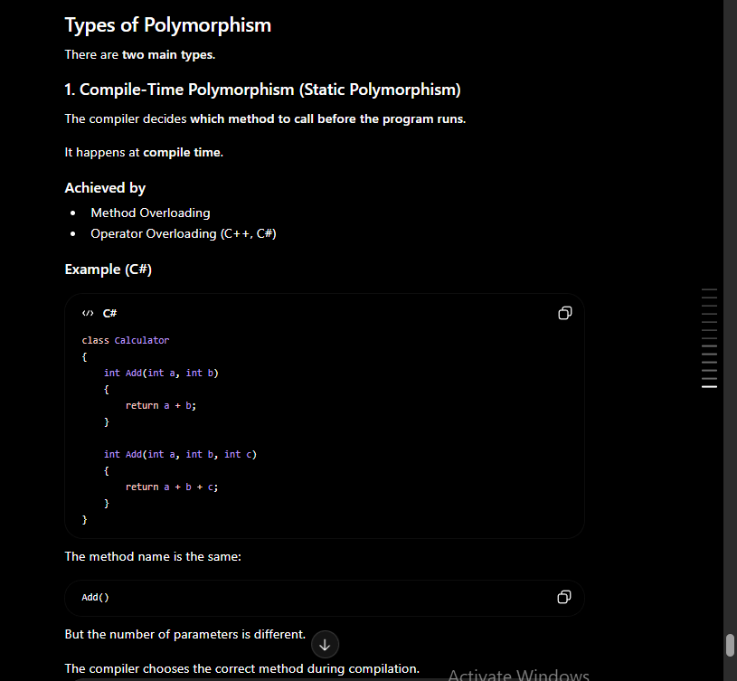

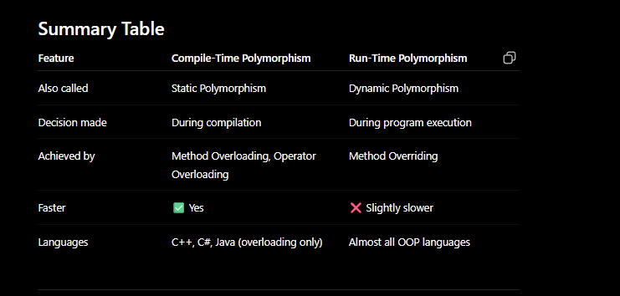
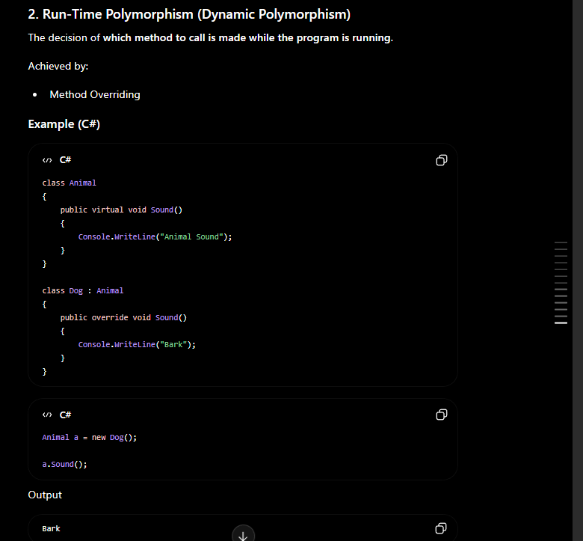

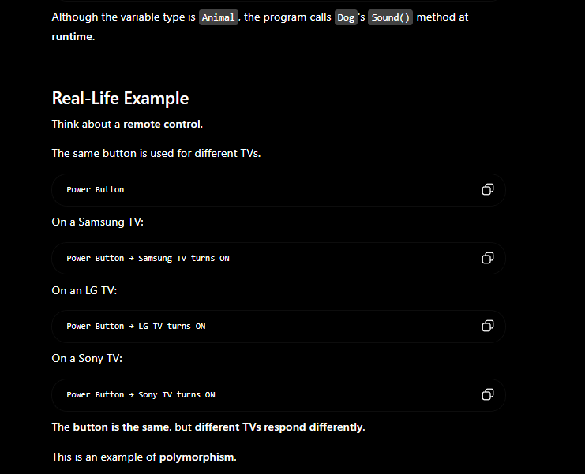

Operating system
1 . List and explain some basic Linux commands and their typical use cases.

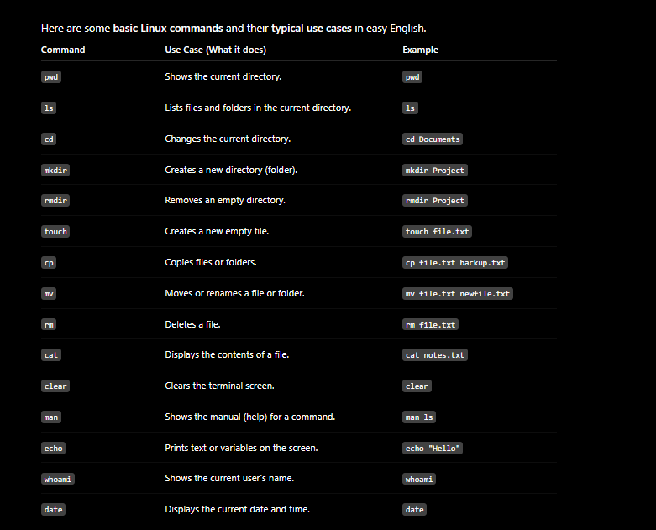

2 What is a deadlock in computing? How can it be prevented or resolved?
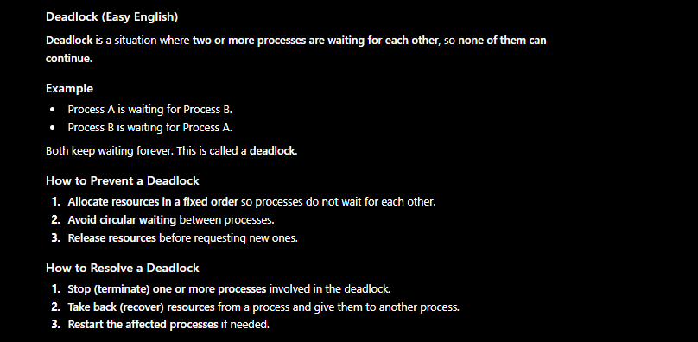

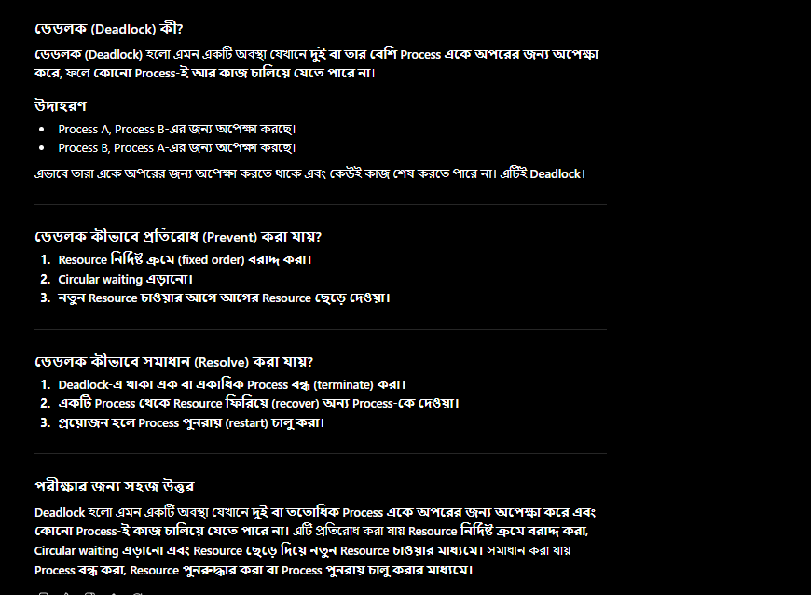

- How can you compare the contents of two text files to determine if they are identical?

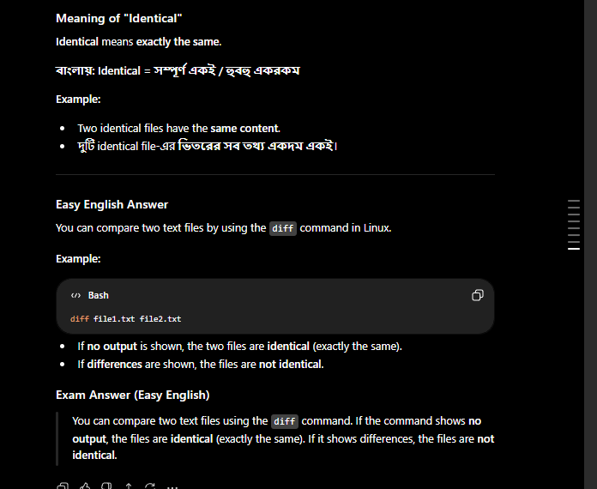

Webtech
What happens when you type google.com and press enter in your search bar

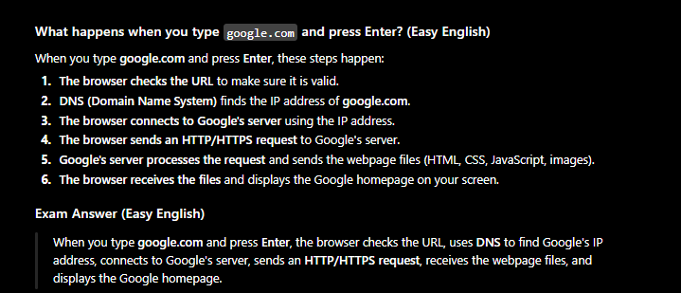

What happens when you copy a file in a computer? Are the copied file and the
original file the same?

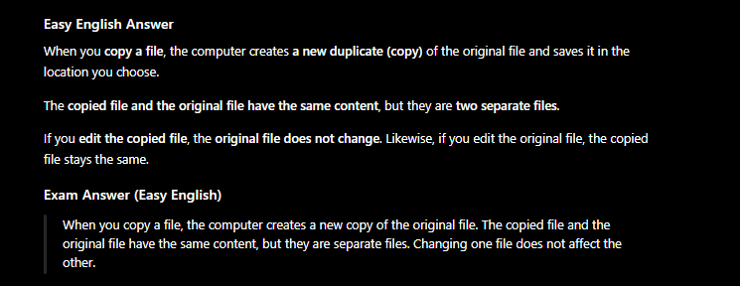

Database

What is database normalization? What are its benefits and common normal forms?

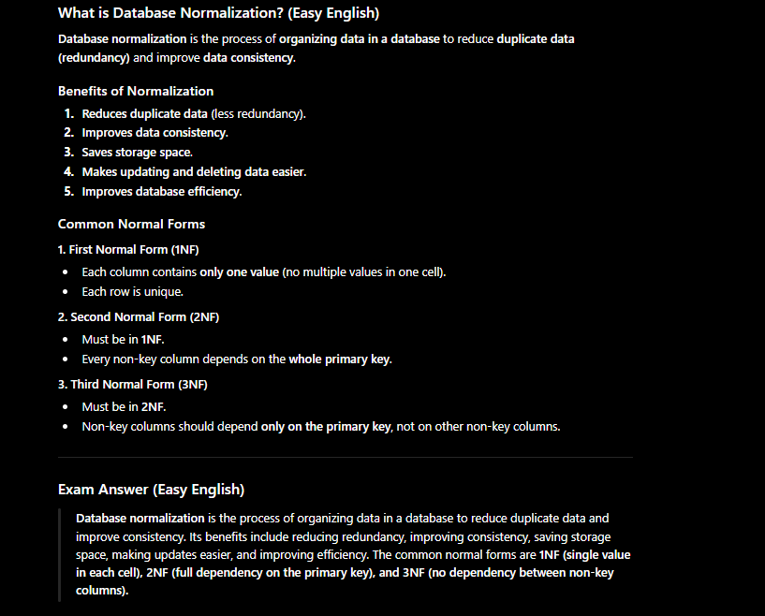

What is concurrency control in databases? Why is it important?

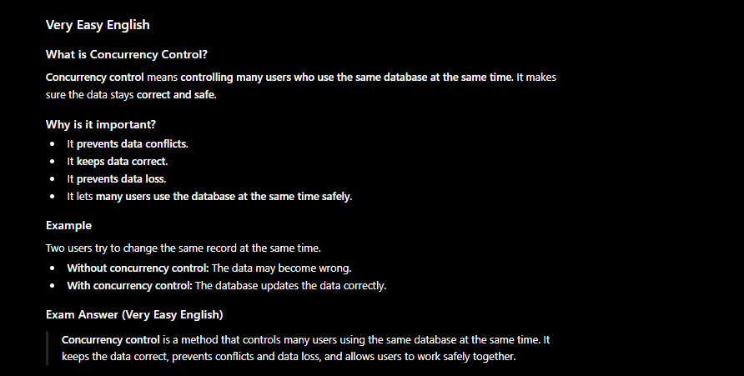
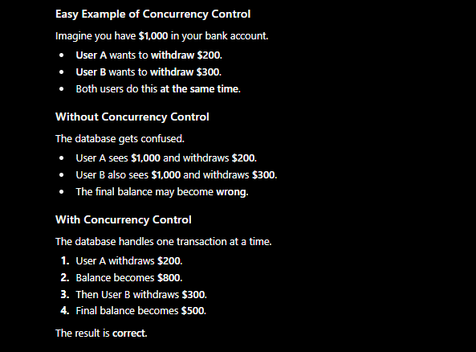

W

