**Bachelor of Science in Computer Science and Engineering**



A Watermarking Technique Based on Combined Contourlet Transform & Discrete Curvelet Transform

October,2018

Department of Computer Science & Engineering

Chittagong University of Engineering & Technology

Chittagong- 4349,Bangladesh.

A Watermarking Technique Based on Combined Contourlet Transform & Discrete Curvelet Transform

This thesis is submitted in partial fulfillment of the requirement for the degree of Bachelor of Science in Computer Science & Engineering

by

Kazi Hassan Shakib

ID:1304106.

Supervised by

Prof. Dr. Kaushik Dev

Department of Computer Science & Engineering (CSE)  
Chittagong University of Engineering & Technology(CUET)

Department of Computer Science & Engineering

Chittagong University of Engineering & Technology

Chittagong- 4349,Bangladesh.

The thesis titled “A Watermarking Technique Based on Combined Contourlet Transform & Discrete Curvelet Transform” submitted by Roll No. 1304106, Session 2016-2017 has been accepted as satisfactory in fulfillment of the reqirement for the degree of Bachelor of Science in Computer Science & Engineering(CSE) as B.Sc Engineering to be awarded by the Chittagong University of Engineering & Technology(CUET).

**Board of Examiners**

1.

Dr. Kaushik Deb

Professor

Department of Computer Science & Engineering(CSE)

Chittagong University of Engineering & Technogy(CUET)

2.

Prof. Dr. Mohammad Shamsul Arefin

Head

Department of Computer Science & Engineering(CSE)

Chittagong University of Engineering & Technogy(CUET)

3.

Department of Computer Science & Engineering(CSE) Member

Chittagong University of Engineering & Technogy(CUET) (External)

**Statement of Originality**

It is hereby declared that the contents of this thesis is original and any part of it has not been submitted elsewhere for the award if any degree or diploma.

Signature of the Candidate

Date:

**Acknowledgement**

First of all I am grateful to almighty Allah who enabled me to complete this thesis successfully. There after my sincerest thanks and gratitude to my honorable project supervisor Dr. Kaushik Deb, Professor of Computer Science & Engineering, Chittagong University of Engineering & Technology for his valuable suggestions, positive advices, encouragement and sincere guidance throughout my thesis work. I also convey my special thanks and gratitude to all of respected teachers of the department. I would like to thank all of my friends and the staffs of the department for their valuable suggestions and assistance. Finally, I would like to thank my parents for their steady love and support during my study period.

**Abstract**

A combined Contourlet and Curvelet based robust image watermarking techniques with Hyper-Chaotic Scrambling is proposed. Because of multi-resolution, multi-directionality and anisotropy property we chose Contourlet transform. To get smooth contours and good image quality Curvelet transform is chosen. Because of randomness of hyper-chaotic cat map, it is chosen. To get sharp edges we have convoluted the transforms. Because of this unique features we are using this methods for watermarking. Imperceptibility and robustness is the targeted by this approach. We have chosen low frequency region for embedding the watermark and pseudo-random bits are generated for the sequence ( 0 and 1 ) bits. To improve scalability as well as finding smooth contours and curves across the image is one of the best features provided by this research work.

# **Chapter 1**

**Introduction:**

In this chapter the overview of watermarking will be described. The background and present state of the problem are mentioned in this chapter. The motivation and objectives of the research are also mentioned in this chapter.

#### **Introduction**

Digital Watermarking is the technique for inserting some cryptographic information into the multi-media objects such as images, video and audio to protect the information. It is used to protect copy-right information. It gives the authenticity of owner rights. It is done with minimum perceptual disturbance.

Difference between cryptography, steganography & watermarking:

In cryptography, the content of message is kept secret. But in steganography, the very existence of the message remains unknown. Watermarking is a process in which the information that verifying the owner is embedded into the multimedia elements. Watermarking is a process in which the information which verifies the owner is embedded into the digital image or signal. Steganography is changing the image in a way that only the sender and the receiver can detect the message sent through it.

Watermarking is of two types; visible watermarking and invisible watermarking.   
In watermarking, a low-energy signal is imperceptibly embedded in another signal. Original signal is called host signal or cover signal. Watermark key is Unique watermark key is used for embedding & detecting watermarks. If the original host image is not needed at the time of extracting original image, it is blind watermarking.

**1.2 Background and Present State of the Problem**

With the development of digital and network technology, humans can easily access, copy, edit and distribute the digital multimedia. Therefore, it is important to protect the owner ship rights of digital element. Digital Watermarking is that technique for embedding some cryptographic information into the multimedia elements such as text, images, video and audio to protect the copyright information. It provides the authenticity of ownership rights [3].

In[1] Preeti and Pallavi proposed a watermarking with Contourlet Transform[1-2], they showed that it is efficient in terms of smooth contours and directionalities, and the anisotrophy properties, thereby provides good geometric shapes of the image. It also is beneficial in embedding larger data into the sub-bands and provides high robustness without affecting the primary (host) image perceptibility. But lacks propitious image quality and despite of sharp contours and good geometric shapes it is not that desirable in having the curves of the image.

In [3], the paper presents a novel biometric watermarking algorithm that embeds a face image data into fingerprint image. The proposed algorithm is based on Curvelet transform in multi-stage. The watermarking algorithm can keep high robustness filtering. Different face verification , iris and signature algorithms could be adopted to test the performance.

They worked on multiple, successive watermarking. But it showed less directionality properties. Edge detection with sharp contours and good geometric shapes but not desirable in having the curves of the image.

In terms of scrambling using Arnold Cat Map [4] or Fibonacci Scrambling [5], after a number of iteration it goes back to original image. So it takes to a great problem in scrambling the image to get encrypted message. Hyper-chaotic Cat Map [6] solves this matter using randomized chaotic sequence.

In [2], the paper presents a novel biometric watermarking algorithm that embeds a face image data into fingerprint image. The proposed algorithm in this paper is based on Contourlet Transform and Quantization. The watermarking algorithm can keep high robustness with Gaussian noise and filtering. Edge detection with sharp contours and good geometric shapes but not desirable in having the curves of the image.

In this proposed method, after scrambling with hyper-chaotic sequence watermark is embedded into low frequency band of the convoluted Curvelet and Contourlet transformed host image. To achieve perceptual invisibility of the watermark, weighted

Correction which is an approach to justify the watermarked image is proposed.

**1.3 Motivation of the Research**

In the recent years, it becomes very problematic to have right ownership details as newer means to copy and attack image has emerged. So it creates the need of watermarking for authenticating the ownership of the image.

**1.4 Objectives:**

In this project ,we shall give our attention to following specifications:

* Making an image watermarking approaching in combined Contourlet and Curvelet transform domain.
* To create robustness and achieve imperceptibility.
* High Resistance to Removal and Geometrical Attacks.
* Precise to extract the complete geometric shape of the image.
* Copyright protection.

**1.5 Organizations of the Paper**

This paper is organized into six chapters. Chapter one contains introductory information on watermarking, background and present state of the problem, motivation of the research and objectives. Chapter two contains brief discussion on digital watermarking, Contourlet Transform, Curvelet Transform and Hyper-chaotic Cat Map. Chapter three deal about overall embedding and extraction process. In chapter four, we will work on the implementation of work. In chapter five,we will work on experimental results and analysis the performance. Chapter six, concludes my overall work and recommendations for future work.

**Chapter 2**

**Literature Review**

In the chapter a brief description of watermarking and its classification, lifecycle phases and applications are given. Contourlet transform, Curvelet transform and hyper-chaotic scrambling are also explained in this chapter.

**2.1 Watermarking**

Watermarking means to add digital signature or embedding images on secured data to certify the ownership authenticity. Watermarks that being imperceptible makes the attackers ignorant of the use of watermark that makes to feel the presence and extraction very hard. Watermarking is becoming quite an important concept for ensuring integrity as newer technologies are used quite often for attack an watermarked image.

**2.1.1 Classification**

**Watermarking Techniques**

Image watermarking techniques which were proposed is embedded in two domains. They are techniques in spatial domain and frequency domain.

**Spatial domain** In this domain the watermarks are embedded by using intensity values. It can be done in number of ways. A easy way is to use Least significant Bit and using a pseudo random number. It has the advantage of low computational complexity & easy implementation. It suffers from being fragile to common image operations ,low resistance to JPEG compression. They offer low bit capacity as they can embed only few bits.

**Transform domain** Watermarks are inserted through transform co-efficient. This technique is applied to whole image or smaller blocks of an image, most commonly 8*8 or 4*4 blocks. Then using the transform co-efficient, the image is decomposed in frequency domain. Then by choosing low band, mid band or high band of the domain, watermark image is embedded into one of the frequency of the image. More information for embedding, better robustness against common attacks or bit capacity is the advantages of this domain. One of the disadvantages are complex, costly etc.

**Quality of watermarking**

There are some factors to determine the quality of watermarked image. This factors are followed and are the most important parts of digital watermarking.

**Robustness**  If watermark can not resist and not able to detect modifications , it is fragile.

A watermarking is robust if it resist and withstands class of attacks like: noise attacks, geometric attacks.

**Imperceptibility** A digital watermark becomes imperceptible if the original image and the water-marked image are perceptually not noticeable or is indistinguishable. Watermarking should not damage the original image. Watermarks should never alter bits of host(original) images. The attacker doesn’t know the existence of watermark.

**Capacity** It refers to the number of bits to be embedded. We don’t want the watermarked video to be too big.

**Security** It refers to detect unauthorized users & modification the embedded-watermarked signal.

**Inseparability** It is done as after embedding separating the watermark is not possible.

**2.2.2 Watermarking Life Cycle Phases**

Watermarking is usually divided into three distinct steps. They are: embedding, attack and extraction.

The signal where the watermark is to be to be embedded is called the host signal. The host image then embedded with watermark by spatial or frequency transformation & produces watermarked signal.

While transmitting the watermarked signal, making Like: compressing data cropping or adding noise causes attack . With malicious intent or by simply processing people do modifications which is called attack. Modifications like lossy compression of the data, cropping causes attack.

An algorithm then being used to extract watermark from host signal . The robustness of the watermark algorithm is defined by the quality of extracted watermark used. Detection or extraction is separating the watermark from the original image.

If the watermarked image is being unmodified, then the extracted image is just as like as the original image. If the attack is applied and modifications are done easily then it is fragile watermarking. It becomes terrible when extracted.

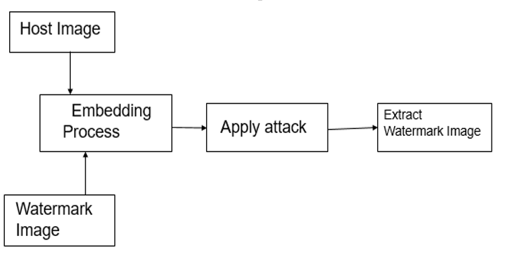

Figure 2.1 : Watermarking technique

**2.2.3 Watermarking Applications**

**Copyright protection** Copyright protection which is done to determine unauthorized use of the multimedia element. Authentication of the right user and to secure a content watermarking is done. To protect ownership details, to prevent piracy attacks watermarking is done.

**Biometric Recognition** Watermarking is used in embedding intelligent fingerprint detection or Iris and other biometric features to get biometric signature. Using the features of multiresolution property of watermarking, biometric recognition is done .

**Piracy deterrence & detection of leaked content** Applications of content of owner’s ability to detect and powerful deterrence of leaked content. It sometimes shows where the attack was being applied to detect source of illegal usage.

**Creating robustness & within the capacity** Watermark is used to create a robust system, because fragile system creates vulnerability in ensuring copyright. Maintaining minimum capacity of the image is also done by watermarking.

**2.3 Contourlet Transformation**

It is a two-dimensional transform method for image representations.

It has properties of multiresolution, directionality, and anisotropy.

By using Contourlet transform contours of original images, can be captured effectively with a few coefficients . It providing precise geometric shapes of the image. It gives smooth contours and effective directions of the image providing better geometric shape than any other frequency domain transform. Though it lacks in giving good quality of image.

The decomposition in Contourlet transform is divided into two processes:

Laplacian Pyramid(LP) and the Directional Filter Bank(DFB).LP first decomposes into

low pass and bandpass image, where low pass image is further decomposed and

bandpass image passes to DFB where it achieves multi-resolution and multi-direction

property[1,2]. LP being used to get smooth contours, low to higher frequency

components of the image and directional edges. The Directional Filter Banks has

wedge-shaped partitioning( frequency) with 2k level subbands as there is K-Ievel binary

tree decomposition. For this decomposition the DFB is also called the Pyramidal Directional Filter Banks (PDFB).

Fig: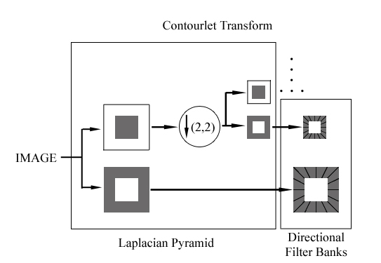

Fig 2.3.1: Contourlet Transform Decomposition

**Multi-resolution** It is used representing in more than one resolution. It also

represents multiple layers of resolution. It has important tools like image pyramids and wavelets. It has application of feature detection and compression techniques. It does add multi-scalability and multidimensional property.

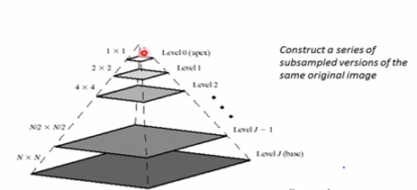

Fig 2.3.2 Multi-resolution of an image

**Multi-direction** Multi-directionality is directional information of smooth

contours and the directional edges of the image.

**2.4 Curvelet Transform**

The curvelet transform analyses an image with different block sizes, but with a single

transform. The idea is to first decompose the image into a set of wavelet bands, and

to analyze each band by a ridgelet transform. The block size may well be changed

at each scale level. In this paper 2nd generation curvelet transform is done. It consists of

USFFT and Wrapping is done.

The Unequally-Spaced Fast Fourier Transform version uses a decimated rectangular

grid tilted along the main direction of each curvelet. There is one such grid per scale and

angle, and this implementation is therefore very close to the definition. For the digital

transform, tilt of grids produces a resampling of the Fourier transform on

semi-regular grids, hence the use of USFFT system.

The wrapping version uses in lieu of a decimated rectangular grid aligned with the

image axes. For a given scale, there are essentially two such grids (decimated mostly

horizontally or mostly vertically). The resulting sampling is not as faithful to the

original transform, but the basis functions are curvelets as much as in the USFFT-

based implementation.

* 1. **Hyper Chaotic Scrambling**

Image scrambling is a method of encrypting digital images . It gives the authentic users ruling over the of algorithms and use of technique of random number. It is based on nD dimensional (n-D) generalized hyper-chaotic cat map.

Transformation matrix in n-D map is constructed by using n(n-1)/2 transformation sub-matrix multiplication. Secondly , the possible sorting numbers of transformation sub-matrix multiplication are used as encrypted keys, which is applied to image encryption. It is Sensitive to initial conditions and values.

This outspreading of sub-matrices cover up entire matrix. If two initiatory points chosen are very close to each other, the distance between their successive under chaotic map diverges exponentially . It has a large key space size. Two Lyapunov exponents are there also.

dx1/dt=a*x1-x2*x3;

dx2/dt=x1*x3-b*x2;

dx3/dt=c*x1*x2-d*x3+g*x1*x4;

dx4/dt=k*x4-f*x2;

**Chapter 3**

**Methodology**

In this chapter the overview of the overall system are given. The proposed embedding process and extraction process are described in this chapter.

**3.1 Overview of the Overall System**

Watermarking is a data hiding technique. It is very popular because of having author or owner’s copyright information. Watermarking techniques are of three parts. They are watermark embedding, apply attacks and extract watermark. Here input is original image, then we apply watermark embedding, apply attack and extract watermark. We find output as MSE, PSNR and co-relation calculation of watermark image.

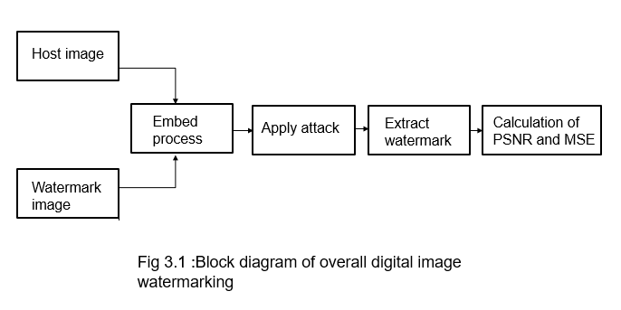**3.2 Embedding Process:**

**3.2.1 Image Resizing**

Host image is resized to 512*512 pixels.

**3.2.2 Apply two level Contourlet Transform on host image:**

Apply two level Contourlet Transform and decompose the host image into low band and band pass image. The low band image is further decomposed using Laplacian Pyramid as per as the level. For bandpass image it is processed in the DFB. LP decomposes in 2^k sub-bands. Then except for the low pass image, again it is decomposed into further lower bands.

Recursive call on lower band is done on LP. Then the coefficients is saved in a variable.

**3.2.3 Divide the horizontal coefficients set into 8*8 blocks:**

Divide the decomposed image into set of coefficients. As it is divided into set of coefficients, it is mainly divided into cell array. Transform it into double value and do further processing.

**3.2.4 Apply Curvelet Transform on the host image**

Apply Curvelet transform on host image and decompose it in frequency bands. Here unequally spaced fast fourier transform & fdct wrapping with number of coarsest wavelet level and number of angles is applied. Low frequency is saved in variables.

**3.2.5 Convolute the decomposed images**

The images then convoluted to get a convoluted matrix. Convolution helps in smoothing, sharpening, and edge detection of images.

H(i,j)= F(i,j) ○ f(i,j).

Here F(i,j) is decomposed matrix in Contourlet transform, f(i,j) is decomposed matrix in Curvelet transform, o is convolution symbol.

**3.2.6 Scramble watermark using hyper-chaotic cat map :**

Scrambling using hyper chaotic cat map is done. It has a large encryption key. It increases watermark secrecy and security level.

**3.2.7 Convert watermark into binary format:**

Convert the watermark image into a binary sequence is done.

**3.2.8 Generate pseudorandom sequence:**

Generate two uncorrelated pseudorandom sequences by using a key. One sequence is used to embed the watermark bit 0 (seq_0) and the other sequence is used to embed the watermark bit 1(seq_1). Pseudorandom sequences are used to increase security level.

**3.2.9 Low frequency embedding**

Embed the two pseudorandom sequences with a robustness factor ἀ in the convoluted matrix(low band) of the host image. Instead of embedding in all coefficients, it embeds only to the low frequency of convoluted matrix coefficients.

If we denote L as the matrix of the low frequency coefficients of the convoluted block,

then if watermark bit is 0,then

L’=L+ (ἀ seq _0).

If watermark bit is 1, then

L’=L+ (ἀ seq _1).

**3.2.10 Apply inverse Curvelet Transform**

Perform the inverse curvelet of the low band coefficients after embedded watermarked bits as described.

**3.2.11 Inverse Contourlet Transform**

Then we apply inverse Contourlet on the transformed image, to produce watermarked host image.

**3.2.12 Justify the watermarked image**

Then we compare the watermarked image with original image.

Let D be the difference between two images(original image I and watermarked image W).

Scramble using Hyper Chaotic Cat Map

Apply Curvelet Transform

Apply two level Contourlet Transform

Watermark Image Formation

Apply Convolution

Generate two Pseudo-Random Sequence PN_0 & PN_1

Embedding Algorithm

Apply Inverse Curvelet Transform

Watermark Bit

Apply Inverse Contourlet Transform

X’=X+ἀPN_1

X’=X+ἀPN_0

Fig 3.

**3.3 Attack on Watermarked Image**

Attack on watermarked image is second part of digital image watermarking overall system. In our propose method we apply total five attacks on watermarked image. List of the attack are following:

* Salt & Pepper Noise.
* Gaussian Noise.
* Poisson Noise.
* Speckle Noise.
* JPEG Compression.

**3.4 Watermark Extraction Process**

To extract watermark bits from the watermarked image the following steps are needed:

**3.4.1 Filtering operation**

Perform pre-filtered operations on the watermarked image.

**3.4.2 Apply 2-level Contourlet Transform**

Apply 2-level Contourlet transform on pre-filtered watermarked image to decompose it.

**3.4.3 Divide the horizontal coefficients set into 8 blocks:** Divide the horizontal coefficients set into 8 blocks.

**3.4.4 Curvelet transform on selected coefficient set:** Apply Curvelet transform on chosen co-efficient set.

**3.4.5 Generate pseudorandom sequences :** Regenerate the two pseudorandom sequences seq _ 0 and seq _ 1 using the same key that was used in the watermark embedding procedure.

**3.4.6 Calculate correlation:** For low-band coefficients and the two generated pseudorandom sequences find out the correlation with seq_0 is higher than the correlation with seq_1,then extracted watermark bit is considered 0,otherwise the extracted watermark bit is considered 0,otherwise the extracted watermark is considered 1.

**3.4.7 Reconstruct extracted watermark :**

The scrambled watermark is reconstructed using the extracted watermark bits.

**3.4.8 Compute the similarity:**

Scramble the extracted watermark with extracted watermark with hyper-chaotic cat map and gain the scrambled watermark.

**Chapter 4**

**Implementation**

In the chapter we will describe the total implementation process of watermark bit embedded into the host image. Then, the different types of attacks that are applied on to the watermark image,will be described. Finally, the implementation process of watermark extraction from the watermarked image is described.

**4.1 Embedding Process**

**4.1.1 Image resize**

Host Image is first resized into height of 512 and width of 512 pixel and gray image is taken.

**4.1.2 Apply two level Contourlet Transform on host image:**

Apply two level Contourlet Transform on host image and decompose the host image into low band and band pass image. The low band image is further decomposed using Laplacian Pyramid as per as the level. For bandpass image it is processed in the DFB. LP decomposes in 2^k sub-bands. Then except for the low pass image, again it is decomposed into further lower bands.



(a)

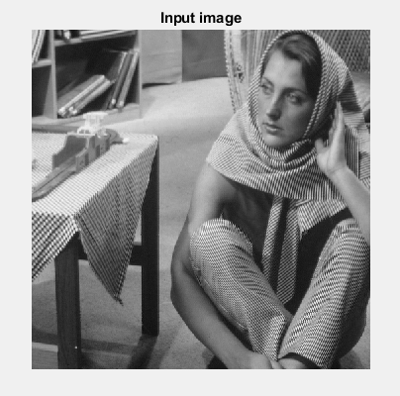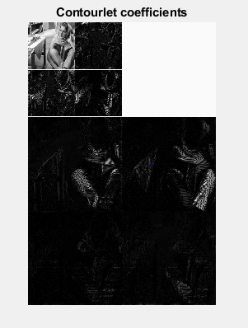

(b) (c)

Fig : 4.1 : (a) Image decomposition process, (b) Host image, (c) Decomposed image.

**4.1.3**  **Divide into blocks decomposed image**

The decomposed image the further resized into 8blocks .

**4.1.4**  **Apply Curvelet Transform on the host image**

Apply Curvelet transform on host image and decompose it in frequency bands. Here, first rescaled with 256 levels and options are taken. Then perform Curvelet transform on rescaled image. So cell array is created as {1 , {1 , {1 , {1 spaced four cells.

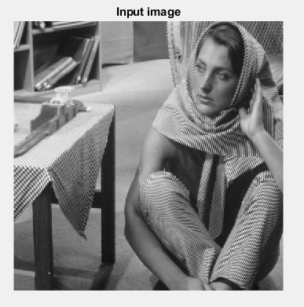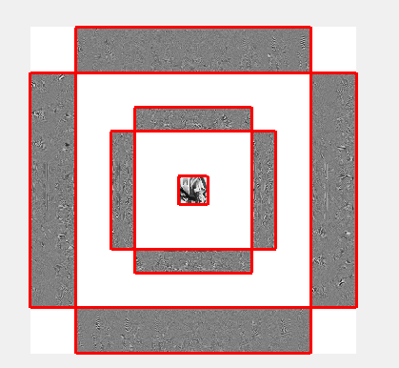

1. (b)

Fig 4.2: Curvelet Transform (a) Host image, (b) Decomposed image.

**4.1.5 Convoluting two images after using cell2mat function:**

After taking cell2mat on a low band image we get matrix which we use cell2mat to make it an matrix from cell as it is inconvenient to work with cell-arrays. We reshape the matrix then by necessary dimension we convolute the matrix.

**4.1.6 Scramble the watermark image:** We apply hyper-chaotic cat map to scramble the watermark image. We take peppers as this watermark image.

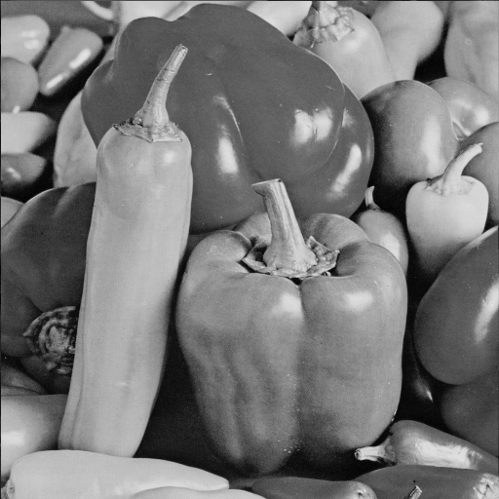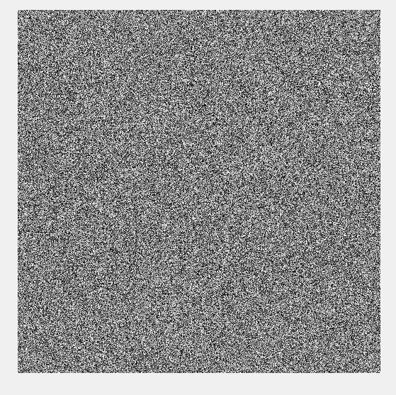

1. (b)

Fig 4.3 Scrambled Image (a) Watermark image, (b) Scrambled image.

**Watermark formation:** Convert the every watermark bit into 0 or 1.

**4.1.7 Generate Random Sequence:** Generate two uncorrelated pseudorandom sequence by using a key.

One sequence is used to embed the watermark bit 0.

Another sequence is used to embed the watermark bit 1.

The two uncorrelated pseudorandom sequence is given below:

Pseudorandom Sequence for one is : seq _1: 0 0 0 1 0 1.

Pseudorandom Sequence for zero is : seq _0: 0 0 1 -1 1 0.

**4.1.7 Embedding position :** Watermark bits are embedded in the low frequency coefficients.

**4.1.8 Embedding equation :**

Lowband ,L= [ 1, 1, 1,0;

1, 1, 0, 0;

1, 0, 0, 0;

0, 0, 0, 0];

If watermark bit is 0, then L’=L+ (ἀ seq_0)

L’=[ 1.2500 -0.3431 72.500 -74.4815;

70.1327 -0.6036 -0.0396 0.5000;

0.0000 0.0957 0.2500 0.2310;

0.9171 -0.5000 0.5576 0.1036];

If watermark bit is 1, then L’=L+ (ἀ seq_1).

L’=[ 1.2500 -0.3431 -0.5000 71.5815;

-2.8673 -72.3964 -0.0396 0.5000;

0.0000 0.0957 0.2500 0.2310;

0.9171 -0.5000 0.5576 0.1036];

Where L denotes the matrix of low frequency coefficients.

**4.1.8 Apply Inverse Curvelet Operation :**

Then inverse Curvelet using threshold to reconstruct image operation is done.

**4.1.9 Apply Inverse Contourlet Operation :**

Then inverse Contourlet (pdfbrec) to reconstruct image operation is done.

**4.1.10 Weighted correlation :**

Then to find the watermarked image weighted correction is done.

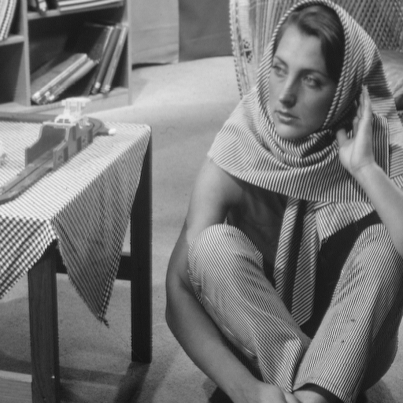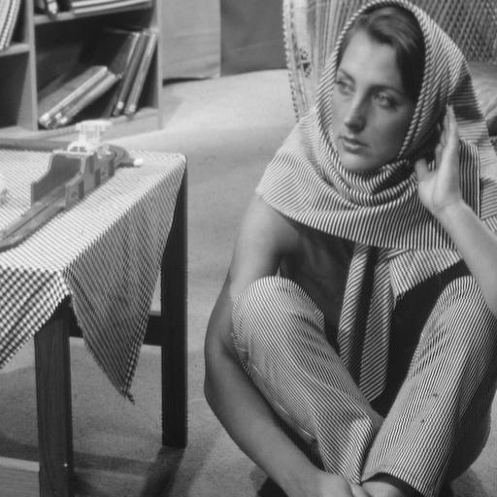

1. (b)

Fig 4.4: (a) Host Image, (b) Final Watermarked image using weighted correction.

**4.2 Attacks on Watermarked Image**

Watermarking has second part of applying attack on watermarked image. We aapply different types of attacks on watermarked image.

They are given below:

* Salt & Pepper Noise.
* Gaussian Noise.
* Speckle Noise.
* Poisson Noise.
* Compression.

**4.2.1 Salt & Pepper Noise**

Salt and pepper noise is typical and common noise on images. It represents itself as randomly occurring when we see white and black spots on an image.

**4.2.2 Gaussian Noise**

It follows Gaussian distribution of probability density function. It is commonly called additive white Gaussian noise as it yields additive white noise also.

**4.2.3 Speckle Noise**

It degrades the quality by random fluctuation in the return signal. It increases the mean gray level of a local area.

* + 1. **Poisson Noise**

Noise that follows Poisson distribution. It is a discrete probability distribution that expresses the probability of a given number of events occurring in fixed interval of time or space.

* + 1. **JPEG Compression**

It is one of the most famous compression techniques. Compression can be lossy or lossless compression. JPEG is being a lossy compression technique. By using DCT(Discrete Cosine Transformation) as a transformation tool it makes the co-ordinates being altered so it begets a lossy compression for image.

* 1. **Watermark Extraction**

**4.3.1 Apply Two Level Contourlet Transform:**

Two level of Contourlet Transform is applied on watermarked image to decompose it into low band multi-resolution coefficients.

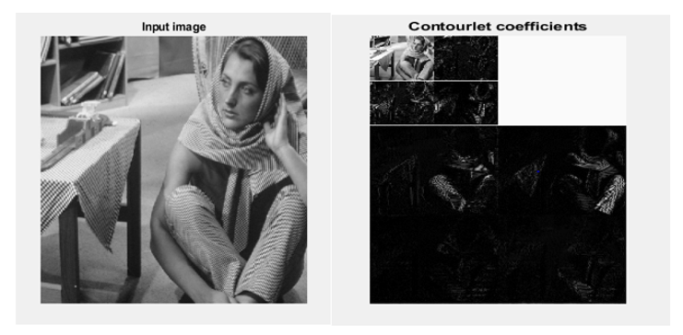

1. (b)

Fig 4.5 (a) Watermarked image, (b) Decomposed watermarked image.

**4.3.2 Resize and divide coefficients set into 8 blocks:**

Divide the coefficients into 8 blocks and height of 512, width of 512 .

**4.3.3 Apply Curvelet Transform:**

After using cell2mat use Curvelet transform co-efficients on the lower band of the image.

* + 1. **Generate Random Sequence:**

Generate two uncorrelated pseudorandom sequence by using a key. One sequence is used to embed the watermark bit 0 and another is used to embed the watermark bit 1. The generated two uncorrelated sequences are given below:

Pseudorandom Sequence for one is : seq _1: 0 0 0 1 0 1.

Pseudorandom Sequence for zero is : seq _0: 0 0 1 -1 1 0.

* + 1. **Correlation Calculation:**

For each block in the coefficient set calculates the correlation between lowband coefficients and two pseudorandom sequences.

If the correlation with seq_0 is higher than with seq_1, then the extracted watermark bit is considered 0, otherwise it is 1.

* + 1. **Reconstruct the watermark and scramble the watermark:**

Extracted watermark with hyper-chaotic sequence and gain scrambled watermark. Compute the similarity between the original and extracted watermarks.

**Chapter 5**

**Experimental Results and Analysis**

At first we will describe the quality measurement and factors to determine the watermarking quality in this chapter. The experimental result and performance analysis with compared to another method are also described in this chapter.

**5.1 Image Quality Measurement**

Measurement of the quality of image compression is important for image processing applications. Measurement using human visual system and making the watermark imperceptible is a goal. As well as quality measurement components such as MSE, PSNR and correlation values are used.

**5.2 Factor to Determine Watermark Quality**

Imperceptibility and robustness are two factors that determine the quality of watermarking. The descriptions of imperceptibility and robustness are given below:

**Imperceptibility :** It means the perceived quality is not distorted by presence of watermark. As a measure of the quality of a watermarked image , the peak signal to noise ratio is typically used. The PSNR is being utilized to calculate similarity between original image and watermarked one.

PSNR= 10 log10 2552/MSE.

MSE is mean square error. Which will be computed firstly and then PSNR value will be calculated.

**Robustness :** It is a measure of the immunity of the watermark against different attacks,=. We measure the similarity between the original and extracted watermark after attack using the Normalized Correlation(NC) factor.

**5.3 Experimental Results**

Simulations were done using standard gray scale image( Barbara, Lena, Peppers etc.) Different types of attacks were performed on the watermarked image.

In the Barbara image watermark was visually imperceptible after watermarking and the PSNR value was 30.5929 without denoising. The recovered watermark showed the NC was 0.9876.

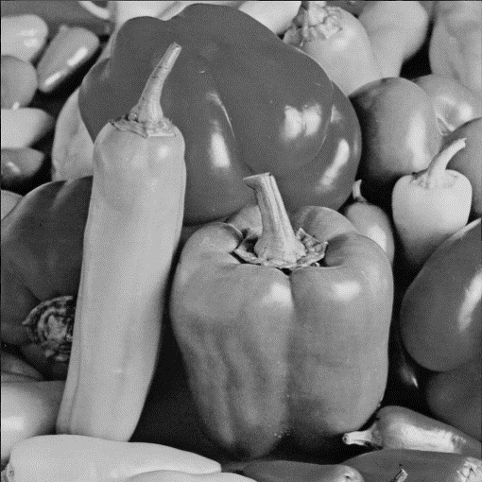

1. (b)

Fig 5.1 (a) Watermarked image,

(b) Retrieved image.

**5.3.1 Noise attack**

We can see the image was clearly attacked by noise and damaged in some areas.

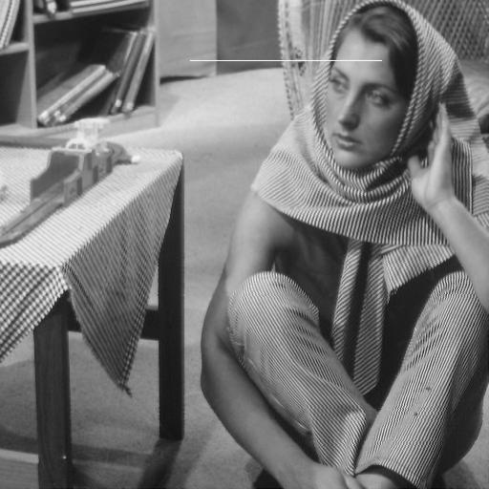

Fig 5.2: Noise attacked image.

**Chapter 6**

**Conclusion**

In this paper, a combined Contourlet and Curvelet based watermarking technique with low frequency watermarking is proposed. In this research, we have chosen low frequency region for embedding the watermark and pseudo-random bits are generated for the sequence ( 0 and 1 ) bits. To improve scalability as well as finding smooth contours and curves across the image is one of the best features provided by this research work.

Various attacks were done to see if the watermarked image can withstand attacks. The experimental result shows high PSNR and NC values which proves it’s imperceptible property. It gives smooth contours and propitious image quality also.

**6.1 Future Recommendation**

This project should have been done in OpenCV rather matlab. As there are many bugs to turn from to matrix it makes difficult to use it.

* RGB image as well video watermarking can be done to see it’s performance.
* The proposed method can be used for multi-scale and multi-resolution biometric authentication with encrypting with hyper-chaotic system as scrambling method.

**Bibliography:**

[1] Preeti Sharma, Pallvi Chawla “Robust Digital Watermarking using Contourlet Transform for Coloured Images” *Third International Conference on Image Information Processing*,2015.

[2]Sirvan Khalighi, Parisa Tirdad, and Hamid R. Rabiee “A Contourlet-Based Image Watermarking Scheme with High Resistance to Removal and Geometrical Attacks” *Hindawi Publishing Corporation EURASIP Journal on Advances in Signal Processing* Volume 2010, Article ID 540723, 13 pages.

[3] YuqiangCaol, Weiguo Gongl, Mingwu Cao, SenBai,“ROBUST BIOMETRIC WATERMARKING BASED ON CONTOURLET TRANSFORM FOR FINGERPRINT AND FACE PROTECTION”*International Symposium on Intelligent Signal Processing and Communication Systems (lSPACS 2010)* December 6-8,2010.

[4] [M. Brindha](https://ieeexplore.ieee.org/search/searchresult.jsp?searchWithin=%22First%20Name%22:%22M.%22&searchWithin=%22Last%20Name%22:%22Brindha%22&newsearch=true) “Periodicity analysis of Arnold Cat Map and its application to

# image encryption”[*2017* *International Conference on Inventive Computing and Informatics (ICICI)*](https://ieeexplore.ieee.org/xpl/mostRecentIssue.jsp?punumber=8360186) 23-24 Nov. 2017.

# [5] [Weigang Zou](https://ieeexplore.ieee.org/search/searchresult.jsp?searchWithin=%22First%20Name%22:%22Weigang%22&searchWithin=%22Last%20Name%22:%22Zou%22&newsearch=true), [Jiangyan Huang](https://ieeexplore.ieee.org/search/searchresult.jsp?searchWithin=%22First%20Name%22:%22Jiangyan%22&searchWithin=%22Last%20Name%22:%22Huang%22&newsearch=true), [Caiying Zhou](https://ieeexplore.ieee.org/search/searchresult.jsp?searchWithin=%22First%20Name%22:%22Caiying%22&searchWithin=%22Last%20Name%22:%22Zhou%22&newsearch=true) “Digital Image Scrambling Technology Based on Two Dimension Fibonacci Transformation and Its Periodicity”  [*2010 Third International Symposium on Information Science and Engineering*](https://ieeexplore.ieee.org/xpl/mostRecentIssue.jsp?punumber=5945013)24-26 Dec. 2010.

[6]Chaoxia Zhang “Hyper-chaotic cat map and its application in image processing” *Applied Mechanics and Materials Vols. 278-280, pp 1392-1396*.

[7] C.Venkata Narasimhulu K.Satya Prasad “A New SVD based Hybrid Color Image Watermarking for Copyright Protection using Contourlet Transform” *International Journal of Computer Applications (0975 – 8887) Volume 20.*

[8]SALAM ABDULNABI THAJEEL, 1LAMYAA MOHAMMED KADHIM,

1SALLY ALI ABDLATEEF “A NEW COLOR IMAGE WATERMARKING TECHNIQUE

USING MULTIPLE DECOMPOSITIONS” ***Journal of Theoretical and Applied Information Technology*** 31st May 2017. *Vol.95. No 10*