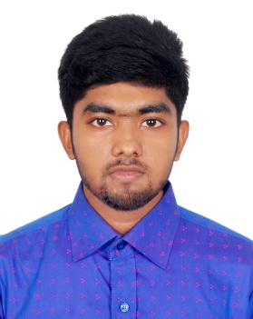**CURRICULUM VITAE**

**OF**

**Kazi Tokir Ahmed Shawon**

House-122, Road-02, Block-A, Bashundhara R/A,Dhaka-1229

Cell: +8801621875088, Email:kazitokirahmed@gmail.com

**Career Objective:** I would like to work proper responsibilities which will utilize my talent and provide me the wider opportunity to develop a career in a challenging and dynamic environment and ensure proper satisfaction with achievements based on my performance.

**Language Skills:**

* Native Bengali Speaker
* Fluent in English
* Intermediate in French
* Intermediate in Arabic

**Functional Skills:**

* Problem-Solving Abilities
* Good Analytical Skill
* Computer Operation and Maintenance
* Positive Attitude
* Fast Learner
* Project Management

**Technical Skills:**

* Programming Languages(C,C++,Python,java)
* Statical data analysis
* Database management(SQL)
* Web Design and Development(HTML,CSS,PHP)
* Operating System: Windows (XP,vista,7,8,10),Kali Linux
* arduino ,Arduino programming
* Software: MS Office, Matlab, Adobe Photoshop, Adobe Illustrator, etc.

**Work Experience:**

* Freelancer-Odesk.com(2015-2017)
* Freelancer-Fiverr.com(2018-Present)

**Educational Qualification:**

* Secondary school certificate (S.S.C):

Al-Jameatul Falahia Kamil Madrasah (Feni,Bangladesh)

Group-Science, Passing year-2015 ,GPA-4.94 (Out of 5)

* Higher Secondary school certificate (H.S.C):

Cambrian School and College (Dhaka,Bangladesh)

Group- Science, Passing year-2017 ,GPA-4.25 (Out of 5)

* Bachelors:

BSC in Computer Science And Engineering ,

Independent University Bangladesh

(Current Student)

Expected Graduation-2022

**Extra-Curricular Activities:**

* Active Member of IUB Jukti club
* Animater
* Graphics Art (victor,raster)
* Active Member of Bikoshito Shomash

**Personal Details:**

* Name : Kazi Tokir Ahmed Shawon
* Father’s Name : Kazi Nazir Ahmed
* Mother’s Name : Feroza Akter
* Date of Birth : 31-01-1999
* Nationality : Bangladeshi
* Sex : Male
* Religion : Islam
* Marital Status : Unmarried

**Reference:**

* **Mr. Moinuddin Chowdhury**

**Lead Visionary & Chief Executive Officer, Society for Leadership Skills Development (SLSD)**

25,Gulshan Ave,Dhaka-1212

Cell:+8801715015459,Email:moin@slsdbd.com

**Declaration:** I hereby declare that the above in for motion given in these curriculum vitae is true to the best out my knowledge.

**­**

.....................................

Signature Of Applicant

Date: