**Feature Description:**

Velocity is the rate at which the position of the stylus pen in the digitized tablet changes with time. Its unit has been measured in pixel/sec. Due to frequent oscillation of hand movement and struggle to keep the stylus pen stable on the surface, the amplitudes of the velocity in ET patients are not constant. It is observable from the figure that the amplitude of the velocity in control group is higher than the ET patients. Thus, calculating the velocity of spiral drawings from the x and y coordinates can be a good biomarker to distinguish between the healthy and tremor group and the severity level of ET patients. However, the regularity of amplitude and frequency is difficult to determine from the velocity of patients. Therefore, Welch’s Spectrogram method was used to determine the peak of the frequency and power spectral density. It was evident that the tremor patients have a higher frequency between 5-12 Hz. Using the peak detection method several numbers of peaks were found between 5-12 Hz from ET patients. On the other hand, the peak detection method found almost no peak from control group. One other method was used under the velocity feature was counting the number of times the velocity changes in each patient. As mentioned above, the amplitude is not constant in ET patients, so the number of times velocity changes is higher in tremor spirals than the healthy ones.

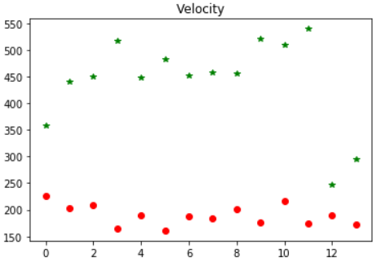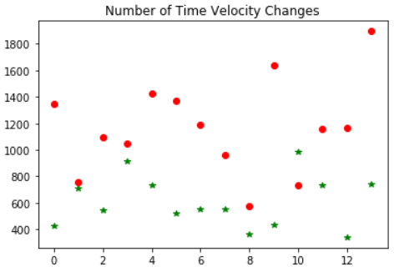

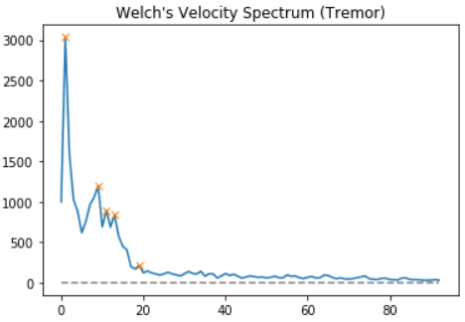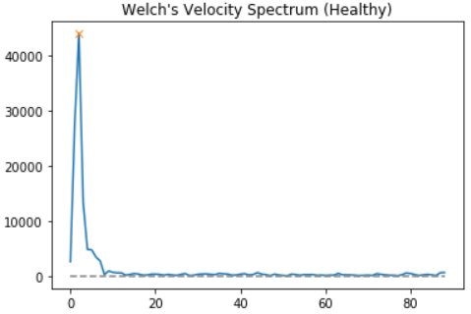

Acceleration is the rate at which the velocity of the stylus pen in the digitized tablet changes with time. Its unit has been measured in pixel/sec2. Being the first derivative of the velocity, this feature provides the same result. The acceleration of the stylus pen increases with increased force and decreases with increased mass. It is proportional to the direction of the force and inversely proportional with mass. Therefore, as the ET patients put high pressure by exerting mass on the digitized tablet and can’t force much, the acceleration rate decreases. Jerk is the rate at which the acceleration of the stylus pen in the digitized tablet changes with time. Its unit has been measured in pixel/sec3. ET patients make small oscillatory movements that don’t change the acceleration rapidly. The healthy spiral’s change of oscillation is high because the control group rapidly draw the circle in an inward direction.

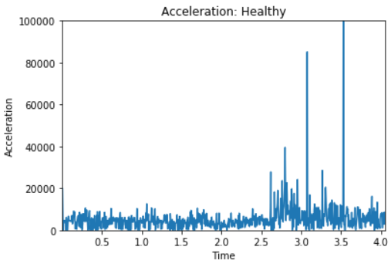 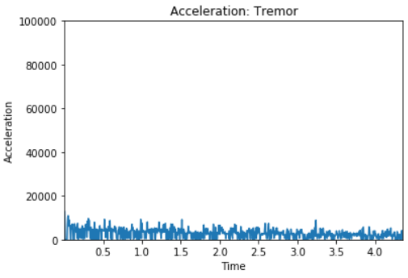

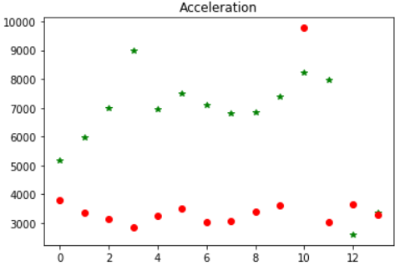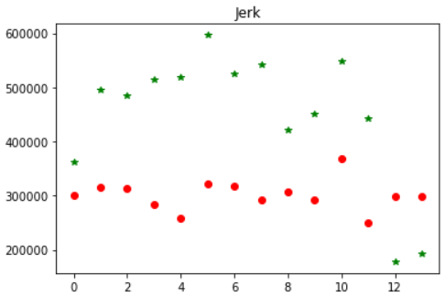

Discrete cosine transformation is used in lossy data compression because it has very strong energy compaction. Its large amount of information is stored in very low frequency component of a signal. DCT representation of a signal tends to concentrate more of its energy in a small number of coefficients compared to other transformations such as DFT. Therefore, this characteristic allows us to keep a small number of coefficients containing the fundamental information about the drawings. Type III discrete cosine transformation was applied to each x and y coordinate in order to get the coefficients. Then the inverse discrete cosine transformation was calculated and subtracted from original signal in order to get the remainder of the signal. This portion of the remaining signal has been used to calculate several time series features from spiral drawing. If we notice from the figure, we can see that the remaining signals for healthy patients are almost regular but in tremor patients the signals are bigger and irregular.

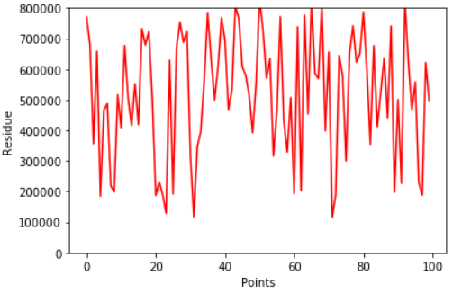 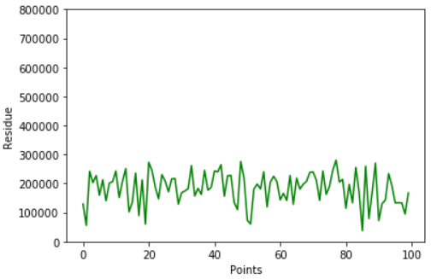

As the standard deviation is a measure of the amount of variation, a low standard deviation indicates that the values tend to be close to the mean of the set, while a high standard deviation indicates that the values are spread out over a wider range. From the standard deviation of the remaining signals it can be noticed that tremor spirals have high standard deviation than the healthy spirals. It means that due to frequent oscillation and high frequency between 5-20 Hz of tremor spirals, the points of the signal change abruptly causing the values spread out over a wide range. In order to evaluate the standard deviation further, we unraveled the spirals (transformed cartesian coordinate to polar coordinate). The absolute value of the angular speed for each point of theta was calculated and summed. We called this parameter as accumulation angle. Then we compared every spiral’s accumulation angle with the ideal spiral and calculated the standard deviation. From the standard deviation of accumulation angle, we also calculated the slope. The slope of a signal identifies how quickly the spectrogram of that signal goes towards high frequency.

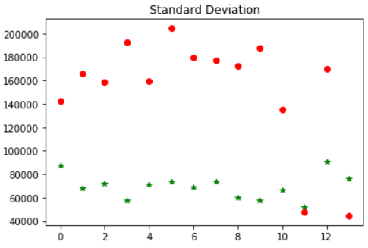

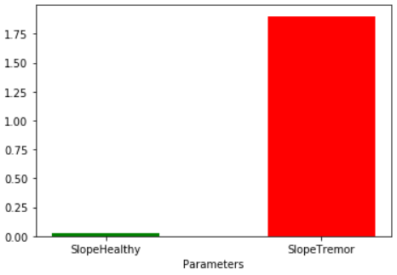 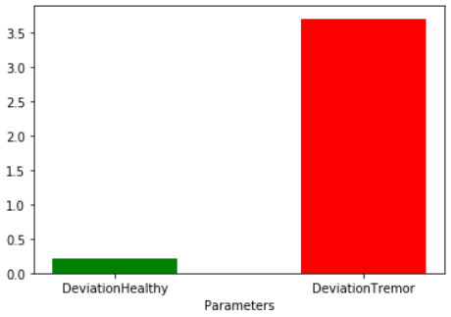

The entropy from each spiral’s residue was calculated as it was validated as an important feature. The entropy of a signal is a measure of how much information it really contains. In other words, it is the [average](https://en.wikipedia.org/wiki/Expected_value) rate at which [information](https://en.wikipedia.org/wiki/Information) is produced by a [stochastic](https://en.wikipedia.org/wiki/Stochastic) source of data. Although entropy is a measure of unpredictability of the state, while predicting the results we can learn new information about that state. Approximate entropy or sample entropy (modification of approximate entropy) is a technique which is used to quantify the amount of regularity and the unpredictability of fluctuations over time-series data. A time series containing many repetitive patterns has smaller approximate/sample entropy and a less repetitive patterns has higher approximate/sample entropy. The ET patient’s oscillatory movement in higher frequency induces many repetitive patterns in spirals compared to the spiral drawing of the control group. Permutation entropy indicates how the series behaves according to the sequence of original pattern. A low permutation entropy means non-uniform distribution of signal. Most of the tremor spirals have low permutation entropy because the probabilities of the points in the signal are not uniformly distributed. The spectral entropy of a signal is a measure of its spectral power distribution.

Fractral dimension is the space filling capacity of a pattern that tells how a fractral scales differently from the space it is embedded in. It measures the number of building blocks that are part of a pattern. Due to less smoothness and more oscillations, the fractral dimension is low in tremor spirals than the healthy ones. Singular value decomposition is a matrix consisting of the time-series data decomposed into left singular vectors which represent the patterns of the motion. The patterns of motion are less frequent in tremor spirals than the normal ones. For exponential smoothing, higher values of exponential factor indicate the reduced level of smoothing.

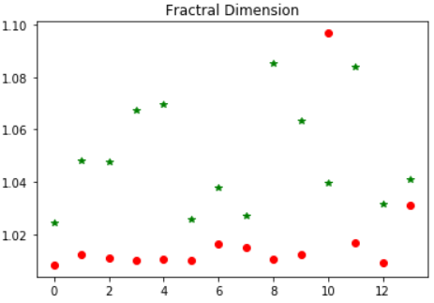

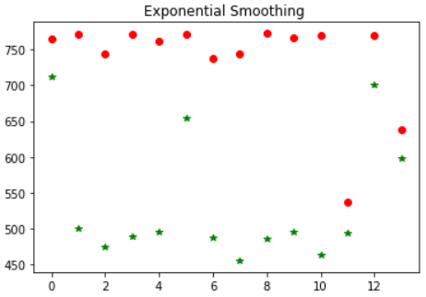

The force of pressure that exerts an ET patient with digitized stylus pen on the tablet is an important feature according to the analysis. Analysis has shown that the tremor patients frequently struggles to keep the pen in place and exerts more pressure than healthy people do.

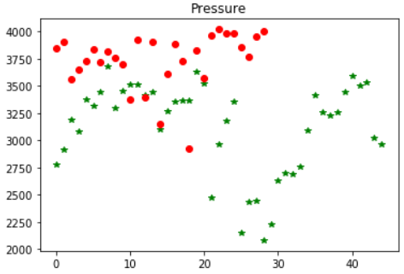

A supervised machine learning model has been developed with 17 features. Logistic regression classifier is implemented in the model by fitting PCA on training set to increase the speed of the algorithm. The accuracy of the algorithm was 93.33%. In order to check overfitting a cross validation technique is implemented with logistic regression. The accuracy score was approximately 97% which proofs our machine leaning model not overly fitted. To look up the significance level of the features we implemented Recursive Feature Elimination which is a type of wrapper feature selection method. From where we get following three of the best features scored 1:

1.Velocity

2. Number of times velocity changes

3. Peak detection from velocity spectrogram

Features:

[Velocity Amplitude, Velocity Spectrum Peaks, Acceleration Amplitude, Jerk Amplitude, Number of time velocity changes, DCT Standard Deviation, DCT Fractral Dimension, DCT Approximate Entropy, DCT Singular Value Decomposition, DCT, Sample, Entropy, DCT Spectral Entropy, DCT Permutation Entropy, DCT detrend fluctuation, DCT Autoregression, Unravelled Spiral Smoothing, Unravelled Spiral SARIMA, Pressure]

Ranks: [ 1 1 2 14 1 13 6 8 10 9 7 11 5 12 4 3]

To visualize the 17-dimension model, a 2-dimension PCA algorithm was implemented

