

Department of Computer Science and Engineering University of Dhaka

CSE – 2201
Database Management Systems-I

Project : Hospital Database Management System

Submitted to:

Mr. Abu Ahmed Ferdaus
Associate Professor
Department of Computer Science and Engineering
University of Dhaka.

Submitted by:

Kazi Shadman Sakib
Roll : FH - 097
Registration Number : 2017-614-973
2nd Year, CSEDU.

Introduction

Hospitals are the institution providing medical and surgical treatment and nursing care for any ill or injured people.
It is an integral part of social and medical organization. The function of Hospital is to provide complete health care to the needy one, both curative and preventive. It is also a center for providing training to health workers and center for bio-social research.

Project Description

The database which I have created contains information of Hospital, Branch name, Departments, Doctors, Patients, Operation, Bill and Treatment. This information can be used to keep track of number of Branches of a Hospital, number of Departments in a Hospital, which Doctor works for which Hospital’s Branch, which Patient gets treatment from which Hospital’s Branch and Department, Bills of Patients which is charged by a certain Hospital, where a Patient have Operation the most, Doctor’s specialties ect.

Design Phases :

Initial Phase : Characterizing fully the data needs of the prospective database users. In this case, Hospital.

Second Phase : An ER Diagram is created which resembles the actual Hospital. This diagram indicates the functional requirements of the Hospital enterprise.

Final Phase : Then moving from an abstract data model to implementation of the database. Here the Entity Relationship Model (ER Diagram) is converted into an Relational Model and corresponding tables are created.

Some queries are also shown at last as an example on how to analyze the data.

P.S – The tables were populated with randomly generated data.

Entity Relationship Model (ER Diagram)

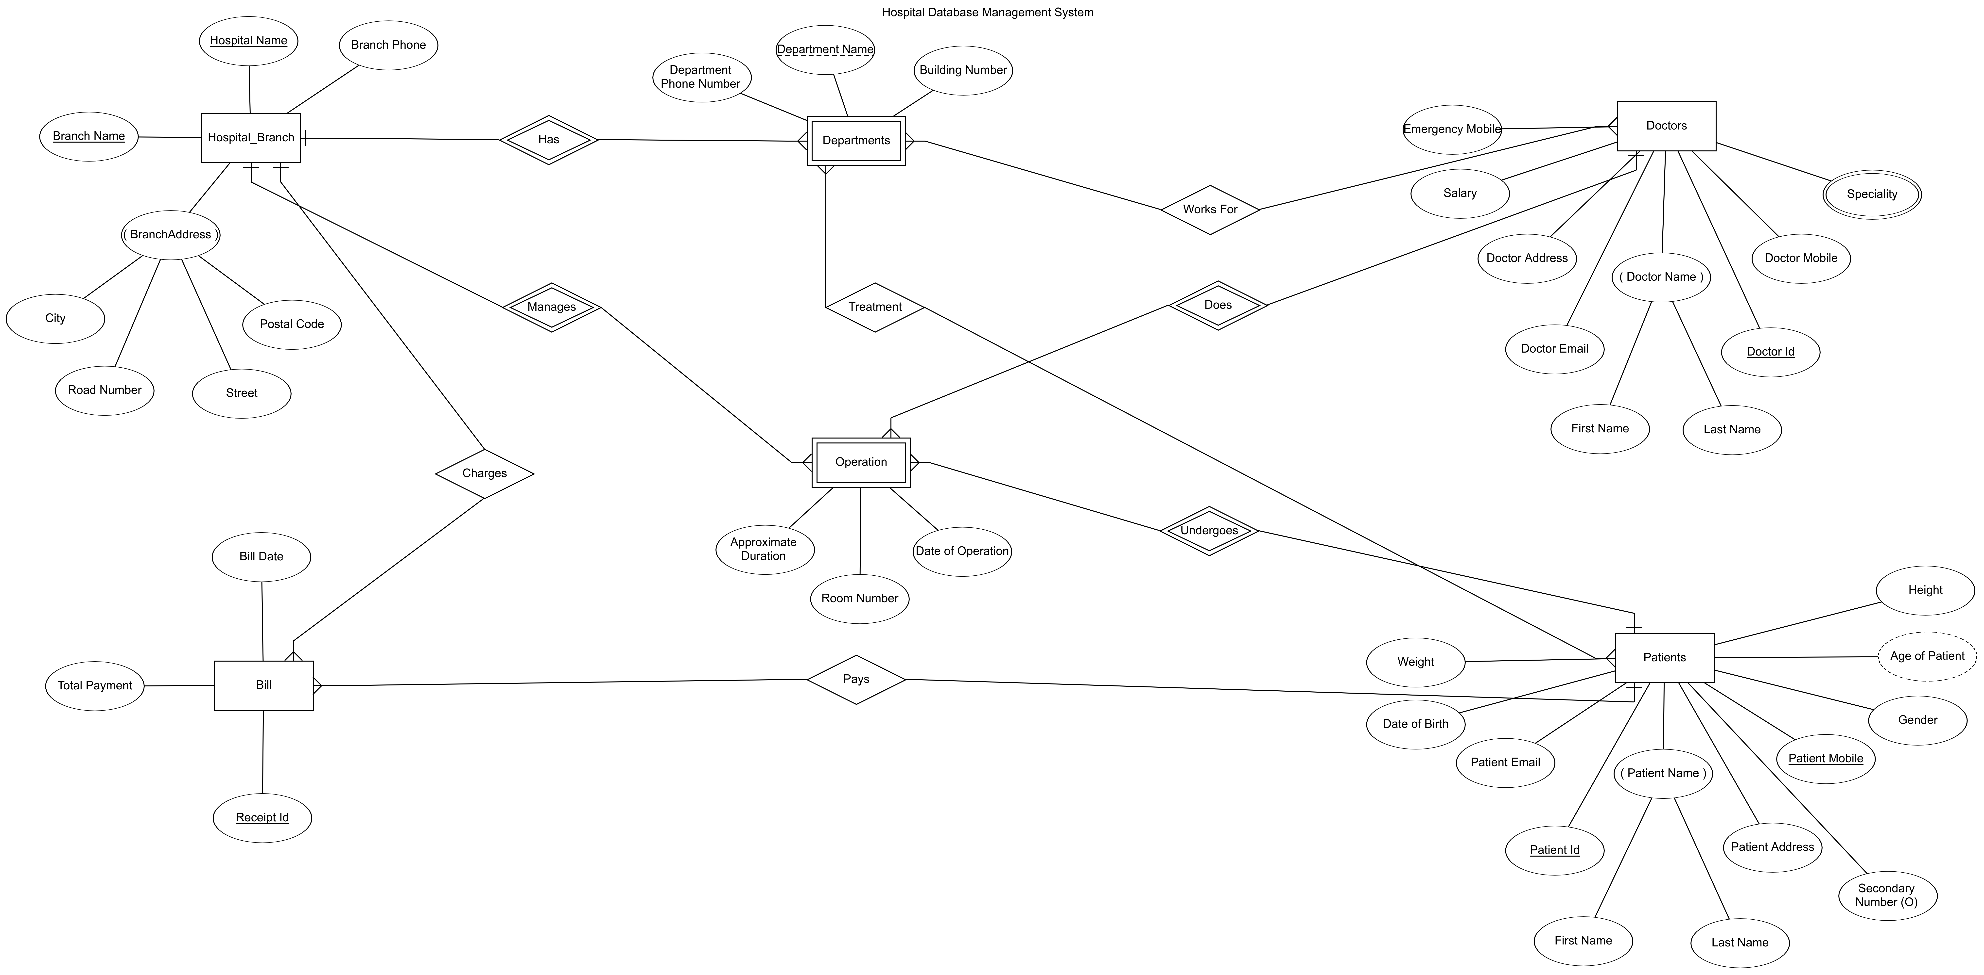

Schema of the Database with Attributes

Hospital_Branch(Hospital Name, Branch Name, City, Road Number, Street, Postal Code, Branch Phone)

Departments(Department Name, Hospital Name, Branch Name, Building Number, Department Phone Number)

Doctors(Doctor Id, First Name, Last Name, Doctor Mobile, Doctor Email, Doctor Address, Salary, Emergency Mobile)

Doctors Speciality(Speciality, Doctor Id)

Patients(Patient Id, Patient Mobile, First Name, Last Name, Date of Birth, Weight, Gender, Patient Address, Patient Email, Height, Secondary Number)

Works For(Doctor Id, Department Name, Hospital Name, Branch Name)

Operation(Doctor Id, Hospital Name, Branch Name, Patient Id, Patient Mobile, Date of Operation, Room Number, Approximate Duration)

Bill(Receipt Id, Total Payment, Bill Date, Hospital Name, Branch Name, Patient Id, Patient Mobile)

Treatment(Department Name, Hospital Name, Branch Name, Patient Id, Patient Mobile)

Schema Diagram of the Database

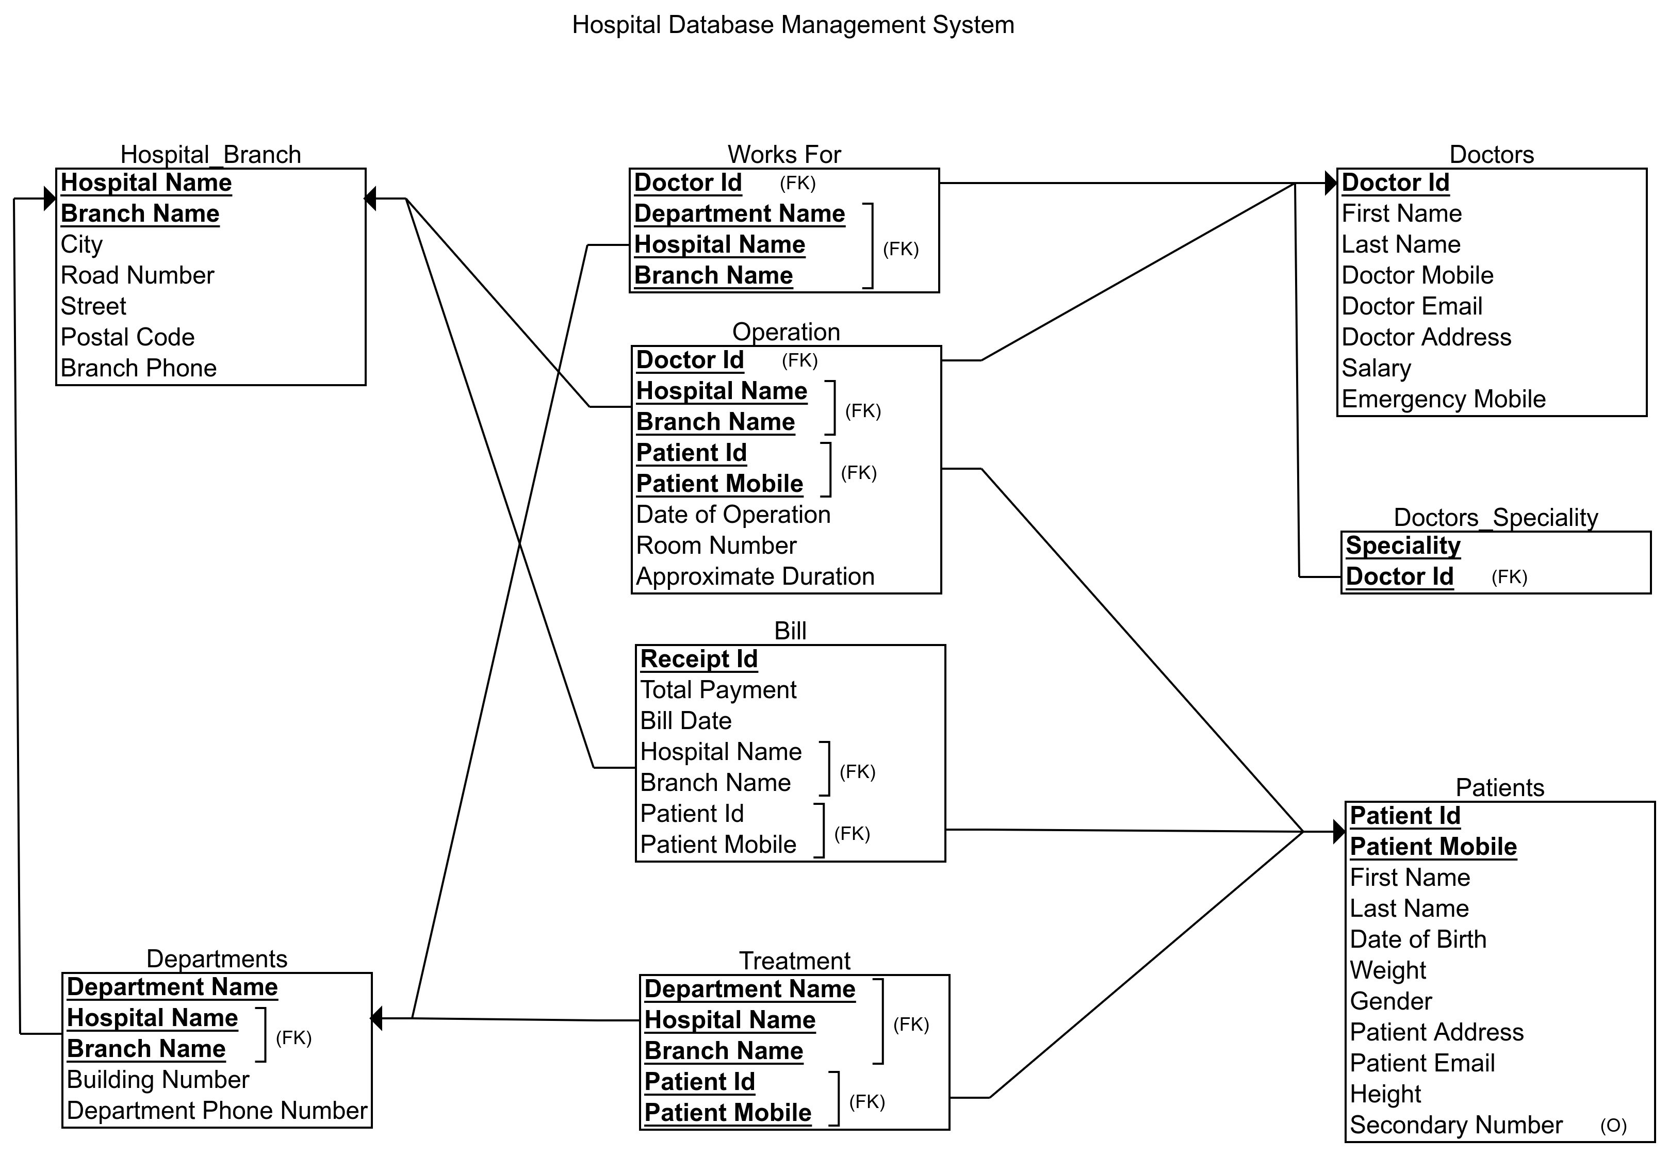

Snapshots of SQL DDL of all the Schema/Tables

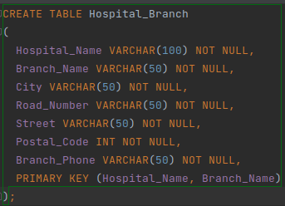
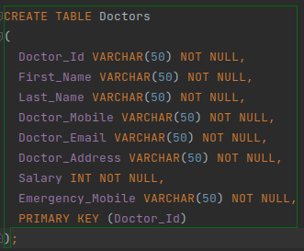

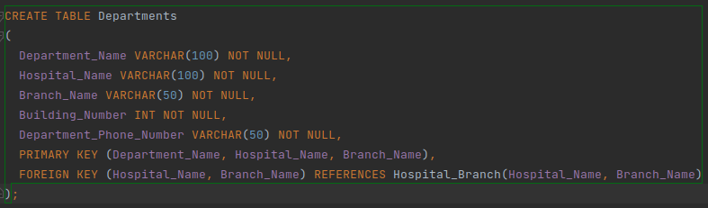

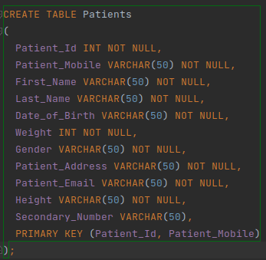
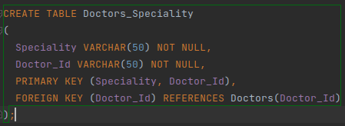

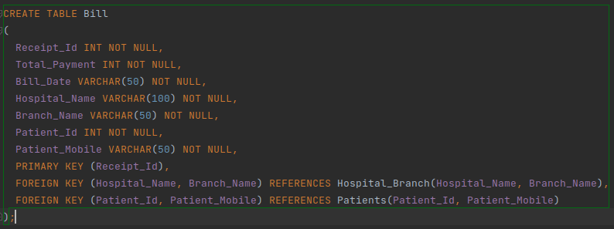
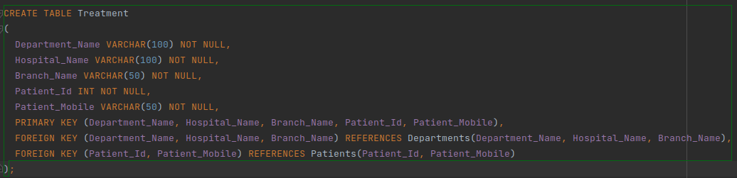
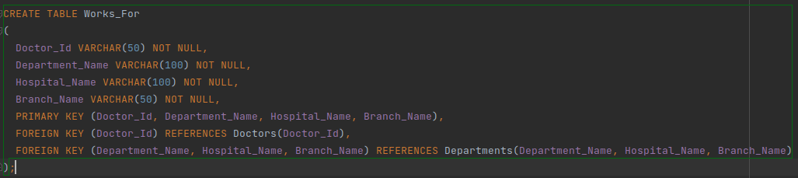
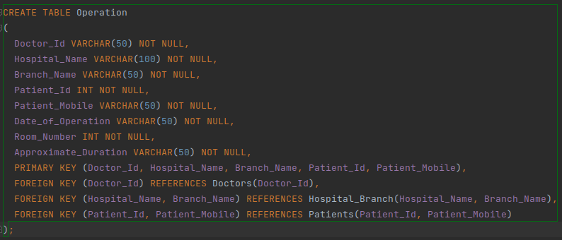

Snapshots of the Instances (Data of the Populated Tables)

Hospital_Branch :

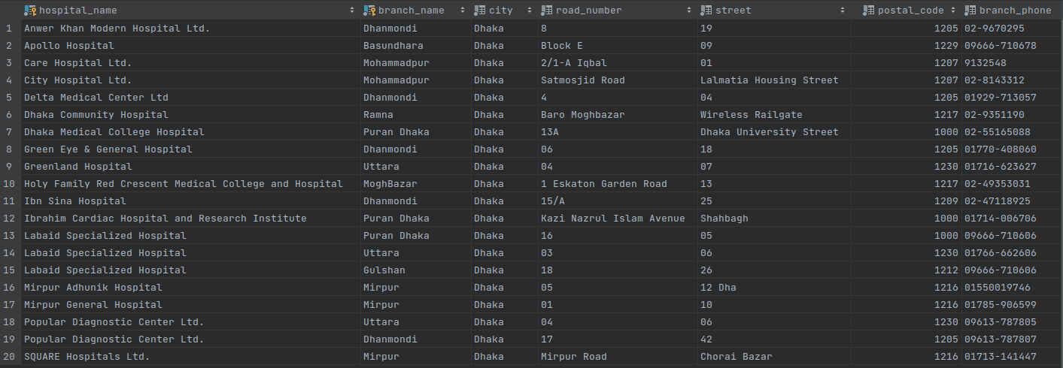

Departments :

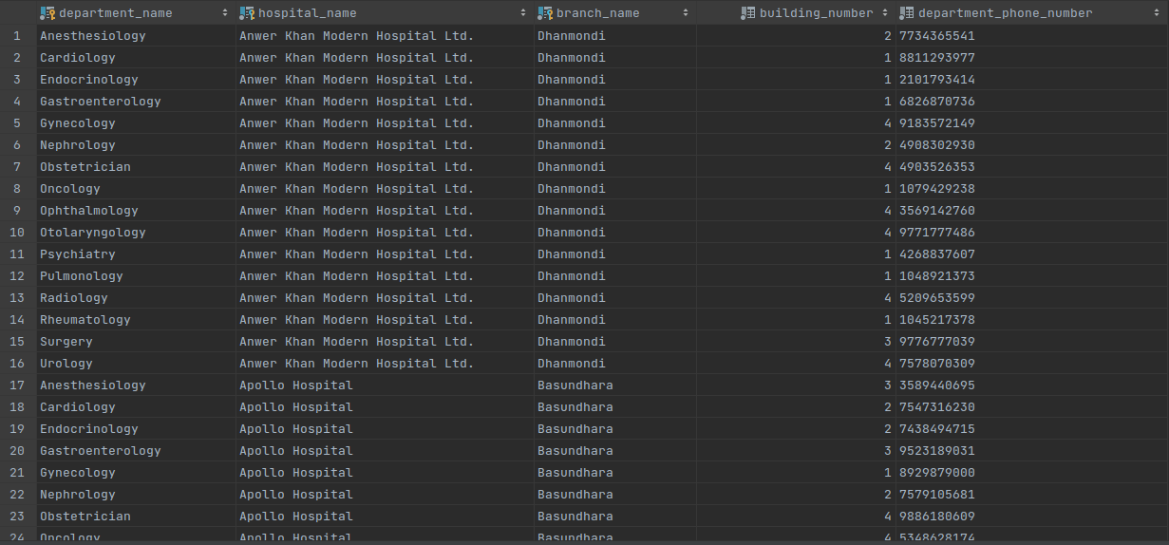

Doctors :

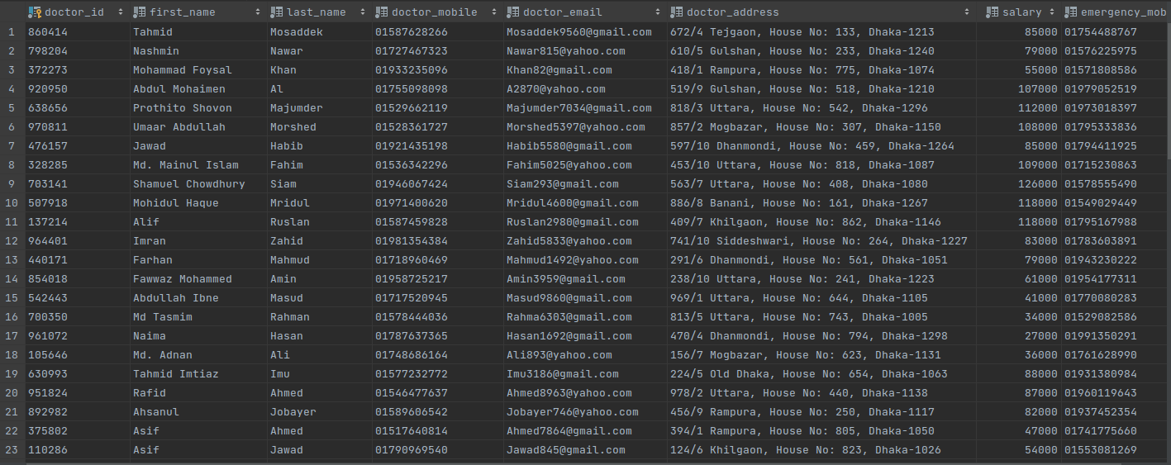
Doctors_Speciality :

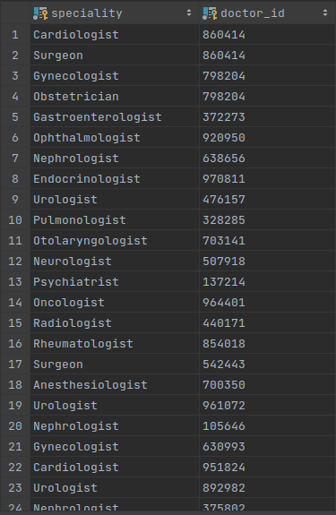

Works For :

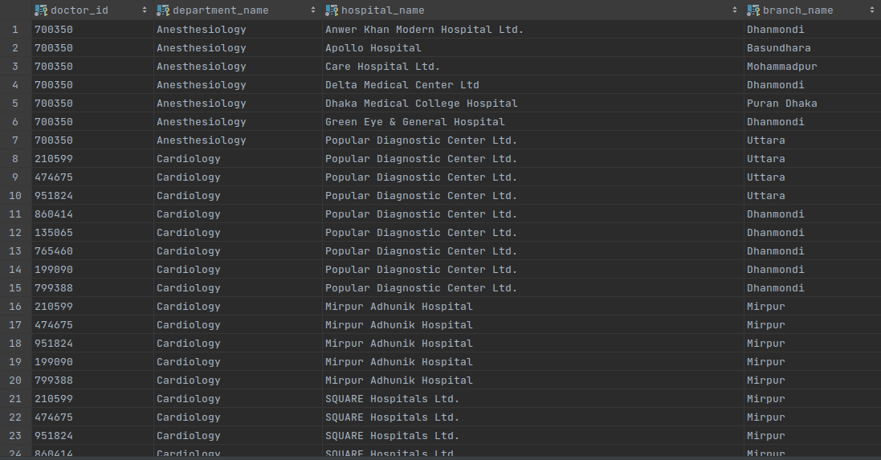

Patients :

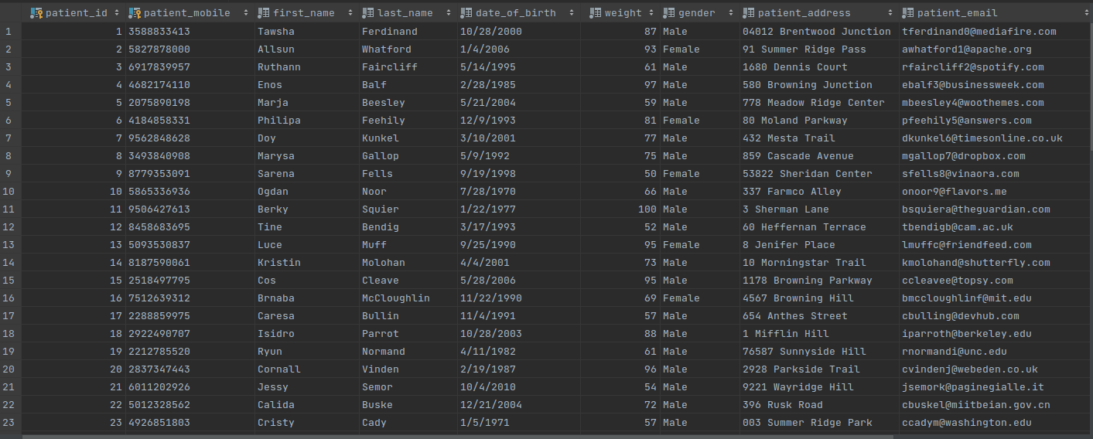

Treatment :

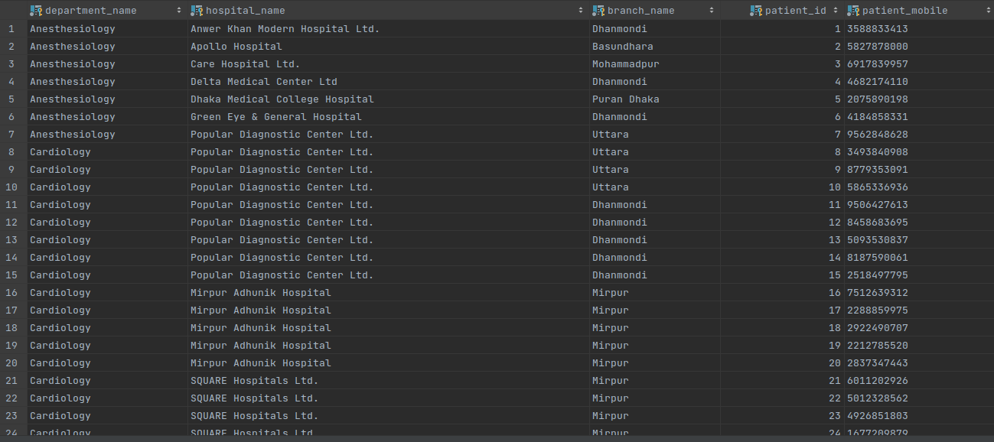

Operation :

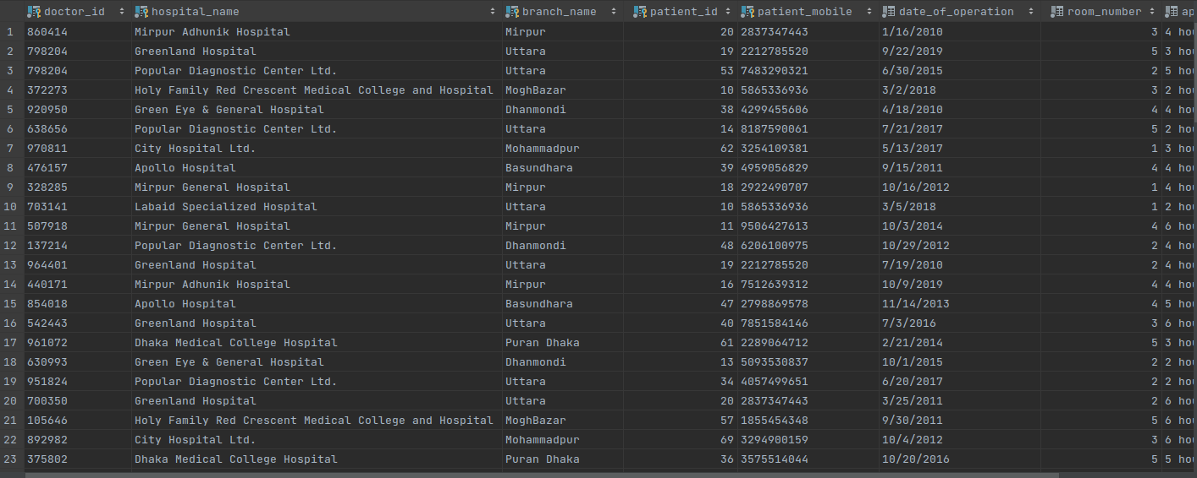

Bill :

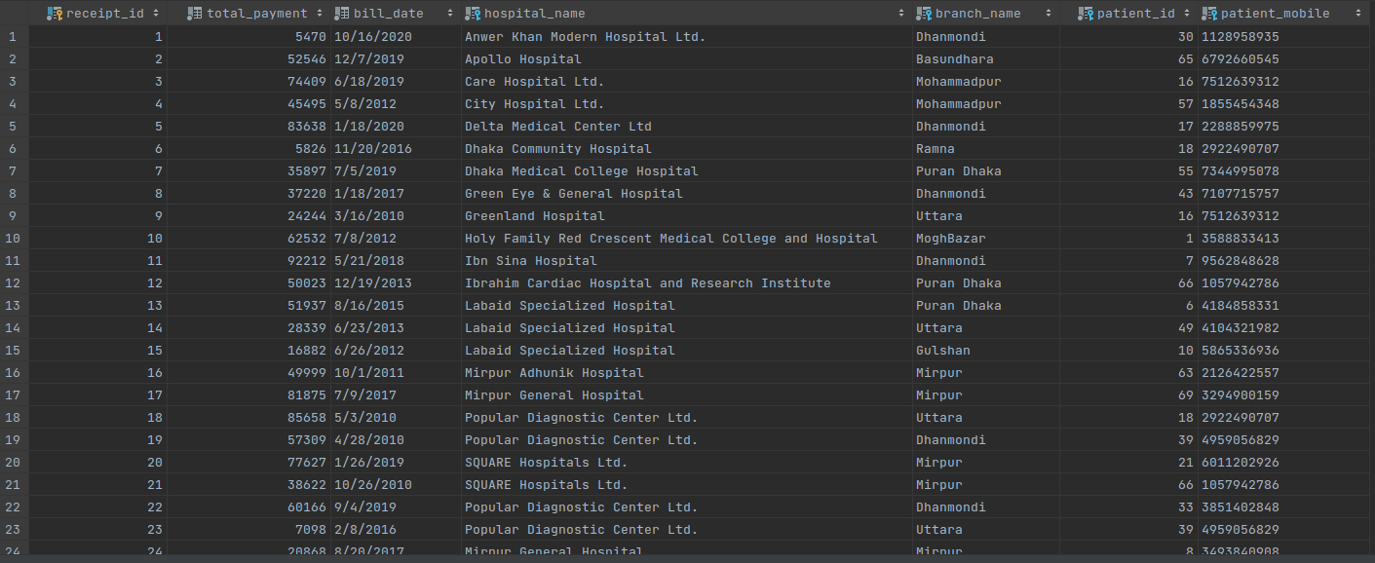

Query Statement, Relational Algebra Expression, SQL Statement

/* 1. List of all the hospitals which have a specific Department */
/* Basic Query */
SELECT Hospital_Name, Branch_Name
FROM Departments
WHERE Department_Name = 'Anesthesiology';

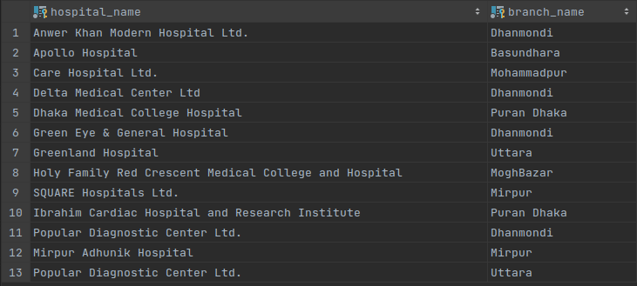
1. Relational Algebra Expression :

Π _{Hospital_Name, Branch_Name} (σ Department_Name = 'Anesthesiology' (Departments))

/* 2. List of patients whom are having an operation on a particular date */
/* Natural Join */
SELECT P.Patient_Id, P.First_Name, P.Patient_Mobile, O.Hospital_Name, O.Branch_Name
FROM Operation AS O NATURAL JOIN Patients AS P
WHERE o.Date_of_Operation = '10/20/2016';

2. Relational Algebra Expression :

Π Patient_Id, First_Name, Patient_Mobile, Hospital_Name, Branch_Name (σ Date_of_Operation = '10/20/2016' (Operation ⋈ Patients))

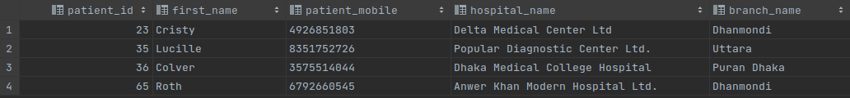

/* 3. List all the Bills of a Specific Hospital and Specific Branch with Patients First Name and Total Payment */
/* Cross product */
SELECT P.First_Name, B.Total_Payment
FROM Patients AS P, Bill AS B
WHERE P.Patient_Id = B.Patient_Id and B.Hospital_Name = 'Apollo Hospital' and B.Branch_Name = 'Basundhara';

3. Relational Algebra Expression :
Π _{First_Name, Total_Payment} (σ Hospital_Name = ‘Apollo Hospital’∧Branch_Name = ‘Basundhara’ (Patients ⋈ Bill))
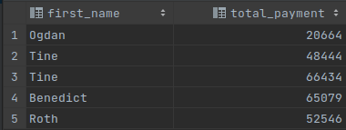

/* 4. List of all the Patients who have no Bills yet */
/* Outer Join */
SELECT P.First_Name, P.Patient_Mobile
FROM Patients AS P NATURAL LEFT OUTER JOIN Bill AS B
WHERE B.Receipt_Id IS NULL;

4. Relational Algebra Expression :
Π _{First_Name, Patient_Mobile} (Patient) – Π _{First_Name, Patient_Mobile} (Patient ⋈ Bill)

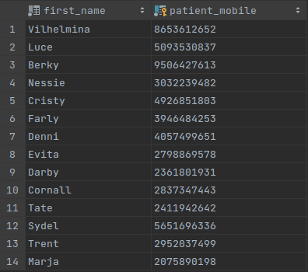

/* 5. List of all the Patients who had operation in Apollo Hospital's Basundhara Branch */
/* Join with On */
SELECT P.First_Name, P.Patient_Mobile, O.Date_of_Operation
From Patients AS P JOIN Operation as O
ON P.Patient_Id = O.Patient_Id
where O.Hospital_Name = 'Apollo Hospital' and O.Branch_Name = 'Basundhara';

5. Relational Algebra Expression :
Π First_Name, Patient_Mobile, Date_Of_Operation (σ Hospital_Name = ‘Apollo Hospital’ ∧Branch_Name = ‘Basundhara’ (ρ_{P} (Patients) ⋈ _{P.Patient_Id = O.Patient_Id} ρ_{O} (Operation)))

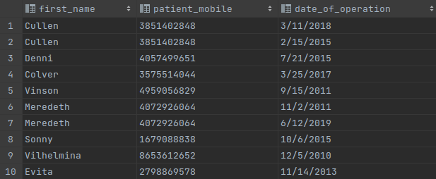

/* 6. List all the Patients who had no Operations */
/* Exists */
SELECT P.Patient_Id, P.First_Name, P.Patient_Mobile
FROM Patients AS P
WHERE NOT EXISTS(
SELECT *
FROM Operation AS O
WHERE P.Patient_Id = O.Patient_Id
);

6. Relational Algebra Expression :
Π Patient_Id, First_Name, Patient_Mobile (Patient) – Π Patient_Id, First_Name, Patient_Mobile (Patient ⋈ Operation)

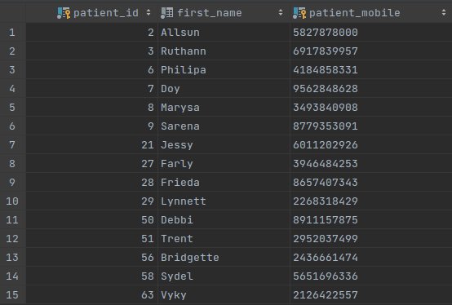

/* 7. List all the Doctors who have the max salary */
/* With and Aggregate Function Max */
WITH Max_Salary(Max_Salary) AS (
SELECT max(Salary)
FROM Doctors
)
SELECT Doctor_Id, First_Name, Salary
FROM Doctors AS D NATURAL JOIN Max_Salary AS M
WHERE D.Salary = M.Max_Salary;

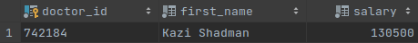

/* 8. In which operation room most of the operations are held in a Hospital*/
/* With, Group By and Aggregate Function (Max, Count) */
WITH Most_Operated_Room(Room_Number, Count) AS (
SELECT Room_Number, count(Room_Number)
FROM Operation
WHERE Hospital_Name = 'Anwer Khan Modern Hospital Ltd.' and Branch_Name = 'Dhanmondi'
GROUP BY Room_Number
)
SELECT Room_Number, Count
FROM Most_Operated_Room
WHERE Count = (
SELECT max(Count)
FROM Most_Operated_Room
);

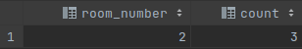

/* 9. Update a Doctor's salary and Emergency Mobile Number */
/* Update Operation, Set Operation */
UPDATE Doctors
SET Salary = 130500 , Emergency_Mobile = '01770172816'
WHERE Doctor_Id = '742184';

/* 10. Delete all the datas of receipt id = 100 */
/* Delete Operation */
DELETE FROM Bill
WHERE Receipt_Id = 100;

/* 11. Show all the Hospitals whose average payment is greater than 55000 */
/* Group By, Having, Aggregate function (avg) */
SELECT Hospital_Name, avg(Total_Payment) as Average_Payment
FROM Bill
GROUP BY Hospital_Name
HAVING avg(Total_Payment) >= 55000;

11. Relational Algebra Expression :
Π _{Hospital_Name, Average_Payment} ( σ _{Average_Payment > 55000} γ _{(Hospital_Name)} avg(Total_Payment) → Average_Payment ρ Bill)

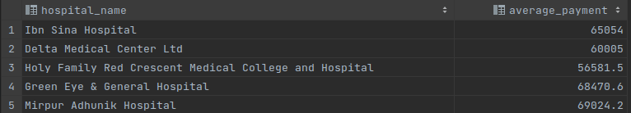

/* 12. List all the total operations done by all the doctors in decreasing order */
/* With, aggregate function (count), Group By, Natural Join, Order By */
WITH Most_Operation_Done_By_A_Doctor(Doctor_Id, Count) AS (
SELECT Doctor_Id, count(Doctor_Id)
FROM Operation
GROUP BY Doctor_Id
)
SELECT MODBAD.Doctor_Id, D.First_Name, D.Last_Name, D.Doctor_Mobile, MODBAD.Count
FROM Most_Operation_Done_By_A_Doctor AS MODBAD NATURAL JOIN Doctors AS D
ORDER BY Count DESC;

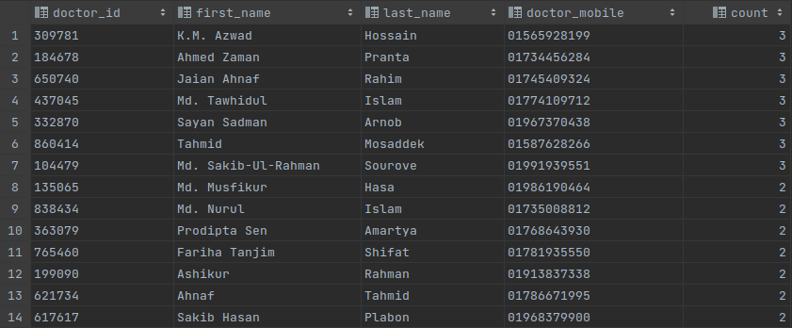

/* 13. List all the Hospitals which have more payment amount than Dhaka Medical College Hospital Branch Puran Dhaka*/
/* All */
SELECT *
FROM Bill AS B1
WHERE B1.Total_Payment > All (
SELECT B2.Total_Payment
From Bill AS B2
WHERE B2.Hospital_Name = 'Dhaka Medical College Hospital' and B2.Branch_Name = 'Puran Dhaka'
);

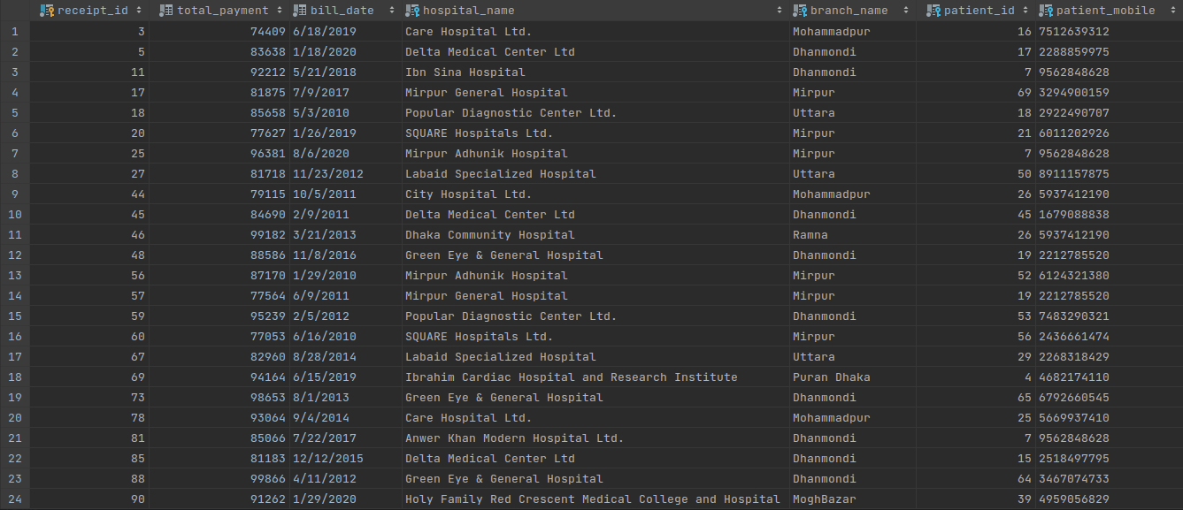
/* 14. List of which Doctor has more Salary than some other doctors whose Salary is also more than 120000 Salary */
/* Some, Order By */
SELECT D1.Doctor_Id, D1.First_Name, D1.Last_Name, D1.Salary
FROM Doctors AS D1
WHERE D1.Salary > SOME (
SELECT D2.Salary
FROM Doctors AS D2
WHERE D2.Salary > 120000
)
ORDER BY Salary Desc;

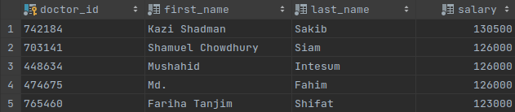

Create Views and use those Views in Answering Queries.

/* 15. Create a view of all the Doctors who works for Cardiology department of Dhaka Medical College Hospital Branch Puran Dhaka */
/* View */

CREATE VIEW Cardiology_Department_DMC AS
SELECT D.Doctor_Id, D.First_Name, D.Last_Name, D.Doctor_Mobile
FROM Doctors AS D NATURAL JOIN Works_For AS WF
WHERE WF.Department_Name = 'Cardiology' and WF.Hospital_Name = 'Dhaka Medical College Hospital' and Branch_Name = 'Puran Dhaka';

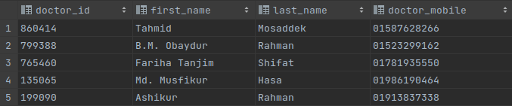

/* 16. Create a view of Doctors who has more than 100000 Salary */
/* View */
CREATE VIEW More_Than_100000_Salary AS
SELECT Doctor_Id, First_Name, Salary
FROM Doctors
WHERE Salary > 100000;
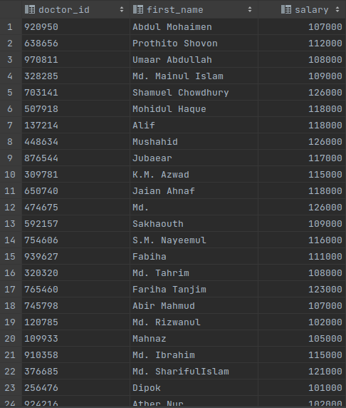

List of Non-Trivial Functional Dependencies

Hospital_Branch :
F = { (Hospital_Name, Branch_Name) →
(City, Road_Number, Street, Postal_Code, Branch_Phone) }

Departments :
F = { (Department_Name, Hospital_Name, Branch_Name) → (Building Number, Department_Phone_Number) }

Doctors :
F = { Doctor_Id → (First_Name, Last_Name, Doctor_Mobile, Doctor_Email, Doctor_Address, Salary, Emergency Number) }

Doctors_Speciality :
No Non-Trivial Functional Dependency is found here.

Patients :
F = { (Patient_Id, Patient_Mobile) → (First_Name, Last_Name, Date_of_Birth, Weight, Gender, Patient_Address, Patient_Email, Height, Secondary_Number) }

Works For :
No Non-Trivial Functional Dependency is found here.

Operation :
F = { (Doctor_Id, Hospital_Name, Branch_Name, Patient_Id, Patient_Mobile) →
(Date_of_Operation, Room_Number, Approximate_Duration) }

Bill :
F = { Receipt_Id → (Total_Payment, Bill_Date, Hospital_Name, Branch_Name, Patient_Id, Patient_Mobile) }

Treatment :
No Non-Trivial Functional Dependency is found here.

Proof that the Schemas are in Desired Normal Forms

A schema is in BCNF if and only if at least one of the following holds :-

i) α → β is trivial Functional Dependency, where β ⊆ α.

ii) α is a Super key for schema R

Hospital_Branch :
F = { (Hospital_Name, Branch_Name) → (Hospital_Name, Branch_Name, City, Road_Number, Street, Postal_Code, Branch_Phone) }

This schema/table is in BCNF, because (Hospital_Name, Branch_Name) is a Super key and there is no other Non-Trivial Functional Dependency where L.H.S is not a Super key.

Departments :
F = { (Department_Name, Hospital_Name, Branch_Name) → (Department_Name, Hospital_Name, Branch_Name, Building_Number, Department_Phone_Number) }

This schema/table is in BCNF, because (Department_Name, Hospital_Name, Branch_Name) is a Super key and there is no other Non-Trivial Functional Dependency where L.H.S is not a Super key.

Doctors :
F = { Doctor_Id → (Doctor_Id, First_Name, Last_Name, Doctor_Mobile, Doctor_Email, Doctor_Address, Salary, Emergency_Mobile) }

This schema/table is in BCNF, because (Doctor_Id) is a Super key and there is no other Non-Trivial Functional Dependency where L.H.S is not a Super key.

Patients :
F = { (Patient_Id, Patient_Mobile) → (Patient_Id, Patient_Mobile, First_Name, Last_Name, Date_of_Birth, Weight, Gender, Patient_Address, Patient_Email, Height, Secondary_Number) }

This schema/table is in BCNF, because (Patient_Id, Patient_Mobile) is a Super key and there is no other Non-Trivial Functional Dependency where L.H.S is not a Super key.

Operation :
F = { (Doctor_Id, Hospital_Name, Branch_Name, Patient_Id, Patient_Mobile) → (Doctor_Id, Hospital_Name, Branch_Name, Patient_Id, Patient_Mobile, Date_of_Operation, Room_Number, Approximate_Duration) }

This schema/table is in BCNF, because (Doctor_Id, Hospital_Name, Branch_Name, Patient_Id, Patient_Mobile) is a Super key and there is no other Non-Trivial Functional Dependency where L.H.S is not a Super key.

Bill :
F = { Receipt_Id → (Receipt_Id, Total_Payment, Bill_Date, Hospital_Name, Branch_Name, Patient_Id, Patient_Mobile) }

This schema/table is in BCNF, because (Receipt_Id) is a Super key and there is no other Non-Trivial Functional Dependency where L.H.S is not a Super key.

Thus, all the schemas are in BCNF. So, we can say that all the schemas are in desired normal forms.

Conclusion

This report shows us the demonstration of a Hospital Database Management System. This Database Management System shows us how the information of many types of data are stored in the Database and how beautifully all the information are connected to each other growing through multiple schemas. This Database provides accurate method for inserting, deleting and updating data from various schemas and a more effective system of data processing for retrieving data from the interconnected tables. This database takes care of all the requirements of an average hospital and is capable to provide easy and effective storage of information related to Patients that come up to the hospital.

This hospital database is developed for the hospital enterprise to store all the data of Doctors, Patients, Operations that they have operated individually, Bills that they charge to Patients or Bills that a individual Patient is getting. Also we can retrieve various information like which Patient is getting treatment from which department of a Hospital, which Doctor is serving in which Hospital ect.

The proposed system can be enhanced by including more facilities like pharmacy system for the stock details of medicines in the pharmacy. Providing such features enables the users to include more contents into the system.

Thank you.

