**COMPUTER GRAPHICS PROJECT Report**

Submitted to,

Aneem Al Ahsan Rupai

Submitted by.

**Group 7**

|  |  |  |
| --- | --- | --- |
| **Group Information** | | |
| **SL No.** | **Name** | **ID** |
| 1 | Kazi Tanzizul Haque Tanzil | 22-47783-2 |

**Table of Contents**

|  |  |
| --- | --- |
| 1.Title | 2 |
| 2.Introduction | 2 |
| 3.Project Graph | 3 |
| 4. List of objects assigning an object ID | 4 |
| 5. List of Functions To Represent Objects | 5 |
| 6. List of Animation Functions with ID | 6 |
| 7. Contribution | 7-8 |
| 8. Conclusion | 8 |

**1.Title:**  Metro Station.

2.**Introduction:**

The project ‘Metro Station’ shows a graphical window display using the OpenGL utility toolkit (GLUT) library. It renders a metro train, including its head, body, windows, and doors. The scene also includes a ceiling, floor, and bulb lights. The metro train can move horizontally, and the doors can open and close with an animation effect.

Key features:

Rendering of the metro train, including the head, body, windows, and doors.

An animation of the metro train's horizontal movement.

Animation shows the metro train's doors opening and shutting.

Rendering shows additional parts, including the ceiling, floor, and bulb lights.

Text rendering is used to display group member names and IDs.

The code defines functions for drawing several scene components, including metroHead, metroBody, metroWindow, metroDoor, and others. It also has functions for animating, text rendering, and applying textures. Overall, this project demonstrates how to utilize OpenGL and GLUT to create interactive 2D graphics program, including rendering complicated forms, handling user input, and performing animations.

Technologies used:

OpenGL: Open Graphics Library (OpenGL) is a cross-language, multi-platform application programming interface (API) for rendering 2D vector graphics.

GLUT: The OpenGL Utility Toolkit (GLUT) is a library of utilities for OpenGL programming, which primarily performs system-level I/O tasks such as window definition, viewport establishment, and keyboard and mouse input.

C++: The project is written in C++.

**3.Project Graph –**

a.Inside Station:

b.Outside Station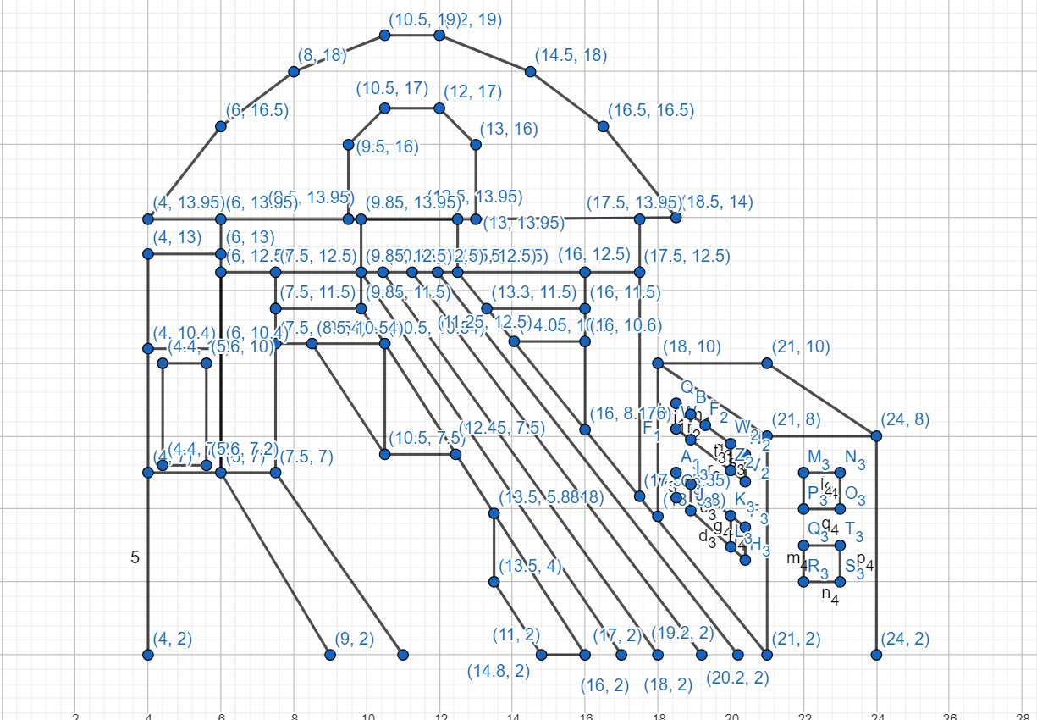

**4. List of objects assigning an object ID –**

|  |  |  |
| --- | --- | --- |
| SL# | Object ID | Object Name |
| 1 | Obj_1 | Text_image1 |
| 2 | Obj_2 | Text_image12 |
| 3 | Obj_3 | Text_image13 |
| 4 | Obj_4 | Image |
| 5 | Obj_5 | MetroHead |
| 6 | Obj_6 | MetroBody |
| 7 | Obj_7 | MetroWindow |
| 8 | Obj_8 | MetroDoor |
| 9 | Obj_9 | DoorOpen |
| 10 | Obj_10 | MetroCeiling |
| 11 | Obj_11 | Bulb |
| 12 | Obj_12 | Floor |
| 13 | Obj_13 | MetroLine |
| 14 | Obj_14 | Backline |
| 15 | Obj_15 | Table |
| 16 | Obj_16 | Text1 |
| 17 | Obj_17 | Text2 |
| 18 | Obj_18 | Man2 |
| 19 | Obj_19 | Rain |
| 20 | Obj_20 | Sun |
| 21 | Obj_21 | Sky |
| 22 | Obj_22 | Cloud |
| 23 | Obj_23 | Cloud1 |
| 24 | Obj_24 | StationCeiling |
| 25 | Obj_25 | RailLine |
| 26 | Obj_26 | Footpath |
| 27 | Obj_27 | FootpathLine |
| 28 | Obj_28 | Road |
| 29 | Obj_29 | Building |
| 30 | Obj_30 | Building2 |
| 31 | Obj_31 | Lift |
| 32 | Obj_32 | Lift2 |
| 33 | Obj_33 | LiftDoor |
| 34 | Obj_34 | InsideLift |
| 35 | Obj_35 | Man |
| 36 | Obj_36 | Text_11 |

**5. List of Functions To Represent Objects-**

|  |  |  |
| --- | --- | --- |
| SL# | Object Name | Function Name |
| 1 | Text_image1 | void text_image1() |
| 2 | Text_image12 | void text_image12() |
| 3 | Text_image13 | void text_image13() |
| 4 | Image | void image() |
| 5 | MetroHead | void metroHead() |
| 6 | MetroBody | void metroBody() |
| 7 | MetroWindow | void metroWindow() |
| 8 | MetroDoor | void metroDoor() |
| 9 | DoorOpen | void doorOpen() |
| 10 | MetroCeiling | void metroCeiling() |
| 11 | Bulb | void bulb() |
| 12 | Floor | void floor() |
| 13 | MetroLine | void metroLine() |
| 14 | Backline | void backline() |
| 15 | Table | void table() |
| 16 | Text1 | void text1() |
| 17 | Text2 | void text2() |
| 18 | Man2 | void Man2() |
| 19 | Rain | void rain() |
| 20 | Sun | void sun() |
| 21 | Sky | void sky() |
| 22 | Cloud | void cloud() |
| 23 | Cloud1 | void cloud1() |
| 24 | StationCeiling | void stationCeiling() |
| 25 | RailLine | void railLine |
| 26 | Footpath | void footpath() |
| 27 | FootpathLine | void footpathLine |
| 28 | Road | void road() |
| 29 | Building | void building() |
| 30 | Building2 | void building2() |
| 31 | Lift | void lift() |
| 32 | Lift2 | void lift2() |
| 33 | LiftDoor | void liftDoor() |
| 34 | InsideLift | void insideLift() |
| 35 | Man | void Man() |
| 36 | Text_11 | void text_11() |

**6. List of Animation Functions with ID –**

|  |  |  |  |
| --- | --- | --- | --- |
| SL# | Animation Function ID | Animation Function | Object/Scene |
| 1 | Anim_01 | void display_1() press “1” | Display scenario_1 |
| 2 | Anim_02 | void display_2() press “2” | Display scenario_2 |
| 3 | Anim_03 | void timerDoor_lift() Press “O” or “o” | Lift door open |
| 4 | Anim_04 | void timerDoor_lift() Press “C” or “c” | Lift door close |
| 5 | Anim_05 | void timerMan() Press “M” or “m” | Move the man towards Lift |
| 6 | Anim_06 | void timerEnter_Man() Press “E” or “e” | Enter into the lift |
| 7 | Anim_07 | void timerLeave_Man() Press “L” or “l” | Leave the lift |
| 8 | Anim_08 | void Timer() Press “T” or “t” | Clouds come to the sky |
| 9 | Anim_09 | void initializeRain() Press “R” or “r” | Raining |
| 10 | Anim_10 | void update() Press “S” or “s” | Metro start moving |
| 11 | Anim_11 | void timerDoor() Press “P” or “p” | Metro Stopped and door open |
| 12 | Anim_12 | void timerDoor() Press “C” or “c” | Metro Door Close |
| 13 | Anim_13 | void timerMan_go() Press “W” or “w” | Man2 go Forward |
| 14 | Anim_14 | void timerMan_right() Press “R” or “r” | Man2 go right |
| 15 | Anim_15 | void timerMan_left() Press “A” or “a” | Man2 go left |
| 16 | Anim_16 | void timerMan_Enter() Press “D” or “d” | Man2 Enter into Metro |

**7. Contribution –**

|  |  |  |  |
| --- | --- | --- | --- |
| Member Name | Implemented Functions | Implemented Animation Functions | Percentage of Contribution |
| Kazi Tanzizul Haque Tanzil | All | All | 100% |

**8. Conclusion**

This project showcases a collaborative effort in creating an interactive graphical application using OpenGL and GLUT. Each team member contributed equally to the development of object representations and their respective animations. The project demonstrates proficiency in graphical programming and user interaction handling, providing a solid foundation for future advancements in more complex graphical simulations.

***Add the IDs as a comment at the start of each function. This will help you to search the functions easily.***