AMERICAN INTERNATIONAL UNIVERSITY-BANGLADESH

Faculty of Science and Technology Department of Computer Science

CSC 3217: Artificial Intelligence and Expert System [Assignment]

# Map Coloring Problem with CSP

For this task, I will be using Constraint Satisfaction Problem (CSP) techniques to model and solve a map coloring problem. I'll design a map based on my name and randomly generate a layout for the regions. The main objective is to ensure that no neighboring regions on the map have the same color while finding a solution to the problem.

## Step 1: Create a Random Map

Using the first five distinct letters from my name, I will define five regions. My name is "KAZI TANZIZUL HAQUE", the five distinct regions could be H, A, Q, U, and E. These regions will represent different areas on a map.

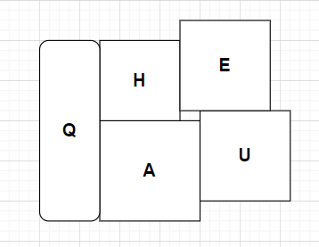

Random Map.

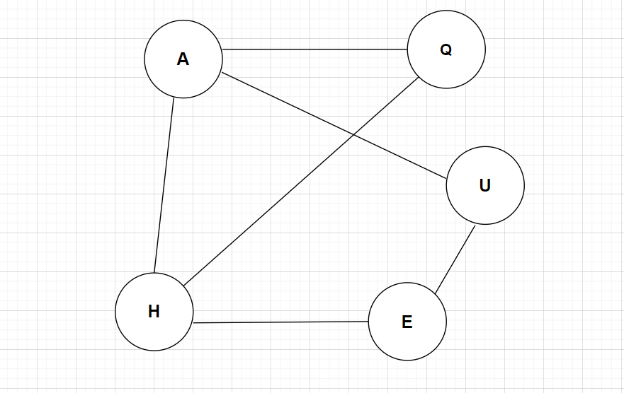

Graph from the map.

## Step 2: Define the Adjacent Regions

List the adjacency relationships between regions based on My random map drawing.

H is Adjacent to A, Q and E.

A is Adjacent to H, Q and U.

Q is Adjacent to H and A.

U is Adjacent to A and E.

E is Adjacent to H and U.

## Step 3: Map Coloring Problem

Model the problem as a CSP with:

Variables: The regions (H, A, Q, U, E). Domains: Red, Green, Blue.

Constraints: Adjacent regions must have different colors.

(H≠A, H≠Q, H≠E, A≠Q, A≠U, U≠E)

Use backtracking search to find a valid color assignment for the map.

Apply the MRV heuristic (choose the region with the fewest available colors first) and forward checking to improve the efficiency of the search.

|  |  |  |  |  |  |  |
| --- | --- | --- | --- | --- | --- | --- |
|  |  | H | A | Q | U | E |
|  | Initial | RGB | RGB | RGB | RGB | RGB |
|  | E=G | RB | RGB | RGB | RB | G |
|  | U=R | RB | GB | RGB | R | G |
|  | A=G | RB | G | RB | R | G |
|  | H=B | B | G | R | R | G |
|  | Q=R | B | G | R | R | G |

