# Project Based Learning Report

On

Simulate the Radar Range Equation to predict the maximum detectable range for various radar configuration

Submitted in the partial fulfillment of the requirements For the Project based learning in “**RADAR & SATELLITE COMMUNICATION**”

in

Electronics & Communication Engineering

By

## PRN-2114110452 ARYAN GUPTA

## PRN-2114110489 FAIZ MAQSOOD

**PRN-2114110466 MOHAMMAD KAZIM**

Under the guidance of Course In-charge

### Prof. V.P.Kaduskar

Department of Electronics & Communication Engineering Bharati Vidyapeeth

(Deemed to be University)

College of Engineering, Pune – 411043

**Academic Year: 2023-24**

**Bharati Vidyapeeth (Deemed to be University) College of Engineering,**

## Pune – 411043

**DEPARTMENT OF ELECTRONICS & COMMUNICATION ENGINEERING**

## CERTIFICATE

Certified that the Project Based Learning report entitled, “Simulate the Radar Range Equation to predict the maximum detectable range for various radar configuration” Is work done by

## PRN-2114110452 ARYAN GUPTA

## PRN-2114110489 FAIZ MAQSOOD

**PRN-2114110466 MOHAMMAD KAZIM**

in partial fulfillment of the requirements for the award of credits for Project Based Learning (PBL) in “**RADAR AND SATELLITE COMMUNICATION**” of Bachelor of Technology Semester VII, in Electronics and Communication.

### Date:

**Prof. V.P.Kaduskar Dr. Arundhati A. Shinde Course In-charge Professor & Head**

**INDEX**

|  |  |  |  |
| --- | --- | --- | --- |
|  | | | |
|  | | | |
| |  |  |  | | --- | --- | --- | | **S.No.** | **Title** | **Page No.** | | 1 | Problem Statement & Solution | 1-2 | | 2 | Software used | 3 | | 3 | Project Description | 4-5 | | 4 | Algorithm | 6-7 | | 5 | Program & output | 8-12 | | 6 | Conclusion | 13 | | 7 | References | 14 | | | | |
|  |  |  |
|  |  |  |
|  |  |  |

# PROBLEM STATEMENT

**QUESTION**

# Simulate the Radar range equation to predict the maximum detectable range for various radar configurations

# SOLUTION

# The radar range equation is a mathematical model used to predict the maximum range at which a radar system can detect a target. The radar system's performance depends on several factors, which are described in the equation as follows:

# Radar Range Equation:

# Rmax=(PtGtGrλ2σ(4π)3LSmin)14R_{\text{max}} = \left( \frac{P_t G_t G_r \lambda^2 \sigma}{(4\pi)^3 L S_{\text{min}}} \right)^{\frac{1}{4}}Rmax​=((4π)3LSmin​Pt​Gt​Gr​λ2σ​)41​

# Where:

# RmaxR_{\text{max}}Rmax​ is the maximum radar range or the furthest distance at which the radar can detect a target.

# PtP_tPt​ is the transmitted power, which represents the power emitted by the radar. A higher transmitted power results in an increased detection range.

# GtG_tGt​ and GrG_rGr​ are the transmit and receive antenna gains, respectively. These gains represent the ability of the antennas to focus and receive electromagnetic energy. Higher gains improve radar range by concentrating energy in a particular direction.

# λ\lambdaλ is the wavelength of the radar signal, which is inversely proportional to the radar frequency (fff) and affects how well the radar energy propagates through space.

# σ\sigmaσ is the radar cross-section (RCS) of the target, a measure of how detectable the target is by the radar. A larger RCS results in a longer detectable range.

# LLL represents system losses, including any inefficiencies or signal attenuation within the radar system or the atmosphere. Higher losses reduce the maximum detectable range.

# SminS_{\text{min}}Smin​ is the minimum detectable signal by the radar receiver. The lower the value of SminS_{\text{min}}Smin​, the more sensitive the radar is, leading to a longer detectable range.

# Steps for Simulation:

# Calculate the Wavelength: Determine the wavelength of the radar signal from the radar frequency, as it affects the radar's propagation characteristics. Wavelength is computed using λ=cf\lambda = \frac{c}{f}λ=fc​, where ccc is the speed of light.

# Analyze the Effect of Each Parameter:

# Increasing transmitted power PtP_tPt​ enhances the radar's detection range.

# Higher antenna gains GtG_tGt​ and GrG_rGr​ focus the radar energy more effectively, increasing the range.

# A larger radar cross-section σ\sigmaσ means the target reflects more energy, making it detectable at a greater distance.

# Reducing system losses LLL improves the radar's efficiency, extending the range.

# Improving receiver sensitivity (lower SminS_{\text{min}}Smin​) enables the detection of weaker signals from farther targets.

# Simulate for Different Configurations: By varying the radar parameters such as PtP_tPt​, GtG_tGt​, GrG_rGr​, and σ\sigmaσ, one can compute different values of RmaxR_{\text{max}}Rmax​ to explore how each parameter influences the maximum detectable range.

# Interpret Results: Simulations reveal how radar system design decisions impact performance. For instance, increasing power or improving antenna gain can significantly enhance range, while system losses or low radar cross-sections can reduce detection capability.

# SOFTWARE USED

MATLAB, short for "Matrix Laboratory," is a high-level programming language and interactive environment widely used for technical computing and data visualization. Developed by MathWorks, MATLAB combines computation, visualization, and programming in a single platform, making it a powerful tool for engineers, scientists, researchers, and students across various domains.

MATLAB is a programming platform designed specifically for engineers and scientists to analyze and design systems and products that transform our world. The heart of MATLAB is the MATLAB language, a matrix-based language allowing the most natural expression of computational mathematics.

.



# PROJECT DESCRIPTION

# Project Overview:

# Radar systems are critical in modern applications, such as defense, aviation, maritime navigation, and weather monitoring. Understanding the maximum range at which a radar can detect a target is essential for designing efficient radar systems. The radar range equation serves as a foundation for calculating this range based on various system and environmental factors.

# In this project, we will simulate the radar range equation using software tools (e.g., MATLAB, Python, or a suitable simulation environment). The simulation will vary key parameters of radar configurations such as:

# Transmitter power

# Antenna gain

# Radar cross-section (RCS) of the target

# Signal-to-noise ratio (SNR) threshold

# Frequency or wavelength of the radar signal

# Environmental factors (e.g., atmospheric attenuation, clutter, etc.)

# Receiver noise figure and system losses

# The output will be a predictive model that shows how these variables impact the maximum detectable range.

# Key Components of the Project:

# Understanding the Radar Range Equation:

# The radar range equation can be written as:

# Rmax=(PtGtGrλ2σ(4π)3SminL)14R_{\text{max}} = \left( \frac{P_t G_t G_r \lambda^2 \sigma}{(4\pi)^3 S_{\text{min}} L} \right)^{\frac{1}{4}}Rmax​=((4π)3Smin​LPt​Gt​Gr​λ2σ​)41​

# Where:

# RmaxR_{\text{max}}Rmax​: Maximum range at which the radar can detect a target

# PtP_tPt​: Transmitted power

# GtG_tGt​: Transmitting antenna gain

# GrG_rGr​: Receiving antenna gain (if the radar has separate transmitting and receiving antennas)

# λ\lambdaλ: Wavelength of the transmitted signal (related to frequency fff by λ=cf\lambda = \frac{c}{f}λ=fc​, where ccc is the speed of light)

# σ\sigmaσ: Radar cross-section of the target (reflectivity of the target)

# SminS_{\text{min}}Smin​: Minimum detectable signal or noise level

# LLL: System losses (due to inefficiencies, atmospheric attenuation, etc.)

# The project will require a detailed study of each parameter and how variations in those parameters affect radar performance.

# Simulation Environment: Develop a simulation model in Python, MATLAB, or another environment that implements the radar range equation. This model will allow users to input various parameters, and the system will compute the maximum range RmaxR_{\text{max}}Rmax​. Some specific functionalities of the simulator will include:

# Parameter sliders for interactive adjustment of values like transmitter power, antenna gain, etc.

# Real-time updates to maximum range calculations.

# Visualization of radar performance under different conditions, such as varying atmospheric losses or target RCS.

# Radar Configurations: The project will simulate various radar configurations:

# Airborne radar: Examining the range of radar systems used in aircraft for detecting other planes or ground targets.

# Ground-based radar: Simulating ground radar systems for air traffic control, military applications, or weather monitoring.

# Maritime radar: Simulating radar on ships, considering factors like sea clutter and environmental noise.

# Space-borne radar: Simulating space-based systems for Earth observation and satellite communications.

# Target Characteristics: Different targets have different radar cross-sections, which directly affect detectability. The project will include the simulation of targets like:

# Aircraft (high RCS)

# Small drones (low RCS)

# Vehicles

# Ships

# Ground clutter

# Environmental and System Effects: Incorporate environmental and system loss factors in the simulation:

# Atmospheric attenuation (varies with frequency and weather conditions)

# System losses due to inefficiencies in the radar equipment

# Clutter and noise from surrounding environments, affecting detectability

# Outputs and Visualization: The output of the simulation will include:

# Maximum radar detection range for different radar configurations and environmental scenarios.

# Graphical plots showing the relationship between range and different radar parameters (e.g., transmitted power vs. range, RCS vs. range).

# Comparative analysis of the performance of different radar configurations (e.g., high-power vs. low-power, ground-based vs. airborne radar).

# Validation and Testing: Test the simulation results against theoretical values and literature. Ensure that the results align with real-world performance data from published studies or field-tested radar systems.

# ALGORITHM:-

CRC Encoding Function

Simulate Error in Data

CRC Decoding Function

Display Results

# Initialize the Environment:

# Clear previous data, command window, and close any open figures.

# Define Constants:

# Set the speed of light (c=3×108c = 3 \times 10^8c=3×108 m/s).

# Define the value of π\piπ.

# Input Radar System Parameters (Default Values):

# Set default values for the radar system parameters:

# Transmitted power (PtP_tPt​)

# Transmitter gain (GtG_tGt​)

# Receiver gain (GrG_rGr​)

# Frequency (fff)

# Radar cross-section (σ\sigmaσ)

# System losses (LLL)

# Minimum detectable signal (SminS_{\text{min}}Smin​)

# Display Initial Radar System Parameters:

# Print the initialized values for system parameters, including power, gain, frequency, wavelength, radar cross-section, system losses, and minimum detectable signal.

# Calculate Maximum Radar Range:

# Compute the maximum radar range (RmaxR_{\text{max}}Rmax​) using the radar range equation: Rmax=(Pt×Gt×Gr×λ2×σ(4π)3×L×Smin)0.25R_{\text{max}} = \left( \frac{P_t \times G_t \times G_r \times \lambda^2 \times \sigma}{(4\pi)^3 \times L \times S_{\text{min}}} \right)^{0.25}Rmax​=((4π)3×L×Smin​Pt​×Gt​×Gr​×λ2×σ​)0.25

# Display the calculated maximum radar range.

# Sensitivity Analysis - Effect of Transmitted Power:

# Create a range of transmitted power values from 100 W to 10,000 W.

# For each value of transmitted power, recalculate RmaxR_{\text{max}}Rmax​.

# Plot a graph of transmitted power vs. maximum radar range.

# Sensitivity Analysis - Effect of Frequency:

# Create a range of frequency values from 1 GHz to 10 GHz.

# Calculate the wavelength for each frequency.

# For each frequency, recalculate RmaxR_{\text{max}}Rmax​.

# Plot a graph of frequency vs. maximum radar range.

# Sensitivity Analysis - Effect of Radar Cross Section (RCS):

# Create a range of radar cross-section values from 0.1 m² to 10 m².

# For each value of radar cross-section, recalculate RmaxR_{\text{max}}Rmax​.

# Plot a graph of RCS vs. maximum radar range.

# 3D Plot - Radar Range vs Frequency and Transmitted Power:

# Create a grid of frequency and transmitted power values.

# Compute the radar range (RmaxR_{\text{max}}Rmax​) for each combination of frequency and power.

# Generate a 3D surface plot of frequency, transmitted power, and maximum radar range.

# Exploring the Impact of System Losses:

# Create a range of system losses from 1 to 3.

# For each value of system loss, recalculate RmaxR_{\text{max}}Rmax​.

# Plot a graph of system losses vs. maximum radar range.

# Exploring the Impact of Minimum Detectable Signal:

# Create a range of minimum detectable signal values from 1×10−121 \times 10^{-12}1×10−12 W to 1×10−81 \times 10^{-8}1×10−8 W.

# For each value of minimum detectable signal, recalculate RmaxR_{\text{max}}Rmax​.

# Plot a graph (logarithmic scale) of minimum detectable signal vs. maximum radar range.

# Conclusion:

# Display a message indicating that the simulation is complete.

# The results demonstrate how different radar system parameters affect the maximum detection range, providing insights into the sensitivity of radar system performance.

**PROGRAM:-**

% Radar Range Equation Simulation

% This script simulates the radar range equation and analyzes the effects of

% various parameters on the radar range.

clear;

clc;

close all;

%% Define Constants

c = 3e8; % Speed of light (m/s)

pi_val = pi;

% Radar System Parameters (default values)

Pt = 1e3; % Transmitted Power (Watts)

Gt = 30; % Transmitter Gain (unitless, linear scale)

Gr = 30; % Receiver Gain (unitless, linear scale)

freq = 3e9; % Radar Operating Frequency (Hz)

lambda = c / freq; % Wavelength (meters)

sigma = 1; % Radar Cross Section (RCS) (m^2)

L = 1.5; % System Losses (unitless)

S_min = 1e-10; % Minimum Detectable Signal (Watts)

% Display initial parameters

disp('Initial Radar System Parameters:');

fprintf('Transmitted Power (Pt): %d W\n', Pt);

fprintf('Transmitter Gain (Gt): %.2f\n', Gt);

fprintf('Receiver Gain (Gr): %.2f\n', Gr);

fprintf('Frequency (freq): %.2f GHz\n', freq/1e9);

fprintf('Wavelength (lambda): %.4f m\n', lambda);

fprintf('Radar Cross Section (sigma): %.2f m^2\n', sigma);

fprintf('System Losses (L): %.2f\n', L);

fprintf('Minimum Detectable Signal (S_min): %.2e W\n', S_min);

%% Calculate Maximum Radar Range

% Radar Range Equation:

% R_max = ((Pt * Gt * Gr * lambda^2 * sigma) / ((4*pi)^3 * L * S_min))^0.25

R_max = ((Pt * Gt * Gr * lambda^2 * sigma) / ((4 * pi_val)^3 * L * S_min))^0.25;

% Display maximum range

fprintf('\nMaximum Radar Range (R_max): %.2f meters\n', R_max);

%% Sensitivity Analysis: Effect of Transmitted Power

Pt_values = linspace(1e2, 1e4, 100); % Vary transmitted power from 100 W to 10 kW

R_max_Pt = ((Pt_values .* Gt .* Gr .* lambda^2 .* sigma) ./ ((4 * pi_val)^3 .* L .* S_min)).^0.25;

figure;

plot(Pt_values, R_max_Pt, 'b', 'LineWidth', 2);

title('Effect of Transmitted Power on Radar Range');

xlabel('Transmitted Power (Watts)');

ylabel('Maximum Radar Range (meters)');

grid on;

%% Sensitivity Analysis: Effect of Frequency

freq_values = linspace(1e9, 10e9, 100); % Vary frequency from 1 GHz to 10 GHz

lambda_values = c ./ freq_values;

R_max_freq = ((Pt .* Gt .* Gr .* lambda_values.^2 .* sigma) ./ ((4 * pi_val)^3 .* L .* S_min)).^0.25;

figure;

plot(freq_values / 1e9, R_max_freq, 'r', 'LineWidth', 2);

title('Effect of Frequency on Radar Range');

xlabel('Frequency (GHz)');

ylabel('Maximum Radar Range (meters)');

grid on;

%% Sensitivity Analysis: Effect of Radar Cross Section (RCS)

sigma_values = linspace(0.1, 10, 100); % Vary RCS from 0.1 m^2 to 10 m^2

R_max_sigma = ((Pt .* Gt .* Gr .* lambda^2 .* sigma_values) ./ ((4 * pi_val)^3 .* L .* S_min)).^0.25;

figure;

plot(sigma_values, R_max_sigma, 'g', 'LineWidth', 2);

title('Effect of Radar Cross Section on Radar Range');

xlabel('Radar Cross Section (m^2)');

ylabel('Maximum Radar Range (meters)');

grid on;

%% 3D Plot: Radar Range vs Frequency and Transmitted Power

[FreqGrid, PtGrid] = meshgrid(freq_values, Pt_values);

LambdaGrid = c ./ FreqGrid;

R_max_3D = ((PtGrid .* Gt .* Gr .* LambdaGrid.^2 .* sigma) ./ ((4 * pi_val)^3 .* L .* S_min)).^0.25;

figure;

surf(FreqGrid / 1e9, PtGrid, R_max_3D);

title('Radar Range vs Frequency and Transmitted Power');

xlabel('Frequency (GHz)');

ylabel('Transmitted Power (Watts)');

zlabel('Maximum Radar Range (meters)');

colorbar;

grid on;

%% Exploring the Impact of System Losses

L_values = linspace(1, 3, 100); % Vary system losses from 1 to 3 (unitless)

R_max_L = ((Pt .* Gt .* Gr .* lambda^2 .* sigma) ./ ((4 * pi_val)^3 .* L_values .* S_min)).^0.25;

figure;

plot(L_values, R_max_L, 'm', 'LineWidth', 2);

title('Effect of System Losses on Radar Range');

xlabel('System Losses (unitless)');

ylabel('Maximum Radar Range (meters)');

grid on;

%% Exploring the Impact of Minimum Detectable Signal

S_min_values = logspace(-12, -8, 100); % Vary minimum detectable signal from 1e-12 W to 1e-8 W

R_max_S_min = ((Pt .* Gt .* Gr .* lambda^2 .* sigma) ./ ((4 * pi_val)^3 .* L .* S_min_values)).^0.25;

figure;

semilogx(S_min_values, R_max_S_min, 'c', 'LineWidth', 2);

title('Effect of Minimum Detectable Signal on Radar Range');

xlabel('Minimum Detectable Signal (Watts)');

ylabel('Maximum Radar Range (meters)');

grid on;

%% Conclusion

% This simulation demonstrates how different parameters affect the radar range.

% The analysis provides insights into the sensitivity of the radar system's

% performance to changes in these parameters.

disp('Simulation Complete.');

**OUTPUT:-**

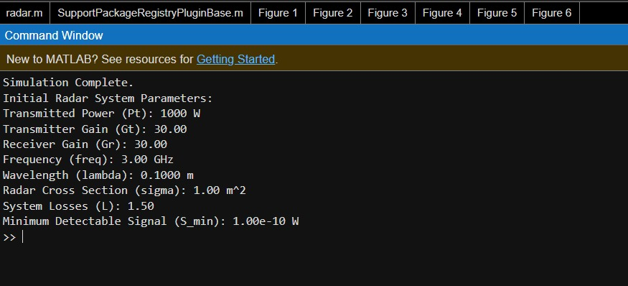

**WAVEFORMS:-**

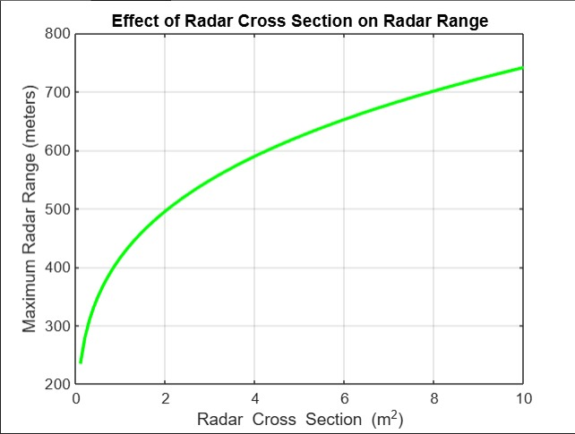

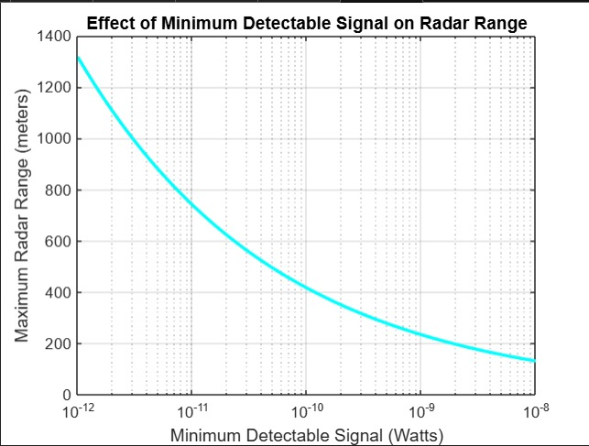

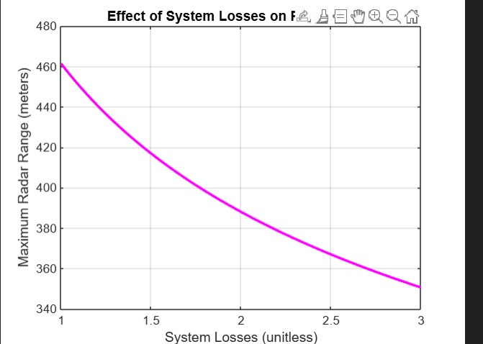

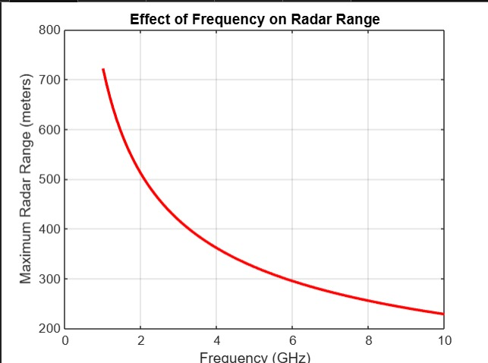

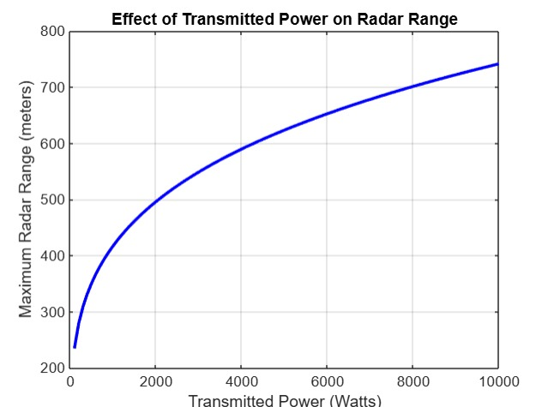

**CONCLUSION:-**

This simulation will help evaluate the impact of different radar configurations on the maximum detectable range. The sensitivity analysis of various parameters provides valuable insights into radar design and performance optimization.

The simulation serves as a flexible tool for exploring the behavior of radar systems across different configurations and environmental conditions, aiding in the design and optimization of modern radar systems.