|  |
| --- |
|  |
| Master of Information Systems |
|  |
| **Work Proposal** |
| School year of 2018/2020 |

|  |  |
| --- | --- |
| Title: | Mobile Application |
| Type of Work | Internship |
| Supervisor: | Paulo Alves |
| Co-Supervisor(s) |  |
| Date of proposal: | 20th April, 2020 |
| Remarks | It is assigned to Kazim Ahmad (40982), student of Masters of Information Systems. |

# Goal

The goal is to develop a mobile application for the final year project of Masters of Information Systems.

# Description

Project is a fleet management solution that combines true fleet intelligence and great customer service for companies worldwide. The Smartphone App is made to be used by fleet managers. After login, the users are able to consult the fleet vehicles, drivers, trips, paths, messages, alarms etc. The user can also interact with drivers, find the nearest vehicles, block vehicles and receive activity notifications of each vehicle.

The code is structured according with Model-View-Presenter architecture.

# Work Methodology

* The story added in the Jira board will contain all the information to make the task possible
  + Functional requirements;
  + Mockups, visual guidelines and icons;
  + Tests scenarios;
* Start of development
* Tests Implementation
* Create documentation in confluence
* Code review

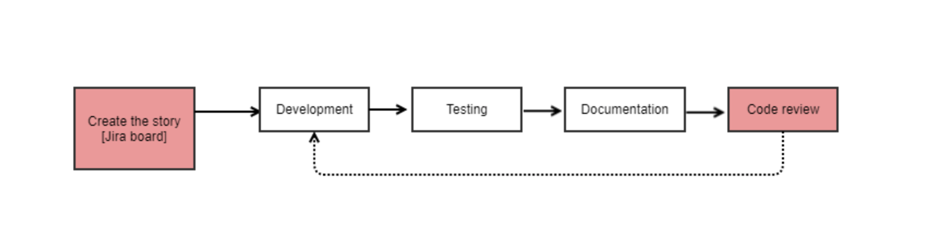

# Activity Schedule

The development start date is 1st March 2020.

Project requires 8 hours per day of work.

|  |  |
| --- | --- |
| **Feature** | **Due Date** |
| API validation | 18-02-2020 (continue) |
| Realm for offline support | 27-02-2020 |
| Splash screen | 19-03-2020 |
| Login screen | 19-03-2020 |
| Home screen | 19-03-2020 |
| Distribution Screen | 19-03-2020 |
| Fleet screen | 30-04-2020 |
| Vehicles Screen | 30-04-2020 |

# Prerequisites

N/A

# Infrastructures and Resources Needed

* Xcode
* APIs
* Realm Local Database
* Firebase
* Google Maps SDK