|  |
| --- |
|  |
| Master of Information Systems |
|  |
| **Work Proposal** |
| School year of 2018/2020 |

|  |  |
| --- | --- |
| Title: | Mobile application for fleet management |
| Type of Work | Internship |
| Supervisor: | Paulo Alves |
| Co-Supervisor(s) |  |
| Date of proposal: | 20th April, 2020 |
| Remarks | It is assigned to Kazim Ahmad (40982), student of Masters of Information Systems. |

# Goal

The goal is to develop a mobile application for fleet management using fleet intelligence and focus on customer service quality

# Description

Project is a fleet management solution that combines true fleet intelligence and great customer service for companies worldwide. The Smartphone App will be made to be used by fleet managers. After login, the users are able to consult the fleet vehicles, drivers, trips, paths, messages, alarms etc. The user can also interact with drivers, find the nearest vehicles, block vehicles and receive activity notifications of each vehicle.

The main innovation of this App will be on the adoption of smart features for fleet management using machine learning algorithms.

The code is structured according with Model-View-Presenter architecture.

# Work Methodology

* The story added in the Jira board will contain all the information to make the task possible
  + Functional requirements;
  + Mockups, visual guidelines and icons;
  + Tests scenarios;
* Start of development
* Tests Implementation
* Create documentation in confluence
* Code review

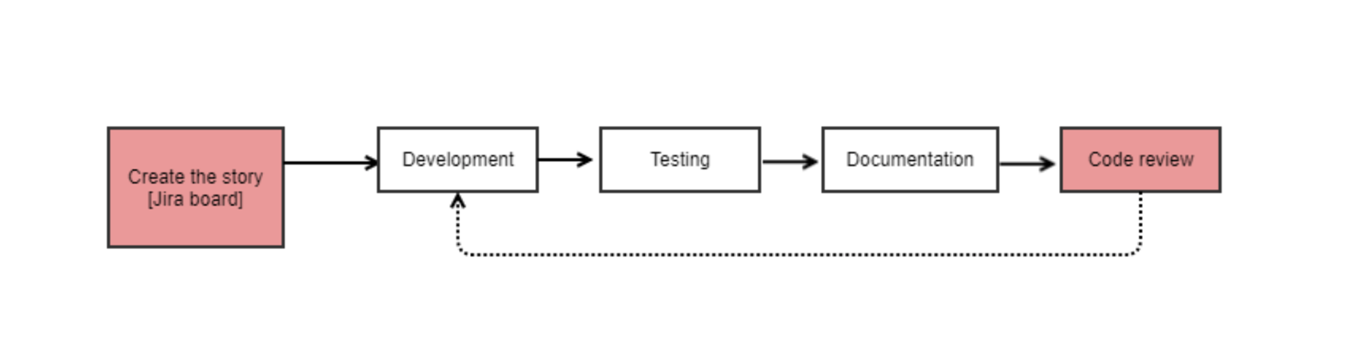

# Activity Schedule

The development start date is 1st March 2020.

Project requires 8 hours per day of work.

|  |  |
| --- | --- |
| **Feature** | **Due Date** |
| API validation | 18-02-2020 (continue) |
| Realm for offline support | 27-02-2020 |
| Splash screen | 19-03-2020 |
| Login screen | 19-03-2020 |
| Home screen | 19-03-2020 |
| Distribution Screen | 19-03-2020 |
| Fleet screen | 30-04-2020 |
| Vehicles Screen | 30-04-2020 |

# Prerequisites

N/A

# Infrastructures and Resources Needed

* Xcode
* APIs
* Realm Local Database
* Firebase
* Google Maps SDK