LAB MANUAL · COMPUTER VISION
OpenCV Lab
Foundations of image processing, in ten building blocks
Item | Details
Lecture | Introduction to OpenCV
Duration | 3 hours in the lab, plus homework
You will need | A laptop or lab PC (Windows, macOS or Linux), Python 3.10 – 3.12, the file opencv-lab-student.zip. A webcam is optional.
Instructor | Dr. Muhammad Kazim, University of Lahore
Student name / ID | ______________________________________

Contents

If the page numbers show as a single field, right-click it in Word and choose Update Field.

1. About this lab
In the lecture you saw ten building blocks of OpenCV. In this lab you type them yourself, run them, and check your result against a known answer. By the end you will have built four small but real programs: a photo booth, a coin counter, a colour tracker and a motion alarm.

1.1 Learning outcomes
After this lab you can:
- Create a Python virtual environment and install libraries into it with pip.
- Load, display, save and record images and video with OpenCV, from files and a webcam.
- Treat an image as a NumPy array: read and write pixels, crop regions, split channels.
- Turn an image into a binary mask with thresholds, colour ranges and bitwise operations.
- Find objects with contours and measure them: box, area, perimeter, centroid, shape.
- Detect colour with HSV and motion with background subtraction, and combine the blocks into a working program.

1.2 How every exercise works
- Open the file, for example exercises/ex04_pixels.py. Read the docstring at the top: it states the goal and the Checkpoint.
- Find each line marked # TODO n:. Replace it with real code. The hint tells you exactly what the line must do; the lecture slide for that block shows the function.
- Run the file from the lab folder with the environment active: python exercises/ex04_pixels.py
- Compare what you see and what is printed with the Checkpoint. Results are also saved in output/.
- Answer the Think about it question in your notebook before moving on.
CONVENTIONS
Commands you type are shown like this: pip install -r requirements.txt
Windows and macOS/Linux differ only in how you activate the environment; every other command is identical.
Windows close with any key; in video windows press q to quit.

2. Part A: set up your Python environment

2.1 Why a virtual environment?
A virtual environment (venv) is a private copy of Python that lives inside the lab folder, in a folder called .venv. Libraries you install go into it and nowhere else. This means:
- Your system Python stays clean, and other courses cannot break this lab (or the other way round).
- Every student has exactly the same library versions, listed in requirements.txt.
- If something goes wrong you can delete the .venv folder and create it again in two minutes.

2.2 Step 1: install Python (once per computer)
System | What to do
Windows 10 / 11 | Download Python 3.12 from python.org → Downloads. In the installer tick Add python.exe to PATH, then Install Now. Check in a new Command Prompt: py --version
macOS | Install Python 3.12 from python.org (or brew install python@3.12). Check in Terminal: python3 --version
Ubuntu / Debian | sudo apt update && sudo apt install python3 python3-venv python3-pip then python3 --version

WHICH VERSION?
Python 3.10, 3.11 or 3.12 are all tested and recommended. Very new releases sometimes wait a few weeks for library wheels; if pip install fails on the newest Python, install 3.12 as well and use it for this lab.

2.3 Step 2: unzip the lab files
Unzip opencv-lab-student.zip somewhere simple, for example Documents/opencv-lab. Avoid folders synced by OneDrive or with non-English characters in the path. Then open a terminal inside that folder:
- Windows: open the folder in File Explorer, click the address bar, type cmd and press Enter.
- macOS: right-click the folder → New Terminal at Folder (or cd ~/Documents/opencv-lab).
- Linux: right-click → Open in Terminal.

2.4 Step 3, option 1: one-click setup
The setup script runs every step of option 2 for you: it creates .venv, installs the libraries, generates the sample data and checks everything.
System | Run this in the lab folder
Windows | setup\setup_windows.bat (or double-click it)
macOS / Linux | bash setup/setup_mac_linux.sh
A specific Python | PYTHON=python3.12 bash setup/setup_mac_linux.sh

2.5 Step 3, option 2: step by step (recommended the first time)
Doing it by hand once teaches you what the script does. Type each command and wait for it to finish.

a) Create the environment
Windows (Command Prompt) | macOS / Linux
py -3.12 -m venv .venv | python3 -m venv .venv

b) Activate it
Windows | macOS / Linux
.venv\Scripts\activate (PowerShell: .venv\Scripts\Activate.ps1) | source .venv/bin/activate
Your prompt now starts with (.venv). From here on python and pip mean the environment's own copies, on every system.

c) Install the libraries
python -m pip install --upgrade pip
pip install -r requirements.txt
requirements.txt installs four libraries:
Library | Why we need it
numpy | Every OpenCV image is a NumPy array.
opencv-python | OpenCV itself, with windows (imshow) and video support.
matplotlib | Plots and histograms, and showing images inside notebooks.
jupyterlab | Optional notebooks for exploring (notebooks/00_playground.ipynb).

DO NOT MIX OPENCV PACKAGES
Install exactly one of opencv-python, opencv-contrib-python or opencv-python-headless. They share the same cv2 module and overwrite each other; having two of them breaks imports in confusing ways.

d) Create the sample data and check everything
python make_samples.py
python check_env.py
python check_env.py --camera # optional: also tests your webcam
A ready environment prints:
OpenCV lab - environment check

OK Python version 3.12.x (Windows)
OK Virtual environment ...\opencv-lab\.venv
OK NumPy 2.x
OK OpenCV (cv2) 5.0.0 (4.9 or newer is fine)
OK Matplotlib 3.x
OK JupyterLab 4.x
OK Sample data 10 files
OK Write an image imwrite works
OK Read a video decoded a 640x360 frame
OK Open a window windows can open

10/10 checks passed.
You are ready for the lab.
CHECKPOINT A
Take a screenshot of check_env.py with every line OK. Your instructor will ask for it.

2.6 Every later session
The environment only has to be created once. Each time you open a new terminal: go to the lab folder and activate it again (step b). When you are done, type deactivate.

2.7 Using VS Code (recommended editor)
- Install VS Code and its Python extension (by Microsoft).
- File → Open Folder… → choose the opencv-lab folder (the folder, not a single file).
- Press Ctrl+Shift+P (Cmd+Shift+P on macOS), type Python: Select Interpreter and choose the one that shows .venv.
- Open a new terminal (Terminal → New Terminal). VS Code activates .venv automatically; check for (.venv) in the prompt.
- Open an exercise and press the ▶ Run button, or type the python command in the terminal. Always run from the lab folder so that data/ and output/ are found.

2.8 Optional: notebooks
With the environment active run jupyter lab notebooks/00_playground.ipynb. The notebook shows images with matplotlib, which is why it converts BGR to RGB first.

2.9 Troubleshooting
Problem | Fix
'python' is not recognized | Windows: reinstall Python with Add to PATH ticked, or use the launcher: py -3.12 instead of python.
ModuleNotFoundError: No module named 'cv2' | The environment is not active (no (.venv) in the prompt), or VS Code uses another interpreter. Activate it, or select .venv in VS Code.
PowerShell: running scripts is disabled | Run once: Set-ExecutionPolicy -Scope CurrentUser RemoteSigned, or use Command Prompt with activate.bat.
No module named venv | Ubuntu/Debian: sudo apt install python3-venv, then create .venv again.
pip install fails or is very slow | Check the internet connection; on a very new Python install 3.12. Behind a proxy: pip install --proxy http://host:port -r requirements.txt.
ImportError: libGL.so.1 | Linux: sudo apt install libgl1
Window never appears / freezes | Every imshow needs a cv2.waitKey. The lab's show() helper does it for you.
Camera: FAIL or black frames | Close other apps using the camera (Zoom, Teams). macOS: System Settings → Privacy & Security → Camera → allow Terminal / VS Code, then restart it. Try camera index 1. Every exercise falls back to the sample videos anyway.
No display (server, WSL, cloud) | Set LAB_HEADLESS=1 (Windows: set LAB_HEADLESS=1): images are saved to output/ instead of shown.
Want to start again | Delete the .venv folder and repeat steps a to d.

3. Part B: the ten exercises
Work through the exercises in order; each builds on the previous one. Aim for about 8 minutes per exercise. Tick each checkpoint as you pass it.
# | Exercise | Lecture block | Done
01 | load, save and display images | 01 | ☐
02 | video files and the live camera | 02 | ☐
03 | drawing shapes and text | 03 | ☐
04 | the image as a NumPy array | 04 | ☐
05 | arithmetic, blending, threshold and masks | 05 | ☐
06 | finding and drawing contours | 06 | ☐
07 | contour features and shape naming | 07 | ☐
08 | the HSV colour space | 08 | ☐
09 | advanced thresholding | 09 | ☐
10 | background subtraction | 10 | ☐

Exercise 01: load, save and display images
Goal: Read an image from disk, inspect its shape and type, show it, and save it as PNG and JPEG.
Run: python exercises/ex01_load_save_display.py

Your TODOs
- TODO 1: read data/scene.jpg with cv2.imread
- TODO 2: unpack the height and width from img.shape
- TODO 3: read scene.jpg again with cv2.IMREAD_GRAYSCALE
- TODO 4: save img as output/scene_copy.png
- TODO 5: save output/scene_q20.jpg with JPEG quality 20

Functions you need
img = cv2.imread("photo.jpg") # BGR, uint8 - None if the path is wrong
gray = cv2.imread("photo.jpg", cv2.IMREAD_GRAYSCALE)
cv2.imwrite("out.jpg", img, [cv2.IMWRITE_JPEG_QUALITY, 90])
CHECKPOINT 01
☐ Colour image: shape (400, 640, 3), dtype uint8. Grayscale: (400, 640).
☐ A wrong path prints None, not an error.
☐ File sizes: PNG ≈ 38 KB, JPEG quality 90 ≈ 15 KB, quality 20 ≈ 6 KB.

THINK ABOUT IT
Why is the PNG larger than the JPEGs, and what do you lose at quality 20? Open the files and zoom in on the edge of the sun.

Exercise 02: video files and the live camera
Goal: Open the webcam (or a video file), read frames in a loop, show colour and grayscale side by side, and record to output/recording.mp4.
Run: python exercises/ex02_video.py (add --source data/traffic.mp4 to use the sample video)

Your TODOs
- TODO 1: read the frame width with cap.get(cv2.CAP_PROP_FRAME_WIDTH)
- TODO 2: read the frame height with cap.get(cv2.CAP_PROP_FRAME_HEIGHT)
- TODO 3: create cv2.VideoWriter(path, fourcc, fps, (w, h))
- TODO 4: read one frame with cap.read()
- TODO 5: write the frame to the file
- TODO 6: release the capture

Functions you need
cap = cv2.VideoCapture(0) # or a file name
writer = cv2.VideoWriter(path, fourcc, fps, (w, h)) # (width, height)!
ok, frame = cap.read()
if cv2.waitKey(1) & 0xFF == ord("q"): break
CHECKPOINT 02
☐ The window shows colour and grayscale video with a frame counter.
☐ output/recording.mp4 plays in any video player (360 frames for the sample video).

THINK ABOUT IT
What happens to the recording if you swap w and h in the VideoWriter? Try it, then put it back.

Exercise 03: drawing shapes and text
Goal: Draw the five primitives, then write a reusable draw_detection() function that draws a labelled box like an object detector.
Run: python exercises/ex03_drawing.py

Your TODOs
- TODO 1: green line from (20, 380) to (300, 200), thickness 3
- TODO 2: blue rectangle from (340, 40) to (600, 180), thickness 3
- TODO 3: filled red circle, centre (470, 290), radius 60
- TODO 4: closed magenta polygon through pts
- TODO 5: white text "Hi" at (40, 250)
- TODO 6: draw the box outline
- TODO 7: draw a filled bar just above the box

Functions you need
cv2.rectangle(img, (x1, y1), (x2, y2), (B, G, R), thickness) # -1 = filled
cv2.putText(img, text, (x, y), font, scale, color, thickness, cv2.LINE_AA)
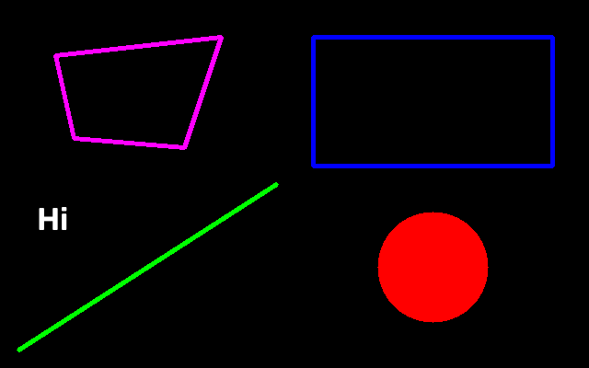
Expected output/drawing.png: colours are (B, G, R), so (255, 0, 0) is blue.
CHECKPOINT 03
☐ output/drawing.png matches the figure and the lecture slide.
☐ output/detection.png has a yellow ‘sun 0.97’ box around the sun.

THINK ABOUT IT
Why does putText take the bottom-left corner of the text, not the top-left?

Exercise 04: the image as a NumPy array
Goal: Read and write single pixels, crop a region, see the difference between a view and a copy, and split the colour channels.
Run: python exercises/ex04_pixels.py

Your TODOs
- TODO 1: read the pixel at row 100, column 200
- TODO 2: paint rows 50-59 and columns 100-109 red
- TODO 3: slice img to get the sun (rows first!)
- TODO 4: make an independent copy of the top-right 50x50 corner
- TODO 5: split img into its three channels

Functions you need
b, g, r = img[y, x] # row first!
roi = img[y1:y2, x1:x2] # a VIEW of img
roi = img[y1:y2, x1:x2].copy() # an independent copy
blue, green, red = cv2.split(img)
CHECKPOINT 04
☐ pixel [100, 200]: B=120 G=66 R=131.
☐ sun crop shape: (130, 130, 3).
☐ Top-left of img becomes [0 0 0] (changed through the view); top-right does not change.

THINK ABOUT IT
The sun looks almost white in the R channel but dark in the B channel. Why?

Exercise 05: arithmetic, blending, threshold and masks
Goal: See why cv2.add is safer than NumPy '+', blend two images, compare the four basic threshold types, and use bitwise operations with masks.
Run: python exercises/ex05_arithmetic.py

Your TODOs
- TODO 1: brighten scene by 80 with cv2.add
- TODO 2: blend A and B with weights alpha and 1 - alpha
- TODO 3: THRESH_BINARY at 127
- TODO 4: AND of the two masks
- TODO 5: keep only the pixels where mask is white

Functions you need
cv2.add(a, b) # saturates at 255
cv2.addWeighted(A, alpha, B, 1 - alpha, 0)
_, bw = cv2.threshold(gray, 127, 255, cv2.THRESH_BINARY)
cv2.bitwise_and(img, img, mask=mask)
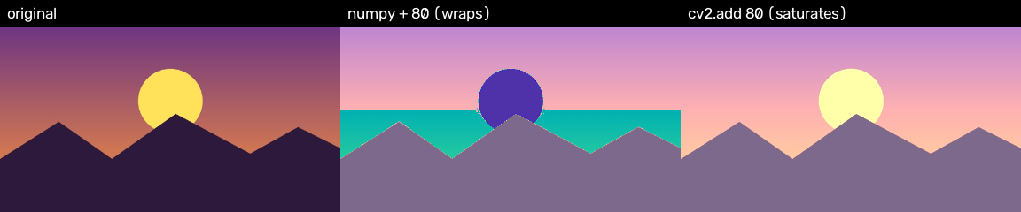
Expected: NumPy '+ 80' wraps around and turns the sky cyan; cv2.add saturates.
CHECKPOINT 05
☐ 250 + 10 → numpy: 4, cv2.add: 255. 10 − 250 → numpy: 16, cv2.subtract: 0.
☐ Step 6 shows only the sun; everything else is black.

THINK ABOUT IT
Explain the cyan sky: which channel wrapped around, and why?

Exercise 06: finding and drawing contours
Goal: Turn an image into a binary mask, find the outline of every white blob, compare retrieval and approximation modes, then run the same pipeline live.
Run: python exercises/ex06_contours.py (then again with --live)

Your TODOs
- TODO 1: convert to grayscale
- TODO 2: blur with a 5x5 Gaussian
- TODO 3: Otsu threshold (T chosen automatically)
- TODO 4: find outer contours with RETR_EXTERNAL
- TODO 5: draw every contour in green, thickness 2

Functions you need
contours, hierarchy = cv2.findContours(bw, cv2.RETR_EXTERNAL, cv2.CHAIN_APPROX_SIMPLE)
cv2.drawContours(img, contours, -1, (0, 255, 0), 2)
CHECKPOINT 06
☐ RETR_EXTERNAL: 11 contours (6 shapes + 5 noise dots). RETR_TREE: 12 (the ring’s hole).
☐ CHAIN_APPROX_NONE stores 2604 points; CHAIN_APPROX_SIMPLE only 818.

THINK ABOUT IT
Why must objects be white on black? What would findContours return on an inverted image?

Exercise 07: contour features and shape naming
Goal: For every real object measure the bounding box, area, perimeter and centroid, and count corners with approxPolyDP to name the shape.
Run: python exercises/ex07_features.py

Your TODOs
- TODO 1: square if w/h is between 0.9 and 1.1
- TODO 2: area of the contour
- TODO 3: upright bounding box
- TODO 4: perimeter of the closed contour
- TODO 5: centroid from the moments
- TODO 6: simplify the outline to its corners (epsilon = 2% of perimeter)

Functions you need
x, y, w, h = cv2.boundingRect(c)
area = cv2.contourArea(c); perim = cv2.arcLength(c, True)
M = cv2.moments(c); cx = int(M["m10"] / M["m00"])
approx = cv2.approxPolyDP(c, 0.02 * perim, True)
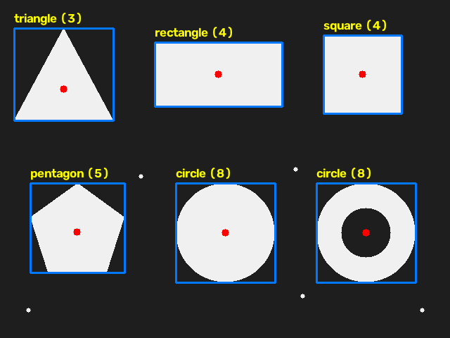
Expected output/features.png: six named shapes; the noise dots are ignored.
CHECKPOINT 07
☐ 6 objects: triangle, rectangle, square, pentagon, circle, circle (the ring).
☐ Triangle area 9100 px, square 12100 px.

THINK ABOUT IT
Change 0.02 to 0.1 in approxPolyDP. Which shapes get the wrong name, and why?

Exercise 08: the HSV colour space
Goal: See why HSV beats BGR for colour detection, build colour masks with inRange (including the two-range trick for red), and locate a ball.
Run: python exercises/ex08_hsv.py

Your TODOs
- TODO 1: convert img from BGR to HSV
- TODO 2: inRange on hsv: H 40-80, S 80-255, V 50-255
- TODO 3: combine r1 and r2 into one mask
- TODO 4: keep the largest contour

Functions you need
hsv = cv2.cvtColor(img, cv2.COLOR_BGR2HSV) # H 0-179, S and V 0-255
mask = cv2.inRange(hsv, (40, 80, 50), (80, 255, 255))
red = cv2.bitwise_or(r1, r2) # red wraps around 0/179
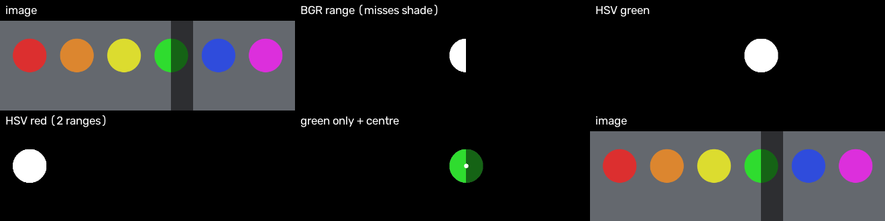
Expected: the BGR range misses the shaded half; the HSV mask keeps the whole ball.
CHECKPOINT 08
☐ Sunlit HSV [60 201 220], shaded HSV [60 201 99]: only V changes.
☐ Green ball centre: (464, 150).

THINK ABOUT IT
Use python tools/hsv_tuner.py data/balls.png to find a range that selects only the orange ball. Write it down.

Exercise 09: advanced thresholding
Goal: Compare a global threshold, Otsu’s automatic threshold and adaptive thresholding on a page photographed under uneven light.
Run: python exercises/ex09_thresholds.py

Your TODOs
- TODO 1: global threshold at 127
- TODO 2: Otsu threshold; keep the returned T
- TODO 3: adaptive MEAN threshold (BLOCK, C)

Functions you need
T, otsu = cv2.threshold(page, 0, 255, cv2.THRESH_BINARY + cv2.THRESH_OTSU)
cv2.adaptiveThreshold(page, 255, cv2.ADAPTIVE_THRESH_MEAN_C, cv2.THRESH_BINARY, 31, 10)
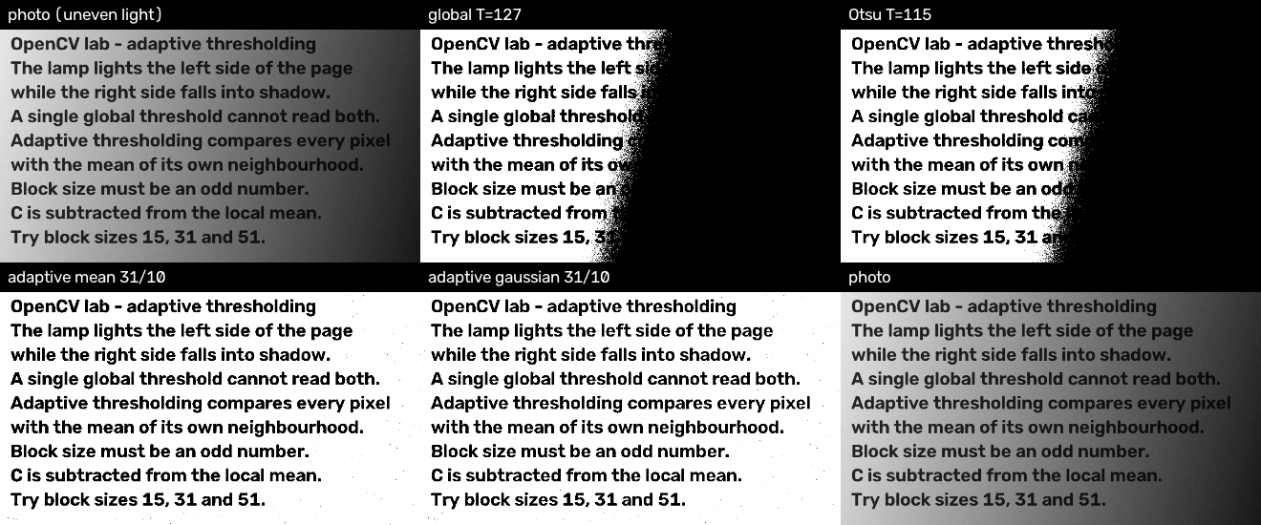
Expected: global and Otsu lose the dark side; adaptive keeps every line.
CHECKPOINT 09
☐ Otsu chose T = 115.
☐ Both adaptive versions keep all lines readable.

THINK ABOUT IT
Try block sizes 15, 31 and 51 and C values 5, 10 and 20. Which combination gives the cleanest page, and why must the block size be odd?

Exercise 10: background subtraction
Goal: Detect moving objects with MOG2, clean the mask, box every object, and compare with plain frame differencing.
Run: python exercises/ex10_background_subtraction.py

Your TODOs
- TODO 1: create a MOG2 subtractor with shadow detection
- TODO 2: apply the subtractor to the frame
- TODO 3: keep only 255 (drop shadows at 127)
- TODO 4: remove speckle noise with a morphological opening
- TODO 5: bounding box of the moving blob

Functions you need
bg = cv2.createBackgroundSubtractorMOG2(history=500, varThreshold=16, detectShadows=True)
fg = bg.apply(frame) # 255 moving, 127 shadow
fg = cv2.morphologyEx(fg, cv2.MORPH_OPEN, kernel)
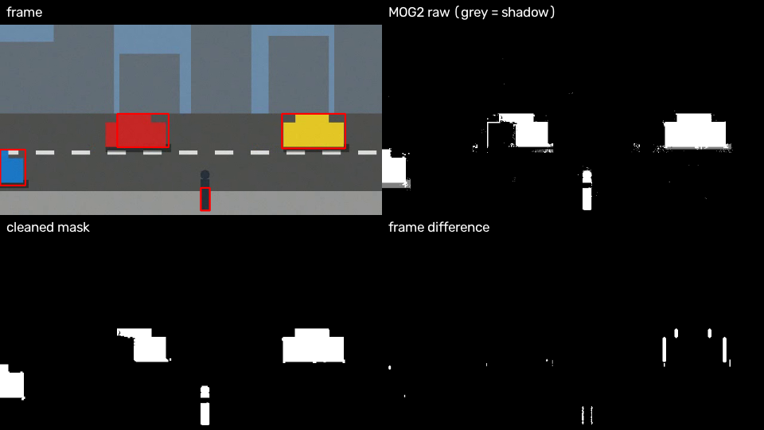
Expected: boxes on the cars and the pedestrian; shadows are grey in the raw mask.
CHECKPOINT 10
☐ After about one second every car and the pedestrian gets a red box.
☐ Shadows are grey (127) in the raw mask and disappear after the threshold at 200.

THINK ABOUT IT
Frame differencing shows only the edges of the cars. Why does MOG2 show the whole car?

4. Part C: mini-projects
Each project combines several blocks into a real program. Everyone should finish Projects 1 and 2 in the lab; Projects 3 and 4 are for fast finishers and homework.

Project 1: photo booth
Blocks used: 01 · 02 · 03
Brief: A live camera app. Draw the date, time and a frame counter on every frame. Press s to save a snapshot, g to toggle grayscale, q to quit.
Run: python projects/p1_photo_booth.py

Your TODOs
- TODO 1: draw a black bar across the top
- TODO 2: write the timestamp in the bar
- TODO 3: write the frame to output/<name>
- TODO 4: convert to gray and back to 3 channels
- TODO 5: toggle grayscale mode
DONE WHEN
☐ Snapshots appear in output/ as snap_YYYYMMDD_HHMMSS.png with the timestamp visible.
☐ g switches between colour and grayscale.

EXTENSION
Add a 3-2-1 countdown drawn on the frame before each snapshot.

Project 2: coin counter
Blocks used: 05 · 06 · 07
Brief: Count the coins in data/coins.png, number each one, and sort them into large and small by area. Coins are dark on light paper, so use an inverted threshold; remove the dust with a morphological opening.
Run: python projects/p2_coin_counter.py

Your TODOs
- TODO 1: blur with a 7x7 Gaussian
- TODO 2: inverted Otsu threshold
- TODO 3: remove the dust with an opening
- TODO 4: outer contours
- TODO 5: keep contours larger than min-area
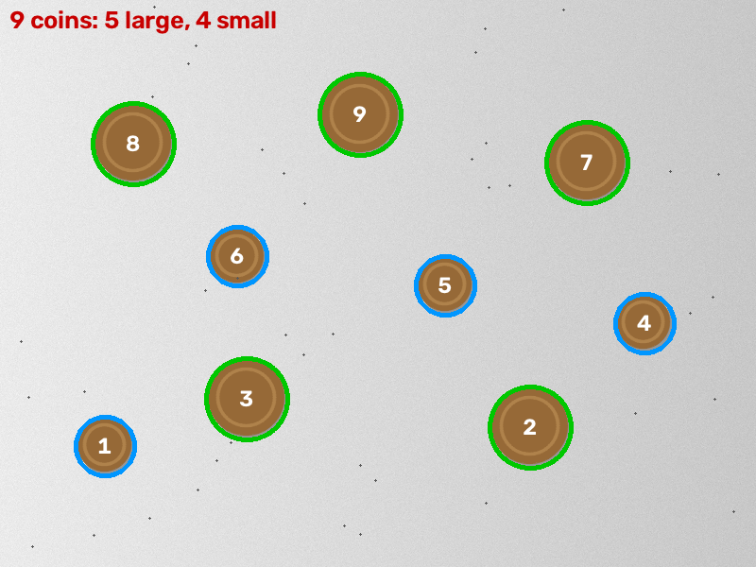
Expected output/coins_counted.png
DONE WHEN
☐ The program prints 9 coins: 5 large, 4 small.
☐ output/coins_counted.png shows every coin numbered.

EXTENSION
Photograph real coins on white paper with your phone and run --image on your photo. What do you have to change?

Project 3: colour tracker
Blocks used: 02 · 03 · 05 · 06 · 07 · 08
Brief: Track a coloured ball: box it, mark its centre, draw a fading trail, and print its offset (dx, dy) from the image centre. That offset is the error signal a drone or robot controller would use to steer towards the target.
Run: python projects/p3_color_tracker.py

Your TODOs
- TODO 1: BGR -> HSV
- TODO 2: colour mask from --lower / --upper
- TODO 3: the largest contour
- TODO 4: centroid
- TODO 5: offset of the ball from the image centre
- TODO 6: connect consecutive trail points
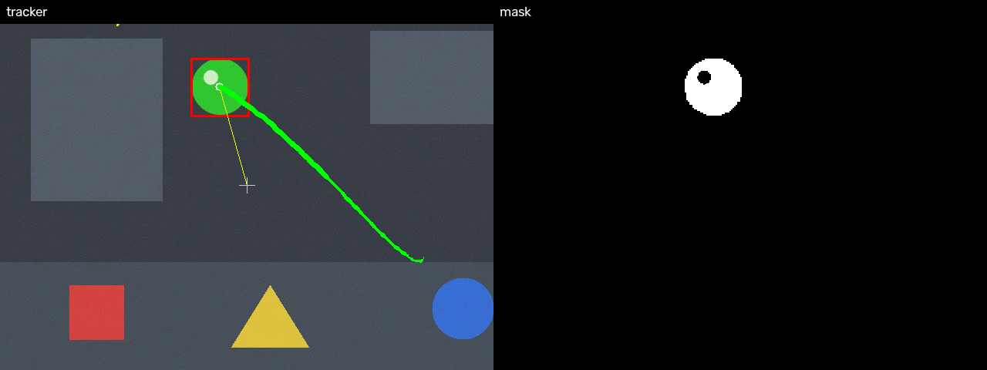
Expected: box, centre, trail and steering error on the green ball
DONE WHEN
☐ The box and trail follow the green ball in data/ball.mp4.
☐ The red, blue and yellow objects are ignored.

EXTENSION
Track a real object with your webcam: find its range with python tools/hsv_tuner.py --source 0 and pass it with --lower / --upper.

Project 4: motion alarm
Blocks used: 02 · 09 · 10
Brief: Watch a camera. When motion lasts a few frames, start recording to output/alarm_<time>.mp4; stop after one second without motion. A small state machine: IDLE → RECORDING → IDLE.
Run: python projects/p4_motion_alarm.py

Your TODOs
- TODO 1: motion = more than min-area white pixels in the mask
- TODO 2: open a VideoWriter for the clip
- TODO 3: close the clip
DONE WHEN
☐ REC appears on screen while something moves.
☐ One or more output/alarm_*.mp4 clips are written.

EXTENSION
Only raise the alarm for motion inside a region you draw (for example a doorway): mask the foreground with bitwise_and first.

5. Part D: submission and grading

5.1 What to submit
- Your completed exercises/ and projects/ folders (not .venv, not data/).
- The output/ images named in each checkpoint, and the screenshot from Checkpoint A.
- A one-page reflection: your answers to the Think about it questions, one thing that failed, and how you fixed it.

5.2 Project rubric (20 marks)
Criterion | Marks
Runs without errors in a fresh .venv | 4
Correct result (count, tracking, recording) | 6
Uses the right building blocks; no hard-coded answers | 4
Clear code: names, comments, constants at the top | 3
Reflection: what failed and how you fixed it | 3
Total | 20

6. Appendix: quick reference

6.1 The sixteen functions
Function | What for | Block
cv2.imread / cv2.imwrite | read and save images | 01
cv2.imshow + cv2.waitKey | show a window | 01
cv2.VideoCapture | camera or video file | 02
cv2.VideoWriter | save frames to a file | 02
cv2.cvtColor | BGR ↔ gray / HSV / RGB | 04, 08
cv2.rectangle, cv2.putText | draw results | 03
cv2.add, cv2.addWeighted | safe arithmetic, blending | 05
cv2.bitwise_and / or / xor / not | combine and apply masks | 05
cv2.threshold | global or Otsu threshold | 05, 09
cv2.adaptiveThreshold | uneven lighting | 09
cv2.inRange | colour range → mask | 08
cv2.findContours | blobs → outlines | 06
cv2.boundingRect | box x, y, w, h | 07
cv2.contourArea, cv2.arcLength | area, perimeter | 07
cv2.moments | centroid cx, cy | 07
cv2.createBackgroundSubtractorMOG2 | motion mask | 10

6.2 Six bugs every beginner writes
Bug | Symptom | Fix
BGR, not RGB | Faces look blue in matplotlib | cv2.cvtColor(img, cv2.COLOR_BGR2RGB)
imread returns None | Crash later on img.shape | if img is None: raise ...
(w, h) vs (h, w) | Empty video file, wrong resize | h, w = img.shape[:2]; sizes are (w, h)
uint8 wraps around | 250 + 10 = 4 | cv2.add, or convert to float first
Hue is 0–179 | Colour ranges twice too big | divide colour-picker degrees by 2
A crop is a view | Drawing on roi edits the original | roi = img[y1:y2, x1:x2].copy()

