Dijkstra Link-State Routing Simulator
A Simulation-Based Study of LSA Flooding, LSDB Synchronization and Shortest Path First Routing
Technology Stack: C++17, Python 3, Pandas, Matplotlib, Git and GitHub
Abstract
Link-state routing protocols require routers to distribute information about their local connectivity, maintain a consistent view of the network, and independently calculate shortest paths. The Dijkstra Link-State Routing Simulator implements these core operations in a controlled software environment. The main simulation is written in C++17 and models routers, weighted links, Link-State Advertisements (LSAs), LSA flooding, Link-State Databases (LSDBs), topology changes and Dijkstra’s Shortest Path First (SPF) calculation. Python is used to analyse the generated CSV results and produce visualizations. The demonstration uses four routers with weighted links, shows the initial shortest route, removes the 1–3 link to force route recalculation, and then restores the link. Performance experiments are performed for network sizes from 4 to 64 routers, measuring SPF execution time and LSA flooding/convergence. The repository also stores routing tables, topology data, SPF measurements, convergence measurements and generated graphs. The report documents the simulator architecture, methodology, implementation, experimental setup, testing, results and limitations.
Introduction
Routing is a fundamental function of computer networks because packets must be forwarded through a sequence of interconnected routers to reach their destinations. In a dynamic network, the forwarding decision cannot remain fixed: links may have different costs, links may fail, and routers must update their knowledge of the topology before selecting new paths. Link-state routing addresses this requirement by allowing routers to advertise their local connectivity and build a common representation of the network.
The project models this process as a self-contained simulation. Each router has an identifier and a set of neighbouring routers with associated link costs. Routers generate Link-State Advertisements containing information about their directly connected neighbours and link costs. These advertisements are flooded through the network and stored in each router’s Link-State Database. Once the network state is available, Dijkstra’s Shortest Path First algorithm is used to calculate the least-cost paths and construct routing-table entries. The repository implements the simulation in C++ and uses Python for post-processing and visualization.
The simulator also includes a controlled topology-change experiment. The initial four-router network provides a lower-cost route from Router 0 to Router 3 through Router 1. When the 1–3 link is removed, updated LSAs are generated and the route changes through Router 2. When the link is restored, the shorter path becomes available again. This sequence provides a compact demonstration of how link-state information and shortest-path computation respond to topology changes.
Problem Statement
A routing protocol must maintain consistent topology information and select efficient paths even when network conditions change. Demonstrating this behaviour directly on a production network is impractical for a controlled academic experiment because real network traffic, hardware, routing implementations and failure conditions introduce variables that are difficult to isolate. The project therefore addresses the problem of building a lightweight simulator that reproduces the essential link-state workflow: router and weighted-link creation, LSA generation, flooding, LSDB synchronization, shortest-path calculation, routing-table generation and route recalculation after a topology change.
A second objective is to quantify selected performance characteristics. The simulator records SPF execution time for networks from 4 to 64 routers and records the number of flooding iterations required for LSDB synchronization. These measurements provide a repeatable way to observe how computational and convergence behaviour changes as the simulated network grows.
Objectives
• Simulate routers and weighted network links.
• Generate and flood Link-State Advertisements through the network.
• Maintain Link-State Databases containing the latest received LSAs.
• Simulate link failure and link restoration.
• Calculate shortest paths using Dijkstra’s Shortest Path First algorithm.
• Generate routing tables containing destination, next hop, cost and path information.
• Measure SPF execution time for different network sizes.
• Measure LSA flooding and convergence behaviour.
• Export topology, routing, SPF and convergence results to CSV files.
• Analyse and visualize the generated results using Python, Pandas and Matplotlib.
System Architecture
The project is organized as a C++ simulation layer and a Python analysis layer. The C++ program creates the network, performs LSA generation and flooding, synchronizes LSDB information, calculates shortest paths, simulates topology changes and writes result files. The Python program reads the generated CSV files and produces graphs for topology, SPF execution time and convergence iterations. The repository contains dedicated source files for the main program, network model, router model and LSA model, together with the analysis script and result/visualization directories.
Stage | Component | Output
1. Network creation | main.cpp / Network.cpp | Routers and weighted links
2. Link-state generation | Router.cpp / LSA.cpp | Router LSAs
3. LSA flooding | Network.cpp | Distributed link-state information
4. LSDB synchronization | Router / Network logic | Latest LSAs at routers
5. SPF calculation | Network.cpp | Shortest paths and routing tables
6. Topology change | Network.cpp | Updated links and LSAs
7. Result generation | C++ result writers | CSV files
8. Analysis | dijikra.py | Plots and performance views
Table 0 — Data flow through the simulator, from network creation to reported output.
Methodology
Network Initialization
The initial demonstration uses four routers. The weighted links are 0↔1 with cost 2, 0↔2 with cost 5, 1↔3 with cost 1 and 2↔3 with cost 2. Link cost is used as the edge weight in the shortest-path calculation. The topology is exported to topology.csv for subsequent analysis.
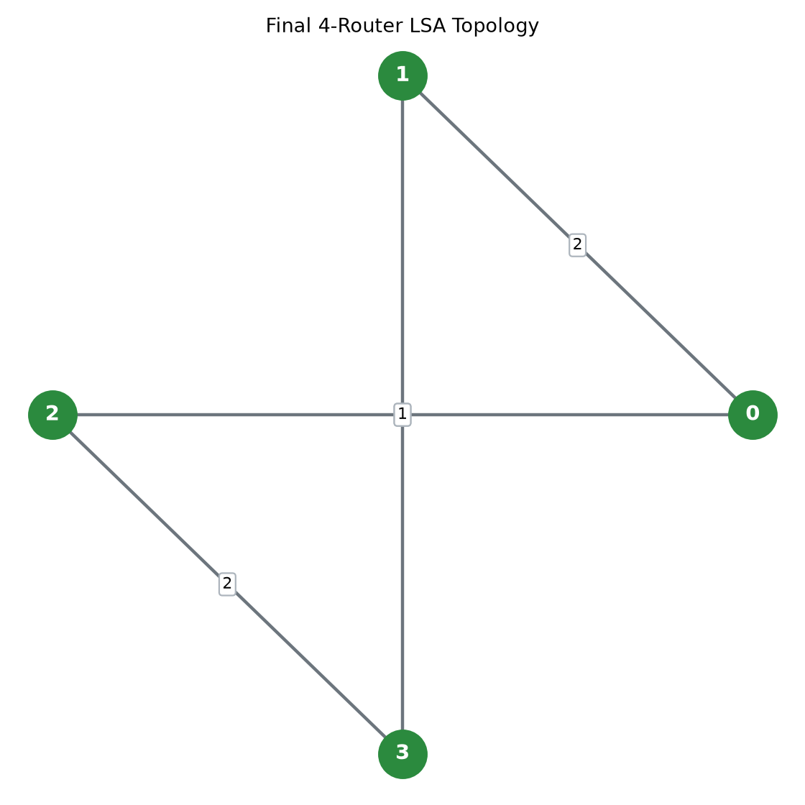
Fig. 1 — Four-router weighted topology used by the simulator.
LSA Generation
Each router generates an LSA containing its identity, a sequence number and information about its directly connected links. For example, Router 3 advertises its connections to Router 2 with cost 2 and Router 1 with cost 1. Sequence numbers allow newer information to be distinguished from older advertisements during flooding.
LSA Flooding
After generation, an LSA is forwarded through neighbouring routers until the information reaches the other routers. The flooding process allows routers to learn link-state information that originated elsewhere in the topology. The simulator records flooding activity and uses convergence results to quantify the number of iterations required for the network to synchronize.
Link-State Database Synchronization
Each router maintains an LSDB containing the latest LSAs it has received. The resulting collection of advertisements provides the router with a representation of the network topology. Once the required link-state information is available, the router can independently run SPF without requiring another router to provide the final route.
Dijkstra Shortest Path First
Dijkstra’s algorithm is used to calculate shortest paths from a source router to the other reachable routers. The implementation uses a priority queue to process the router with the smallest known distance. The procedure starts by assigning distance zero to the source, selecting the minimum-distance router, examining its neighbours, relaxing shorter distances and continuing until the reachable routers have been processed. The resulting predecessor/path information is then used to create routing-table entries.

Routing Table Generation
The routing table records the source router, destination, next hop, total path cost and complete path. For Router 0 in the initial topology, Router 3 is reached through Router 1 with cost 3 because 0→1→3 costs 2+1, which is lower than the alternative 0→2→3 path with cost 5+2=7.
Source | Destination | Next Hop | Cost | Path
0 | 1 | 1 | 2 | 0→1
0 | 2 | 2 | 5 | 0→2
0 | 3 | 1 | 3 | 0→1→3
1 | 0 | 0 | 2 | 1→0
1 | 2 | 3 | 3 | 1→3→2
1 | 3 | 3 | 1 | 1→3
2 | 0 | 0 | 5 | 2→0
2 | 1 | 3 | 3 | 2→3→1
2 | 3 | 3 | 2 | 2→3
3 | 0 | 1 | 3 | 3→1→0
3 | 1 | 1 | 1 | 3→1
3 | 2 | 2 | 2 | 3→2
Table 1 — Routing-table entries generated for the initial four-router topology.
Topology Change: Link Failure
The simulator removes the link 1↔3. Before the failure, Router 0 reaches Router 3 through 0→1→3 at total cost 3. After the failure, updated LSAs are generated, flooded and incorporated into the LSDBs. The new available route becomes 0→2→3 with cost 7.
Link Restoration
The removed 1↔3 link is subsequently added back to the topology. The link-state information is updated and the shorter route becomes available again. This demonstrates the complete response cycle of the simulation: topology change, new advertisements, flooding, database update, SPF recalculation and routing-table recovery.
Implementation
Development Environment
The repository uses C++17 for the main routing simulation and Python 3 for analysis. Pandas is used for CSV-based data handling and Matplotlib is used for graph generation. Git and GitHub provide source-code versioning and repository management.
Project Structure
File / Directory | Purpose
main.cpp | Creates the network and runs the simulation.
Network.cpp / Network.h | Handles the network, links, LSA flooding, topology changes and routing.
Router.cpp / Router.h | Represents routers and their connected links.
LSA.cpp / LSA.h | Represents Link-State Advertisements.
dijikra.py | Reads generated results and creates analysis graphs.
results/ | Stores topology, routing, SPF and convergence CSV files.
visualization/ | Stores topology, SPF-time and convergence graphs.
Table 2 — Main implementation files and generated artefacts.
Router Model
The Router class maintains a router identifier, a sequence number and neighbouring-router information. The implementation provides operations for adding and removing neighbours and checking whether a neighbour exists. This gives the network model a compact representation of the local topology associated with each router.
LSA Model
The LSA class stores the origin router, sequence number and link information associated with the advertisement. The constructor initializes these fields so that the network can create advertisements reflecting the current state of a router’s direct connections.
Network Model
The Network component coordinates the overall simulation. It is responsible for network links, LSA generation and flooding, topology changes, route calculation and result generation. This separation keeps router-level information distinct from network-wide operations.
Python Analysis
The Python analysis script consumes the CSV files produced by the C++ simulator and generates the visualization artefacts. The repository contains graphs for the network topology, SPF execution time and convergence iterations. The analysis therefore separates simulation from presentation and allows the numerical results to be examined independently.
Experimental Setup
The performance experiments use networks ranging from 4 to 64 routers. The SPF result file contains five runs for each network size, with the number of SPF runs equal to the number of routers in the tested network. The convergence result file similarly contains five runs for each network size and records total flooding iterations, maximum LSA iterations and LSDB synchronization status. All recorded convergence cases in the repository have the LSDB synchronization field set to true.
SPF Execution-Time Experiment
For each network size, the simulator measures the total and average execution time of SPF operations. The generated spf_results.csv file contains network size, edge count, run number, number of SPF runs, total execution time in microseconds, average execution time in microseconds and a checksum field. The network sizes are 4, 8, 12, …, 64 routers, with the corresponding edge counts increasing from 6 to 96.
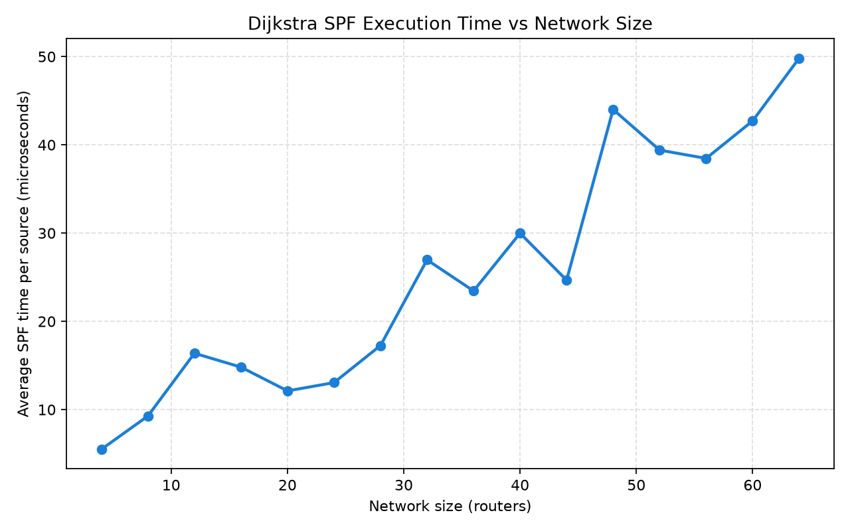
Fig. 2 — Average SPF execution time derived from the repository’s spf_results.csv data.
LSA Convergence Experiment
The convergence experiment measures the number of flooding iterations required for link-state information to synchronize across the network. The convergence_results.csv file records total flooding iterations, maximum LSA iterations and whether the LSDB became synchronized. For the tested network sizes, the recorded runs all report successful LSDB synchronization.
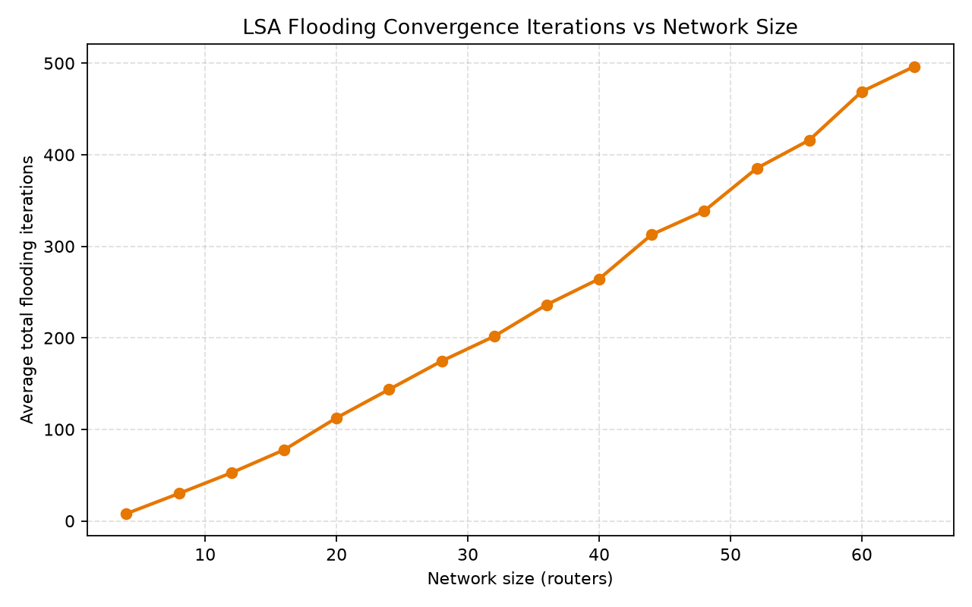
Fig. 3 — Average LSA flooding iterations derived from convergence_results.csv.
Execution and Testing
Compilation and Execution
The repository specifies a C++17 compilation command using g++ with optimization enabled: g++ main.cpp Network.cpp Router.cpp LSA.cpp -std=c++17 -O2 -o routing_simulator.exe. The generated executable is then run from the project directory. The simulation creates the topology, performs LSA flooding, synchronizes LSDBs, calculates shortest paths, applies topology changes and generates result files.
For analysis, the repository specifies installation of Pandas and Matplotlib using Python’s package manager, followed by execution of the Python analysis script. The script reads the CSV outputs and generates the visualization graphs stored in the visualization directory.
Testing Scenarios
• Initial network: the four-router topology is created and LSAs are generated and flooded.
• Link failure: the 1↔3 link is removed and routing information is recalculated.
• Link restoration: the same link is added back and the shorter route becomes available again.
• Different network sizes: SPF execution time and convergence measurements are performed for networks from 4 to 64 routers.
Results and Discussion
Routing Result
The routing-table output confirms the expected shortest paths for the initial topology. Router 0 selects Router 1 as the next hop for Router 3, producing the path 0→1→3 at cost 3. The alternative route through Router 2 costs 7, so Dijkstra’s calculation correctly selects the lower-cost path.
SPF Performance
Routers | Edges | Average SPF (µs) | Minimum (µs) | Maximum (µs)
4 | 6.0 | 5.50 | 3.50 | 11.75
8 | 12.0 | 9.28 | 6.75 | 11.62
12 | 18.0 | 16.38 | 14.83 | 19.00
16 | 24.0 | 14.81 | 11.44 | 19.75
20 | 30.0 | 12.12 | 11.45 | 13.00
24 | 36.0 | 13.06 | 12.38 | 13.54
28 | 42.0 | 17.26 | 15.96 | 19.18
32 | 48.0 | 26.97 | 22.69 | 32.41
36 | 54.0 | 23.45 | 19.83 | 33.64
40 | 60.0 | 29.99 | 24.55 | 36.90
44 | 66.0 | 24.67 | 23.61 | 26.41
48 | 72.0 | 44.01 | 39.15 | 49.88
52 | 78.0 | 39.40 | 27.21 | 74.23
56 | 84.0 | 38.46 | 31.11 | 50.48
60 | 90.0 | 42.72 | 34.83 | 56.37
64 | 96.0 | 49.83 | 40.11 | 71.62
Table 3 — Summary of the five recorded SPF runs for each network size.
The repository results show that SPF execution time generally increases as the network size increases, although individual runs fluctuate. For example, the 4-router runs have average times in the low-microsecond range, while the 64-router runs include substantially larger measurements. This variation is expected in execution-time measurements because the simulator is measuring actual program execution rather than an analytical complexity formula. The overall trend demonstrates the increasing computational work associated with processing larger simulated topologies.
Convergence Performance
Routers | Edges | Average Flooding Iterations | Minimum | Maximum
4 | 6.0 | 8.0 | 8 | 8
8 | 12.0 | 30.0 | 28 | 32
12 | 18.0 | 52.6 | 51 | 54
16 | 24.0 | 77.6 | 73 | 83
20 | 30.0 | 112.6 | 110 | 115
24 | 36.0 | 143.6 | 136 | 157
28 | 42.0 | 174.6 | 166 | 182
32 | 48.0 | 201.6 | 192 | 228
36 | 54.0 | 236.2 | 221 | 256
40 | 60.0 | 264.4 | 251 | 277
44 | 66.0 | 312.8 | 294 | 328
48 | 72.0 | 338.6 | 327 | 362
52 | 78.0 | 385.2 | 360 | 415
56 | 84.0 | 416.0 | 413 | 418
60 | 90.0 | 469.0 | 437 | 504
64 | 96.0 | 496.4 | 482 | 510
Table 4 — Summary of the five recorded convergence runs for each network size.
The convergence results show a clear increase in total flooding iterations as the number of routers increases. The four-router network requires eight total flooding iterations in every recorded run, while the 64-router network requires between 482 and 510 iterations across the five runs. The maximum LSA-iteration field also rises from values around two at four routers to values around nine or ten at the largest tested networks. Every recorded run reports successful LSDB synchronization.
Topology Change Behaviour
The link-failure experiment provides a functional result in addition to the performance measurements. Removing the 1↔3 link invalidates the original shortest route from Router 0 to Router 3. The simulator responds by generating updated LSAs, flooding the changed information and recalculating routes. The selected path changes from 0→1→3 with cost 3 to 0→2→3 with cost 7. Restoring the link makes the lower-cost path available again.
Advantages and Limitations
Advantages
• Provides a controlled demonstration of the major steps in link-state routing without requiring physical routers.
• Separates the routing simulation from result analysis, making the workflow easy to reproduce and inspect.
• Demonstrates both normal shortest-path routing and dynamic response to a link failure.
• Produces structured CSV outputs for topology, routing, SPF performance and convergence.
• Provides visualization of topology, SPF execution time and convergence behaviour.
• Supports experiments over a range of network sizes from 4 to 64 routers.
Limitations
• The simulator is a software model and does not represent packet-level behaviour on a real network.
• The demonstration topology is small, while the performance experiments use generated network sizes rather than a full production routing environment.
• Execution-time measurements are machine-dependent and should be interpreted as simulator performance measurements rather than universal hardware-independent values.
• The project focuses on the core link-state workflow and does not attempt to reproduce every feature of a production link-state routing protocol.
• Only the topology changes included in the repository are demonstrated: removal and restoration of the 1↔3 link.
Future Scope
• Extend the simulator with larger and more varied network topologies.
• Introduce multiple simultaneous link failures and recovery scenarios.
• Add packet-level traffic simulation to study routing decisions under load.
• Compare Dijkstra-based link-state routing with alternative routing algorithms.
• Add interactive topology editing and real-time route visualization.
• Expand performance analysis to include memory usage, flooding message counts and route-recalculation frequency.
• Add automated regression tests for routing-table correctness and LSDB synchronization.
Conclusion
The Dijkstra Link-State Routing Simulator provides a compact, reproducible demonstration of the principal operations of a link-state routing system. Routers maintain local connectivity information, generate Link-State Advertisements, flood the advertisements through the network and build Link-State Databases. Dijkstra’s Shortest Path First algorithm then uses the resulting topology information to determine least-cost paths and generate routing tables. The four-router demonstration clearly shows the selection of the 0→1→3 path with cost 3 and the subsequent change to 0→2→3 with cost 7 when the 1↔3 link fails.
The project also extends the functional demonstration with quantitative measurements. SPF execution time is recorded for networks from 4 to 64 routers, while LSA convergence is measured through flooding-iteration counts. The repository results show increasing computational and convergence requirements as the network grows, while all recorded convergence runs successfully synchronize their LSDBs. By combining a C++ network simulation with CSV-based result generation and Python visualization, the project offers an effective academic environment for studying link-state routing, shortest-path computation and the effect of topology scale on routing performance.

References
• J. F. Kurose and K. W. Ross, Computer Networking: A Top-Down Approach, Pearson.
• A. S. Tanenbaum and D. J. Wetherall, Computer Networks, Pearson.
• E. W. Dijkstra, “A Note on Two Problems in Connexion with Graphs,” Numerische Mathematik, 1959.
• Python Documentation.
• Matplotlib Documentation.
• Pandas Documentation.

