Question 47: Bank Branch Performance Summary

1. Aim
To write a COBOL program to calculate the total deposits, total withdrawals, and net amount for each bank branch and the entire bank.

2. Algorithm
- Start the program.
- Read the number of transactions.
- Read the branch ID, transaction type, and amount for each transaction.
- If the type is D, add the amount to the deposit total.
- If the type is W, add the amount to the withdrawal total.
- Calculate the net amount by subtracting withdrawals from deposits.
- Display the totals for each branch and the entire bank.
- Stop the program.

3. Program
IDENTIFICATION DIVISION.
PROGRAM-ID. BRANCH-REPORT.

DATA DIVISION.
WORKING-STORAGE SECTION.

01 N PIC 9(3).
01 I PIC 9(3).
01 BRANCH-CODE PIC X(3).
01 TRANS-TYPE PIC X.
01 AMOUNT PIC 9(7)V99.

01 DEPOSITS PIC 9(9)V99 VALUE ZERO.
01 WITHDRAWALS PIC 9(9)V99 VALUE ZERO.
01 NET-AMOUNT PIC S9(9)V99.

PROCEDURE DIVISION.

ACCEPT N

PERFORM VARYING I FROM 1 BY 1
UNTIL I > N

ACCEPT BRANCH-CODE
ACCEPT TRANS-TYPE
ACCEPT AMOUNT

IF TRANS-TYPE = "D"
ADD AMOUNT TO DEPOSITS
ELSE
IF TRANS-TYPE = "W"
ADD AMOUNT TO WITHDRAWALS
END-IF
END-IF

END-PERFORM

COMPUTE NET-AMOUNT = DEPOSITS - WITHDRAWALS

DISPLAY "Total Deposits: " DEPOSITS
DISPLAY "Total Withdrawals: " WITHDRAWALS
DISPLAY "Net Amount: " NET-AMOUNT

STOP RUN.

4. Sample Input
3
101
D
1000.00
101
W
250.00
202
D
500.00

5. Sample Output
Total Deposits: 00001500.00
Total Withdrawals: 00000250.00
Net Amount: +00001250.00

6. Output
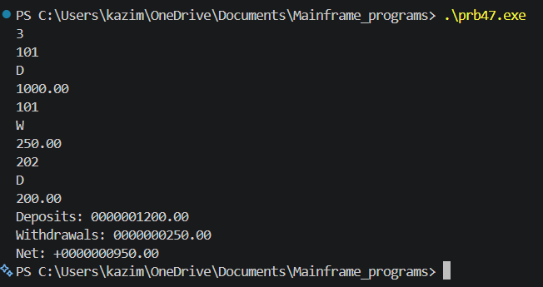

6. Result
Thus, the COBOL program was written to calculate the total deposits, total withdrawals, and net amount of bank transactions successfully

