**Mobile Charger Module Using KiCad**

**Kazim mohamed S A**

**Abstract:**

This project involves designing a mobile charger circuit that converts 220V AC input to a regulated 5V DC output using a compact and efficient switch-mode power supply (SMPS). The circuit is designed in KiCad and focuses on using essential components like diodes, capacitors, transistors, and transformers to achieve safe and efficient voltage conversion.

The charger circuit follows the typical process of AC to DC conversion, with an intermediate step of high-frequency AC generation to reduce the size of components, making the circuit compact and suitable for mobile chargers.

**Project Overview**

* Input Voltage: 220V AC, 50Hz
* Output Voltage: 5V DC
* Components Used: Diodes, capacitors, resistors, transistors, optocoupler, transformer, Schottky diode, and LED indicator.

The circuit is designed with safety features like a fusible resistor, MOV (Metal Oxide Varistor) for surge protection, and optocoupler isolation to ensure safe operation.

**Working Principle**

1. AC Input (220V) passes through a fusible resistor, which limits the current.
2. The bridge rectifier converts the AC input to pulsating DC.
3. The filter capacitor smooths the DC voltage.
4. The oscillator circuit converts the DC to high-frequency AC (15 to 50 kHz) using two transistors.
5. The transformer steps down the high-frequency AC voltage to a safe 5V output.
6. The output stage converts the AC to DC using a Schottky diode and a filter capacitor.
7. The feedback circuit stabilizes the output voltage by controlling the primary side transistor through an optocoupler.

**Components Required:**

1. **Fusible Resistor:** 260Ω
2. **Bridge Rectifier:** 4 x 1N4007 diodes
3. **Filter Capacitor:** 2.2μF, 450V
4. **Transistor T1:** S8050
5. **Transistor T2:** 13001
6. **Transformer:** inductors in KiCad
7. **Fast Switching Diode:** 1N4148
8. **Schottky Diode:** 1N5819
9. **Filter Capacitor (Output):** 470μF, 10V
10. **Optocoupler:** PC817C
11. **Zener Diode:** 4.2V
12. **LED Indicator:** Red/Green
13. **Output Connector:** 2-pin terminal block

**SCHEMATIC DIAGRAM**:

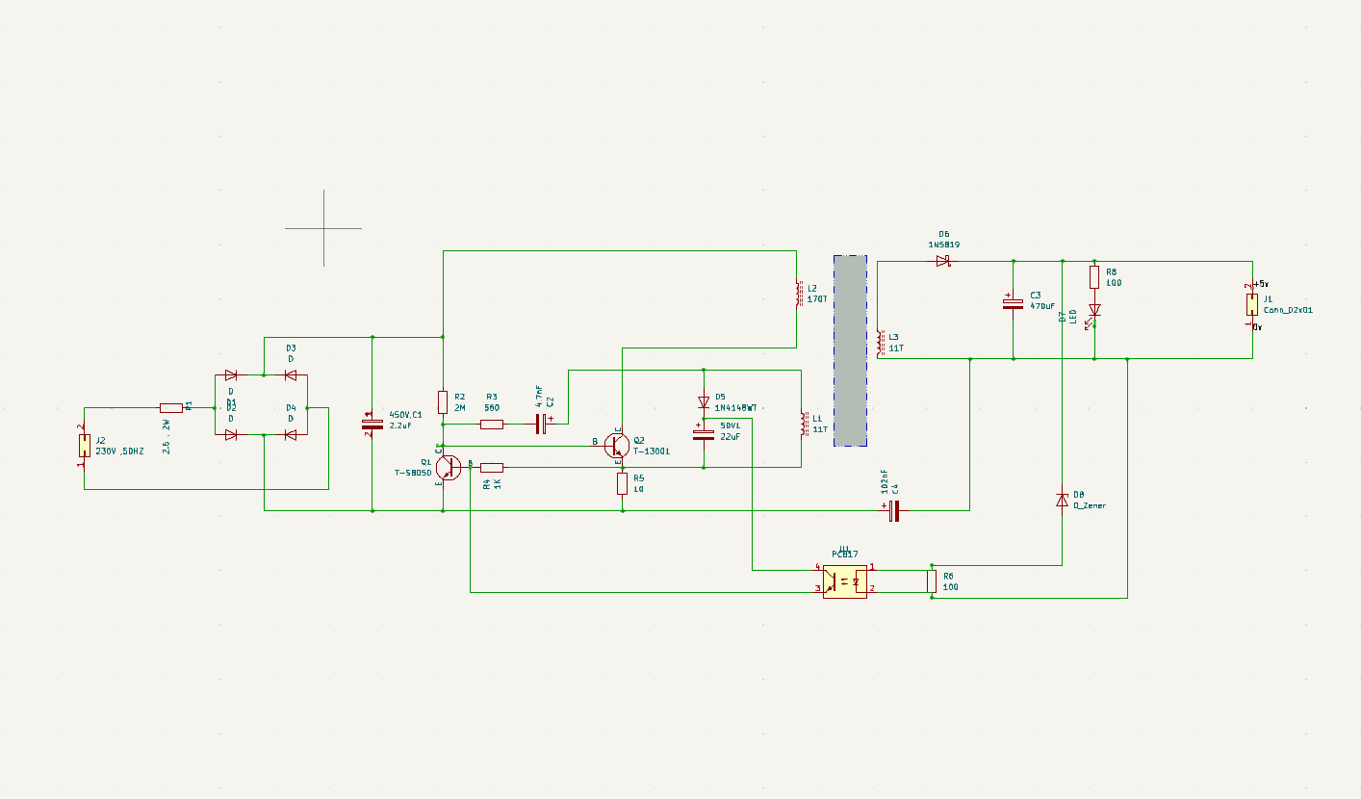

**PCB layout:**



**3D View:**

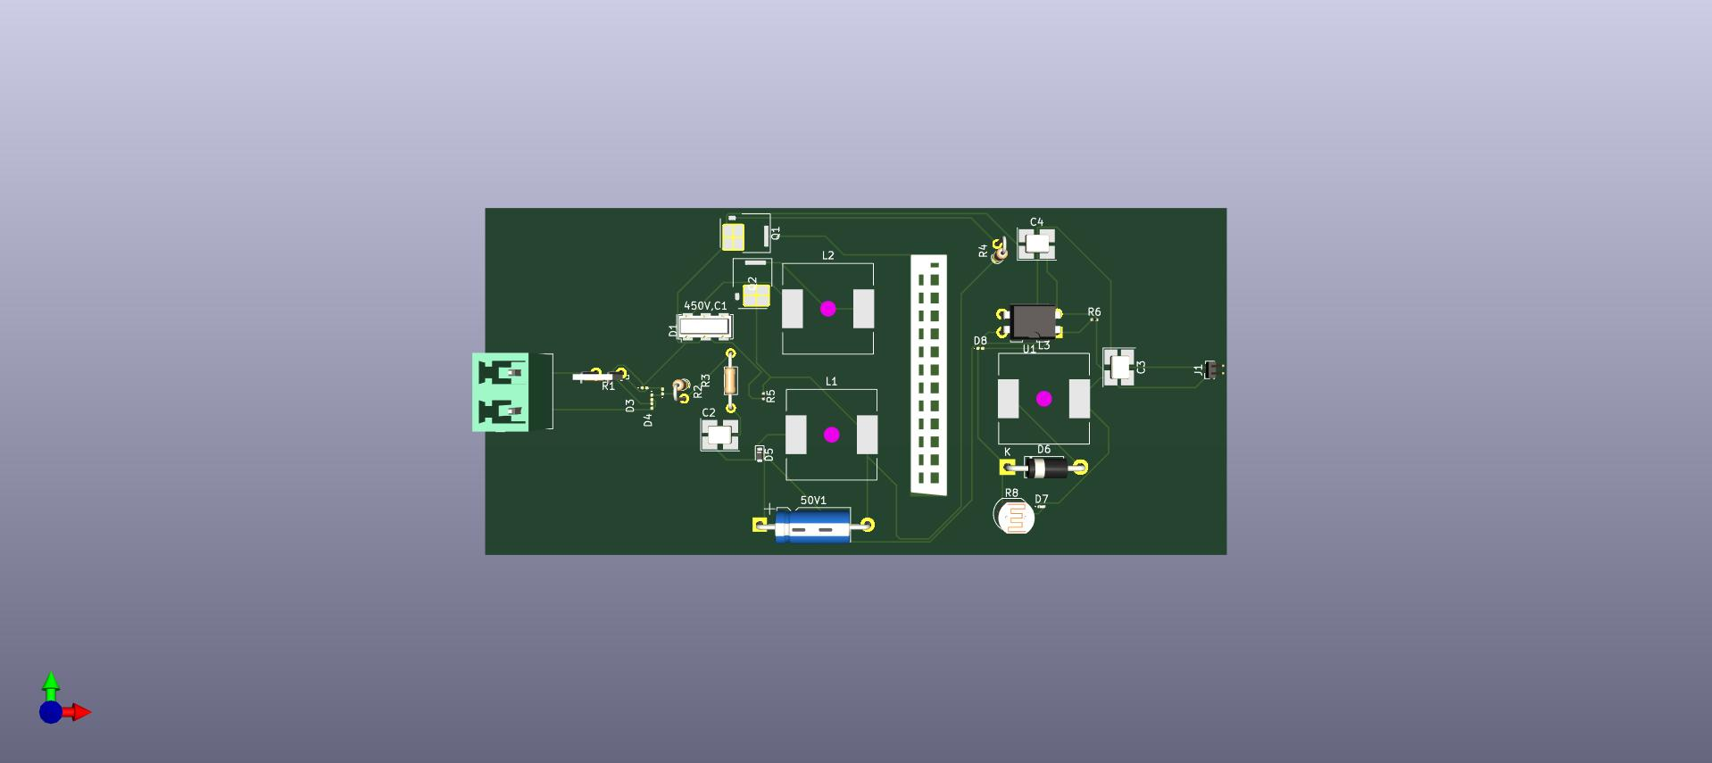

**Conclusion**

The Mobile Charger Module efficiently converts 220V AC input to 5V DC output using a high-frequency transformer-based design. The use of feedback control, optocoupler isolation, and safety components ensures stable operation and protection against voltage fluctuations. The entire circuit is designed and implemented in KiCad, with a focus on component placement, trace routing, and safety considerations to produce a compact, reliable mobile charger.