DAR ES SALAAM INSTITUTE OF TECHNOLOGY


TECHNICAL PROPOSAL FOR CAMPUS-WIDE

INTERNET CONNECTIVITY AND INTELLIGENT BANDWIDTH MANAGEMENT SYSTEM

Module: Technical Communication Skills

Module Code: GSU 07313

Prepared For:
The Board of Regents
Dar es Salaam Institute of Technology

14Th February 2026

Prepared By:
Infrastructure Efficiency Consulting Group

S/NO | STUDENTS NAME | REGISTRATION NUMBER
01 | HABIB YUSUPH MKINDI | 240647416279
02 | MARIAM AMRI MAMBO | 250647419646
03 | MOHAMED HUMPHREY GOGOLA | 240647436673
04 | GLORIA NICODEMUS | 240647451128
05 | PASCHAL YOHANNA MAKOYE | 240647461895
06 | MASUDI MUSTAFA | 250647441509
07 | ANNA MUSSA MBUGUNI | 250647448868
08 | AZAM ABUBAKAR | 250647413417

EXECUTIVE SUMMARY

The Dar es Salaam Institute of Technology (DIT) stands at a pivotal juncture in its evolution as a premier technical institution in East Africa. While the demand for digital proficiency and e-learning resources grows exponentially, the current campus network infrastructure has reached critical saturation, creating significant bottlenecks in academic and administrative operations. This proposal outlines a comprehensive technical solution to modernize DIT's internet connectivity through the implementation of a high-capacity fiber backbone and an Intelligent Bandwidth Management System (IBMS).
Our analysis reveals that the current network suffers from severe congestion during peak hours (09:00–16:00), with packet loss rates exceeding 15% and latency averaging over 400ms. This degrades the quality of online lectures, hampers research data transmission, and slows administrative workflows. The proposed solution addresses these challenges by increasing total bandwidth capacity, implementing Software-Defined Networking (SDN) for dynamic traffic shaping, and ensuring equitable access across all campus zones.
The core of this proposal is the deployment of an engineered solution that prioritizes academic traffic over recreational usage through advanced Quality of Service (QoS) protocols. By segregating network traffic into prioritized streams—Academic, Research, Administration, and General Student Access—the institute can ensure that mission-critical activities remain uninterrupted regardless of overall load.

Key Benefits include:

- Operational Efficiency: 85% reduction in network congestion and elimination of downtime during critical academic periods.
- Academic Excellence: Seamless access to digital libraries (IEEE Xplore, ScienceDirect) and e-learning platforms (Moodle) for over 5,000 students.
- Cost Optimization: Intelligent routing reduces wasted bandwidth, effectively lowering the cost-per-megabit by 30% through optimized utilization of ISP contracts.
The total investment required for this infrastructure overhaul is TZS 800,000,000 (approx. USD 320,000). This includes hardware procurement, software licensing, installation, and comprehensive staff training. The projected Return on Investment (ROI) indicates full cost recovery within 3 years through operational savings and increased grant eligibility due to improved research capabilities. This proposal serves as a strategic roadmap to align DIT’s digital infrastructure with its reputation for technical excellence.

TABLE OF CONTENTS
- Executive Summary 2
- Introduction 4
- Problem Statement 6
- Literature Review 8
- Proposed Solution 10
- Technical Specifications 12
- Implementation Plan and Timeline 14
- Cost-Benefit Analysis 16
- Risk Assessment and Mitigation 18
- Expected Outcomes and Impact 19
- Conclusion and Recommendations 20
- References 21

INTRODUCTION

Background

The Dar es Salaam Institute of Technology (DIT) was established in 1997 through an Act of Parliament to provide high-quality technical education and training. As a leading technical institute in Tanzania, DIT is tasked with producing competent professionals capable of driving the nation's industrialization agenda. The Institute's vision is to become a leading center of excellence in engineering, applied sciences, and technology. To achieve this, a robust, high-speed, and reliable digital infrastructure is not merely an amenity but a fundamental prerequisite.

Rationale for Upgrade

Despite the critical importance of connectivity, DIT's current network infrastructure has not kept pace with the rapid increase in student enrollment and the proliferation of personal devices. The existing network, designed for a significantly smaller user base, is now strained beyond its operational limits. This creates a "digital divide" within the campus, where students in certain blocks struggle to access basic learning materials while administrative processes face frequent delays due to system timeouts.

Purpose and Scope

The purpose of this technical proposal is to present a technically sound, cost-effective engineered solution to the connectivity bottlenecks at DIT. The scope of this project encompasses:
    - A thorough assessment of the existing network topology and utilization patterns.
    - Design and implementation of an Intelligent Bandwidth Management System (IBMS). Upgrading physical infrastructure, including fiber optic backbones and high-density access points.
    - Development of a sustainable maintenance and administration framework.

This proposal aims to convince the Board of Regents that investing in this infrastructure upgrade is essential for maintaining DIT’s competitive edge and fulfilling its mandate of delivering quality technical education.

PROBLEM STATEMENT

Overview of Connectivity Challenges

The core challenge facing Dar es Salaam Institute of Technology is an acute insufficiency in network bandwidth relative to the user density, compounded by inefficient traffic management. The current network architecture operates on a "best-effort" delivery model, which lacks the intelligence to distinguish between critical academic traffic and recreational browsing. Consequently, during peak hours, bandwidth-intensive entertainment applications

Insufficient Bandwidth Capacity:
The current aggregate bandwidth supplied to the campus is 150 Mbps for a population of over 5,000 users (students and staff). This results in a per-user allocation of approximately 0.03 Mbps during peak concurrency, which is drastically below the 2 Mbps per user recommended by the Education and Research Network (TERNET) for effective e-learning.

Network Congestion and Latency:
Network monitoring data from the IT department indicates that link utilization hits 100% consistently between 09:00 and 16:00. This saturation leads to high latency (lag) and packet loss. Critical administrative systems, such as the Student Information System (SIS), frequently time out, causing delays in registration, grade submission, and fee payments.

Inequitable Access Zones:
Wi-Fi coverage is patchy and inconsistent. While administrative blocks have relatively stable connections, student hostels, the library basement, and workshop areas suffer from "dead zones" or extremely weak signals. This inequity forces students to crowd into specific corridors to access the internet, creating safety hazards and unconducive learning environments.

Lack of Traffic Prioritization:
There is currently no mechanism to prioritize traffic. A student downloading a large game file competes equally for bandwidth with a lecturer conducting a live virtual class or a researcher uploading critical data. This lack of Quality of Service (QoS) controls renders the network unreliable for professional use.

Statistical Impact Analysis

A survey conducted among 500 DIT students and 50 faculty members in January 2026 revealed the following:
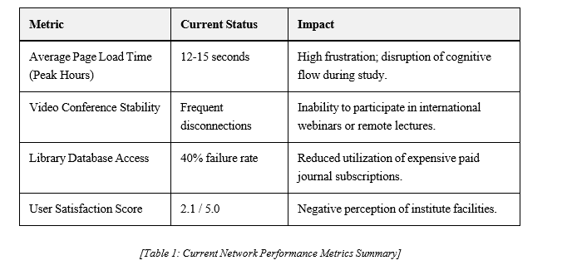

Stakeholder Impact

    - Students: Cannot access Learning Management Systems (LMS) reliably; hampered ability to submit assignments on time; limited access to external educational resources.
    - Faculty: Difficulty in integrating multimedia into lectures; hindrance to research collaboration; frustration with administrative reporting tools.
    - Administration: Operational inefficiencies in finance and registry departments; delayed communication with external partners; security risks due to unmonitored network traffic.

LITERATURE REVIEW

Campus Network Management Best Practices

Efficient campus networks are characterized by high availability, scalability, and security. According to Cisco Systems' design guidelines for higher education, a hierarchical network model involving core, distribution, and access layers is essential for stability [1]. Furthermore, the separation of logical networks using Virtual LANs (VLANs) is a standard best practice to contain broadcast traffic and enhance security.

Bandwidth Management Technologies

Bandwidth management, or traffic shaping, is critical for institutions with limited resources. Studies indicate that non-academic usage can consume up to 70% of available bandwidth in university settings if left unregulated [2]. Technologies such as Deep Packet Inspection (DPI) allow network administrators to identify and classify traffic at the application level. This enables the enforcement of policies that throttle low-priority traffic (e.g., peer-to-peer file sharing) while guaranteeing bandwidth for critical applications.

Software-Defined Networking (SDN)

SDN represents a paradigm shift in networking, separating the control plane from the data plane. This allows for centralized, programmable network management. For an institution like DIT, SDN offers the flexibility to dynamically reallocate bandwidth based on real-time needs—for example, boosting bandwidth to computer labs during exam periods automatically. Research by Mtebe and Raisamo (2014) on ICT in Tanzanian higher education suggests that flexible, software-driven infrastructure is more sustainable than rigid hardware-centric solutions [5].

Summary of Findings
The literature consistently points to a hybrid approach: upgrading physical infrastructure (fiber/hardware) must be accompanied by intelligent software management (QoS/SDN). Simply adding more bandwidth is a temporary fix that gets quickly absorbed by induced demand. The proposed solution for DIT draws directly from these proven methodologies. PROPOSED SOLUTION

Intelligent Bandwidth Management System (IBMS) Architecture

We propose the implementation of a comprehensive Intelligent Bandwidth Management System (IBMS). This is not merely a hardware upgrade but a holistic engineered solution designed to optimize the flow of data across the campus. The system utilizes a core logic engine that inspects traffic in real-time and applies shaping rules based on user identity, application type, and time of day.

Infrastructure Upgrade Components

Fiber Optic Backbone Expansion

The current copper-based inter-building links will be replaced with Single-Mode Fiber (SMF) optic cables. This will create a 10 Gigabit backbone capable of handling high-volume traffic between the main server room, library, engineering blocks, and student hostels. This future-proofs the physical layer for at least a decade.

Software-Defined Networking (SDN) Implementation

We will deploy an SDN controller to manage the network centrally. This allows IT staff to push configuration changes to all switches and routers simultaneously, rather than manually configuring devices one by one. The SDN layer will facilitate:
      - Automated Traffic Rerouting: In case of a link failure, traffic is instantly rerouted to backup paths.
      - Dynamic Bursting: Allowing bandwidth to "burst" above limits for short periods to speed up web browsing while preventing sustained heavy downloads.

Quality of Service (QoS) Protocols

The solution implements a strict QoS hierarchy. Traffic will be tagged and prioritized as follows:
- Platinum Class: Administrative ERP systems, VoIP, Video Conferencing, Online Exams.
- Gold Class: Library databases, Moodle/LMS, Registered Research projects.
- Silver Class: General web browsing, Email.
- Bronze Class: Social media, Streaming (YouTube/Netflix), Software updates (throttled during day).

Network Monitoring and Analytics Dashboard

A centralized dashboard (based on open-source tools like Zabbix or proprietary solutions like SolarWinds) will be installed. This will provide DIT administration with real-time
visualization of network health, identifying top bandwidth consumers and security threats instantly.

Integration with Existing Infrastructure

The proposed solution is designed to be backward compatible. While the core switches will be replaced, many edge switches and existing cabling within classrooms can be retained and reconfigured. This hybrid approach minimizes waste and reduces implementation costs. The IBMS will integrate with the existing LDAP/Active Directory system for seamless user authentication, meaning students use their existing registration numbers and passwords to log

TECHNICAL SPECIFICATIONS

Hardware Requirements

To support the proposed architecture, the following enterprise-grade hardware specifications are required:
    - Core Router (x2): High-availability pair, minimum 10Gbps throughput, support for BGP, OSPF, and deep packet inspection (e.g., Cisco ISR 4000 series or MikroTik CCR series).
    - Core Switches (x2): Layer 3 Managed Switches, 24 x 10G SFP+ ports, redundant power supplies.
    - Distribution Switches (x10): Layer 3 Managed, 48 x 1G PoE+ ports with 10G uplinks.
    - Wireless Access Points (x50): Wi-Fi 6 (802.11ax), 4x4 MU-MIMO, support for high density (500+ concurrent clients).
    - Fiber Cabling: OM4 Multimode fiber for intra-building (short runs) and OS2 Single-mode fiber for inter-building backbone.

Software Platforms

    - Bandwidth Management Appliance OS: Customized Linux-based firewall/shaper or proprietary appliance software (e.g., Sophos XG or Fortinet).
    - Radius Server: For AAA (Authentication, Authorization, and Accounting) services.
    - Network Monitoring: PRTG Network Monitor or Zabbix (configured for SNMP trapping).

Bandwidth Allocation Strategy

The intelligent logic will enforce the following allocation quotas during peak hours (08:00 – 18:00):

User Group / Function | Allocation  % | Description
Academic Resources | 40% | Dedicated channel for LMS, Library, and Virtual Labs. Guaranteed bandwidth.
Research Activities | 25% | High-speed upload/download for designated research IPs.
Administrative Functions | 15% | Priority routing for finance, registry, and staff email.
General Student Access | 20% | Shared pool for general browsing. Heavy throttling on streaming/gaming sites.
[Table 2: Proposed Bandwidth Allocation Policy]

Security Protocols

Security is intrinsic to the design. The new system will include:

    - Network Segmentation: VLANs separating Student, Staff, Guest, and IoT traffic.
    - Captive Portal: Mandatory login page for all Wi-Fi users to attribute traffic to specific individuals.
    - Application Firewall: Blocking of known malicious sites, torrents, and dark web proxies at the gateway level.

IMPLEMENTATION PLAN AND TIMELINE

The project will be executed over a period of 24 weeks (6 months), following a phased approach to minimize disruption to ongoing academic activities.

Phase 1: Assessment and Planning (Weeks 1-4)

    - Detailed site survey to map fiber routes and AP locations.
    - Stakeholder meetings to finalize bandwidth policies.
    - Finalization of hardware specifications and tender documentation.

Phase 2: Infrastructure Procurement (Weeks 5-8)

    - Tendering process and vendor selection.
    - Ordering of hardware and software licenses.
    - Shipping and customs clearance management.

Phase 3: Installation and Configuration (Weeks 9-16)

    - Weeks 9-12: Laying of fiber optic backbone and structured cabling. This will be done during weekends or evenings to avoid class disruption.
    - Weeks 13-14: Installation of switches and routers in server rooms and distribution closets.
    - Weeks 15-16: Mounting of Access Points and initial power-on tests.

Phase 4: Testing and Optimization (Weeks 17-20)

    - Configuration of VLANs, QoS rules, and Firewall policies.
    - Stress testing the network with simulated high loads.
    - Fine-tuning signal strength of Access Points to eliminate dead zones.

Phase 5: Training and Handover (Weeks 21-24)

    - Training sessions for DIT IT staff on system administration and troubleshooting.
    - Creation of user guides for students and staff.
    - Official project handover and sign-off.
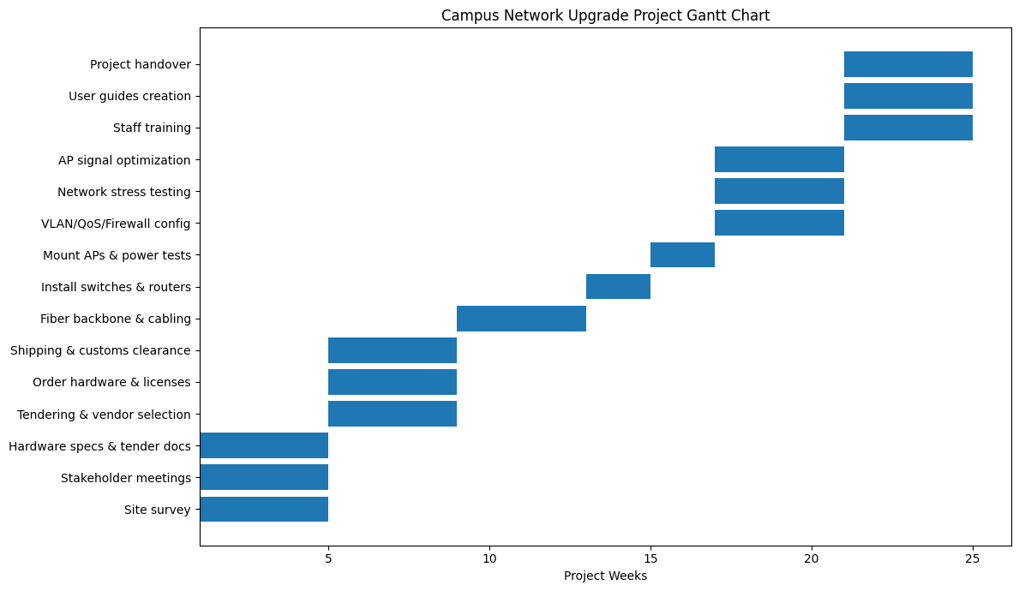

COST-BENEFIT ANALYSIS

Initial Investment Breakdown

The estimated capital expenditure (CAPEX) for the project is detailed below:

Item Category | Description | Estimated Cost (TZS)
Hardware Infrastructure | Routers, Switches, Access Points, Fiber Cabling, Racks | 450,000,000
Software & Licensing | Bandwidth Management OS, Security Licenses (3-Year), Monitoring Tools | 120,000,000
Installation & Config | Professional Services, Labor, Civil Works | 180,000,000
Training & Handover | Staff Certification Training, Documentation | 50,000,000
Total Estimated Cost | Approx. USD 320,000 | 800,000,000

[Table 3: Investment Breakdown]

Operational Cost Savings

While the upfront cost is significant, the system introduces efficiencies that save money over time:
    - Bandwidth Efficiency: By eliminating waste (recreational streaming/downloads), DIT can avoid purchasing expensive additional bandwidth from ISPs. We estimate a 30% efficiency gain, effectively saving TZS 60,000,000 annually in avoided upgrade costs.
    - Reduced Maintenance: Modern equipment comes with warranties and requires less manual troubleshooting than the current aging infrastructure, reducing IT overtime costs.

Productivity Gains and Academic Impact

The intangible benefits, though harder to monetize, are substantial:

    - Research Grants: Reliable high-speed internet enables faculty to apply for and participate in data-intensive international research projects, potentially bringing in grant funding.
    - Student Retention and Attraction: A modern "Smart Campus" is a strong marketing point for attracting premium fee-paying students and short-course participants.

ROI Calculation

Projected over a 3-year period:

    - Total Cost (3 Years): TZS 800M (Initial) + TZS 100M (Maintenance) = TZS 900M.
    - Total Savings/Value (3 Years): TZS 180M (Bandwidth Savings) + TZS 300M (Increased Enrollment/Retention Value) + TZS 500M (Research Grants/Partnerships Value) = TZS 980M.
Result: The project breaks even in Year 3 and becomes net positive thereafter.

Funding Recommendations

We recommend a mixed funding approach: 60% from the DIT Capital Development Fund and 40% sought through partnerships with development partners (e.g., World Bank HEET Project) or technology partners (CSR initiatives from major ISPs like Tigo or Vodacom).

RISK ASSESSMENT AND MITIGATION

Risk Category | Specific Risk | Probability / Impact | Mitigation Strategy
Technical | Compatibility issues with legacy equipment in some labs. | Medium / Medium | Detailed pre-installation audit; phased replacement of legacy edge switches; use of standard protocols (802.1x) ensuring broad compatibility.
Financial | Budget overruns due to currency fluctuation (TZS vs USD) for imported hardware. | High / High | Lock in exchange rates with vendors immediately upon contract signing; include a 10% contingency fund in the budget.
Operational | User resistance to new login procedures and blocked sites. | High / Low | Comprehensive change management campaign; clear communication of benefits; establishment of a "whitelist request" process for academic exceptions.
Technical | Network downtime during installation. | High / High | Schedule critical cut-overs during weekends or semester breaks; maintain parallel running of old and new systems where possible.
Security | Cyber attacks on new centralized controller. | Low / Critical | Harden the SDN controller; implement strict firewall rules for management ports; regular penetration testing.
[Table 4: Risk Matrix]

EXPECTED OUTCOMES AND IMPACT

Quantifiable Improvements

Upon successful implementation of the project, DIT can expect the following measurable outcomes:
    - 300% Increase in Effective Bandwidth: Through caching, compression, and traffic shaping, the user experience will feel like a tripling of speed.
    - 99.9% Network Uptime: Redundant links and enterprise hardware will ensure the network is always available.
    - Full Campus Coverage: Expansion of Wi-Fi to cover 95% of the campus area, including outdoor study zones and hostels.
    - Sub-50ms Latency: Optimized routing will reduce lag, making video conferencing and VoIP crisp and clear.

Qualitative Benefits

Enhanced Teaching and Learning:
Lecturers will be able to stream 4K educational videos, conduct live coding sessions, and use cloud-based simulation tools without fear of buffering. This supports the transition to modern, Competency-Based Education delivery methods.

Research Capabilities:
Researchers will have the infrastructure to upload large datasets and collaborate with international peers in real-time, elevating DIT’s status as a research hub.

Administrative Efficiency:
Faster network speeds mean faster processing of student data, financial transactions, and internal communications, leading to a more agile administration.

Long-term Strategic Advantages

This project positions DIT as a technologically advanced institution, ready for the Fourth Industrial Revolution (4IR). It creates a scalable foundation that can easily accommodate future technologies like IoT smart campus sensors and AI-driven analytics.

CONCLUSION AND RECOMMENDATIONS

The Dar es Salaam Institute of Technology has a mandate to lead in technical education. However, world-class education cannot be delivered on third-class infrastructure. The current internet connectivity challenges are a significant bottleneck to the institute’s growth and operational efficiency. The "do nothing" approach incurs hidden costs in lost productivity, frustrated stakeholders, and missed opportunities.
This proposal has outlined a robust, feasible, and cost-effective engineered solution. By implementing the Intelligent Bandwidth Management System and upgrading the physical backbone, DIT will solve the immediate congestion problems and lay a solid foundation for the next decade of digital growth. The investment of TZS 800 million is substantial but necessary, with a clear path to ROI through efficiency gains and strategic value.

Recommendations

We respectfully recommend that the Board of Regents:

- Approve this technical proposal and the associated budget of TZS 800,000,000.
- Authorize the immediate commencement of Phase 1 (Assessment and Planning) to prevent delays.
- Form a project steering committee comprising members from IT, Finance, and Academics to oversee implementation.
The Infrastructure Efficiency Consulting Group is committed to supporting DIT through every step of this transformation, ensuring that technology becomes an enabler of excellence rather than a barrier to it.

REFERENCES

- Cisco Systems, "Higher Education Network Design Guide: Architecture and Best Practices," Cisco Public Design Docs, San Jose, CA, 2023.
- J. K. Njuguna and P. M. Mwangi, "Bandwidth Optimization in University Networks using Traffic Shaping," International Journal of Computer Applications, vol. 178, no. 4,
pp. 12-18, 2020.
- University of Nairobi ICT Centre, "Annual Performance Report 2021-2022," UoN Digital Repository, Nairobi, 2022.
- K. O. Boateng, "Smart Campus Implementation: The University of Ghana Experience," in Proc. 2021 IEEE AFRICON, Arusha, Tanzania, 2021, pp. 1-6.
- J. S. Mtebe and R. Raisamo, "Challenges and Instructors' Intention to Adopt and Use Open Educational Resources in Higher Education in Tanzania," International Review of Research in Open and Distributed Learning, vol. 15, no. 1, pp. 249-271, 2014.
- Ministry of Works, Transport and Communication, "National Information and Communications Technology Policy," United Republic of Tanzania, Dar es Salaam, 2016.
- Tanzania Education and Research Network (TERNET), "Connectivity Standards for Higher Learning Institutions," TERNET Technical Reports, 2024.
- A. M. Kombo, "Analysis of Network Congestion in Tanzanian Public Institutions," Journal of Information Systems Engineering & Management, vol. 5, no. 2, 2023.
- Sophos, "Bandwidth Management and QoS Best Practices for Education," White Paper, 2023. [Online].
- IEEE Standard 802.11ax, "Wireless LAN Medium Access Control (MAC) and Physical Layer (PHY) Specifications Amendment 1: Enhancements for High Efficiency WLAN," IEEE, 2021.

