

Edvalter Jamba

220446571

Assignment Term 1

Individual submission

**Stream name Application Development.**

**Course: Project 3**

**Course code: PRT3**

**Supervisor: Ayodeji Olanrewaju Afolayan**

**Student Name: Edvalter da Costa Jamba**

**Student Number: 220446571**

**Student Email: 220446571@mycput.ac.za**

**Contents**

My role in the group. 2

Allocated tasks in the group, tasks completed, and outstanding tasks. Be honest, as it is not always possible to complete all tasks as planned. 2

**Work done in each task** 3

Suggest possible improvements for the group and you as an individual 5

LinkedIn Learn certificate of the courses completed aiding the group to develop the application. Your supervisor will give you a list of courses to be completed 5

GitHub 6

What I have learned: 6

# **My role in the group.**

My group is group 29. I am one of the members as we already have a secretary and a leader, I only contribute with all the information asked in each task given to me and submit it to the group accordingly to the due date we agree. I was also actively involved in different tasks as in the first group all team members needed to come up with 2/3 ideas each for the project.

# **Allocated tasks in the group, tasks completed, and outstanding tasks. Be honest, as it is not always possible to complete all tasks as planned.**

|  |  |  |
| --- | --- | --- |
| **Tasks Given** | **Tasks Completed / Outstanding** | **Date** |
| 1. Each group member to explain their ideas (2/3 ideas each) | Completed | 01/03/2022 |
| 1. Brainstorming ideas. | Completed | 10/03/2022 |
| 1. Scope Statement (How did the Covid-19 pandemic lead us to want to create this website?)   - Scope Statement (Stakeholders) | Completed | 2021/04/04 |

Although, as a Group, we have had a lot of work to do and meetings to attend, therefore there was not a reason for me to have not done any work on time. From the first task given to me until the last task, was possible to get done with everything on time as planned. On the other hand, the table below shows all the tasks given and the information that were done as planned.

## **Work done in each task**

1. **Each group member to explain their ideas (2/3 ideas each)**

Before the first meeting, all members needed to come up with a project idea, and during the meeting, each member would explain the idea.

For the first meeting, I suggested the following idea:

1. As most new CPUT students are having trouble with accommodations, we could create a system/app that could help them manage this situation, so students could get accommodated and have accurate information regarding accommodation.
2. Or we could create as well an app that would help us in case of being robbed this app would be working directly with the police station the user will only need to press one of the buttons of his/hers mobile and it will send a notification with the exact location to the police station... and that specific person could also get help from the nearest people in the same area who is using be the same app.
3. **Brainstorming ideas**

As the main idea is to create a web platform that would allow the students to buy and sell stuff that they do not need anymore, the same platform would have the function that each member of the team would give

At the second meeting, all members needed to come prepared to explain how each idea would fit in the main idea of the web platform that the team want to create.

For the second meeting, I suggested the following idea:

My contribution was that this system could be an open system (a system with different functions) the same system would allow two different users (students and admins) student side they would be allowed to report any emergencies that happen on the campus or the accommodations. On this page, they would just fill in and report whatever situation they are going through, and as well they would be able to see accurate information about how many rooms are still available in the accommodation, as well as dates to apply for it and so on. And from the admin’s side, the admins should be able to insert the exact number of the rooms in the accommodation so the students could get accurate information regarding the spaces available for accommodations and manage all the emergency information sent by the student.

1. **Topics to make research**

After the team select a project idea the team leader allocated some tasks for each team member to investigate and was given the following subjects to Edvalter Jamba:

* Scope Statement (How did the Covid-19 pandemic lead us to want to create this website?).
* Scope Statement (Stakeholders).

Edvalter Jamba Contribution:

**How did the Covid-19 pandemic lead us to want to create this website?**

The Covid-19 pandemic has shown the world a new way of living, which nobody was used to it before. On other hand with a covid-19 pandemic, the way of living has been harder and makes it difficult to reach solutions for the situations that everybody faces every single day.

Therefore covid-19 has been a pandemic capable of bringing societies and economies to their knees, and some of the changes that happened during this pandemic are:

* **Way of doing business**

More than ever people are making use of e-commerce the way that allows everybody to do business or transactions through the internet.

Furthermore, the main idea of this website is also to allow the students to get what they need even from campus, this platform will be used for selling purposes where students will be able to sell stuff that they do not need anymore and buy stuff from others students that they need.

**Stakeholders (Internal & External)**

1. **Internal**

Internal Stakeholders are those individuals or groups who have an interest in the company.

* Team members (US)
* The teachers
* Students
* Parents
* Support staff.

1. **External**

External stakeholders are groups, individuals, or organizations outside of a company.

* Investors
* Suppliers

# **Suggest possible improvements for the group and you as an individual**

From the meetings that the group had, was possible to see some points that the group need to get over, some of the team members are not taking the group seriously, which makes it difficult for the group to get to other levels and stay one step behind because of some members that do not usually attend the meeting and just send messages on WhatsApp when the group is about to submit anything.

Therefore, the group should also change the way of doing an application/website critical thinking skills is important as well knowing how to describe the functional requirement of a system is also important, what was possible to see is that we have ideas but when we try to get it together, we hardly see the point on how it will all be working as an application or websites.

**LinkedIn Learn certificate of the courses completed aiding the group to develop the application. Your supervisor will give you a list of courses to be completed.**

We have received links for LinkedIn courses, I have attached my certificates as proof that I have had completed some courses that might be important during my participation in this project.

**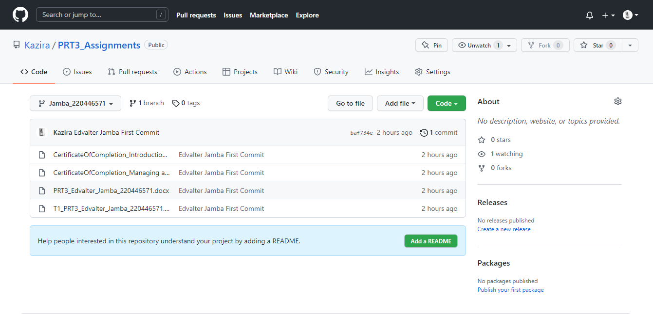****GitHub**

**GitHub individual Link:**

https://github.com/Kazira/PRT3_Assignments.git

**GitHub Group Link:**

<https://github.com/Kazira/CPUTCommunalWebsite.git>

# **What I have learned:**

Working in a group is one of the hardest things in a project, there are advantages and disadvantages, the good thing about it is that at the end of the day you get more knowledge because of the different culture and critical thinking that each team member has as skill.

Therefore, has taught me how to work in a team, and to be always a calm demeanour.

**References**

<https://www.universityworldnews.com/post.php?story=20210505075301937> [20 March 2022].

[Post-pandemic transformations: How and why COVID-19 requires us to rethink development - PMC (nih.gov)](https://www.ncbi.nlm.nih.gov/pmc/articles/PMC7566764/) [20 March 2022].

**Details of the Group I belong to:**

GROUP LEADER:

* Sharfaa Sedick Anthony 220041571

SECRETARY:

* Franciel Danilo De Carvalho Sebastiao 219466912