

6/7/2021

Edvalter Jamba

220446571

Assignment Term 2

Individual submission

**Stream name Application Development.**

**Course: Project 2**

**Course code: PRT2**

**Supervisor: Ayodeji Olanrewaju Afolayan**

**Student Name: Edvalter da Costa Jamba**

**Student Number: 220446571**

**Student Email: 220446571@mycput.ac.za**

Contents

**No table of contents entries found.**

**ABOUT US PAGE**

In this assignment I was assigned to do the “About us page”

About us page is the page that the visitor or user will be looking for in case they want to know more about who we are or about the app or what we do.

About Us Page is not the kind of page where User will need to introduce data, therefore the “About Us” page is used to display information such Team member details, and the function of the application.

This page will be access for those who wish to know more about of the team and what the application does.

**FUNCTIONAL REQUIREMENTOF THE ABOUT US PAGE**

**Application Used for code**

* **Android Studio**

**Application Used for Wireframe**

* **Balsamiq Wireframes**

**Colours Used**

* **Backgrounds-**
* **Text-**

**System Design and Implementation**

In the System Design, there will be made the analysis design of what it will tell us and how the page will be configured and constructed.

There are some points to consider about of what the user or visitor expect to find in the About us page:

* **Who**

Who had the idea, who is in charge, team members?

* **What**

**“What”** We will tell them or what kind of the application we are creating, and what it has to offer to the user.

* **Why**

Why the creation of the application, what the application does.

* **How**

How anyone will be able to contact us.

**Construction of the “About us page”**

After the Construction of the design will be able to go to the implementation of the page, Following the structure bellow as a guide.

For the Construction of the about us page, I divide it as follows:

|  |  |  |  |  |
| --- | --- | --- | --- | --- |
| **Title** | **About Us** | | | |
| **Body** | **Load Shedding App.** | | | |
| . Our app that we will be designing will be alert the users based on the area that they are located and at what time load shedding will be taking place so that they can be more prepared. | | | |
| **Sub-Content** | **Team Members** | | | |
| **Member1**  **Name:** | | **Member2**  **Name:** | |
| **Mmeber3**  **Name:** | **Mmber4**  **Name:** | | **Member4**  **Name:** |
| **Footer** | **Some link of our Social media** | | | |

For the design of this page, I wanted to use colours or interface that somehow would not affect the interaction with the user. And as it is a mobile application, and this page requires information, the user will be able to scroll the screen in case the information isn’t showing hundred percent in the screen or in case there is more information to be seeing.

**DESIGN REQUIREMENTS AND PAGE FUNCTIONALITY**

Here we will be able to see how I could get to the design showed above.

**Version1.1**

For the first Version I used photoshop to create an image of what I wanted like to code.

Following the diagram above I could get to this version of the About Us page.

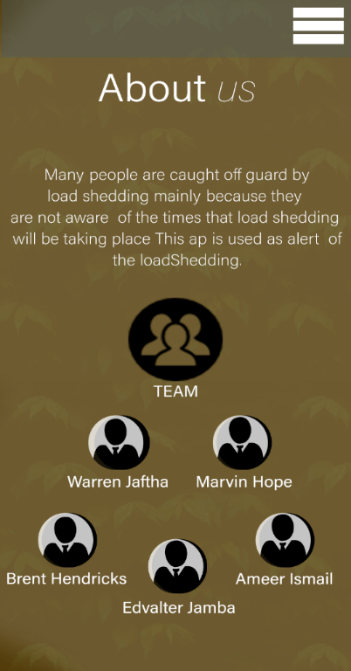

Due some issue of how we could provide the final work in the end of the year, the leader and the secretary advise us use Android Studio instead of java. Therefore, I could get the second version of the about Us page using Android Studio as shows in the picture bellow. Therefore, my version 1.1 of my design could not be executed in the code.

In other was possible to execute the second version of the design I wanted into a code using Android Studio.

**WIREFRAMES**

These wireframes will show how the about us page will be looking like and how it will work or interact with the other pages.

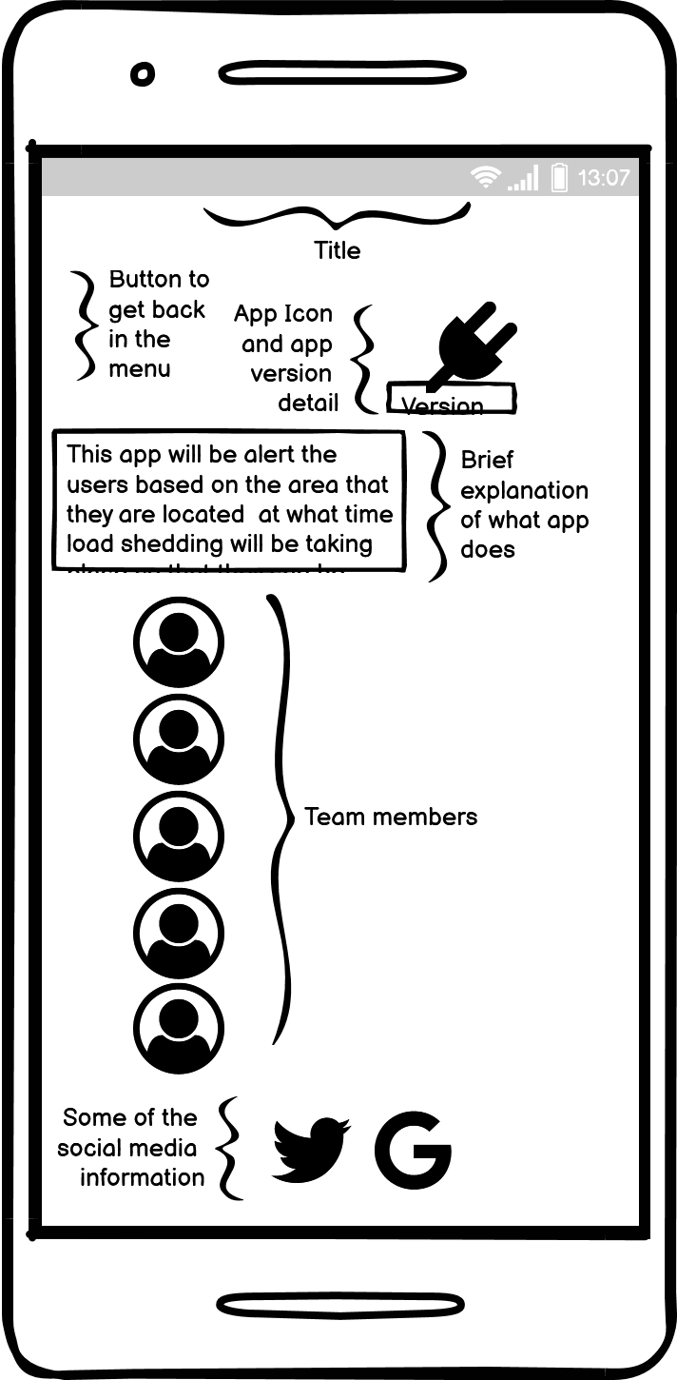

The wireframe above is the illustration of our main page (About Us Page), in this page there will show the Following details:

* Title (About us)
* App Icon
* Version Details
* Information of what is the application used for
* Team member names and Pictures
* Some social media Links where the user can get more information.

**In other hand in this section is divided by header, body, and footer.**

In the header the user will be able to find a button and this button will allow the use to go to the other pages of the application in case, he/she wants to leave the About Us page.

In the body of the About Us Page the user will be able to see the version Information, the detailed information of what is the application used for, and the members details

And in the footer of the application the user will find some Social media links where can also find more about of each member or the application.

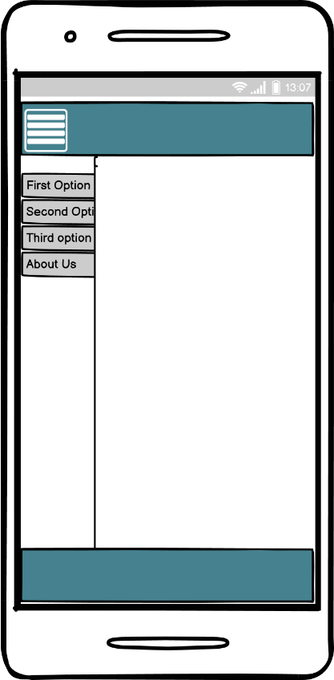**Frame1 Frame2**

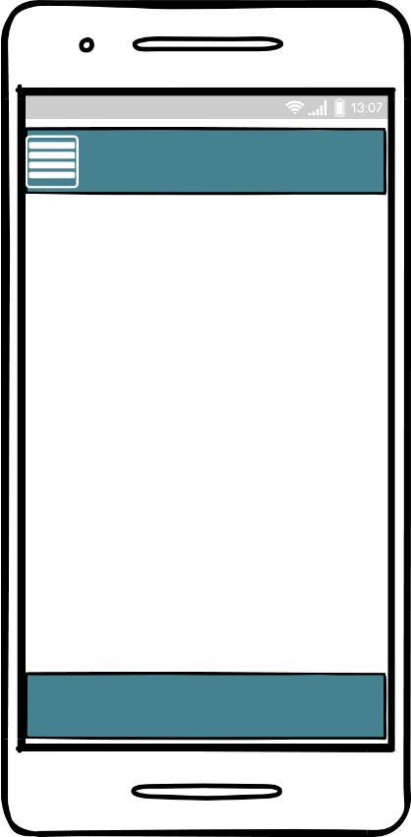

**Frame3 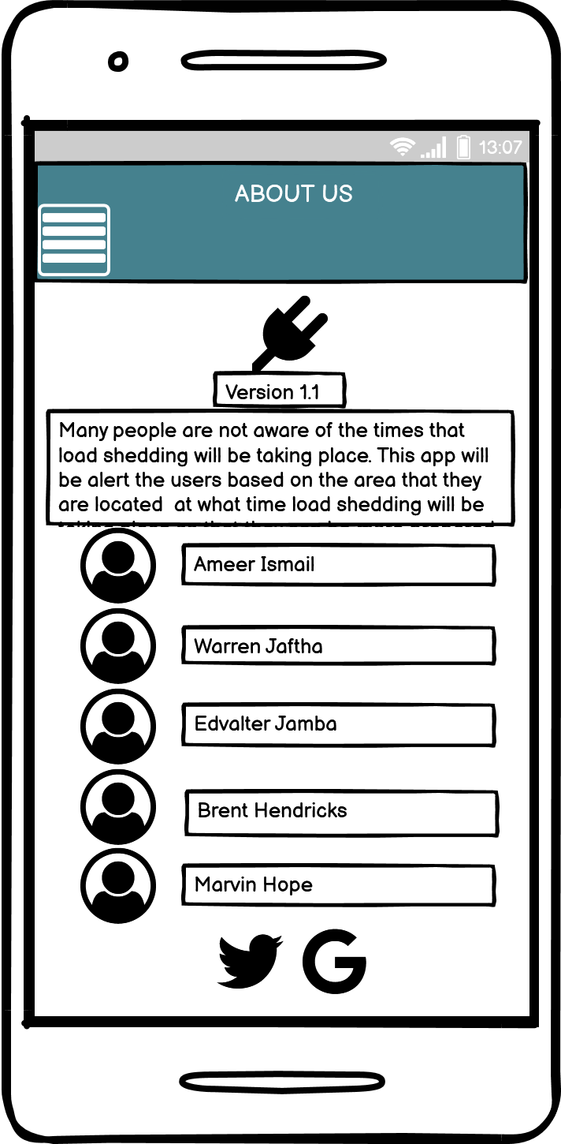 Frame4**

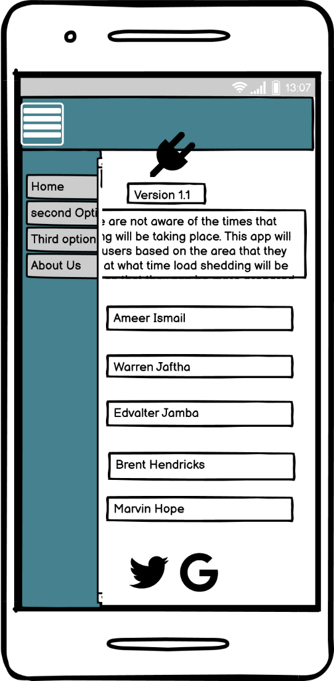

In the **Frame1** it show an example of the main form of the application and once the user click to the button above it will show different option as shows in the **Frame2** and once the user click on the “About Us” the user will be sent to the **Frame3** that is exactly the “About Us Page”, and the user will be able to see all the details mentioned above. If perhaps the user wants to get to the previous page, the user will only need to click again on the button above in the header and will show others option as it shows in the **Frame4**

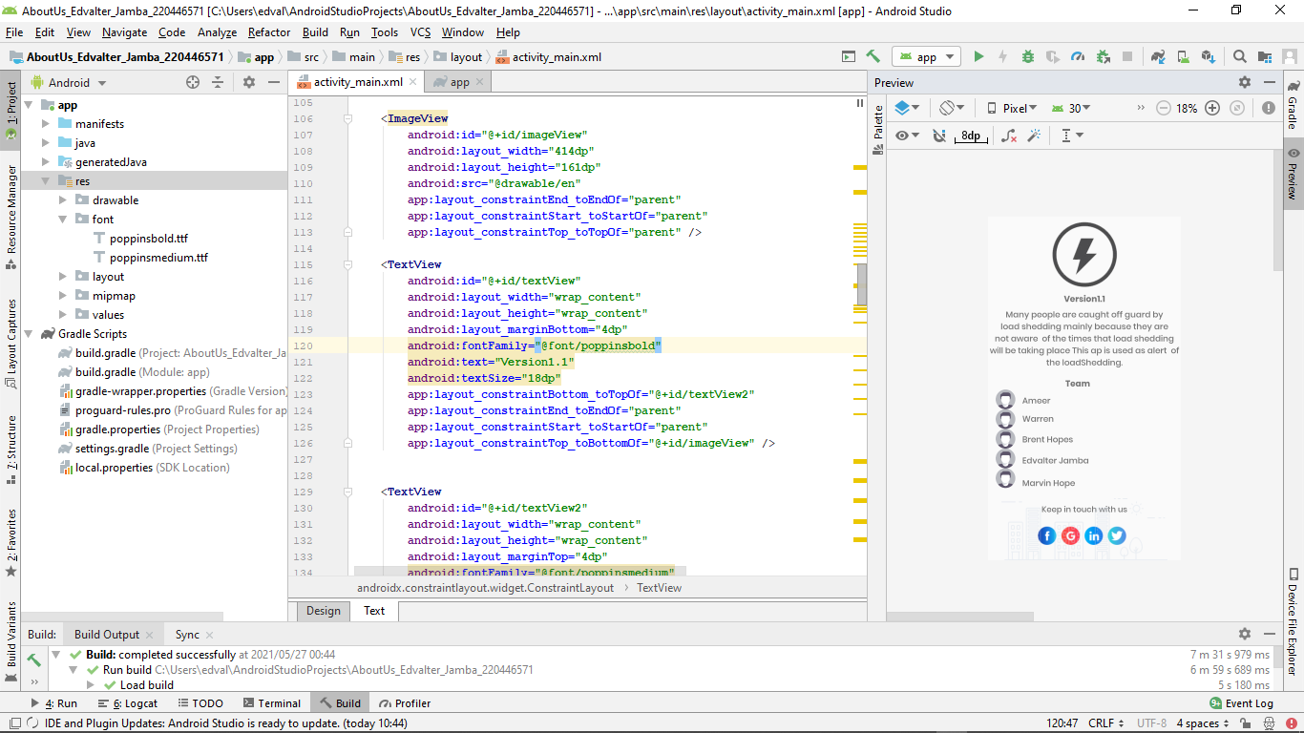**PROOF OF THAT THE CODE IS/WAS DONE**

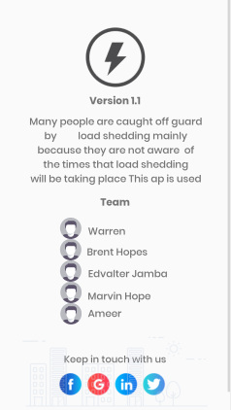**THE PAGE AFTER RUN THE CODE IN ANDROID STUDIO**

**Git Hub**