Alyssa Ballestro

Wireshark

1. Are DHCP messages sent over UDP or TCP?

UDP

2. Draw a timing datagram illustrating the sequence of the first four-packet

Discover/Offer/Request/ACK DHCP exchange between the client and server. For

each packet, indicated the source and destination port numbers. Are the port

numbers the same as in the example given in this lab assignment?

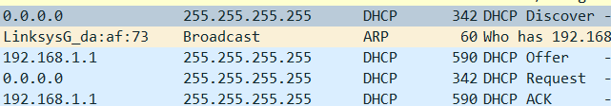

3. What is the link-layer (e.g., Ethernet) address of your host?

Ethernet II is Dell_4f:36:23

4. What values in the DHCP discover message differentiate this message from the

DHCP request message?

The request message has the MAC address of the Client

5. What is the value of the Transaction-ID in each of the first four

(Discover/Offer/Request/ACK) DHCP messages?

Transaction ID = 0x3e5e0ce3

What are the values of the Transaction-ID in the second set (Request/ACK) set of DHCP messages?

Transaction ID = 0x257e55a3

What is the purpose of the Transaction-ID field? Identifier code.

6. A host uses DHCP to obtain an IP address, among other things. But a host’s IP

address is not confirmed until the end of the four-message exchange! If the IP

address is not set until the end of the four-message exchange, then what values are

used in the IP datagrams in the four-message exchange? It uses a blank hold for the client IP and puts it in as “Your (client) IP address”

For each of the four DHCP messages (Discover/Offer/Request/ACK DHCP), indicate the source and destination IP addresses that are carried in the encapsulating IP datagram.

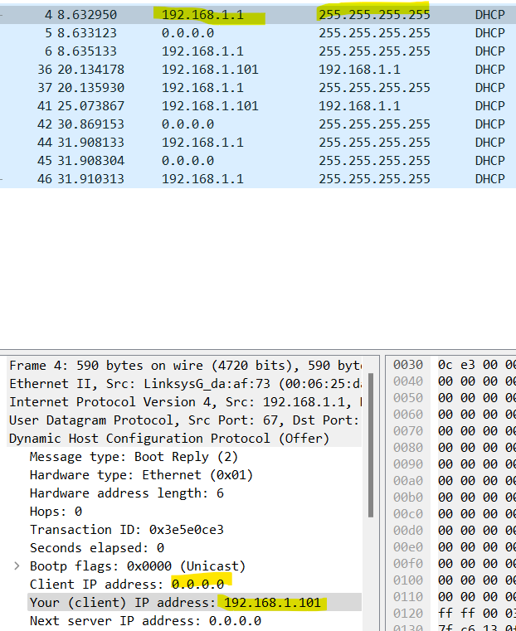

7. What is the IP address of your DHCP server?

0.0.0.0

8. What IP address is the DHCP server offering to your host in the DHCP Offer

message? Indicate which DHCP message contains the offered DHCP address.

192.168.1.1

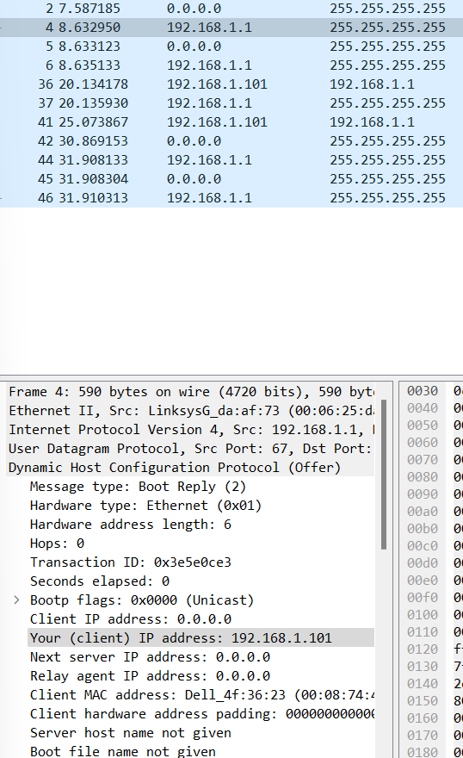

9. In the example screenshot in this assignment, there is no relay agent between the

host and the DHCP server. What values in the trace indicate the absence of a relay

Agent?

The 0.0.0.0 agent address.

Is there a relay agent in your experiment? No

If so what is the IP address of the agent?

10. Explain the purpose of the router and subnet mask lines in the DHCP offer

Message.

These are offered as a filler since there is nothing defined for those slots within the DHCP that it currently has.

11. In the DHCP trace file noted in footnote 2, the DHCP server offers a specific IP

address to the client (see also question 8. above). In the client’s response to the

3 What do we mean by “annotate”? If you hand in an electronic copy, it would be great if you could also highlight and annotate. first server OFFER message,

does the client accept this IP address? Yes

Where in the client’s RESPONSE is the client’s requested address?

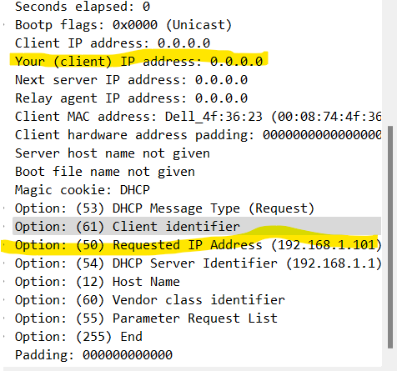

12. Explain the purpose of the lease time. How long is the lease time in your

Experiment? The lease time means how long the request will go for. The one given lasts a day (86400s)

13. What is the purpose of the DHCP release message?

To stop the timer from rerunning or the packets repeating itself.

Does the DHCP server issue an acknowledgment of receipt of the client’s DHCP request? Yes

What would happen if the client’s DHCP release message is lost?The timer would continue and the process would rerun again and again until the timer ran out.

14. Clear the bootp filter from your Wireshark window. Were any ARP packets sent

or received during the DHCP packet-exchange period? Yes

If so, explain the purpose of those ARP packets. The address Resolution Protocol is asking who has the address for 192.168.1.101 and then connects it to the Dell source.