Ten: Nguyen Quang Huy

Mssv: 22647811

Bai 1:

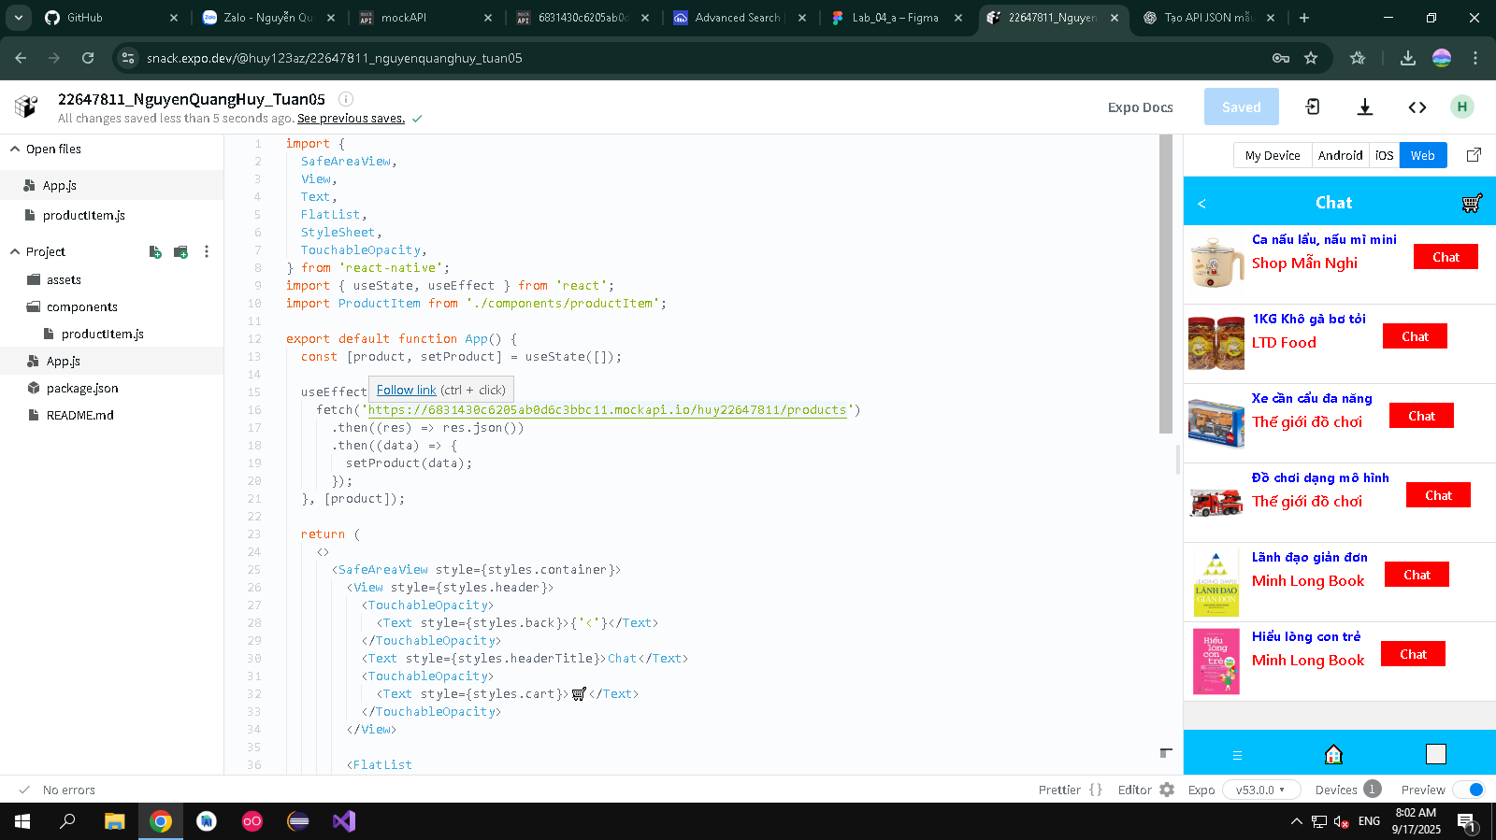

Bai 2:

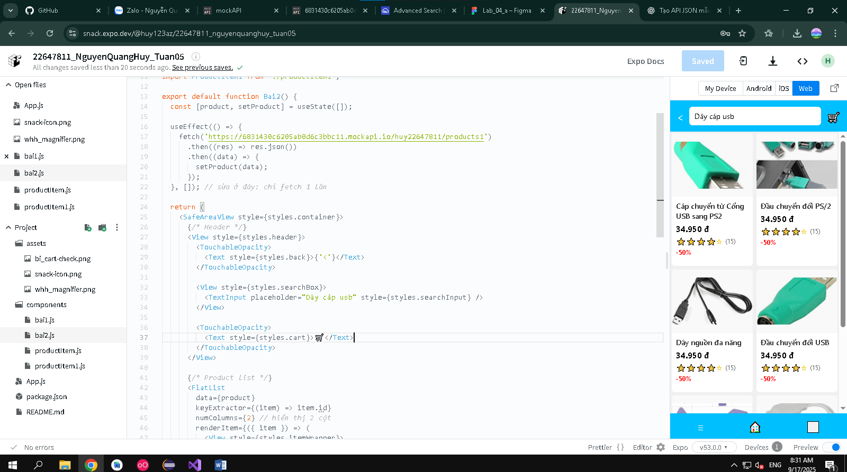

Bai 3:

