Final report

18643047　Kazushi NOMURA

1. Experiment

In this experiment, I conducted 5 motion. The experiment scenery is shown below.

One operation was repeated 5 times, and data for three people was acquired.

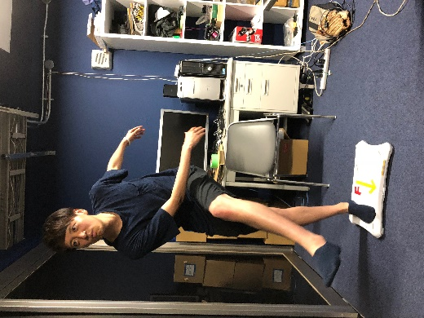

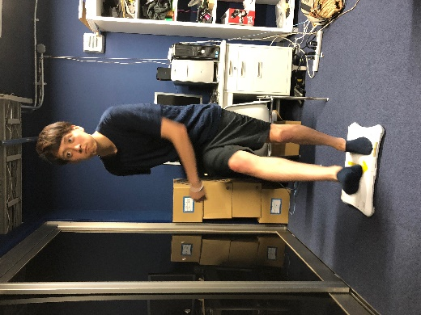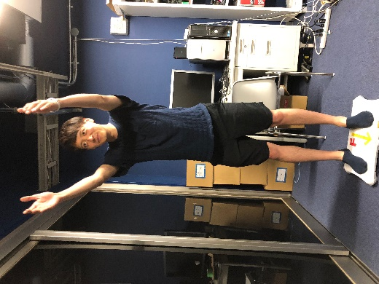

Fig.1　Kick(left foot) Fig.2 Kick(right foot) Fig.3 Throw

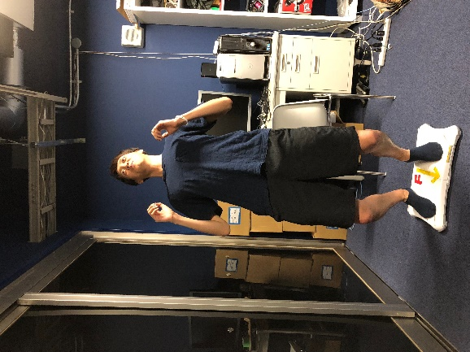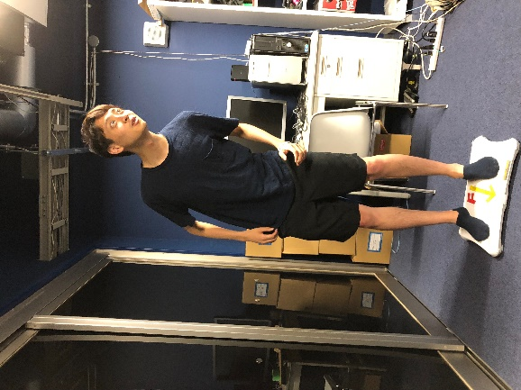

Fig.4 Heading Fig.5 Chest Trap

1. 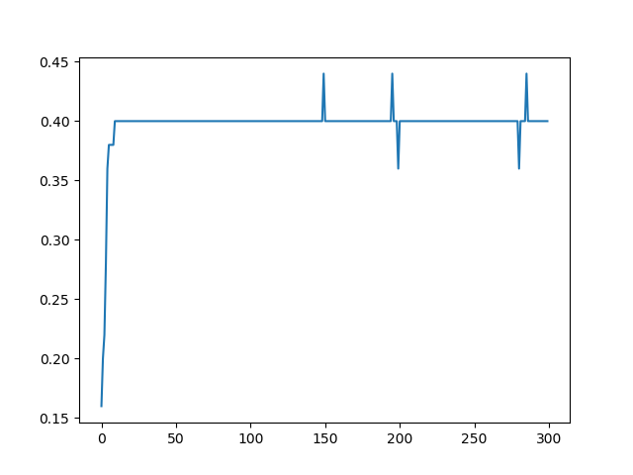Result

The result is shown below.

Fig.6 Training Accuracy

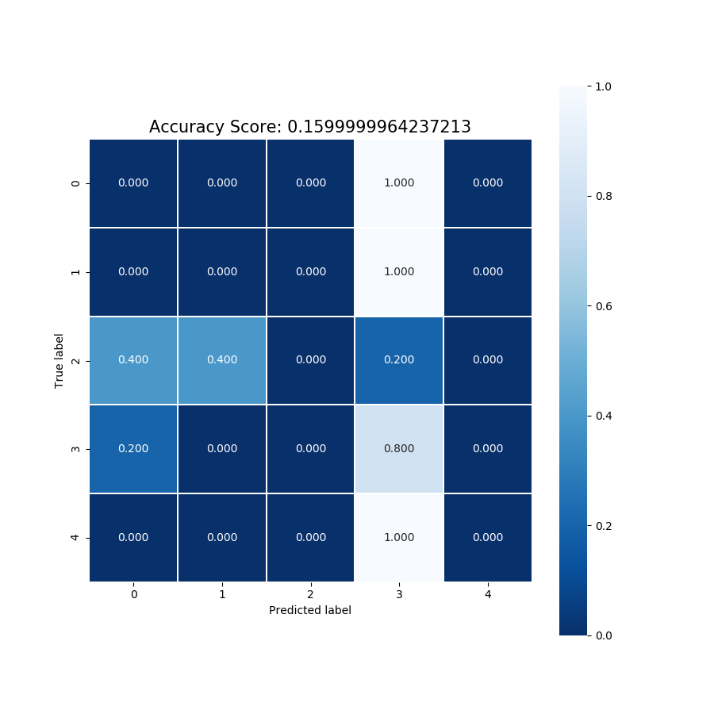

Fig.7 Confusion matrix

1. Consideration

The result was not good this time. As a cause, it is thought that the number of data is small. Moreover, it is thought that there is not much difference in the operation and the operation was late. In the future I will increase the number of data, I need to examine the action type. It was a very good opportunity to study machine learning. Thank you so much.