**Name:**

**Class:**

**Date:**

**Do the 2 assignments below and upload this document on Teams(English)**

1. **Assignment: My Favourite City.**

Write about your favourite city?

I dont have a favourite city but I do I have some things that I like about some places.

What is the name of the city?

I don’t have a favourite city

Where is it located?

Cant answer it

What kind of touristic acttraction activities or buildings are in the city?

I do know some that I like. I like it when its lively at night but not to crowded or noisy. Also unique architecture is also very nice to see for example I like how old fashioned some Japanese buildings are as specially the traditional ones . Aslong as there are some public places form where you can observe the city in peace and quiet.

Why do you like it?

 Because I enjoy night more then day.

**Don’t forget to add pictures!

1. **Assignment: Creative Thinking.**

Think of how you can make a city appealing for people to come live?(Think of things that need to be in the city).

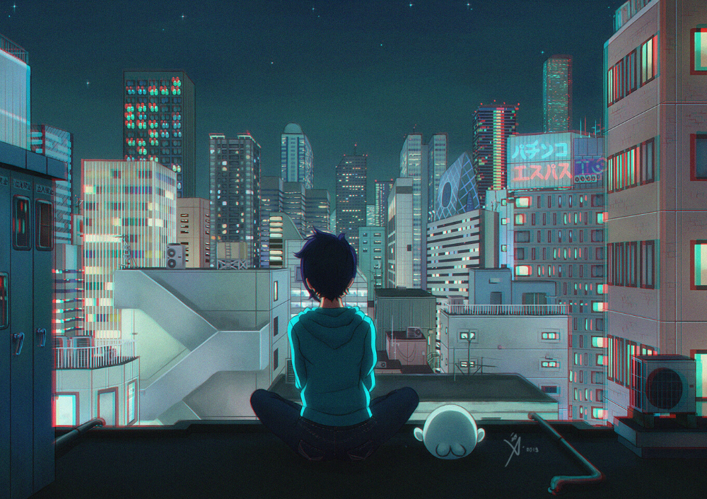

Even if this is a drawing this is the kind of view i enjoy.

I would like more unique buildings though but still the lights on the buildings are a good example for how lively I wanted it to be as for the streets I like this better. There are not to many people there but its still a little lively with the ones that are going home

