

**[Sardar Vallabhbhai National Institute of Technology](https://en.wikipedia.org/wiki/Sardar_Vallabhbhai_National_Institute_of_Technology,_Surat)**

**Project Report on**

“Simple E-Bank Management System”

**Subject: Software Tools- III**

**Academic Year: 2019-20**

**Submitted By:** Mohak Chaudhary (U17CO057)

**B.Tech (CO) - III**

**5th Semester**

**Jury Signature Student’s Signature**

**Order for Contents of Report**

1. **Title Page**
2. **Introduction** (must contain description about your project and its feature)
3. **Process Flow diagram (**relevant to your project)
4. **Output** (must contain Screenshots of important pages of your project along with description)

**Instruction for Report Writing:**

* + - 1. Contents of the report should be Times New Roman Font Style.
      2. Font Size of Chapter Heading: 16, Sub-Heading: 14 and Font Size of Regular Contents: 12 with 1.5 line spacing in paragraph.
      3. Report should be of 5-10 pages.
      4. Report should be duly printed out and filed in the Plastic-Strip File.

**E-BANK MANGAEMENT SYSTEM**

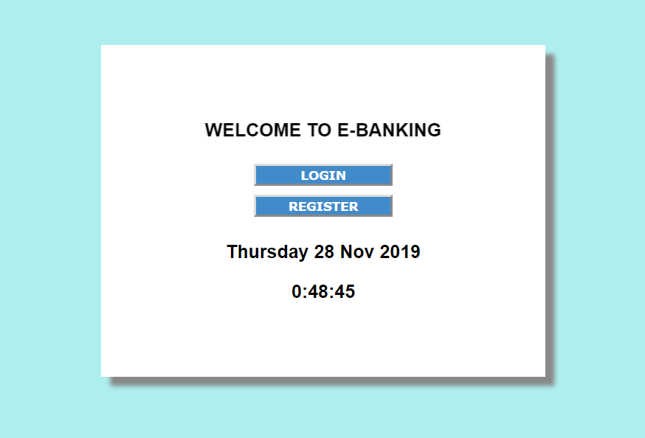

Simple E-Banking System is developed using PHP, CSS, and JavaScript. Talking about the project, it contains the essential features. This project contains an admin side where Admin can manage banking transactions like withdrawing, depositing and viewing balance. The Admin plays an important role in the management of the system. In this project, the user has to perform all the main functions from the Admin side. A user can also register as a new user if he/she does not have an account.

###### **About System**

The Admin has full control of the system, all the functions are to be performed from Admin panel. Here, the admin can set deposit certain amount easily. In order to set deposit amount, the user has to enter an amount and short description. For withdrawing amount, the user just has to provide an amount. All the transactions are stored permanently in the database. This project contains features of CRUD functions. Design of this project is pretty simple so that the user won’t find any difficulties while working on it. Simple E-Banking System in PHP helps in easy management of various account amount within a short period of time.

**Software Used**

**Server**: XAMPP server

**Language Used**

1. **Front End :** HTML ,CSS, JAVA SCRIPT, JQUERY

2. **Server Language :** PHP

3. **Database :** MYSQL

**Features of web-application:-**

USER

1. Login/Register
2. Deposit
3. Withdraw
4. Check total balance

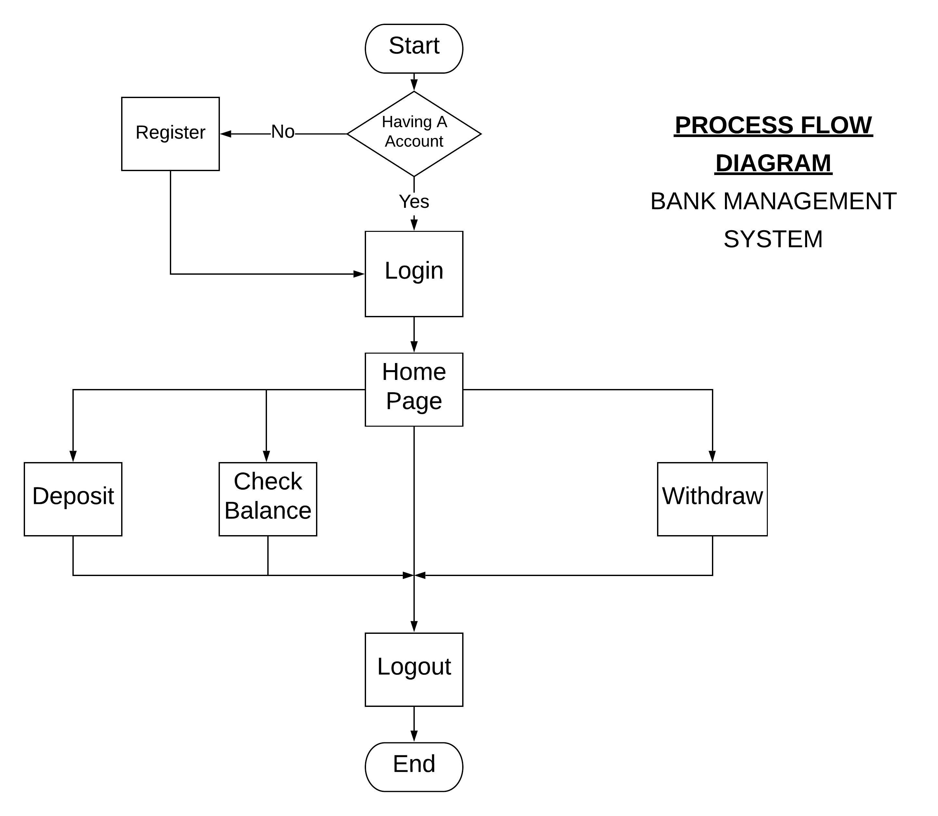

1. **REGISTRATION PAGE FOR A NEW USER**

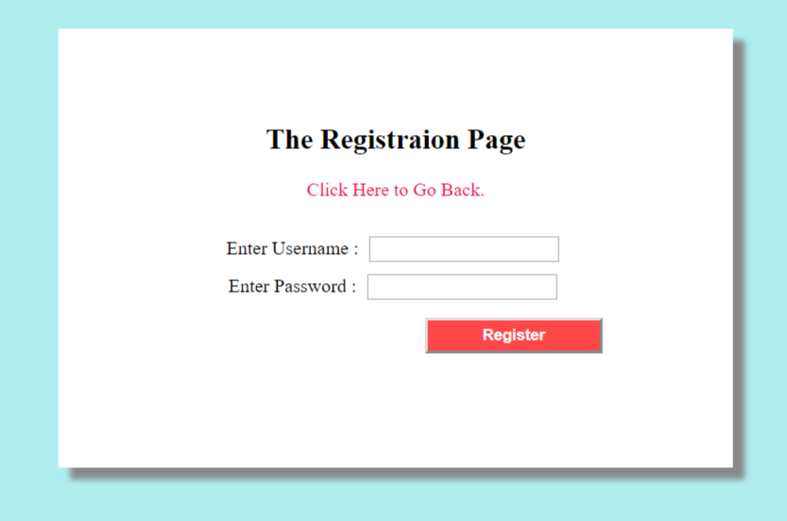

1. **LOGIN PAGE FOR AN EXISTING USER**

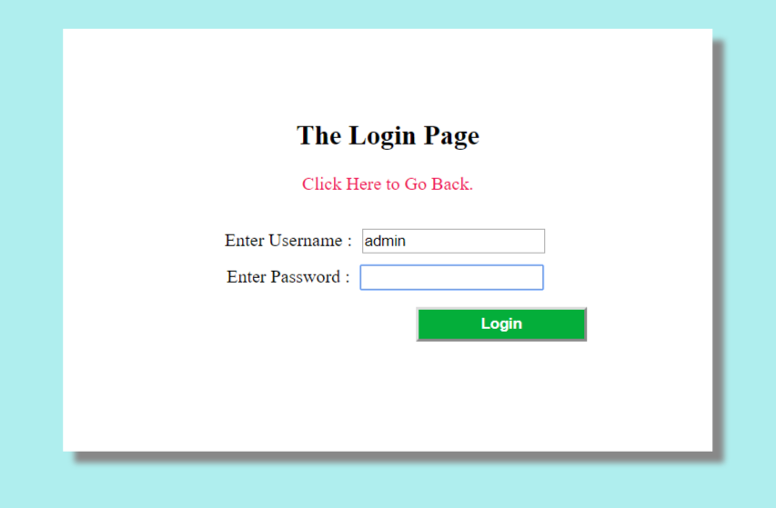

1. **HOME PAGE OF A USER**

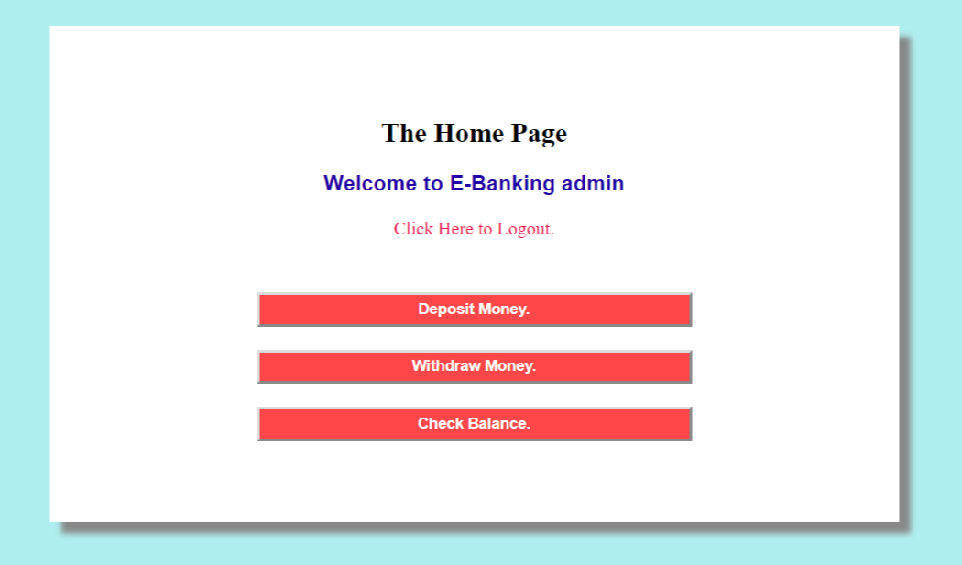

1. **DEPOSIT MONEY**

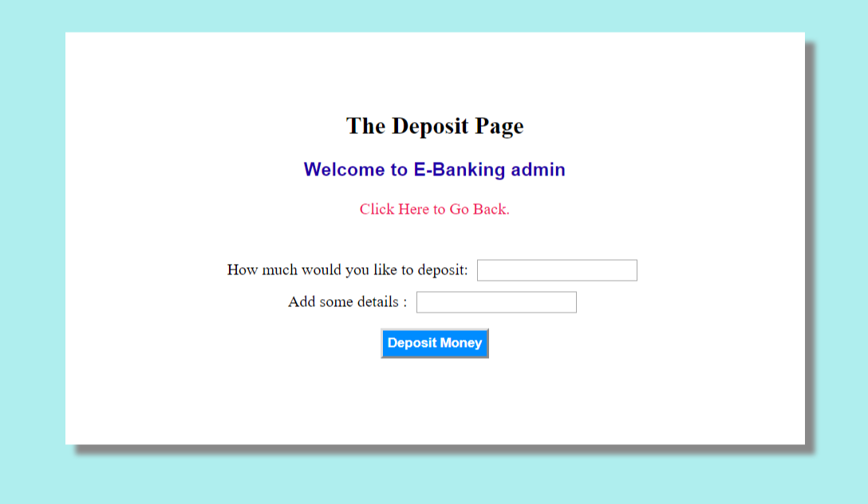

1. **VIEW BALANCE**

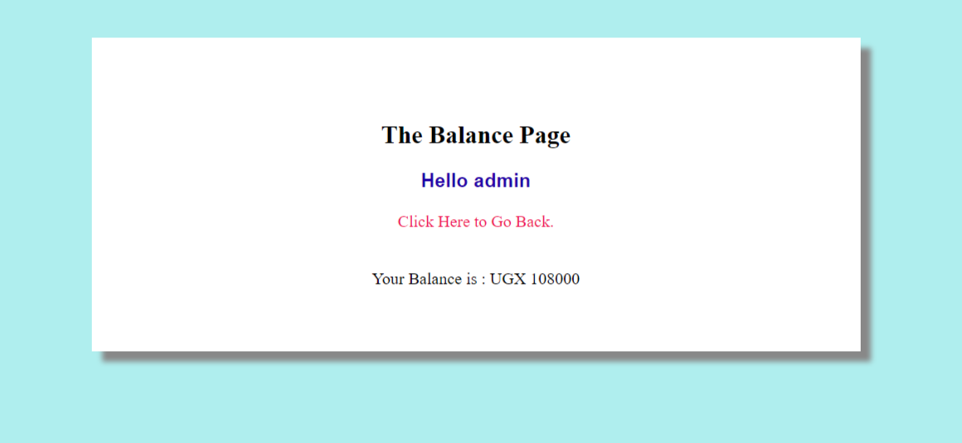

1. **WITHDRAW BALANCE**

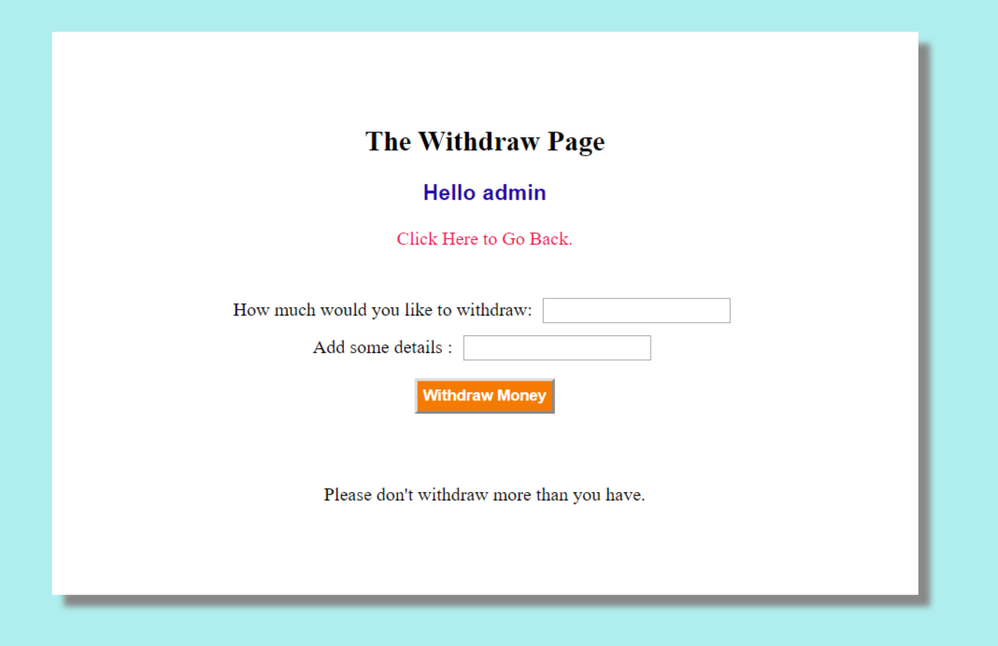

**DATABASE STRUCTURE**

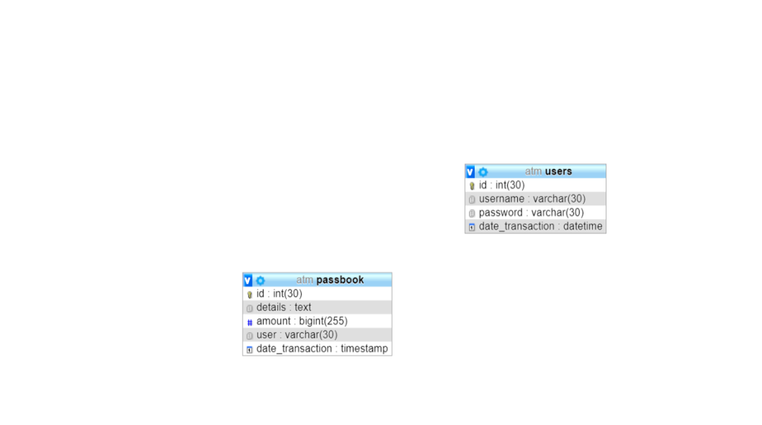

1. **USER TABLE IN DATABASE**

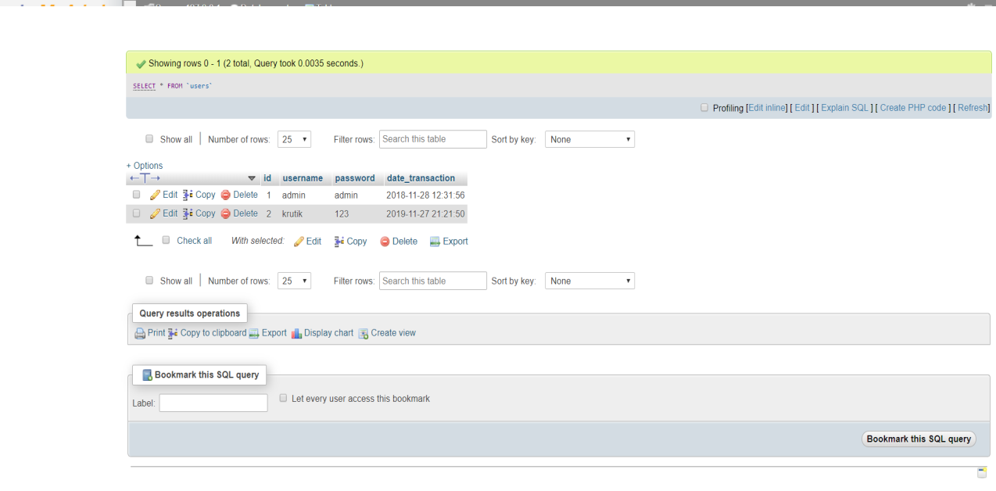

1. **PASSBOOK TABLE IN DATABASE**

