Machine learning nano-degree capstone project

Interpret number strings in real world images

Santhosh Kulandaiyan

Definition

Project overview
This project deals with the problem of recognizing digits from real world images. This has multiple real world applications like:
- Automatic detection of postal codes that will enable sorting posts for different regions into different bins without human intervention. Automatic number recognition can also be used in banks for cheque processing.
- We can apply this technique to automatic number plate recognition (ANPR) which can be used by police forces for law enforcement purposes (for example, to check whether a vehicle is registered or not)
- Recognizing numbers in photographs captured at street level is used in map making.
References
[1] https://en.wikipedia.org/wiki/Automatic_number_plate_recognition
[2] http://static.googleusercontent.com/media/research.google.com/en//pubs/archive/42241.pdf

Problem statement
We are given a real world image which contains a sequence of numbers. These numbers can be things like street view numbers, vehicle license plate numbers or postal codes. The problem is to train a model that can recognize the number present in the image. The project will be implemented as a python script.
The script should be able to accurately (i.e with low misclassification error) detect the number present in the image (assuming that we test the model on different images that contain many different strings of numbers in them).
Strategy for solving the problem:
- First we will use the SVHN dataset and preprocess that dataset. This is in Section 3.1 : Data exploration and pre-processing.
- Then we apply a convolutional neural network on this data and train the network over several epochs. This is described in section 3.2 : Implementation
- Then we will refine the CNN and fine tune the hyperparameters so as to achieve better generalization. This is described in section 3.3 : Refinement
- Finally an analysis of the resuts is presented along with graphs that summarize the behaviour of the model. This is described in detail in section 4 : Results

Metrics
How well the model performs can be quantified by the score of the model on the testing set. We will use a simple evaluation metric like misclassification error. i.e for a particular image to be classified correctly, all the digits in the image should be labelled correctly in order. Partial correctness of the digits in an image would be considered as misclassification.
Full number level accuracy = count (numbers correctly predicted) / count(total numbers)
As a secondary metric, we also consider the digit level accuracy (i.e how many digits in the image the model got right) as another evaluation metric. Therefore, to summarize, we are going to consider both full number level accuracy and individual digit level accuracy. We could argue that these 2 are directly proportional.
Digit level accuracy = count (number of digits correctly predicted) / count(total number of digits)
Sometimes when there is class imbalance in the data, classification accuracy alone cannot give a good performance metric. So in this case we will also consider a metric like F1 score which uses both precision and recall to overcome class imbalance issues.
The F1 score formula is given by :

Also while training we will consider the cross-entropy score as a metric. The cross entropy is defined as
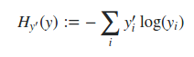

where y_i` is the target value and y_i is the predicted value. The cross entropy tells us how close the predicted output is to the target output (instead of just simply saying whether the prediction is correct or incorrect). But note that we will use the cross entropy measurement only during the training phase, since when we deliver the final model, it is usually better to report the classification accuracy on the test set.
Ref:
[1] https://jamesmccaffrey.wordpress.com/2013/11/05/why-you-should-use-cross-entropy-error-instead-of-classification-error-or-mean-squared-error-for-neural-network-classifier-training/
[2] http://scikit-learn.org/stable/modules/generated/sklearn.metrics.f1_score.html

Analysis

Data exploration and pre-processing

Dataset
For training and testing, we will use the publicly available Street View House Numbers (SVHN) dataset, which is a large scale dataset of house numbers in Google Street View images.
The SVHN dataset requires minimum preprocessing and it is similar to the MNIST dataset, but contains significantly more number of images (around 600,000) captured from real world images.
References:
The SVHN dataset has 10 target class labels, 1 for each digit. For example, the image with digit ‘4’ has the label 4. One thing to consider is that the image with digit 0 has the label 10.
There are 73257 training digits and 26032 testing digits. Additionally there 531131 digits which are slightly less difficult examples.
The dataset for SVHN comes in 2 formats:
- Format1
This is the original, variable resolution, color house images with character level bounding boxes as shown in the picture below. The dataset contains compressed .tar.gz files for training, testing and an additional training dataset. A sample set of images along with bounding box information is shown below.
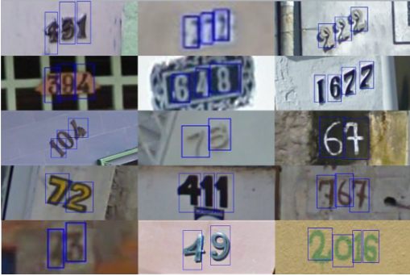
The bounding box information is stored in digitStruct.mat file which is packaged into the compressed file. The digitStruct.mat file contains a structure called digitStruct with the same length as the number of original images. Each element in digitStruct has the following fields:
- name : string containing the name of the file name for the image
- bbox : struct array that contains the position, size and label of each digit bounding box in the image. E.g digitStruct(300).bbox(2).height gives height of the 2nd digit bounding box in the 300th image.
- Format 2
The original bounding boxes (as presented in format 1), are extended in the appropriate dimension to become square windows. Finally, each of the cropped digits are resized to 32x32 pixels (note that each of these is a color pixel just like in format 1, so there are 3 color channels for each pixel denoting the RGB channel values). There are 3 .mat files for for each of the training, testing and additional datasets named train_32x32.mat, test_32x32.mat, extra_32x32.mat respectively. Loading the .mat file creates 2 variables, X which is a 4-D matrix containing the images and y which is a vector of class labels. To access the i-th image, we specify X(:, :, :, i) and y(i) gives the corresponding class label.
[1] http://ufldl.stanford.edu/housenumbers/
[2] Yuval Netzer, Tao Wang, Adam Coates, Alessandro Bissacco, Bo Wu, Andrew Y. Ng Reading Digits in Natural Images with Unsupervised Feature Learning NIPS Workshop on Deep Learning and Unsupervised Feature Learning 2011
Which data format to use:

(Just a piece of notation : When we refer to a ‘number’ this corresponds to an image file and it typically contains multiple digits.)
Note that we need both individual digit level accuracy and also accuracy score for the full number. In format2, it is not possible to co-relate which number each digit belongs to. Therefore, we can only get individual digit level accuracy. However in format 1, we not only have the bounding boxes for each digit present in the image, but also we can figure out to which image each digit belongs to. Therefore the dataset for our model will be coming from format 1.
But if we are going to train the model on individual digits, then we have to do a bit of pre-processing to get the individual digits out each image. For this, I have re-used (with minor adaptation) the technique of extracting individual digits from images by using the bounding boxes defined in digitStruct.mat from the fuel project available in github. Reference source code available at https://github.com/mila-udem/fuel/blob/master/fuel/converters/svhn.py.

Exploratory visualization
We plot a histogram of the digits available in the training set to see if there is any skew in the data.
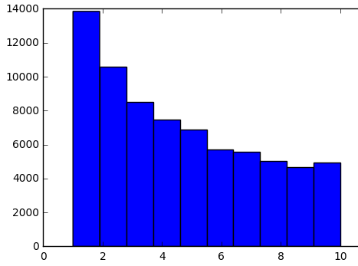

In the above figure, the x-axis denotes the digit number (10 denotes the digit 0) and the y axis is the number of samples of each digit. As we can see there is a little bit of skew towards digits 1 and 2 (i.e they appear more in the training data compared to other digits). So instead of just using accuracy alone as a evaluation metric, we will also use the F1-score of the multi-class classification weighted by the fraction of times each label appears in the test data.
Also we note that the digits in the bounding boxes are rectangles with variable dimensions for each digit. We rescale each digit to dimension 32x32 so that the number of variables are kept manageable.
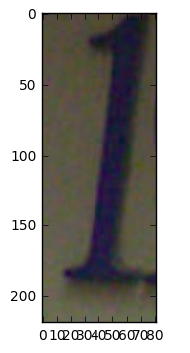
Digit : Without scaling (220x80)
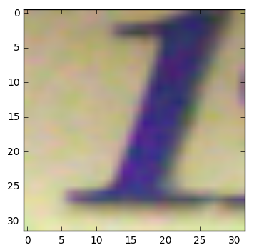
Digit : With 32x32 scaling

In the above figure we see the digit cropped from the original image as per the bounding box and also the same digit after rescaling it to 32x32. As we can clearly see, some amount of clarity is lost, but this step is essential to keep the training time for the network within reasonable bounds.

Algorithms and techniques
The solution to this problem will be to build a supervised model using the dataset. Supervised because, the dataset contains images with the actual labels (i.e number present in the label) and we can use this information for learning a model and then evaluate the model on the testing set.
Specifically, we will split the dataset into training, validation and testing subsets and train the model using the training dataset and evaluate the performance of the model on the validation datasets so that we can tune the hyper-parameters of the model and also determining the point at which to stop. Finally we will report the performance of the model on the testing set.
Since this is a classification problem we could consider approaches like Logistic Regression, SVM or Neural networks. The approach that is used in this project is convolutional neural networks with 2 layers of convolution and 2 fully connected layers. This is largely motivated by the exceptional results obtained for several image classification tasks using CNNs as described here http://rodrigob.github.io/are_we_there_yet/build/classification_datasets_results.html.
Just a small note on couple of other models that could be used and some of their pros and cons:
Logistic regression is a simple model in the sense that it is equivalent to an ANN without any hidden units and with a sigmoidal activation unit. Also LR cannot capture non-linear relationships between the dependent and independent variables. So LR will only work well if the classes are linearly separable. For our dataset, the features are pixels in the images and could result in highly non-linear classes. Also there could be co-relation between the independent variables and this cannot be captured by LR models. Note that ANNs can capture both non-linear relationships and correlation via hidden units.
Support Vector machines : With regards to comparison to SVM’s, note that we don’t have just 2 classes of outputs to classify, but rather a wide range of outputs; Possibly SVMs would work ok if the image consists of only 1 digit, so in that case we would have 10 SVMs one for each digit. But in the case where the image can have n digits, it is not clear how an SVM can be trained for the whole set of digits in an image. Maybe we should localize the digits in the image and then use the multi class classification using the SVM. And also in the paper http://yann.lecun.com/exdb/publis/pdf/bengio-lecun-07.pdf it is argued that SVM architectures are shallower compared to the deep neural network models. Shallower meaning “ They consist of one layer of fixed kernel functions, whose role is to match the incoming pattern with templates extracted from a training set, followed by a linear combination of the matching scores. Since the templates are extracted from the training set, the first layer of a kernel machine can be seen as being trained in a somewhat trivial unsupervised way. The only components subject to supervised training are the coefficients of the linear combination”
Advantages of deep neural networks:
In http://www.kdnuggets.com/2016/04/deep-learning-vs-svm-random-forest.html, it is argued that we have to worry less about feature engineering when we use deep neural nets compared to classifiers like SVMs (but for this to be accomplished in a small amount of training time and limited computing power, we need to ensure that the number of features is reasonably small to begin with. We can reduce the dimension of the original image by resizing or gray scaling the image) So even though deep neural networks take a lot of time to train and require a relatively large number of training examples, considering that this is a complex problem and we really need not worry about designing great features upfront and let the hidden layers do the feature abstraction part, we will go with deep convolutional neural nets.
A brief description of Convolutional Neural networks:
(Start from convolutions, explain through an image, describe other terms like pooling layers, activation and drop outs, etc)

Convolutional neural networks are similar to ordinary neural networks (in that each layer is connected to the next layer via weights and an activation function is applied to the input at each neuron and out comes the output).
The whole network expresses one differentiable function and there is indeed a loss function that will be optimized and the activation functions at each node are typically non-linear.
But they are different in the sense that conv nets make the assumption that the inputs are images

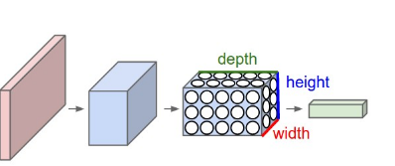

Benchmark
As a benchmark model, we consider the model implemented in the paper Multi-digit Number Recognition from Street View Imagery using Deep Convolutional Neural Networks by Ian J. Goodfellow, Yaroslav Bulatov, Julian Ibarz, Sacha Arnoud, Vinay Shet.
This uses the DistBelief implementation of deep neural networks to train large, distributed neural networks. This model uses a convolutional neural network with the best performance at 11 hidden units. This achieves an accuracy of over 96% on the SVHN dataset.
DistBelief network is described in Dean, J., Corrado, G., Monga, R., Chen, K., Devin, M., Le, Q., Mao, M., Ranzato, M., Senior, A., Tucker, P.,Yang, K., and Ng, A. Y. (2012). Large scale distributed deep networks. In NIPS’2012

Methodology

Data preprocessing
We use the code available from fuel project to read the data from format 1 and convert it into individual digits while also maintaing track of which number each digit belongs to. Note that we also scale the digits from variable resolution to 32x32 resolution (mainly to bring the images to uniform dimension and also to reduce the number of features so that the weight vectors can be of reasonable size).

Implementation
For training, we use 53k images and for validation we use 20k images while the entire test set of 26k images is used for testing (note that we use the dataset in multiples of 1000’s for ease of implementation and graphing)
First we shuffle the digits in the dataset so that in a given minibatch we do not have highly correlated examples. Ref : https://www.quora.com/Does-the-order-of-training-data-matter-when-training-neural-networks
Terminology:
- Mini-batch : Every time we take a subset of the training set and run the gradient descent optimization algorithm with error back-propagation, it is called as a mini-batch.
- Epoch : Once we run several mini-batches that cover the entire set of training data once, it is called an epoch.
What to optimize :
We attempt to optimize both the cost function and the classification accuracy (also note that we will measure the F1 score on the test set towards the end).
- Cost function : For the cost function we use the softmax cross entropy with logits. What this does is to compute the cross entropy of the result after applying the softmax. Note that the logits are the unnormalized output of the network before softmax is applied on them. And the softmax function squashes an unnormalized vector of real values to the range (0,1) that add up to 1. For discrete p and q, the cross entropy is defined as
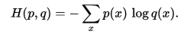

Intuitively, this measures how different p is from q. If p and q are close enough, then the entropy is close to 0. If they are very different, then the entropy is close to 1.
- Classification accuracy : number of digits classified correctly by our model.
The cost function is mostly for visualization purposes just to check and debug if our gradient descent update step is indeed reducing the error cost. The classification accuracy/F1 score serve more practical purposes as to output our final estimate of classification accuracy on out of sample test data. But it would be expected that lower the cost function, better would be the accuracy and we can validate this later via the validation curve.
Hyper-parameters :
- Batch size : how many training examples we pass to the gradient descent optimizer at a single time.
- Learning rate : at what rate are the weights updated.
Some notes on the above 2 hyperparameters :
Batch size : As a general rule of thumb, the smaller the batch size, the more fluctuations there will be in the way the weights get updated but the convergence will happen sooner; On the contrary, the larger the batch size, the convergence curve to the optimal will become more and more smoother but it takes a longer time for convergence. So in our training, we choose a relatively small number of 500 as the batch size initially, and later on as the cost update gets smaller and smaller, we will use a larger batch size. But since with a larger batch size, each update takes a much longer time due to the amount of computation involved, we will run only a fewer number of epochs with the larger batch size and plot the progress the model is making with each epoch until the evaluation of validation set shows a reduction in the cost. We will stop when the cost function applied to the validation set does not show any further reduction over a significant number of epochs.
Learning rate : In general we would like to start with a larger learning rate as the training begins and later on as the weight updates become smaller and smaller, we should reduce the learning rate. However, we will use the Adam optimizer which has an adaptive learning rate update.
Optimization algorithm:
We use the Adam optimizer for our problem, since it has adaptive learning rate and momentum. The Adam optimizer is described in more detail in the following link : http://cs231n.github.io/neural-networks-3 and also in the original paper here : http://arxiv.org/abs/1412.6980
To summarize the way the optimizer works, it has 2 main features, namely adaptive learning rate and momentum. From the links cited above, the following is the update rule for Adam optimizer.
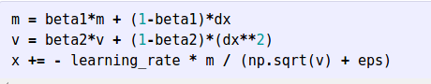

Here, dx is the raw gradient of the parameter we are trying to optimize.
Learning rate, beta1, beta2 and eps are hyperparameters.
Note that the learning rate is adaptive, in the sense that we divide the learning rate by v. And the v parameter is a combination of the per parameter sum of squared gradients and the existing value of v taken in the proportion (1-beta2) and beta2 respectively. So the weights that have a higher gradient will have a lower effective learning rate and also the previous value of v gets carried over to some extent for the current update. So this is a case of adaptive learning with respect to the gradient value and the current iterations learning rate gets carried over with exponential decay into future iterations.
The m parameter is a combination of the current gradient value weighed by (1-beta1) and the previous value of m weighed by beta1. So we can think of this as the smoothed version of the gradient m (which not only has the gradient value of current iteration, but it also has the gradient values from previous iterations with exponential decay)
Model:
The neural network model is adapted from the tensorflow implementation using convolutional neural networks for the MNIST dataset (ref: https://www.tensorflow.org/versions/r0.8/tutorials/mnist/pros/index.html)
We use a fairly similar model with 2 convolutional layers followed by a fully connected layer followed by a softmax layer which is used to read off the digits.
The full convolutional network architecture used in this project is shown below (I have used the code available from https://github.com/gwding/draw_convnet/blob/master/draw_convnet.py to generate this convnet diagram)
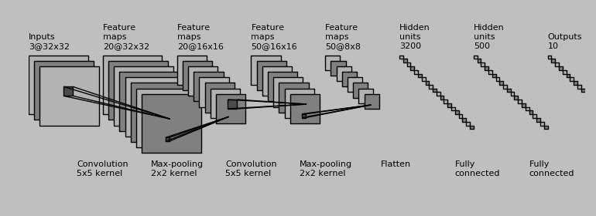
Convolutional layers:
Let’s denote Convolutional layer 1 and 2 as CONV1 and CONV2 respectively. will Both CONV1 and CONV2 use 5x5 filter. For CONV1, the input depth is 3 color channels (note that this is nothing but the number of color channels of the input data) and the output is 20 color channels. So the filter for CONV1 is [5, 5, 3, 20]. Similarly CONV2 which operates on the output of CONV1 has input depth as 20 and output depth as 50, so the filter for CONV2 is [5, 5, 20, 50]. For both the convolutional layers, we maintain a stride of 1 and have padding as SAME, so that the output size of the conv layer is the same as that of its input.
In each convolutional layer, after the convolution operation is applied, we also add the bias defined for that layer. So for CONV1, the dimension of the bias is [20] since there are 20 output channels for each input image. And similarly for CONV2, the dimension of the bias is [50].
At each convolutional layer, after adding the bias to the output of the convolution operation we do max pooling in a window of 2x2. So the output dimension of each convolution layer will be halved in the x and y dimensions. After applying max pooling we apply the ReLU non-linearity to get the output.
The first few layers are:
[INPUT] --> [CONV1] --> [MAX_POOL1] --> [RELU1] -->[CONV2] --> [MAX_POOL2] --> [RELU2] --> [OUT_1]
- The dimensions of the data as it moves through each of the above layers are :
- Input to CONV1 – [32x32x3]
- Output of CONV1 – [32x32x20] (this also includes adding the bias to the output of the conv layer)
- Output of MAX_POOL1 – [16x16x20]
- Output of RELU1 – [16x16x20] (note that relu layer does not reduce the dimension, but rather introduces non-linearity into the model)
- Output of CONV2 – [16x16x50]
- Output of MAX_POOL2 – [8x8x50]
- Output of RELU2 - [8x8x50]
Fully connected layers:
Now, using the output of CONV2, we pass it through a fully connected layer (called FC1) with output dimension 500 (also adding bias to the output of that layer). Note that the output of CONV2 is of size 8*8*50 and hence FC1 maps input of size 8*8*50 to output of size 500. We also apply relu to the output of FC1.
Then we get to the 2nd fully connected layer (FC2, also called read-out layer because the dimension of the output of this layer is 10 and using this we could simply read out which digit it is that out model has estimated). FC2 converts data from input dimension 500 to output dimension 10 (Note that in this layer also the bias is added). At this point we have added 2 more fully connected layers to out network and these 2 are also described in the figure above.
Finally we use softmax function that converts output scores to probabilities of the input corresponding to each digit. We define the cost function as the cross entropy using logits which is what we want to minimize. We also define the training step as the process of minimizing the cross entropy. Note that as we already saw, we attempt to minimize the cross entropy for out training step. We use the Adam optimizer which was described in a previous section (note that Adam is a more recent optimizer, which combines both momemtum and adaptive learning rate as explained in that section)
Stopping condition:
At each epoch, we let the model run for all mini-batches once and at the end we calculate the cost function and accuracy on the cross validation dataset.
To save on training time, we do not calculate the cost function on the entire training data, but rather only on the cross validation dataset and we plot the number of epochs vs cross validation loss as a graph. There are some refinements that we do here, which are described in the next section, but generally speaking, when the loss on the cross-validation does not go down any further (even after tuning the hyper-parameters) , we stop the training and calculate both the loss and the classification accuracy (both at individual digit level and full number level).

Refinement
We use a batch size of 500 digits for each mini-batch. We run a total of 200 epochs over the entire training set of 53000 digits. In each epoch we calculate the loss function and the number of misclassified digits for the validation set of 20000 digits. In each epoch we also calculate the loss function and number of misclassified digits for a subset of the training data (we take a random sample of 20000 digits from the training set for this during each epoch; this is to save on the time taken to evaluate the training error if we calculate the loss on the entire training set of 53000 digits). The following hyperparameters were tuned as the training was progressing:

- Dropout
  - Dropout is a regularization technique to avoid overfitting in neural networks. This works by dropping visible/hidden units from the neural network. If dropout rate is 20%, then we randomly drop 20% of units from the neural network. This will enable the network to learn the same feature (i.e the feature that has been dropped) from other parts of the image (which have not been dropped).
  - In our approach, Initially we begin with no dropout and as and when the validation score does not improve more than 0.5% over the last 10 ecpochs, we start to increase the dropout by 10%. This is based on the reasoning that if the validation score has not improved in the last 10 epochs, then we have possibly hit a local minimum and additionally if the training score keeps going downward then we have indeed started overfitting. So this would be a good place to increase the dropout.
  - Indeed, in the network that I trained over 200 epochs, the validation score hit a plateau at around 90th ecpoch. So here the dropout was made 10%. As we can see from the validation curve, the validation cost takes a steep downward path at the 90th epoch (see next section was the validation curve). Perhaps not surprisingly, the training cost goes upwards initially and then starts coming down (this indicates that the model was initially overfitting the training data and once we introduce dropout, the overfitting reduced a little bit). A similar (but less pronounced effect was observed at around the 150th epoch when the validation curve hit a plateau again and the dropout rate was increased from 10% to 20%)
- Pooling
  - For the convolutional layer, initially, we use max pooling for the 200 epochs (as max pooling has given empirically promising results)
  - After the 200 epochs, we switch to average pooling to see if this has any benefit. We run average pooling for only 20 epochs. As we observed in the validation curve, there is no noticeable benefit. Infact, the training cost goes down whereas the validation cost goes up slightly indicating that the model starts to overfit. So we just stop with the max pooling and do not use average pooling in our tests.

Results

Model evaluation and validation

We plot the 2 graphs, the first one shows how the training and validation cost function changes over time (the x axis is the number of epochs and the y axis is the cost function). Note that the training was actually run for 150 iterations but I just removed the first 10 values of the training and validation cost due to the large amount of fluctuation.
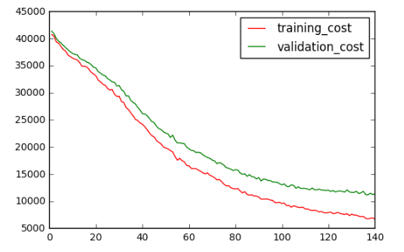
Here, we can see that the validation error keeps on going down until towards iteration #150, where it starts stabilizing and further improvements are rather small. So this would be a good point to stop the training.
In the 2nd graph, we plot the number of misclassifications as a function of the number of epochs. We can see that the cost function is related to the number of misclassified examples. i.e, if the cost function is low, then the number of misclassified examples is also small. Intuitively, this makes sense because the cost function is the cross entropy function that tells us how different the prediction is from the actual value and a low value here indicates that we are doing well in classifying the correct digit.

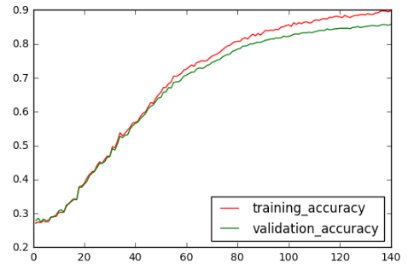

Beyond 150 epochs or so, we notice that there is very little improvement in the cost function and also in the classification accuracy. So we stop here and calculate the classification accuracy on the test set at individual digit level and report this as the final output which in our model comes to 82%. Also the full number level accuracy is 68% when evaluated on the test set.
We note that the validation curve closely follows the test curve and towards the end, the validation curve flattens out but does not degrade further and from this we can say that there is no more effective learning happening at this point so this would be a good place to stop.
A note on the parameters of the final model : We use the Adam optimizer for training with the default parameters for beta1, beta2 and epsilon. We only altered the learning rate to 0.0001 instead of the default of 0.001 (this is mainly because since we are training on only the 53000 training digits and we do not use the extra training set, and so we do not want the weight update to fluctuate on the error surface, so we go with a smaller learning rate thereby also making the weight updates to slowly but more surely moves towards the (local) optima). But it would also be the case that the initial learning rate does not matter so much in this case, as it is updated adaptively based on the exponential decay of the past gradients.
For the other parameters like beta1, beta2 and epsilon, we do not do much hyperparameter tuning mainly because the learning rate is adaptive in Adam, and also from original Adam paper https://arxiv.org/pdf/1412.6980v8.pdf we see that the default values have given good empirical performance.

Final results and Justification
The test accuracy that was obtained with the model that we trained in this project is 82% at an individual digit level and 68% at the full number level. The F1-Score on the test set is computed as 0.823 (which indicates that both precision and recall are fairly good)
Compared to the benchmark model accuracy of 96% described in section 2.4, we are not able to reach anywhere reasonably near. But it should be noted that due to computational constraints, the model we used in this project is trained using only the 53k training digits and only used 2 convolutional layers and trained for a period of 5-6 hours compared to the DistBelief version which trained on much larger datasets over 6 days using 10 replicas is Distbelief which is a deep network comprising of 8 convolutional layers.

Conclusion

Free-form visualization
Below is a visualization of the confusion matrix corresponding to the predicted digits versus the actual digits (lets see the confusion matrix with and without normalization)
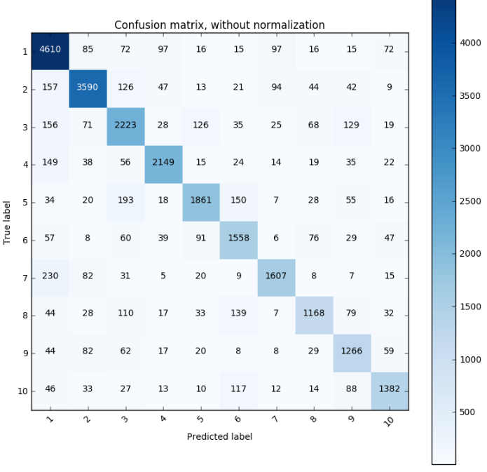
Note that the label 10 denotes the digit 0. In the above picture, the diagonal elements denote the total number of correct classifications and the off-diagonal elements denote the total number of misclassifications; Besides this we can also know what was the predicted digit for each misclassified digit. For example, some of the largest misclassifications are 5 gets misclassified as 3 and 7 gets misclassified as 1. This kind of makes sense intuitively because 5 and 3 share a common shape at the bottom end and 7 and 1 can look quite similar in some cases when the digits are written in a free flowing fashion. Also note that a relatively large number of 8’s gets misclassified as 3’s and 6’s.
Due to the skew in the test data, we can see that there is a relatively larger number of 1’s compared to other digits. So to get a normalized view of the data, we divide the estimated prediction count for each label by the total number of elements of that label present in the test set and that summary is presented below pictorially. In this picture, the off diagonal elements denote the percentage of misclassification and even here we can see that some of the biggest offenders are 7 gets misclassified as 1 and 5 gets misclassified as 3 and 8 gets misclassified as 3.

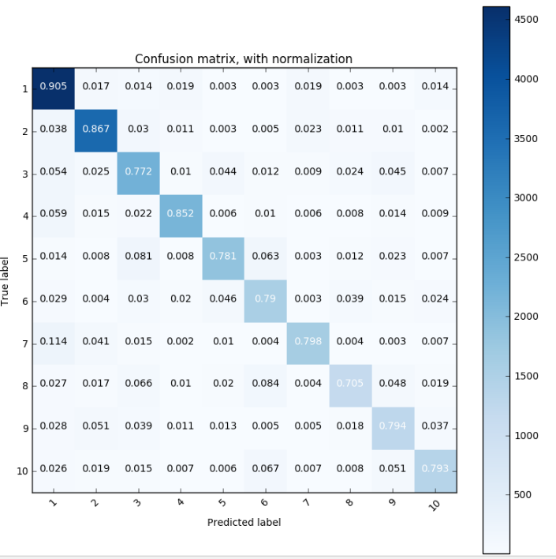
We also note that the full number accuracy of 68% is lower than the individual digit level accuracy of 82%. This can be attributed to the fact that each number comprises of multiple digits and if 2 digits belong to different numbers, then if both those digits are classified incorrectly, then we also consider both those numbers to be misclassified, notwithstanding the fact that there could be other digits that belong to each of those numbers that were indeed classified correctly.

Reflection
Below is a summary of the project and some of my reflections over the course of the project:
Classifying digits occurring in natural images is much harder than classifying printed images or MNIST like data due to the large amount of variations in the size of the digits, and the variation in the background color of the images.
The classification of SVHN is highly non-linear in nature with several thousands of parameters as in the case of the network used in this project. Also note that for MNIST like data convolutional neural networks are amongst the top performers when it comes to classification accuracy. This can be attributed to various factors like using convolutions to learn basic shapes of digits like lines, curves, etc at the initial layers and in the later layers combining these lower level primitive features them into higher level abstract features. Along each convolution, a non-linear transformation like ReLU is applied which preserves the gradient during weight updates (thus escaping from the vanishing gradient problem if we use a sigmoid like activation function). All of the above features make CNNs ideally suited for doing image classification.
So just following from there, I used Convolutional neural networks for classifying SVHN dataset also.
Due to computational constraints (I had to train this model only on a CPU), I could not use the additional training set given. Even with the training dataset, the training period was around 6 hours for 150 epochs. So considering this, I think the individual digit level accuracy of 82% is reasonable, even though it is not that close to the state-of-the-art.

Improvement
Following are some of the improvements that I would carry out in the future.
- Use GPU and the additional training set to see if the model accuracy/generalization improves.
- Use other optimizers like RMSProp and Gradient Descent with momentum to see how they perform (even though it could be argued that Adam combines the best of both the above mentioned algorithms, I would still like to try them out in the future)
- The number of output channels I used for CONV layers are relatively small, i.e 20 and 50 for CONV1 and CONV2. Also the FC1 was 500 in size. I would experiment with increasing the complexity of the layers by introducing more weights and see how that performs and also perhaps introducing a few more convolutional layers and see if that has an impact.
- Due to the large amount of computational resources involved, I just resorted to the default parameters of the Adam optimizer for beta1, beta2, epsilon and learning rate. I would ideally like to spend more time on searching this space for optimal set of hyper parameters.
- In the initial step, since I rescaled the data from variable dimensions to 32x32, some of the image contrast could have been lost. Ideally, I would like to increase the contrast of the input data and then run the same model to see if that results in any improvement.
- The 3 color channels may or may not have much of an impact on the shape of the digit, so to improve the training time, I could average the RGB channels and create a single channel.

