Verifying LLM Smart-Home Agents with a Small Model and a Solver
Approach 2: pre-flight gate for time-based scheduling (SimuHome QT4)

1. Problem Statement
Large language model (LLM) agents are increasingly used to control smart homes through device APIs. Many everyday requests are time-based: “turn on the light 10 minutes from now”, “raise the fan 8 minutes after the previous action”, or “start the dishwasher now and pause it when the dryer finishes”. The agent must work out the correct times, choose the correct device commands and schedule them.
SimuHome [1] (ICLR 2026) evaluates exactly this. Its workflow-scheduling category QT4 has three sub-types: QT4-1 (relative and clock times, including actions chained to earlier actions), QT4-2 (actions timed relative to when a device finishes) and QT4-3 (coordinating one device with another device’s finish time). Each sub-type has possible requests and impossible ones, in which two parts of the request give the same action contradictory times.
The SimuHome authors report that scheduling is the most persistent challenge for current agents. Agents often fail to recognise that a request is temporally impossible. The scheduling tool only confirms that a workflow was registered, so wrong times or failing commands are never reported back to the agent. Self-correction prompts and fine-tuning bring limited gains, and large reasoning models are too slow for real-time home use.
Research question: can a small language model working with a formal solver check both the user’s request and the agent’s plan before anything runs in the home, so that a large agent becomes more reliable at little extra large-model cost? This is a form of small–large model collaboration.

2. References
- G. Seo, J. Yang, J. Pyo, N. Kim, J. Lee, Y. Jo. SimuHome: A Temporal- and Environment-Aware Benchmark for Smart Home LLM Agents. ICLR 2026, arXiv:2509.24282. (Benchmark, simulator, agent and scorer used for all experiments.)
- S. Yao, J. Zhao, D. Yu, N. Du, I. Shafran, K. Narasimhan, Y. Cao. ReAct: Synergizing Reasoning and Acting in Language Models. ICLR 2023, arXiv:2210.03629. (The agent strategy SimuHome uses; left unchanged.)
- Qwen Team (A. Yang et al.). Qwen3 Technical Report. arXiv:2505.09388, 2025. (Base model of the small parser, Qwen3-1.7B.)
- E. J. Hu, Y. Shen, P. Wallis, Z. Allen-Zhu, Y. Li, S. Wang, L. Wang, W. Chen. LoRA: Low-Rank Adaptation of Large Language Models. ICLR 2022, arXiv:2106.09685. (Fine-tuning method for the parser.)
- L. de Moura, N. Bjørner. Z3: An Efficient SMT Solver. TACAS 2008, LNCS 4963. (Solver that proves contradictions and computes allowed time windows.)
- H. Wang, C. M. Poskitt, J. Sun. AgentSpec: Customizable Runtime Enforcement for Safe and Reliable LLM Agents. ICSE 2026, arXiv:2503.18666. (Related work: runtime checks on agent actions.)
- C. Qian et al. Current Agents Fail to Leverage World Model as Tool for Foresight. arXiv:2601.03905, 2026. (Motivates enforcing the simulation check instead of offering it to the agent as an optional tool.)
- Q. McNemar. Note on the sampling error of the difference between correlated proportions or percentages. Psychometrika 12(2), 1947. (Paired significance test between methods on the same episodes.)

3. Proposed Solution (Approach 2)
A gate is placed around SimuHome’s scheduling tool. The large agent itself is not modified. The gate works in two phases (Figure 1).
- Phase 1 (once per request, before the agent starts): a fine-tuned small model (Qwen3-1.7B + LoRA) converts the request into time constraints. Device finish times are read directly from the home. Z3 then checks whether a single schedule can satisfy all constraints. If not, the request is contradictory: in hint mode the agent is warned, and in answer mode the gate replies to the user directly with no large-model call. If yes, Z3 computes an allowed time window for every requested action.
- Phase 2 (every scheduling call of the agent): A refuses scheduling on an impossible request. B checks that the start time lies inside the action’s window. C dry-runs the workflow on a copy of the home and refuses steps that would fail or change nothing, returning the correct command names and arguments. A refused call goes back to the agent with the reason, so it can fix the call. Each kind of refusal is limited to two per episode, so the agent can never get stuck.
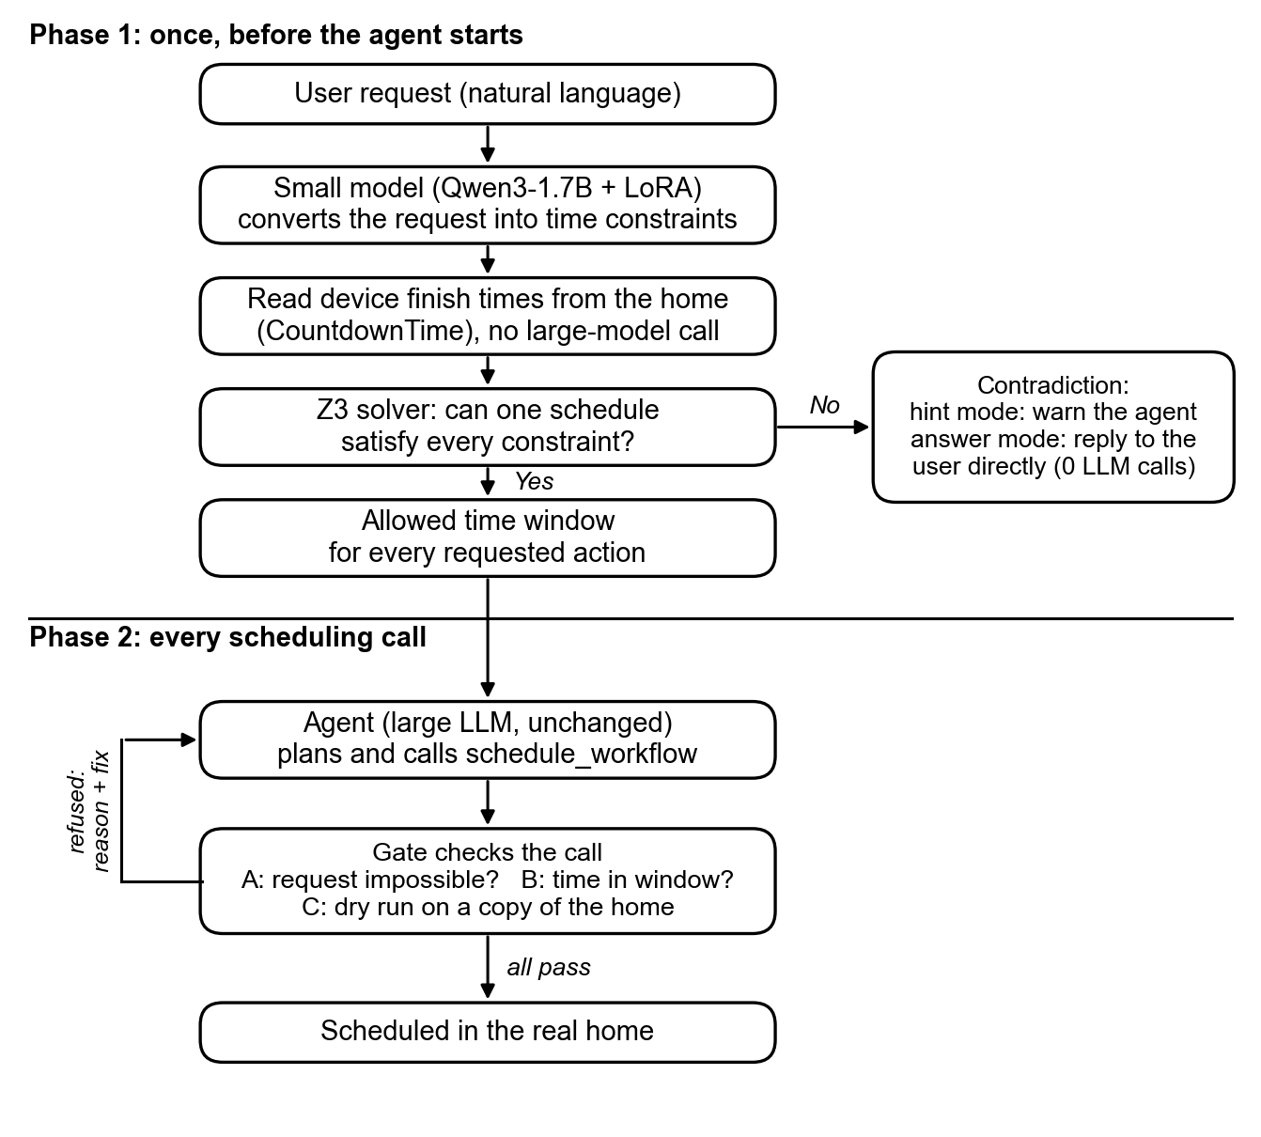
Figure 1. Approach 2: pre-flight check of the request, then a check of every scheduling call.

4. Current Results
Setup: SimuHome QT4, agent and judge Gemma-4-31B (NVIDIA API), held-out test episodes the parser never saw (8–10 per sub-type and case). “Calls” is the number of large-model calls per request.
Impossible requests | QT4-1 | QT4-2 | QT4-3* | Calls (QT4-1 / QT4-2)
Agent alone | 4/10 | 0/8 | 4/9 | 3.1 / 6.9
Prompt self-check | 10/10 | 8/8 | 5/9 | 1.1 / 3.5
Gate, hint mode | 10/10 | 8/8 | 4/9 | 1.0 / 2.0
Gate, answer mode | 10/10 | 8/8 | 4/9 | 0 / 0
Table 1. Impossible requests correctly refused. *5 of the 9 QT4-3 cases are device run-time conflicts outside the gate’s scope, so 4/9 is its maximum.
The gate detects every QT4-1 and QT4-2 contradiction, and in answer mode it does so without calling the large model at all. Compared episode by episode with the agent alone, answer mode is significantly better (McNemar’s test, p = 0.002, first session, all three sub-types pooled). A one-line self-check prompt reaches the same accuracy on this agent but needs one to four large-model calls per request.
Possible requests | QT4-1 | QT4-2 | QT4-3
Agent alone | 2/10 | 5/8 | 2/9
Prompt self-check | 3/10 | 4/8 | 0/9
Gate (v2.0) | 5/10 | 4/8 | 1/9
Gate (v2.1) | 2/10 | – | –
Table 2. Possible requests completed correctly (– = not yet run).
On possible requests no method is yet clearly better than the agent alone. With 8–10 episodes per cell the differences are within run-to-run variation.
Offline check of the current gate (v2.2). Replaying every recorded agent trace through the gate, it blocked none of the 29 correct plans. It flagged the agent’s mistake in 33 of 42 failed episodes from the first session and 18 of 20 from the second.
Small-model parser. On the 54 held-out requests it gave the correct possible/impossible verdict in 47 of 49 scored cases, and an exactly correct structure in 33 of 54.
In progress. Gate v2.2 is being evaluated on all 300 QT4 episodes (50 per cell) with a 5-fold cross-validated parser and paired comparisons. The same experiment will then be repeated with a smaller agent model.

