Verifying LLM Smart-Home Agents with a Small Model and a Solver
Approach 2: pre-flight gate for time-based scheduling (SimuHome QT4)

1. Problem Statement
Large language model (LLM) agents are increasingly used to control smart homes through device APIs. Many everyday requests are time-based: “turn on the light 10 minutes from now”, “raise the fan 8 minutes after the previous action”, or “start the dishwasher now and pause it when the dryer finishes”. The agent must work out the correct times, choose the correct device commands and schedule them.
SimuHome (Seo et al., ICLR 2026) evaluates exactly this. Its workflow-scheduling category QT4 has three sub-types: QT4-1 (relative and clock times, including actions chained to earlier actions), QT4-2 (actions timed relative to when a device finishes) and QT4-3 (coordinating one device with another device’s finish time). Each sub-type has possible requests and impossible ones, in which two parts of the request give the same action contradictory times.
Current agents handle this poorly: they often miss that a request is impossible, and their wrong plans are never reported back to them (Section 2). Large reasoning models do better but are too slow and costly for real-time home use.
Research question: can a small language model working with a formal solver check both the user’s request and the agent’s plan before anything runs in the home, so that a large agent becomes more reliable at little extra large-model cost? This is a form of small–large model collaboration.

2. Literature Study
SimuHome (Seo et al., ICLR 2026, arXiv:2509.24282). A benchmark for LLM agents in a simulated, time-evolving smart home built on the Matter device standard. Scheduling requests (QT4) are scored by checking the home’s state at the requested times; impossible requests are judged by an LLM panel. The authors find scheduling the most persistent challenge: agents often fail to see that a request’s time constraints cannot all be satisfied, and the scheduling tool gives no feedback, so wrong plans go unnoticed. Self-correction prompts and fine-tuning help little. As future work they suggest testing plans in the simulator before committing them. We use SimuHome’s benchmark, agent and scorer unchanged and add exactly this kind of pre-check.
AgentSpec (Wang, Poskitt and Sun, ICSE 2026, arXiv:2503.18666). Run-time enforcement for LLM agents: hand-written rules (a triggering action, conditions, and an enforcement step such as blocking the action or asking the user) are checked every time the agent is about to act. It shows that checking actions outside the model is a practical way to make agents reliable. Our gate follows this idea, but its checks are derived automatically from each request: a small fine-tuned model turns the request into time constraints, and Z3 proves whether they are consistent and computes the allowed time for every action.
Agents and world models (Qian et al., 2026, arXiv:2601.03905). Agents given an optional simulator to foresee the result of their actions rarely use it, often misread its predictions, and sometimes do worse with it. Hence, in our gate the simulation (a dry run on a copy of the home) is not an optional tool: it runs on every scheduling call and decides whether the call is accepted.

3. Proposed Solution (Approach 2)
A gate is placed around SimuHome’s scheduling tool. The large agent itself is not modified. The gate works in two phases (Figure 1).
- Phase 1 (once per request, before the agent starts): a fine-tuned small model (Qwen3-1.7B + LoRA) converts the request into time constraints. Device finish times are read directly from the home. Z3 then checks whether a single schedule can satisfy all constraints. If not, the request is contradictory: in hint mode the agent is warned, and in answer mode the gate replies to the user directly with no large-model call. If yes, Z3 computes an allowed time window for every requested action.
- Phase 2 (every scheduling call of the agent): A refuses scheduling on an impossible request. B checks that the start time lies inside the action’s window. C dry-runs the workflow on a copy of the home and refuses steps that would fail or change nothing, returning the correct command names and arguments. A refused call goes back to the agent with the reason, so it can fix the call. Each kind of refusal is limited to two per episode, so the agent can never get stuck.
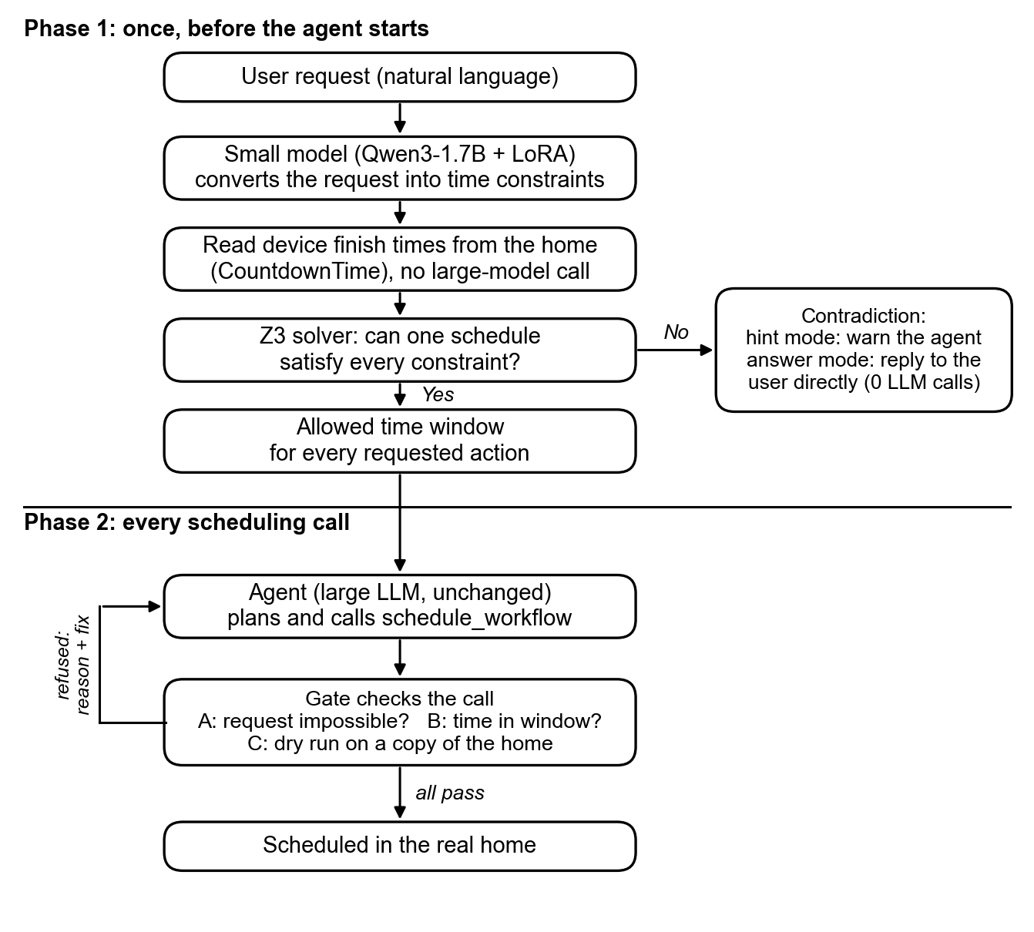
Figure 1. Approach 2: pre-flight check of the request, then a check of every scheduling call.

4. Current Results
Setup: SimuHome QT4, agent and judge Gemma-4-31B (NVIDIA API), held-out test episodes the parser never saw (8–10 per sub-type and case). “Calls” is the number of large-model calls per request.
Impossible requests | QT4-1 | QT4-2 | QT4-3* | Calls (QT4-1 / QT4-2)
Agent alone | 4/10 | 0/8 | 4/9 | 3.1 / 6.9
Prompt self-check | 10/10 | 8/8 | 5/9 | 1.1 / 3.5
Gate, hint mode | 10/10 | 8/8 | 4/9 | 1.0 / 2.0
Gate, answer mode | 10/10 | 8/8 | 4/9 | 0 / 0
Table 1. Impossible requests correctly refused. *5 of the 9 QT4-3 cases are device run-time conflicts outside the gate’s scope, so 4/9 is its maximum.
The gate detects every QT4-1 and QT4-2 contradiction, and in answer mode it does so without calling the large model at all. Compared episode by episode with the agent alone, answer mode is significantly better (McNemar’s test, p = 0.002, first session, all three sub-types pooled). A one-line self-check prompt reaches the same accuracy on this agent but needs one to four large-model calls per request.
Possible requests | QT4-1 | QT4-2 | QT4-3
Agent alone | 2/10 | 5/8 | 2/9
Prompt self-check | 3/10 | 4/8 | 0/9
Gate (v2.0) | 5/10 | 4/8 | 1/9
Gate (v2.1) | 2/10 | – | –
Table 2. Possible requests completed correctly (– = not yet run).
On possible requests no method is yet clearly better than the agent alone. With 8–10 episodes per cell the differences are within run-to-run variation.
Offline check of the current gate (v2.2). Replaying every recorded agent trace through the gate, it blocked none of the 29 correct plans. It flagged the agent’s mistake in 33 of 42 failed episodes from the first session and 18 of 20 from the second.
Small-model parser. On the 54 held-out requests it gave the correct possible/impossible verdict in 47 of 49 scored cases, and an exactly correct structure in 33 of 54.
In progress. Gate v2.2 is being evaluated on all 300 QT4 episodes (50 per cell) with a 5-fold cross-validated parser and paired comparisons. The same experiment will then be repeated with a smaller agent model.

